Experiment -3
3. Execute and display the results for the following commands in Kali Linux Operating
Systems:

Tree
Head
Tail
Aim
To execute and study the tree, head, and tail commands in the Kali Linux operating system and observe their results.
1.TREE COMMAND
Command:
tree
Use:
The tree command displays files and directories in a hierarchical tree structure. 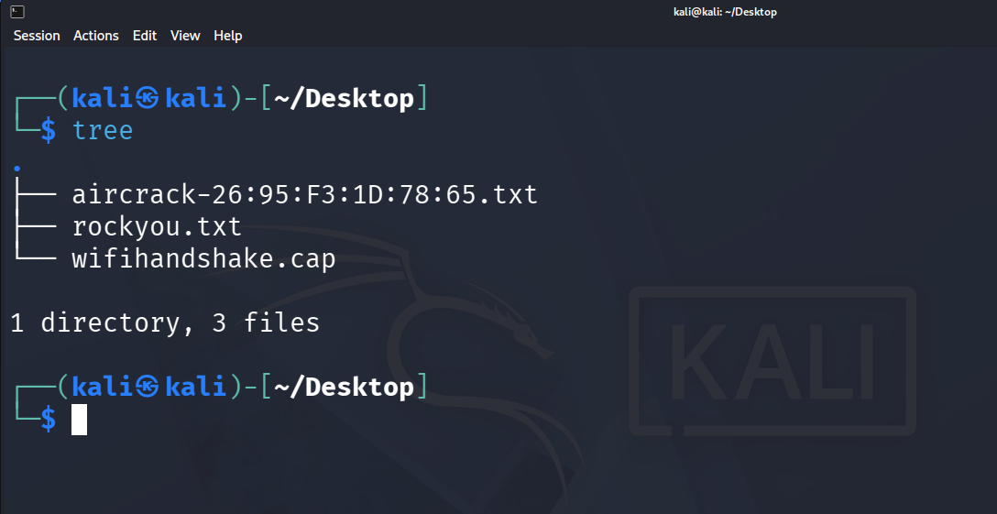

2.HEAD COMMAND
Command:
head numbers.txt
Use:
The head command displays the first few lines of a text file. 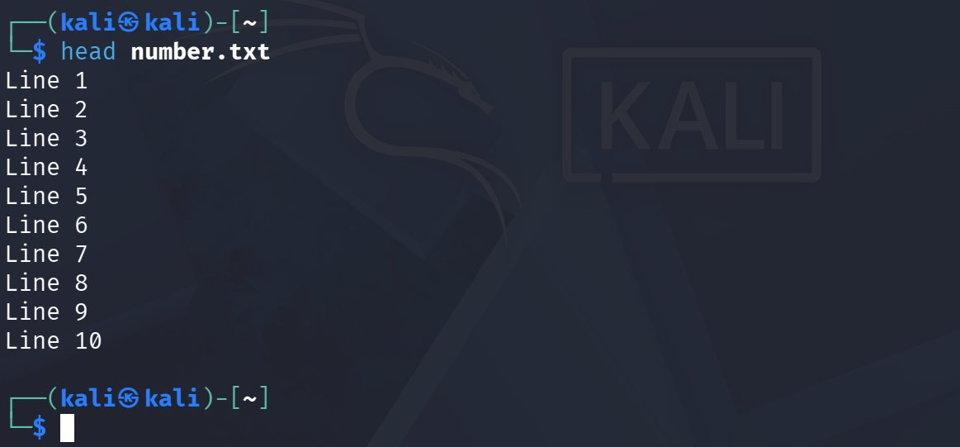

3. TAIL COMMAND
Command:
tail numbers.txt
Use:The tail command displays the last few lines of a text file. 