Experiment -4
4. Execute and display the results for the following commands in Kali Linux Operating
Systems:

i) Ls
ii) Cat
iii) Mkdir
Aim
To execute and study the ls, cat, and mkdir commands in the Kali Linux operating system and observe their results.
1.LS COMMAND
Command:
ls
Use:
The ls command is used to list files and directories in the current directory.
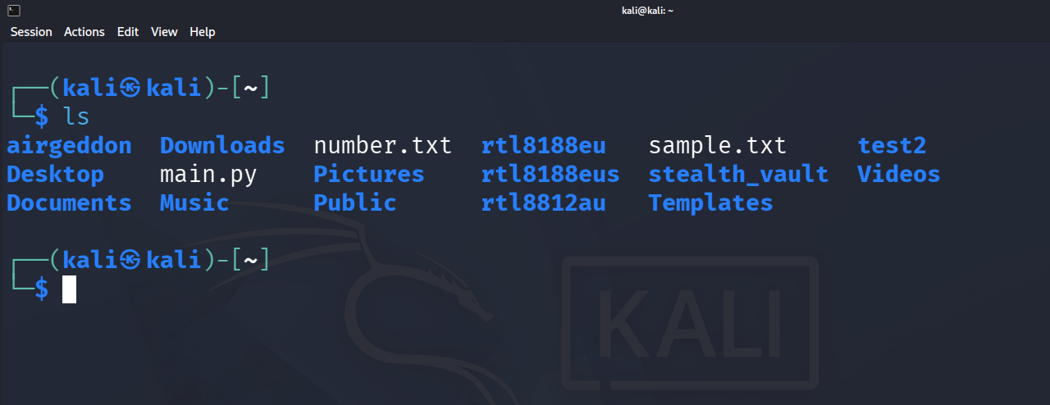

2.CAT COMMAND
Command:
cat sample.txt
Use:
The cat command is used to display the contents of a file. It can also be used to create and combine files.
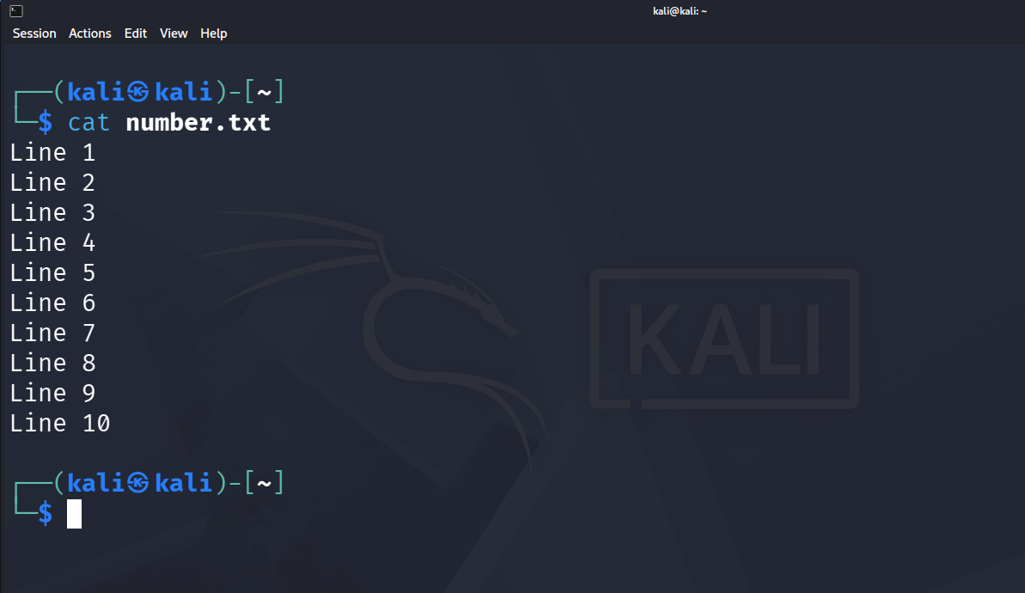

3. MKDIR COMMAND
Command:
mkdir myfolder
Use: The mkdir command is used to create a new directory (folder). 