Experiment -5
5. Execute and display the results for the following commands in Kali Linux Operating
Systems:

i) Uptime
ii) Date
iii) Mv
Aim
To execute and study the uptime, date, and mv commands in the Kali Linux operating system and observe their results.
1.UPTIME COMMAND
Command:
uptime
Use:
The uptime command displays information about how long the system has been running, the number of users currently logged in, and system load averages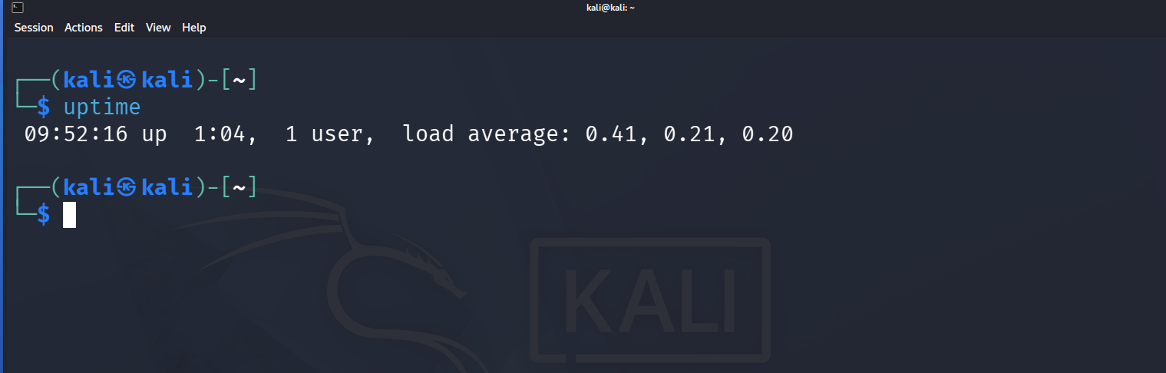

2.DATE COMMAND
Command:
date
Use:
The date command is used to display the current system date and time. 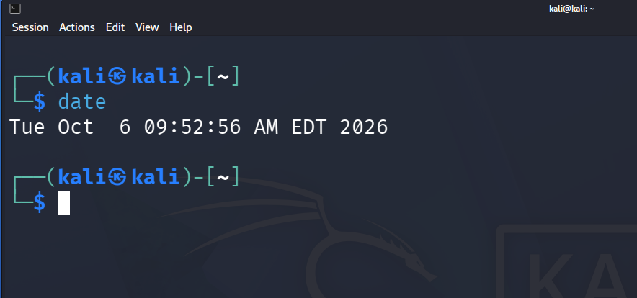

3. MV COMMAND
Command:
mv oldfile.txt newfile.txt
Use: The mv command is used to move or rename files and directories. 