Experiment -6
6. Execute and display the results for the following commands in Kali Linux Operating
Systems:

i) Touch
ii) Pwd
iii) Wget
Aim
To execute and study the touch, pwd, and wget commands in the Kali Linux operating system and observe their results.
1.TOUCH COMMAND
Command:
touch test.txt
Use:
The touch command is used to create a new empty file. It can also update the timestamp of an existing file. 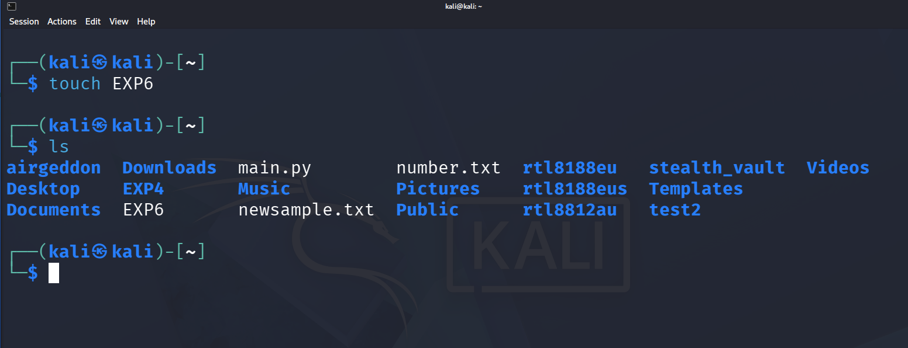

2.PWD COMMAND
Command:
pwd
Use:
The pwd command stands for Print Working Directory. It displays the full path of the current directory. 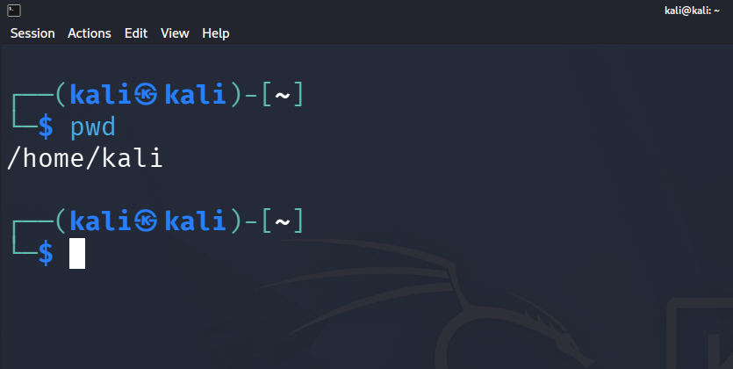

3.WGET COMMAND
Command:
wget https://example.com
Use: The wget command is used to download files from the Internet using HTTP, HTTPS, or FTP. 