Experiment -7
7. Execute and display the results for the following commands in Kali Linux Operating
Systems:

Cd
Cp
Ls
Aim
To execute and study the cd, cp, and ls commands in the Kali Linux operating system and observe their results.
1.CD COMMAND
Command:
cd /home/kali
Use:
The cd command stands for Change Directory. It is used to move from one directory to another. 

2.CP COMMAND
Command:
cp original.txt copy.txt
Use:
The cp command is used to copy files and directories.
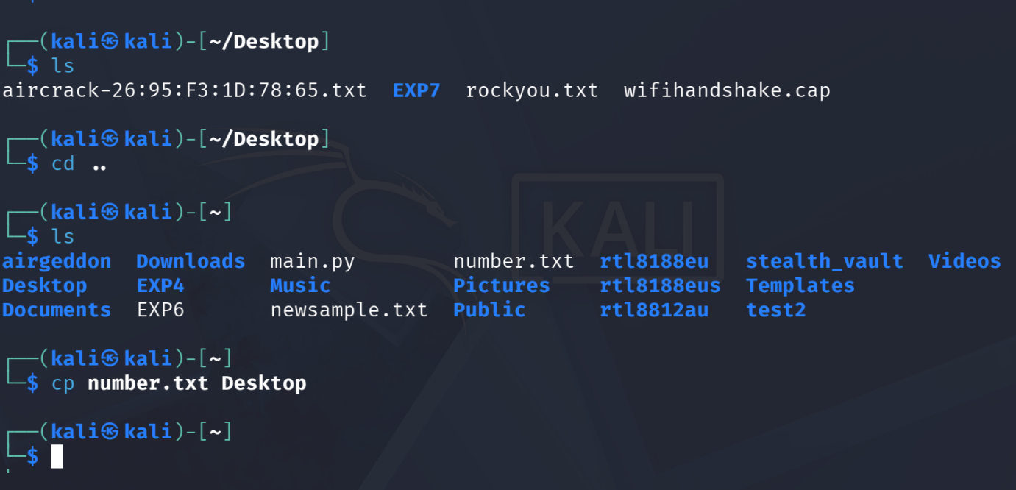

3.LS COMMAND
Command:
ls
Use: The ls command is used to list files and directories in the current directory.