S LIKITHESWAR REDDY

1VI23CD045

Inside Sales Analysis Project Report

Project Question/Objective
Analyze the inside sales dataset and generate insights on:

- Sales performance by Region

- Sales performance by Product

- Comparison of Actual sales vs Target sales

- Regional contribution share in sales Create:
- A Dashboard

- Visual Story using Region, Product, and Sales Comparison charts

Step-by-Step Implementation Guide
Step 1: Data Connection & Preparation

- Open Tableau Desktop

- Connect to "Text file" and select `Inside_Sales.csv`

- Verify data types are correctly identified
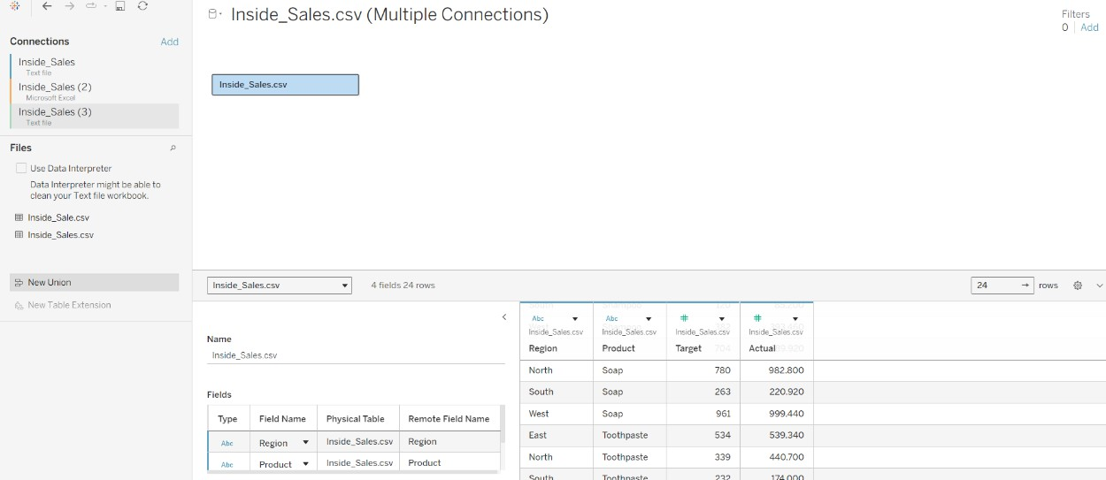

Data successfully loaded into Tableau with proper field recognition Step 2: Sales by Product Visualization
  - Create new worksheet

  - Drag Product → Rows

  - Drag Actual → Columns

  - Click Sort descending based on SUM(Actual)

  - Rename sheet → "Sales by Product"
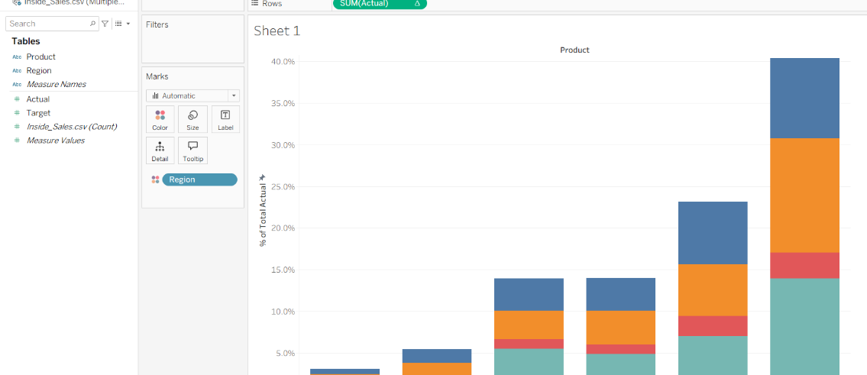

This view displays highest selling product at the top based on actual sales Step 3: Actual vs Target Sales Comparison (Grouped Bars)
- Create new worksheet

- Drag Product → Rows

- Drag Measure Values → Columns

- Drag Measure Names → Filters → select only ✔ Actual, ✔ Target

- Set Marks → Bar chart

- Set Measure Names → Color (two colored bars per product)

- Go to Label → Show mark labels

- Rename sheet → "Actual vs Target by Product"
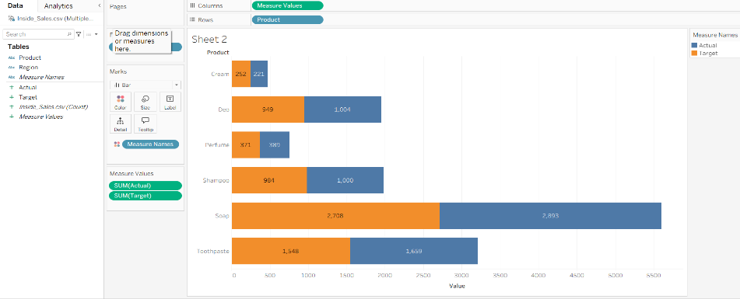
Caption: shows two side-by-side bars comparing Actual sales and Target values

Step 4: Largest Selling Regions (Treemap)

- Drag Region → Color

- Drag Region → Label

- Drag Actual → Size (ensure it shows SUM)

- Click Show Me → Treemap

- In Label add: Region SUM(Actual)
- Format SUM(Actual → 0 decimals + enable comma)
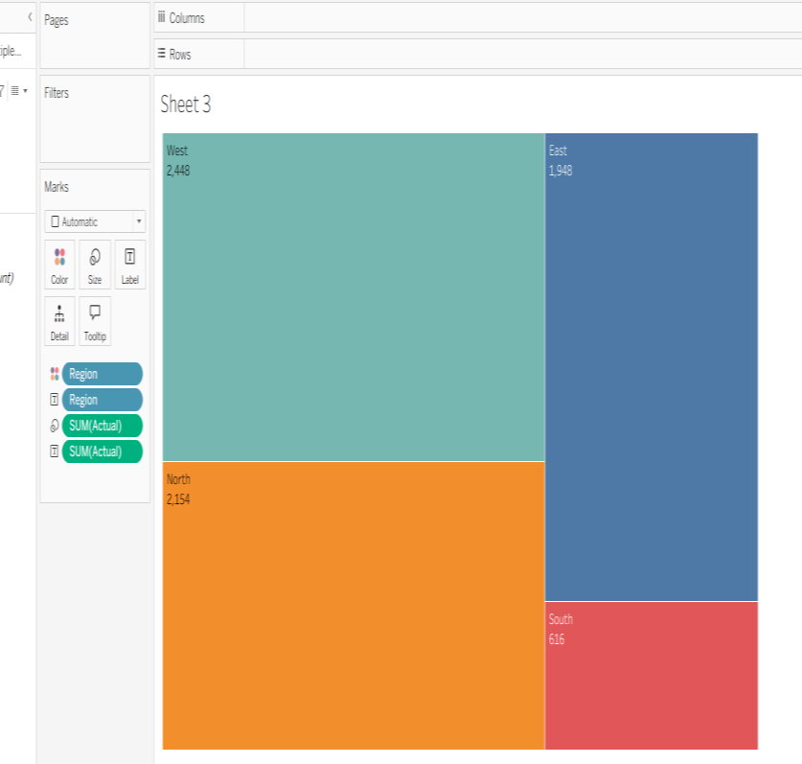

Treemap automatically highlights the largest selling region using the biggest box size, showing regional contribution clearly.
Step 5: Packed bubble to show product sales

- Drag Product → Detail (Marks card).

- Drag Actual → Size.

- On Marks card change Mark Type → Circle.

- Go to Show Me → click Packed Bubbles

- Drag Product → Label

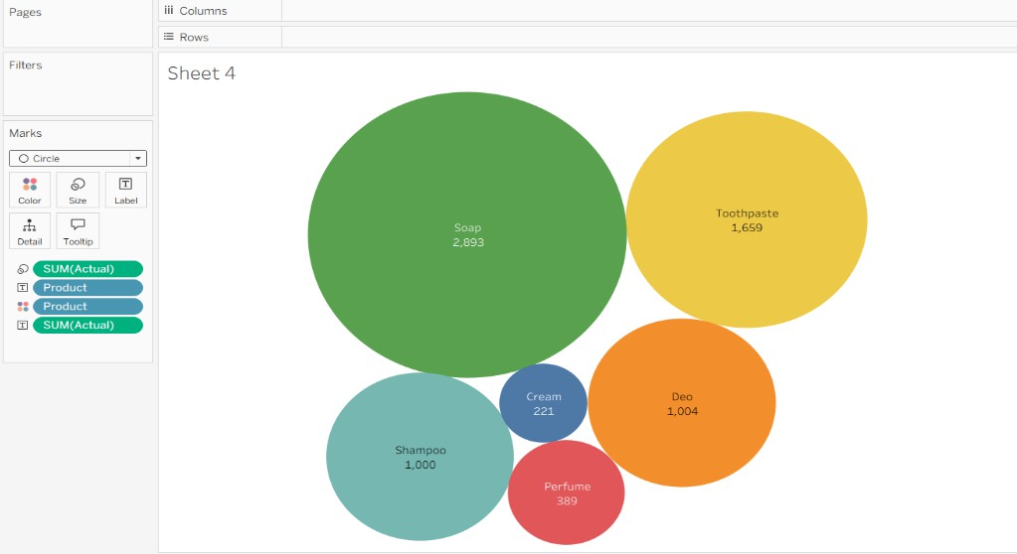
Shows the creation a packed bubble where bubble size = product sales Step 6 : Side-by-side circle chart to compare Actual vs Target for different products
- Drag Product → Rows.

- Drag Measure Names → Columns.

- Drag Measure Values → Size on the Marks card.

- Filter Measure Names to only Actual and Target.

- On Marks card, change Mark Type → Circle.

- Drag Measure Names → Color.

- Drag Measure Values → Label.
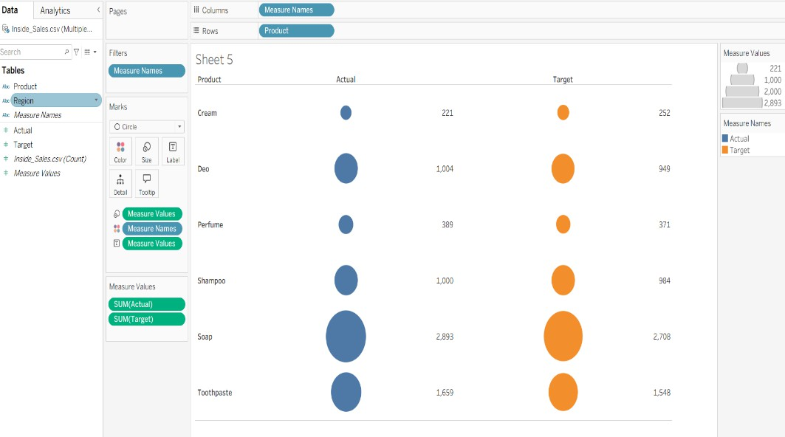

shows two circles side-by-side per product (Actual vs Target) sized by their values.

Step 6: Build Interactive Dashboard

- Click New Dashboard

- Drag sheets:

  - Sales by Product

  - Actual vs Target by Product

  - Treemap (Region Sales)

  - Region Distribution chart

- Arrange neatly

- Add Dashboard title → "Inside Sales Performance Overview"

- Enable Filter Actions
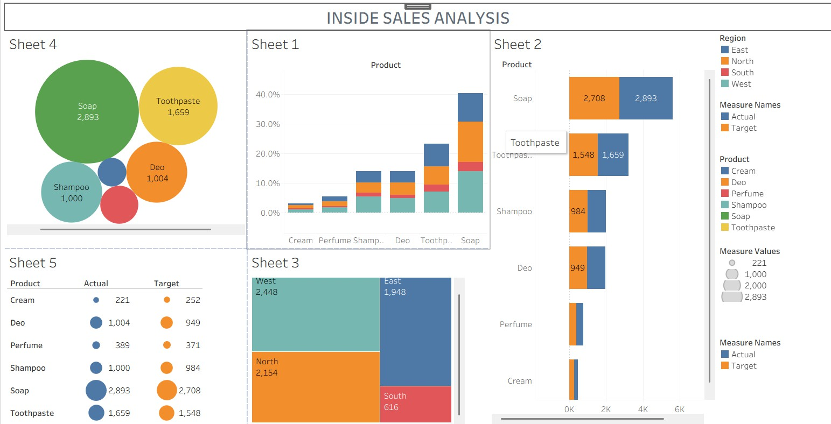
Interactive dashboard allowing cross-filtering between all views

Tools Used
- Tableau Desktop / Tableau Public

- Inside_Sales.csv dataset for analysis

- Excel dataset fields (Region, Product, Target, Actual)

Files Created
  - Inside_Sales_Dashboard.twbx

  - Project Analysis Report Document

