**Name : p.sree sai likhitha**

**Roll number: 2420030028**

**Sec:02**

**TASK-2:**

Execute the following network commands like Ipconfig, tracert, telnet , netsh, ping, nslookup, netstat.

**PROCEDURE**

**STEP-1 :**

Launch cisco packet tracer.

Double click the cisco packet tracer icon on your desktop or find it in your application list and open the program.

**STEP-2:**

Create a simple network topology

1. Add devices

Drag and drop a router and a switch from the device list on the work space.

Drag and drop 2 PCs on the work space .

1. Connect devices

Use the connection tool to connect the devices

* Connect one PC to the switch using the copper straight-through.
* Connect the switch to the router using another copper straight-through cable.
* Connect the second PC to the switch using copper straight-through cable.
* Connect the switch to the router using another copper straight-through cable.

Configure the devices

* Click on the router go to config tab and assign IP address to the router interface

Eg: Interface G0/0 : ip address 192.168.1.1, Subnet mask: 255. 255.255.0

Configure the PCs

* Click on each PC go to the desktop option and then ip configuration

Assign the IP address to the PC

Eg : PC0- IP address 192.168.1.2

Subnet mask 255.255.255.0

Default Gateway 192.168.1.1

**STEP -3**

Execute the networking command

Open the command prompt from PC0

Click on PC0

Go to the desktop tab and open the command prompt from PC0

**Command1: ipconfig**

This command displays all correct tcp ip network configuration values and all dehead and

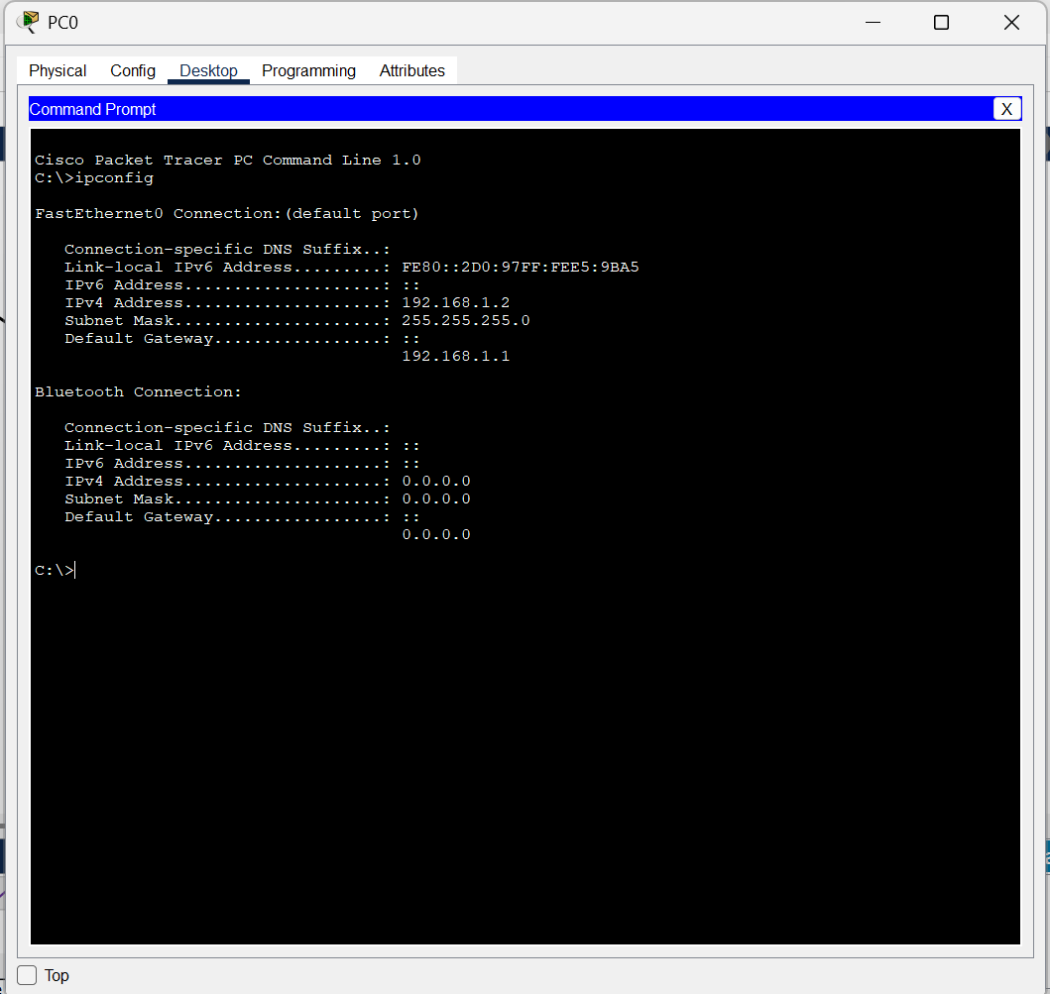

**Command2: tracert**This command traces the path taken to a destination by sending ICMP Echo Request messages.

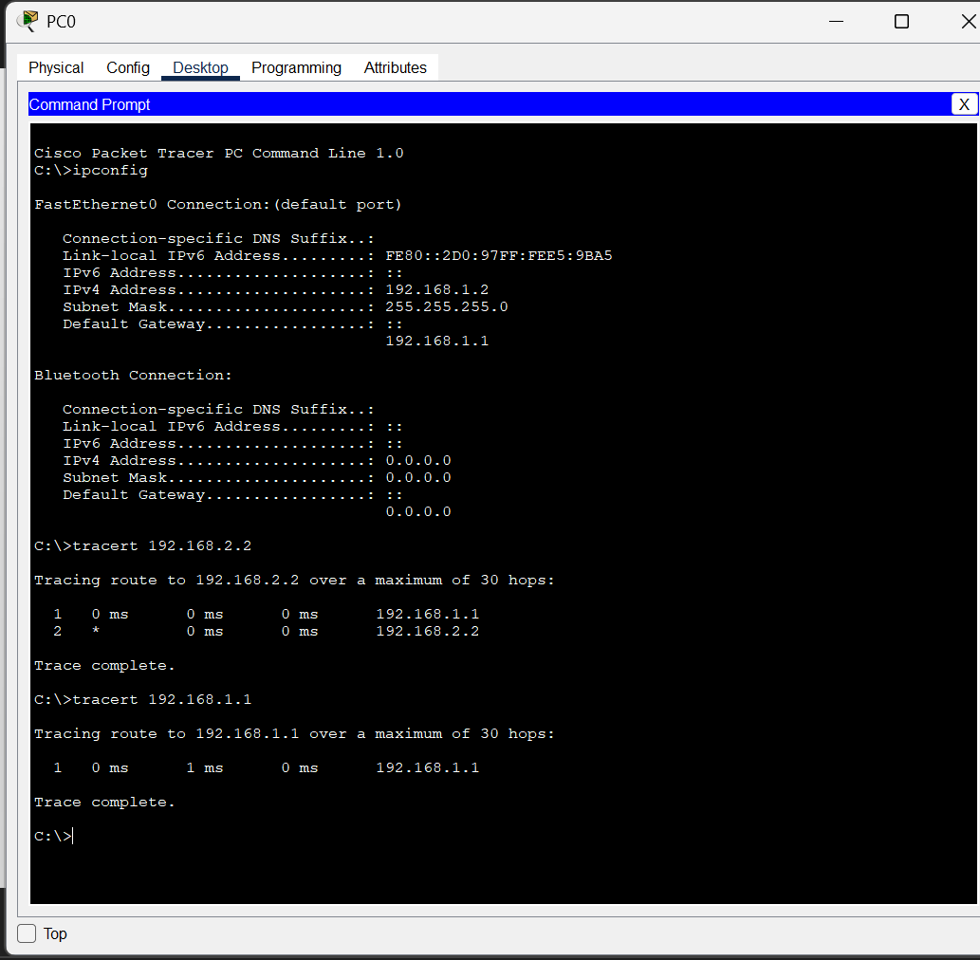

**Command 3 : telnet**This command is used for interactive with another host using a telnet protocol.

1.Open Command Prompt  
 Go to the PC0 and go to desktop tab and open the command prompt and execute the telnet command.

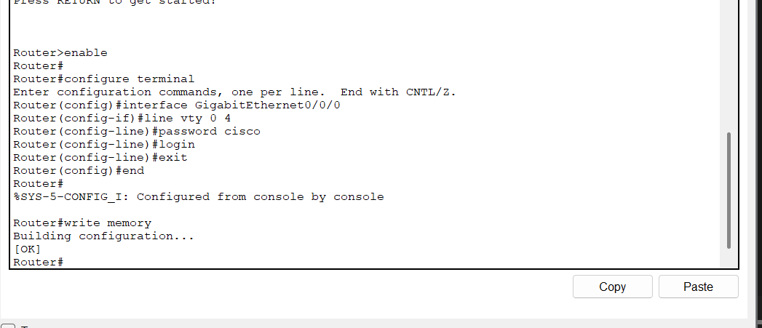

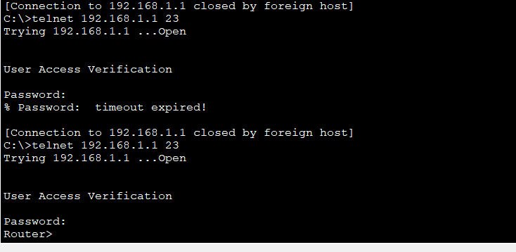

**Command 4 : Router configuration and Brief ip interface**

This command is a scripting utility that allows you to display or modify the network configuration of a configuration.

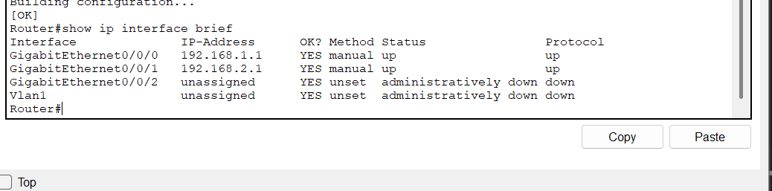

**Command 5 : Ping**

ICMP Echo

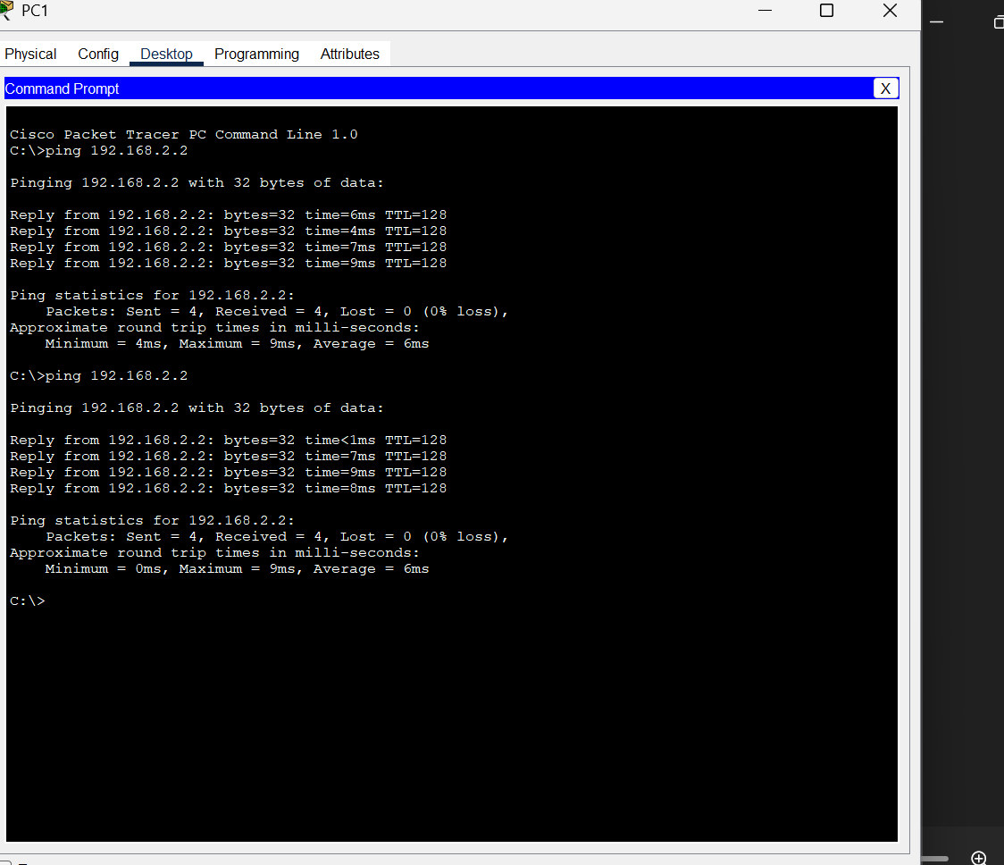

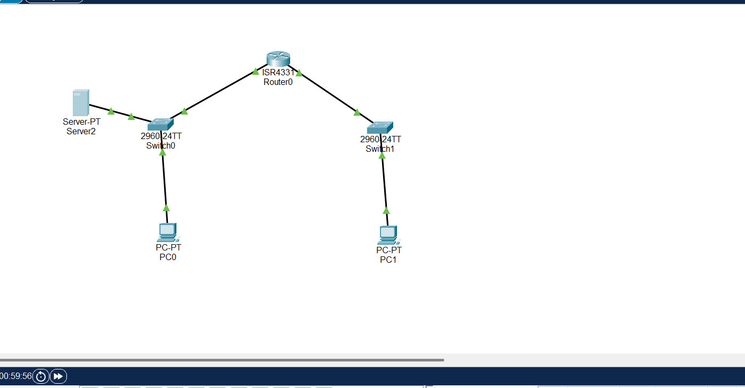

**Command 6 : Nslookup**

Add the server and connect it to the PC0 through switch  
go to server and click on service and select DNS and click on and then go to name and name it as [www.google.com](http://www.google.com) and add it.

Go to PC0 and click on command prompt and execute the following  
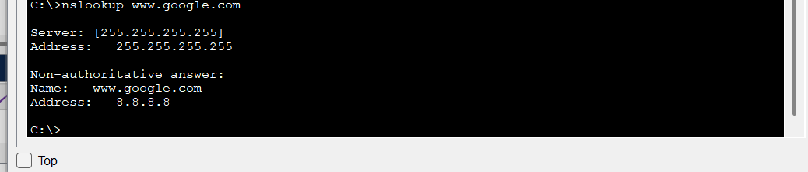

**Command 7: Netstat**This command displays network connections for the transaction control protocol(TCP),routing tables,and a number of network interface and network protocol statistics.

