NAME :p.sree sai Likhitha

Roll number: 2420030028

Subject: computer networks

**Experiment: Configuration of Encapsulation dot1Q using Cisco Packet Tracer**

**Aim:**

To configure VLANs and trunking with IEEE 802.1Q encapsulation on a Cisco switch using Cisco Packet Tracer and verify connectivity between PCs.

**Need for VLANs and Dot1Q Encapsulation:**

1. **Network Segmentation**  
   VLANs allow dividing a larger network into smaller isolated segments. Each segment can be assigned to a department/group, reducing broadcast traffic and improving performance.
2. **Security**  
   Sensitive data can be isolated in VLANs. Users in one VLAN cannot access another VLAN without proper routing and access control.
3. **Flexibility and Scalability**  
   VLANs allow adding/removing devices without physical changes. New VLANs can be created easily.
4. **Traffic Management**  
   VLANs limit broadcast domains, reduce unnecessary traffic, and improve network performance.
5. **Simplified Network Management**  
   VLANs provide easier management and troubleshooting. Logical management reduces configuration complexity.
6. **Inter-VLAN Routing**  
   Dot1Q encapsulation allows multiple VLANs to traverse trunk links between switches. This enables communication between VLANs via a router or Layer 3 switch.

**Network Topology:**

* 2 Switches (Multi-layer Switches) connected through a trunk link.
* 4 PCs connected to switches.
* PCs assigned different VLANs with the following IPs:
  + PC0 → 192.168.1.2
  + PC1 → 192.168.2.2
  + PC2 → 192.168.1.3
  + PC3 → 192.168.2.3
* 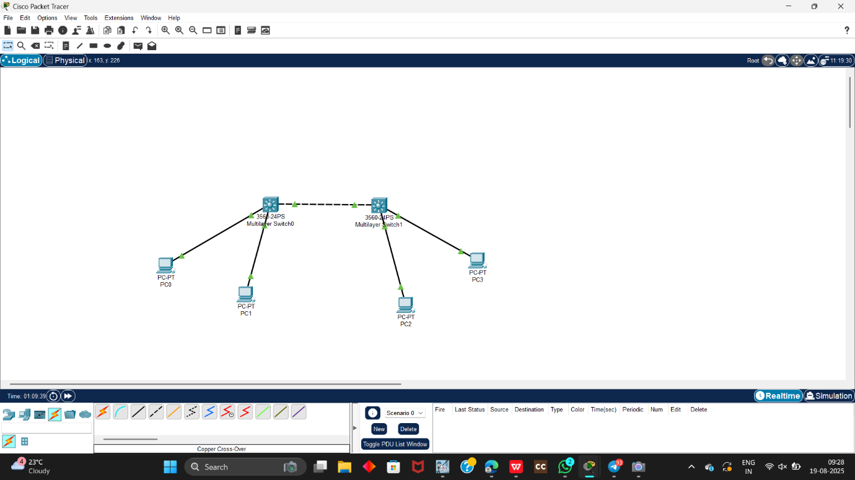

**Step-by-Step Configuration:**

**Step 1: Set Up the Network**

1. Open Cisco Packet Tracer.
2. Place two multilayer switches and four PCs.
3. Connect PCs to switches using straight-through cables and connect switches with a trunk link.

**Step 2: Configure VLANs**

**Switch 1 Configuration**

* Switch-enable
* Switch #configure terminal
* Enter configuration commands, one per line. End with CNTL/Z

Create VLAN 10

* Switch(config)#vlan 10
* Switch(config-vlan)#name VLAN10 Switch(config-vlan)#exit

Create VLAN 20

* Switch(config)#vlan 20
* Switch(config-vlan)#name VLAN20
* Switch(config-vlan)#exit

**Set a Port to Trunk Mode SO**

* Switch (config)#interface fa0/24
* Switch(config-if)#switchport mode trunk
* Switch(config-if)#exit

1. Create VLANs on switches and assign ports to VLANs.
   * VLAN 10 → PC0, PC2
   * VLAN 20 → PC1, PC3

**Step 3: Configure Trunking**

1. Set the link between switches as a trunk.
   * switchport mode trunk
   * switchport trunk allowed vlan 10,20
   * commad show interface brief
2. 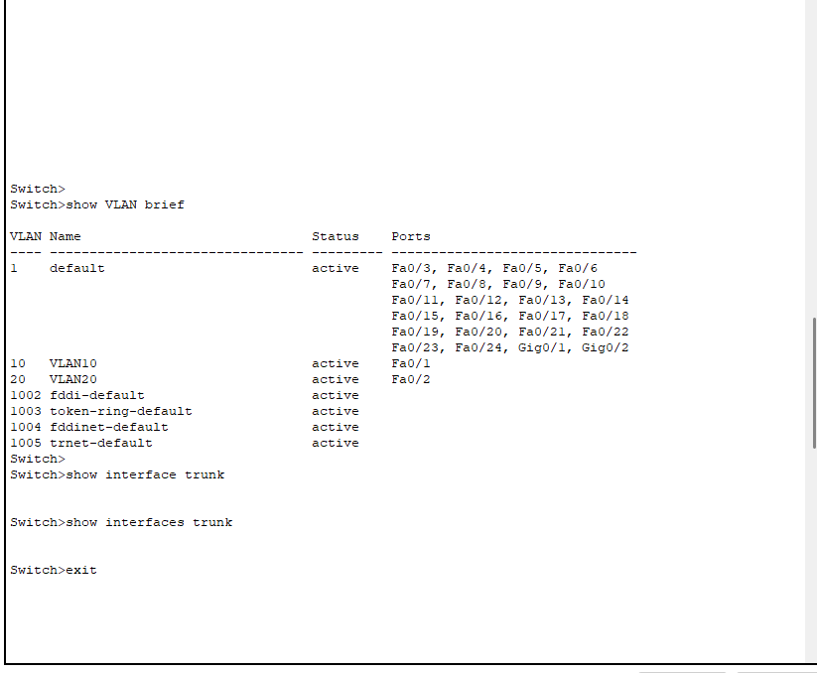
   * Command show interfaces trunk
3. 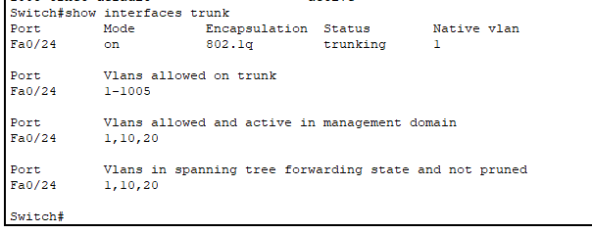

**Step 4: Assign IP Addresses**

1. Assign the following IP addresses to PCs:
   * PC0: 192.168.1.2
   * PC1: 192.168.2.2
   * PC2: 192.168.1.3
   * PC3: 192.168.2.3

**Step 5: Test Connectivity**

1. Open Command Prompt in PC0 and ping PC2 (192.168.1.3).
   * Successful reply indicates same VLAN communication works.
2. Ping between VLANs to verify routing.

Example:

* Ping from 192.168.1.2 → 192.168.1.3 ✅ Successful
* Ping from 192.168.1.3 → 192.168.2.2 ✅ Successful
* Ping from 192.168.2.2 → 192.168.2.3 ✅ Successful
* 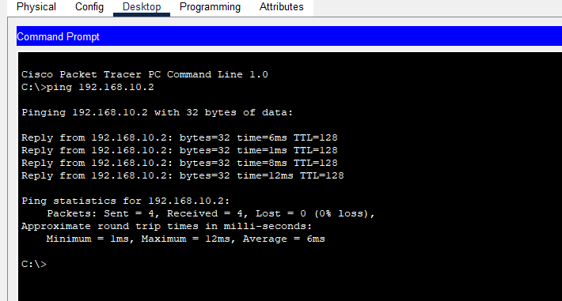

**Result:**

VLANs were created and trunking with dot1Q encapsulation was configured successfully. The PCs in the same VLAN communicated directly, and inter-VLAN communication was achieved using proper routing.

