CHAPTER VII (Section 88 to 122)
MANAGEMENT AND ADMINISTRATION

Section No. | Contents
88 | Register of members, etc.
89 | Declaration in respect of beneficial interest in any share.
90 | Investigation of beneficial ownership of shares in certain cases.
91 | Power to close register of members or debenture holders or other security holders.
92 | Annual return.
93 | Return to be filed with Registrar in case promoters‘ stake changes.
94 | Place of keeping and inspection of registers, returns, etc.
95 | Registers, etc., to be evidence.
96 | Annual general meeting.
97 | Power of Tribunal to call annual general meeting.
98 | Power of Tribunal to call meetings of members, etc.
99 | Punishment for default in complying with provisions of sections 96 to 98.
100 | Calling of extraordinary general meeting.
101 | Notice of meeting.
102 | Statement to be annexed to notice.
103 | Quorum for meetings.
104 | Chairman of meetings.
105 | Proxies.
106 | Restriction on voting rights.
107 | Voting by show of hands.
108 | Voting through electronic means.
109 | Demand for poll.
110 | Postal ballot.
111 | Circulation of members‘ resolution.
112 | Representation of President and Governors in meetings.
113 | Representation of corporations at meeting of companies and of creditors.
114 | Ordinary and special resolutions.
115 | Resolutions requiring special notice.
116 | Resolutions passed at adjourned meeting.
117 | Resolutions and agreements to be filed.
118 | Minutes of proceedings of general meeting, meeting of Board of Directors and other meeting and resolutions passed by postal ballot.
119 | Inspection of minute-books of general meeting.
120 | Maintenance and inspection of documents in electronic form.
121 | Report on annual general meeting.
122 | Applicability of this Chapter to One Person Company.
“There are no limits to what you can achieve with your life,
Except the limits you accept in your mind”

Shubhamm Sukhlecha (CA, CS, LLM)

C...h°'f> t-v"l VU [_S�• C8 8 - \ 'l..Cl..°]
t-ll_o. �eJr""\.t- onci 4=\d� -rv' htv'e>J4 on

-tcv C.D h�l\ �•,n-ts::>\ n �
0 V\� � Me..n""\b �
® R.. /",\-u-1., ot- c\�bQs-\ c.. ho'\d�.
® 'A\-o-\. 0 1 on.:J ofu-t.>"\ �-e... '� �o\d.�

-v-"\..
'\/'::, So �v -<V"\ove...

'1A'K>-'\
c..c. c...e-p o�j
0 � /.:)�d e.- � r'\. • ,
>-\e..A�cl,j� ous�,de..

-'-'\ \ I\ \-v1 i� Or'\::) C...0 \:> 'I\ ?f'.r�
A€.. , � no\d..
�r\CM°'· Q_t Qe>t'r\ • btj ProA'J


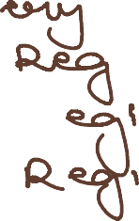

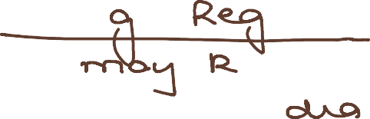
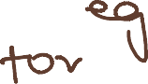

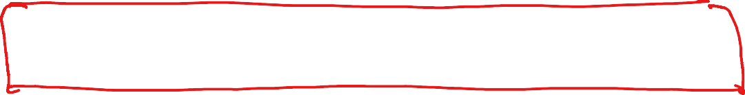



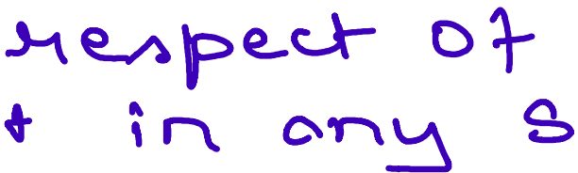
Se� '8 9 � D e.c.\ C>.J-\.o..\4 o -n ·, n
Coe.n �' clo.l ;f""\

1'
c\-l/2C...'-'A/\� °'� h't-,re..Lh \T""\ tt'"'\.e..-
'\J, o\e...o l't"'"\ o\e.A�p,p�o-n bO"'-,..

1
Se-c..• .9 o: R� tA.k>-1 O, 9:,��t'' 'f' c..cn-\ Rre.-n�cla,
0'-.A)f1't>'\.,h lr\ (>. C..Of"'f"'f:>01"'\�.

CA Shubhqmm Sukhlechq

o v- de..be.1""\ e. ho\
� A \v-\.. o 'T Me.AV\ b-l.)-c.l)
t)V 0.f--\-\-0--C. �-e_.(Ll 'hi

-Co CQn, cuOA€.. � M�cA'\-V-\ o) vY'\e..Yr\b� ov O
-H��k>-'\. ,-o� .mo�- 3o do� � o-nc:.JL ��
r
'-t5 cl.A� ,n � CU<- , " � � -
- Advor"\c....e.. noh c..e 0\- � +o be.. Uive..n.

P>4:.
Se.c.-, 9 � '. A n"I""\ uo1 R_e,_ n

-1--o be- p\oc..� o-n
We..bh�� 0,-L-o

''"'"Q\ _r,
R.e_pov-1]

CStea""'l -e.d. b�
D o.nd C..f:» l,'OY C..£; ;""�
(F.o" $rt'\S),, u, 1A. 0 ��
��'a"'"'� b� c� l 1)]

Roe...

Pe..r\_o\� ,'n-"\pOA�
on. \-'r\e.. c..o ov D -
- ,'ti' R-O• , Ho\o>. ',� c..n J
� /.:>UOA· c_o QAl'-)0�°'-.� CO-
'
-e/'--, , Cl e..b , k>r'\• rv
po.\' n.

\re.Jv'\\.!)f)

de..ro,�" -o, rf"'\e.N"\b Ov')
ond. de..b· ho\d�

�rn-e..e...\-i� l�"'l, Ct\.-'\.,LJ--\.l
�

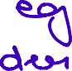
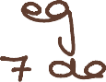
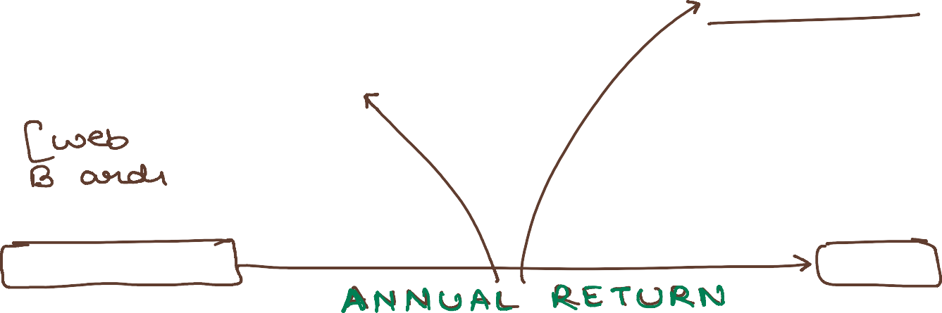


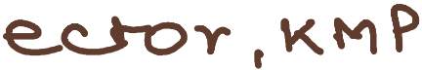

CA Shubhqmm Sukhlechq

* 9,e..c..•Ql�·.Re..\ n h:> b-e..fl� �,�Roe_ ;n
CP"':)� pvomok.M� ht-c...R..e. c..h��e.
(orn,\te..d"')

� Se.c_. � � � P \ °'c. e.. ot Re.e.p\<"\9 o-ru::l \n� pe..c...\-i on
ot V"G \� \--V-v'> , R.e... -n e.-+c...

- A.() \P.) L) \ $; � � � /.) 'h..0,l \ b-Et. � ep..
A f"\-r"\ � , Re.... n o \� 9 .2.. D._� .H h 't-u-\, �
'°'"

<I!.t- h'hot1. be�P-e..p.+ � o �j o�
0 \-+'' 0 t +ne. c..o_

<

p\oce. ,'Y""'\ .i. �dv-°' c....v h"'-YI e.. T"<I ov ,e_
-r\-\..o...""" , / , o ,t"\-\ o,- tr-o-t...0, y-"'\ o • o i
rne.�b ��,de_, b'j po/V\i ru:) � SR..

- q-�re.c.1-ion •.
CDn be... i � t,:>e.
c:Pn bQ. ,n/\pe..�

, e..-\-c... "4-o b-e.. e...v, d�nc_e..

R�,�h>-" 01� '68 ➔ /2r\..Q\l bQ. pv·,�

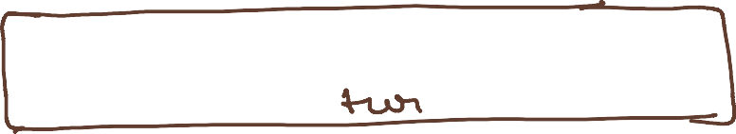
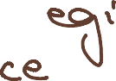
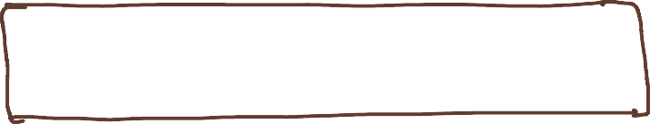
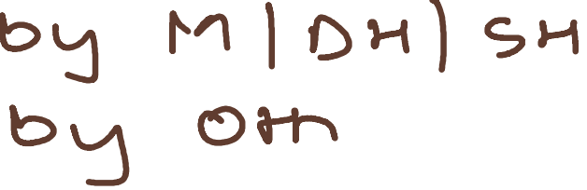
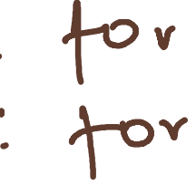

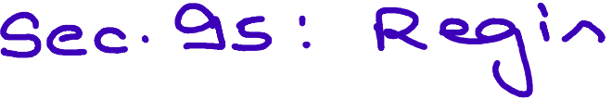
A n·ruJol Re.�n u\s 9 �
�c...i e. e...v \ d-e. nc...e
o i t /\ c...o n """"n t'i'\.
+

CA Shubhclmm Sukhlechcl

� S€..C...· �b � �n-nuQ\ C.e.n-t..>"\..Q' "--\-e...e..M�
_J tov C.O"A.. o
th a..'f'"\ o-rc...

+o be. C..OTI cl.u c..kd u.:> f \-h; n
9 'N""\OT'\tt'"'Y\ 'r"OT"'t'"'I �e_ F•"'I·

(_No e,_,c. � n�, on ,/\ o..\ \o v.:>�J

Sub�tc...n� AlAH : /.>lr\Ot., \d c..or(""it.>,� t..0i \+,
- one. A..U\ "'-1 in e.o� �
- w,,t-n; n . <om· >re om +n -e.. e.� o � � -"t •
- C.Q.p bl vu +v.:> o F\ C\ H CJ:>r"\ 1""'0--\- e.x. c...e..� \Sm·

( R..o C.. CD n �, v e.. e-xk.
"('"\�,of'"' to"'" up t-o '2> rn •J

�+ R.·O· ov Or'\� Oth-t.>1. p,oc...e.. \1""'\ a--t'-l-e..
6ome. c_jr1j, v,,,�-e. ov �u:>n.

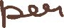
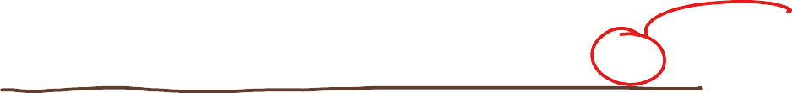

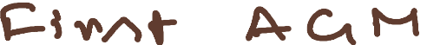
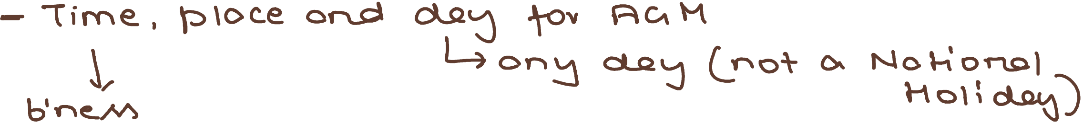

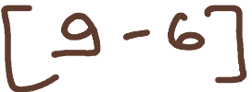
[ ACt H o\ on unHA�d C.o CDr"'\ be.
p\oc..e. in � , ',-\ C.O'f'°'/->e.:rv\-
d-he.. t--'\e.mb"-'"'\Aj
C..Ond..J..,c.l-<..d � on�
\A (),v.e..n bj o \ \

CA Shubhqmm Sukhlechq

�
- -u-
((o" �

Sec.• � -=f. : Pov-:> u-\. o+ 1'n' bu f'\.0 I -+-o c.s,\\ A-C\. H

  - g:>t- o\e..to'-'\� '0- de. ; 'r' h o '\ cl,. � ACA+--\ � \ C .9 c ,
  - OT""\ opt=>\ 1 c.oko-n o,- on� r-n-e.,Y"'l"\b� ,
  - 'T-,r b u ru=>\ c...o'""' e.d � e.. c._p\ \; "'1 °t ��H
  - or-,d a\/::J.O �,v-e.. hU� onci\\\OM'-1 e..C...MO-n.6
\, R.e -e..v -e..T"'\ OT\e. 'f"f"\e..N"'lb-tJ.'\ pv ��"° i""' f>-u--\A'OT\ ov
b� pYo ,c.'j �n.0,, bQ. cle..e .-n-ed d-o C..0-r"/)��k
cyu O VU YT\ .

0/
vo" �
./'

Se.c.-- 9S ' Po �V-1 o+ \V\ b\.:>1"\0l re C,.g\\ ...--n-e.L-'4� o+
rne..�b�, e.+c..-

T+ i-\- IA ·,mpvo c..n c.ab1e. +-o

j,
Tvibun.cl c.Dn ov

+-o c..oY"\.o\.ucJ- t-n c... He.e. n�

Suo �o� c...-
'� . '

01'""\.cl c..01""\ 0 \I\ 0 ccl Ve_ 0 T'"'\ C) \ 1 OJ-\�
e..c..l-i, OT\6 \ i Re.
�e..c_ •9 -=1-.


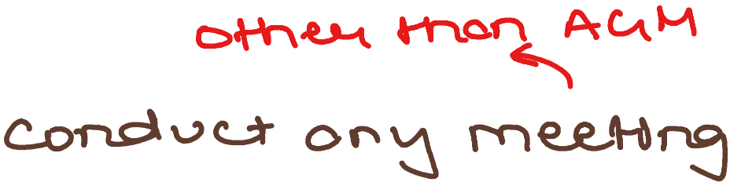
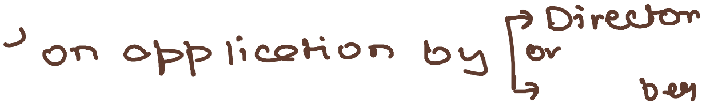
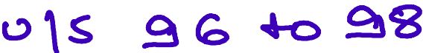
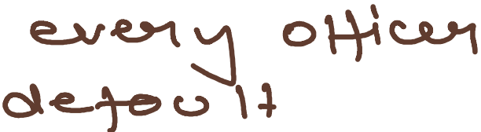

c.o.

'
' f""\
\.00,000

CA Shubhqmm Sukhlechq

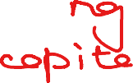

Sec.- \00 •. G:::>\\,� o1 £.')t�o.- Ovd,<"'-0-)-\� Cie..'f'"\oi.o,
M�e.\-i�

t ..i. � t
Q,�{1� Bt1 �00.)-\� 11� Re.�i/\,hoT"'\\A+ n�T-
h\JO f"'("\Ql"'O on �e.orui�i '\-ion +ne..TY"\Ae..\v� [98]
-L, J,. *' .j, --- 'l...
� Of'\� p\o.C...e G o D h, c.o,, 1-1'\e H - f'i'.\- tt')e. m · ·,A no-\-
i""' �nd�� Lo1�\n �\ �l.f" �, \-e.d tJO • � \ � ov-
*� '\" om � e&y\j;/\"�'vi') t"'\O+ he..\cl. t.-0 • � c;�
o'Ni c_.o f\d.\.:> c.J-�-e. R.e°v. c.o-n �or-due.+
M . L>.); t-h' f' '--\ s c:A...OV(' .\-'he. 'N\ee. h �
')' om v�"';.h, \-i on. ,\-r\-e.,tn·M.jv � L.o • '2,-rn.

� \ •. \,t'h-o c.9n � i-vc _,.,,�o;�; Mon�

� \ J,
� C..O· ha-v,� Sh�· p- C..o· no'\ h.Qv;� �h-cs,\=>·
Me-mb.co-lA. Y""l.P'-'01 to·t. "'1e�b-o-v\ �v;� 1- o'J_ O}- S e \ ot 'V oh ":9 )-'\�" 't.\ • hov·1� VO�� R\eil"'\'rA ·
0 rroo"'e
'1� , • l .•
�;;\. Al\ +t.e. ,c...p ,nc... � b.!J .L'\�ui 1--,\ ri°"'V\:l..h
� c.o-rduc...+ �� rne..e. H� �ti.0\\ be,
'1e..-\rnb�� b� �-e_ CD-
'1...
,t-h-e.. orf"CL'>n>r /)he,\\ be.de..cLuc..� 1"'0"' en�
'f'"� �c'(job, e +o +-'r-.e. cl e.;-ot., \ \-i � ct.:." e.c...t-ov.

CA Shubhqmm Sukhlechq

� � �ho\� ov:>n-ed �ubh,d..\o.J."'1� 0 T o.. Co-rr"pa.T"\�
ine-ovpovo.k..d O�A\de... �nd.�O\ c.s:>n c..ond.\.!>c:3-
�� A�M, O�A,oe. �nol;°'-·

Se.c.· \0\ ' No'Hce..
-
- d.olk. '01 Nohc.e.
e.xc..\ud tA : • c:AA,.� OT Ke.e.��
- L"\ff hO� (�
poh�-

�' c.\� d,.g'-r 1"\0h c.e. i1., v�c.;,,v-ed \o" �Q.'"' 0-\0\\ '""'e.e.Hne 1
e..i H'"\Oo\ , n u::,-v, t=, '"'9 ov +h" o� "r\ e..,e.c_� o n, c. 'N" o d-e.

-' l'Y"\ee.\i":5 es>n be. es,,,� O\'r °' h'h�\-t.J.\ 1""\oh� ·,+ �6'•1. o�
The A e.,...o\clU'\.h [ b� VOtt":9 ""'9n'""J '()'" (LJ\ �'-A."1 ��'"-

•Notlc.e. /2\-u2\\ be.. 9 '"'e..1""\ \-o :
- e.v�� rnC.T'l"b-U-1 (_ \�0\ Me.���ntiA\-{ v�
0�''\\"n-e.t. 0-\-

ot dee,_-
\� o, v e..n� -rnem)

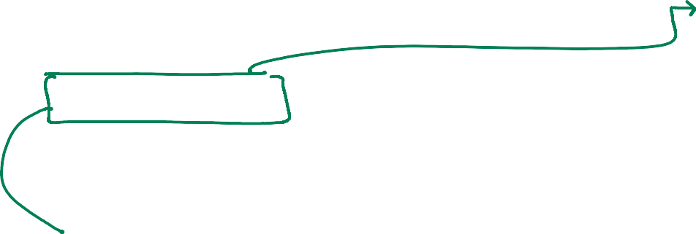
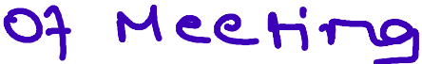

- Rn� <AC.C..,dE!...r\�\ orn,l'v'-.,o-n ti:> �,v-e.. no\-\c...e. TO o.n':1
'N""t� b.\>-\ h � \\ T"l'O'r °\T"\ v O\;� � +-'n-e... p-v o c:R..e...d.l
[if'l"'\p1�� OT"'I� volun �� 'OrC""\N'-, 01"") L.O,,, ,n'VO.\� -"]

CA Shubhqmm Sukhlechq

� Se..c..- \o� '. S�\C N\C-n\- +o be.. on-n-e-�,e,,d ..\-o No�c.e..
(_E�p \0-n°' \-ov� 5�me.n +J
eP.ov e..v.u-t.� ,k.YV"\ o, hpe.-clQ\ b1n�AA ₁ "'°"o vo·,� '(V"'\.��Q\
tce-tA, +o be. Of"\'f"'\«..)t e..dt :

- in\-v"\E!J\t- (_�T\on C.:.°' \ E>v Ott"\-t>\ v0,At..J 0-\ D \�Mt>\ � o.�
\ • J.-\ e..\.o \-\ ve. .
on� oth-u-c. in\• u.:>h,cl-\ \A .)-\V-4!..v0.1'\- trov �u.,� O\e-c,

J
-t"h e.1"'\ c\-im -e. o'r\d p\ o c:.-e. wl'\ � e... � u c..n d o c \.?rn .e..l"\ t
LJ>T"'\ be.. in .op e_ c...� no� +o b-e- � \ v-e.-n .

\ n �"' � ea -e.."' \ cU h Cl Oh \.J..Y\ e.. , on .:3 be..�-\-
0.CC>-'\ u� +o hUc:.h p"'v0rt'O� r e_c..)-OV' ₁ f"l'\.0 �

ov- O�U-1. K.Mi> D'f �� J...,\e...\o.Hv-e._
C
.t--r\�

�'""' o u \...d ho l d tt----e. be..n e...f t , n +tu At o Y"'\..Cl
,+ bo.� ,4--o �e.. c..o'N""lpo.-n�-

B1ne.Jv\..
J,..
"°-,A.$\ c.s )
c\v-on�°'c...,� �
E.""P'���
���\"-" �
�o-n..�+o�



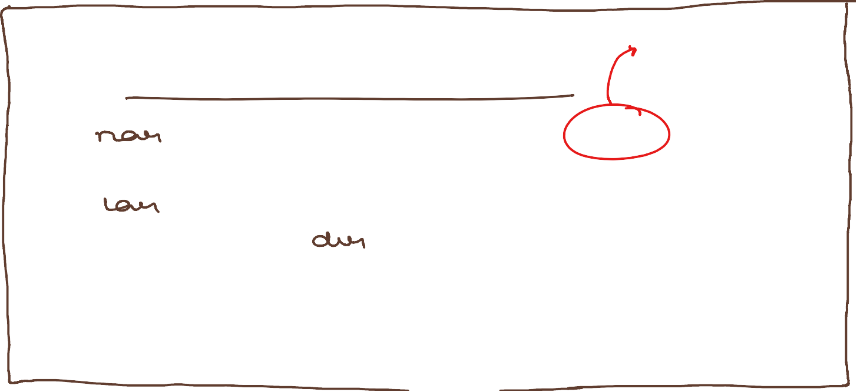



Ovd.� � b1n�
=
--,, c.o n�, cl V--\ °"\-\ o--n Ot � � -
- o,\e..c... °'-Hon O'\- d..,:\v.
- °'ppo,l"\:itr N"'\�" O\- • ��
- CApr-,o,nl-<n-tn� 01 oud,'kN (_�J
9.�o.\ b'ne..M
-4,
o \\ tt--\e_ b'n-e.tv\
  - c:_e...p 't- rov t-'f-\e_,
fo m-e.n"°'o"T\�

CA Shubhqmm Sukhlechq

.:JI,. Se.c..- \oC2, •. CQuovuN""\ ,-0"' ""e..e..\-in°V'-
\

c.o

    - <i:'t +he.. e>yuov'-'"' \.A no:tc- pve.1\-e.."' u.:>, 1--'n\n 3t> rn,n\!> \-<A
...\..,
l-�e.e..b� /\�� �JO"""'f'� �
�o.�e. �rt'\�, p\oc.e. ON'\� c:J...Q_�, n�t- l/4>U-R.
.t
'i't-o..r tt'"\� �O\.N"'T'\� m�c..\-i� 0\\A'O O\{OOV\;>-rf'"\ ih
no� pv�<!..f'\� t.e i h-\ \ n � o m; rnJ \<.,\ , rn e..N"b U'\.A
f>�e. /:)�"' hr\D\\ be.. °VU O V \.:J r<l .

� Se.c..- \ o Lt c...nou.>-1r,'"\CT""I

f""II.PT"'I 0-\ � e_ C.0 •. c.T'\0.\ V 'f'V°"'I OW"'"\ Q ,- 1--1,
.. "(Y"\.A "l"'"'i 'A Y"'\ O°' pv V\ '4t.n \ \JO \ � , n , s; 1"C"'\\ n>
�f"\ ,� �
..j,
one.. ON""\0� t--n.e_ C),v e..u-ov : C..h0-\v o\ K·
lt-\- f"'\O • e.C..�Y' \/'> p-v-e..A-e..n'" ov un u:> ·, ru�

i


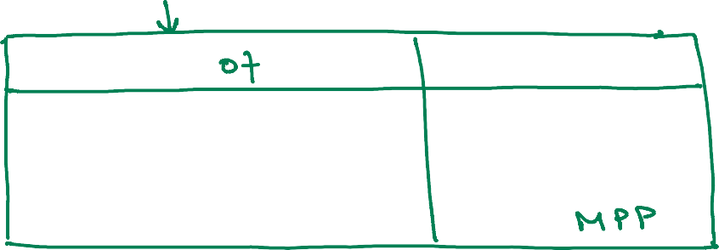
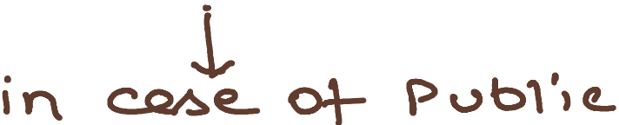
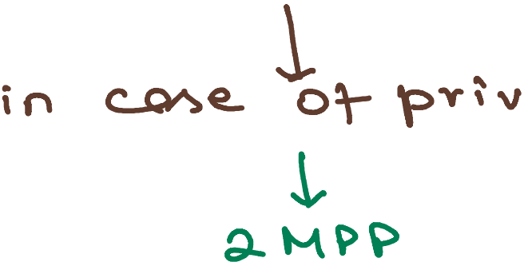

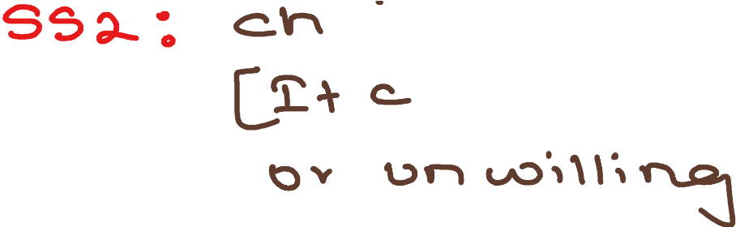

Se.c::.. \ O '-1 ': OT"\ e.,_ 01"'n 0�
°"f>po\n\-co\
�� g.h 0\J--\e.ho\ cl:t.,-� � be..
O'\. c.. r\ o; �e_ c..o.

CA Shubhqmm Sukhlechq

- A1""� f'i'"'\C.TY'\b ,o.., e n � l-1-e. '4-o o..� n.d. � v o1-'C- l,\:>\ l\ "r\..Dv e.
°'- J--\\�n� -t-o °'Pt-> o,n\ p--,ox �-

� ,' \ \ ,t'-\'0-r b e C..
c...ci? L:> r-) � ro-v (Q_U OV c.:>TO

Ca1'l T""'\OT vok on
.l!)novv o1 'r-\0 <. _; c.._gn vo� on
po1\

- N o�c.e ot tt,-e_ rn e.e. H � +-o i � c..\ "d -e.. °" /!:>� \-e.:men�
-t"h� o,.. f"Y"'\ e.."N"\ bu-, e..n� T\ e.. +-o Ck�� an..a.. v O �
C.Q'r'""\ �po;n + p-v o x�. •

- �V01'j to bE.. de.po�, ""'-.d L\ � 'r-.o
C.C..o c...P f" ""'o t e. ti � o.. to�� \

- Um, 't- OT- ?"' o"Iy-

J.. I


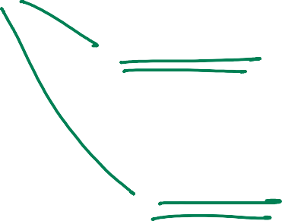
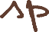
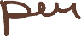

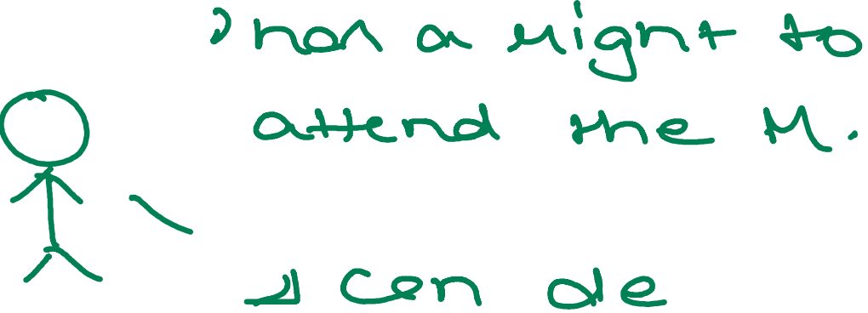
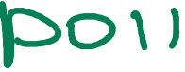
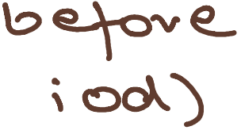
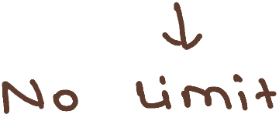
�-t 01. f"'""-�o-n t I'"> °'c_.\-i �
-1.t °'
0/\ pvo,c..� tov jv-"t one.
1""1""'1&-N""\ b-t>1

r. J, ' '
poU,-\1\0"n \_.A.- �'""'�
0-'\ p�o�'j 10°" �O'V e.. \-'n.Cl-11
o-n e.. rt""\��bU-1
G "'' � 1. •. Ko� . s-o K �'N'\t> Vv)
v1"nlt =l '. fv\.o�. \O'L 'oh·�-

CA Shubhqmm Sukhlechq

Se..c..- \ o fo : R @. � � ; c...H o ri OT'\ Vo\-i� �'�""'-�h
1vvh-t.M� c.,s>\'\A- hJ2.v-e_
<"\o+ b � 4e. T"'\ h1D \ d. .
OV 1--

Se..c...., o-:r- •. \lo'°'"'� b� �how 01'" h.P

A-\- C\ H , Un ,eAA pO 1' °'"' de..f'"'("\.,O�� l O'n � J.-\ e.AO \ \J '-..f 0'1"')
�\-\o\\ be_ de..c.>.d� b� Shove Ot ho

[ on Sno\A) 01 ho , -+ne. c.. N"\.0f"'\ '""" cte.c.... o..�on

or"\d OT-\ e..n""�'
o, ·,-½ ,n N"'\,n u \-e.A hl""\.0\\ �-Q..

C..OT'\ c.\ u�, v e_ ev, cl e.1"'\ c.e. ot t-n-e. ..He.A-o \u- \-\ 01""'\7

l BA�lC s)

Shov0 o, h.o
on� f""('"\.01"""). oT"\e. vo\-<.

Po\\ one. h e. , one. "'o�
L
�CI°' n, c.s:,,,'j 'V o � v.. � ?Jl.>1
po,cl � c..s,p\�l

E:.vo,� HA� C.o· oncl e..v�.,-HJ C....O· nov,� \ ooo OY- move.
l'f"\ e.'l""t"'\boi.h --? �hP', pvo-v, oe -t-t°'e.. �c) H � o,- e..-vo'r\�.

---=) �od \i� O� e.c- vo\,� � M-e... n o� tov
l""'\,n � d.Q� on.d �"-Sl,, c...\oAe. � 5 f> \.-\ on
� e. cl.0� �e c.�e..dJ � '"""'° C\ ""'-.


- bo� d� o-n.cl -p-ri
{ CP)\� "n� A
0

CA Shubhqmm Sukhlechq

c..on VO� , n e.- v O \-1� .
- e::>n c..e. '\JO te , A c..P\ k.d , i \ c.P1°""1 T"'O-t be... c..tL -<l.d..
- °' ��011 'j °'-�n.cl t-n-e.. C,1\\--'\ -e v� o -
vol-\� �vo�n e.--vo'M� .[_buJ- c..onn�r \JO}Y
-, So--tu \,-; n, '2-'U-\ Tt? be. o.f=>p o, ri b C.0.
Y PC.A l Pc A., Pc..c;, I Ad'VO �k ri':'.J p-t-"V'-on
-4,
C.no� e,_"""'r>'O'(f-'-')
- �c.>-1\;> �rn\2..-0,, T-o �,ve. O. .)..;\-E!...i->O'v� � �-e... C..o ,
�n,C,\-"\ �� be. f=>\oc.� on v-:>e.b)_0,k o,- C.O.

* Se..c..- \ 09 •. .De..'N"'\01""\Q fov Po,\

Po\\ c..Pn be. o\ .e.."C"'("\0 f"'\ cl�
'�
b�
Ajfov C-0¹A h.ov ·,� Sn· c_gp &.
�em bU"\..\. 'V'\Qv ,� \ o·,. 0-\- the..
VO"'� ?Ov:>� 'OY 5 .00,000
'pC \ °'- vf> c.Df>\-to,\ •
GJtoV Q,ttw-, C-0¹/\
Merf'\bv-t.A nPv ;� \Q'/. V· P.

'=>e..\-0-V e_ 0 V OT'\
c\e..c.. °"-.Hon O'r tt""\e..
.);\-e._�o\+A o��e
Vo\-;�.

- De..'f""r\.c.-n.d.. e+
�o\\ c..P� be-
v0, �°'-'""-o.\.,On
C.1"'\'af"'\°N\e b�op�-




- Po\\ d e..N"\c.ncie..d to-v od..) O LAJ"\�m�nt o1 TY\�e_� �
o-t °'P p o; "'t 1"n e.nr ot e.- f"\ A �, \ b e.
\-CA� \ovtt'\ l.,.:)l� [ot-h-t.M. v0\.Ae ;'f""'\ 4-g \-\.o�J

CA Shubhqmm Sukhlechq

c� '°..:J Y""\Of'\� c.s:>a-\o� 'h.� �Q.A\,M.,b-Cl.d.. �Pc-G·,n 'V'e.hOlu"
+o be. p�ed b!:1 poht"C.\ b01.\ \�-t.
[_�uvtn� +nc. �p�uf<..d ikN'\A. c_gn be.- ��� o,j-
°" N"\ e.seJ-\ � u:>t '""" -re>U , \ � 01 €.- Vo+\��

  - P>'\oc.L.d

No')-{ c...e.
+ Dv-o.>rr"" �ceA't> \\.J\-1 OT'\

Nol-, t.e..

v.)e..'oh;k

C..o Bo'D A-pr-, oin+

- ""'o.'Q...c.. ex .).A.��\-u)
��c..o"°' 0/'-1\e..n'\- �
� T"'\t) � 01"\
e...""\:)\0 '()-e./l
o��e..ts>•

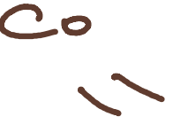


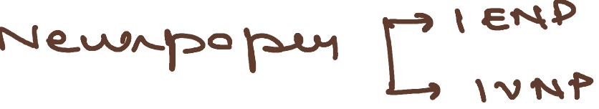


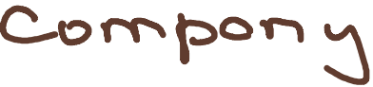


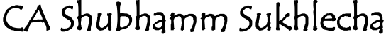
-'-'e...c..e.:,v -e...d. v::>" \-1°'\; n .\-i me.. �"'-c>v b q_g
� �e. 0\. R_e..p 0V \- . Oru::;l. � \ '\I e_, 7
rt:> H--\e. C.o.

+ sC>'\\)\ \ f"\\ �'°',.
.H.e.pov\-

Se.c..1,, �, v -eA.. p v o c..e..d. � e.. val'\-e...n >'\�e>; A, l-\ on
t.h �e. c..t..\ v� "\ c; \ oo .

M· �- c.:>1s ,on
C.o A\\ M� b .tt.)"'\b

L.vlv..o c..opI,eA

n_'\
�

\-he.

•
)-\�"'\A\

lI1on,

,6,'c)n-Q...d. b� lr-r'\e... ..),,'\ �\,;)\ l\l \-i Ot"\,A'rh
-h::> be.. Cle.f>oh,'k.cl o.3 R�,A-\-U"\�

Re.p• o1 P.J-"\eA,d �Y"'\-t
o n.cl � o"'°"�o.,.A
i f"""'\ rn e.e..\-\�
Re.p- o,- P) CA u0:, \\
�e. °''' Ht-e. �\\)�JI\
, \ R.e. 1> \ � [_ t.A:> \ l\ no�
be...��� °"" �-1o�j

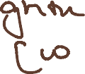

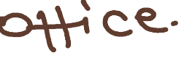
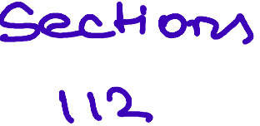



\ ''2> R.e..'p • o7 C...0-v-\=>o-t� \-i on R'4> . o+ Co l.O i \, t"\Sl-v'.e.
o\\ +-ne.. J-.o\.\ u�

CA Shubhclmm Sukhlechcl

se.c- '''"" •• Ovo\,n� o� spe..clQl
c...o • MOf\A
R..� O \ '-> K O"'f'V\

--1.....
(!)V"O;'r"'\ °'->-1� J.,\ Eth'O \ '-' � 00

- no� c...e_ d.o\:) t \"'-e..n .
- in�n Hon +h.cu- \-he
�et\.o \u Hon ,.A $R...
-\-Q b e.. /2:>P<L�� �.

0VO\-C.;'\ �\-c.A in '\"'°'\JO'-"'""\
ro b-e... mo-ve.. h-\.on
VO� c..o-"\-C..d �o·,��
c\"""he.. .>-\ CAo \ u �on .
- \I O�t\ � �e,>t in
'\eVOu>-\ +-o be. s H�
o\ vo\.eA �1-e.A °"Oa.·,��-

\ \S: R�o \u� on ���iv,� ��<:JQ\
(_no-\- \I� �on '611"\")
� 4 d.Q\.-Y' b�tove.. \-t°"\-Q... M.-J
Sp«-�01 No�c.�
NoHc.e.

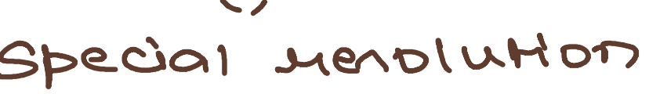


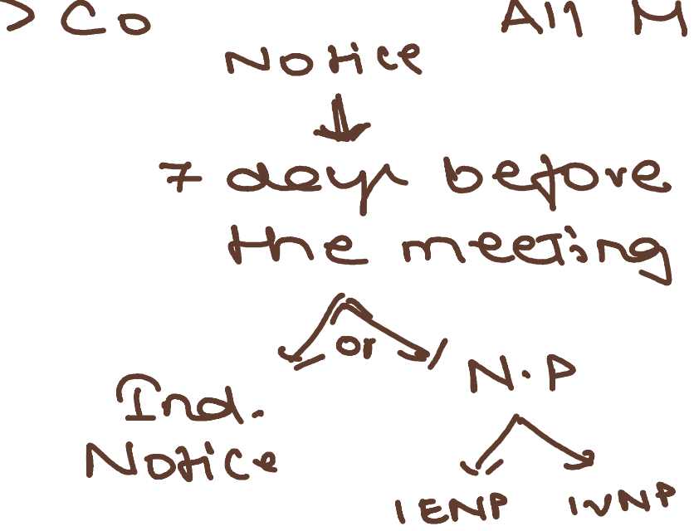

��
ho\c::l;�
,L
�· I • o,- '\J {[J O v \_S ,0 0 ,0 00 'l:l

CA Shubhclmm Sukhlechcl

R.e4o\uhon '?ON\.�➔
oJ- R�ov..,,,ne.o. -M·

\ l+ R�o\u\-\of'V\ o�
%'() • +-o be. � 1--e.cl
/> no.\ t be.. '2d. -4-c
b e,_ PON\..ce...cl. 01"\
a\...Q..\-e._ ; -r �Cy\ oc... \�
PO'\/\.�·
S�e..cif Q.d ��- on.ct
��- � be..�� +-o
R-oc..._ vQ,'t-h,n 81::> �UV\.
' n �I'\ � \ \ '-1-

\\'B 't'Hnvtre.A. ot CM\ �M\e.tr�-=, t-"lif°"'u� ot �,, \-h� H,
rob� pve..p�� o�
R.,Q..f>'l- l.A)l'�1f") �O�-

\\9 � 1'V!)pe..c...\-\ OT'\ O1 M 1nu \-(.e., � V\e.N'\ c.an, 'f"Y\.�c.J � � R.t t
M-e. m e;n, � e.!.r c..i:>'p;-t.A ',� £ E

\�o Mo, n � n0ri C..<2 o-ru:::l .5''l'V\'P - ➔
\<.e.Q. i->�,
m, n "' kA ,

�t cjoc..- 1n e..\e.c.�on,c.
"'"°v.,...,..,
.}""\e_c..ov� , ..9---\. A"9'U"v)
\1'""\ e...'\�n\ 'f"f7
o.\\ovu�-


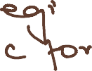
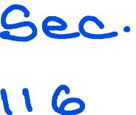
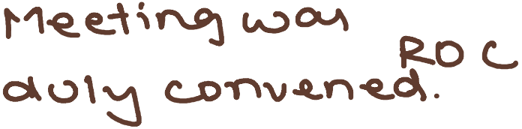

\�� App• o\ t-n-e. C-h.O\=)t-v-i AC\ H not V � �,v Q.q ..
'r-0 OPC.. ➔ OR-\ �2.. � ..H��iv�, +-o
be...juht m-e..n'""Of°"' � in
rn,nu\-tA. 'booR Oh �Q.N'\�..
CA Shubhqmm Sukhlechq

