Distributed Job Queue and Worker
Management over SDN
Final Project Report — Deliverables 1 and 2
TCP Socket Programming · Mininet · Open vSwitch · Ryu (OpenFlow 1.3)

1. Problem Understanding and Project Architecture
Clients submit computational jobs over TCP to a central coordinator. The coordinator validates and queues requests, then assigns them to available worker nodes. Workers execute the assigned computation and return results. An SDN controller built with Ryu observes coordinator–worker traffic through OpenFlow statistics and reacts to network events. The final implementation combines application-level worker fault handling with network-level backup-path rerouting.

1.1 Project objectives and requirement mapping
Requirement | Implementation
Concurrent TCP clients | The coordinator handles incoming connections using separate threads.
Job submission and acknowledgement | Client sends SUBMIT; coordinator replies ACK|jobId and later DONE|jobId|result.
Worker registration and liveness | Workers register and send HEARTBEAT every 3 seconds; 10 seconds without a heartbeat is treated as failure.
Job queue and scheduling | FIFO job queue; available worker selection considers reported network load and worker availability.
Network traffic monitoring | Ryu requests OpenFlow flow statistics every 2 seconds and reports per-worker LOAD values.
Dynamic flow management | Ryu installs and removes worker-specific TCP port 6000 flow rules, identified using cookies.
Worker failure recovery | Worker disconnect, heartbeat timeout or worker-link LINK_DOWN causes affected jobs to be re-queued.
D2 backbone resilience | Two switches are joined by primary and backup links; Ryu reroutes traffic when the primary link fails.
Performance evaluation | Tests measure throughput, scheduling distribution and worker-failure recovery time, including a no-SDN baseline comparison.

1.2 Final architecture (D2)
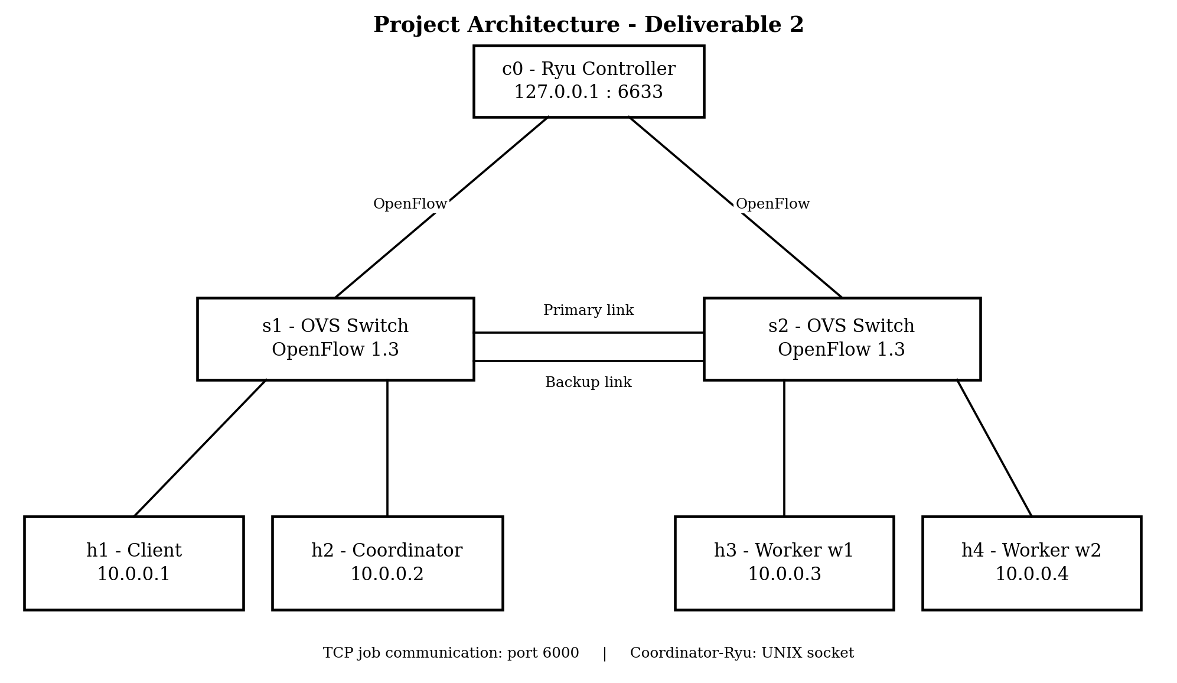
Figure 1. Final two-switch topology. Client and coordinator are attached to s1; workers are attached to s2. The switches have primary and backup inter-switch links.
Node | Role | IP address | Connected to
h1 | Client | 10.0.0.1 | s1
h2 | Coordinator (TCP port 6000) | 10.0.0.2 | s1
h3 | Worker w1 | 10.0.0.3 | s2
h4 | Worker w2 | 10.0.0.4 | s2
s1, s2 | Open vSwitch; OpenFlow 1.3 | — | Two inter-switch links
c0 | Ryu remote controller | 127.0.0.1:6633 | OpenFlow connection to switches

2. TCP Socket Implementation
Application communication between the client, coordinator and workers uses TCP sockets and a newline-terminated text protocol.

2.1 Application message protocol
Message | Direction | Meaning
SUBMIT|n | Client → Coordinator | Submit a job for integer n (|n| ≤ 10⁹).
ACK|jobId | Coordinator → Client | Acknowledge that the job was accepted.
DONE|jobId|result | Coordinator → Client | Return the computed result n².
ERR|reason / ERR|jobId|reason | Coordinator → Client | Report rejected input or a failed job.
REGISTER|workerId | Worker → Coordinator | Register a worker in the pool.
HEARTBEAT | Worker → Coordinator | Periodic liveness signal, every 3 seconds.
JOB|jobId|n | Coordinator → Worker | Assign a job to a worker.
RESULT|jobId|r / ERROR|jobId|reason | Worker → Coordinator | Return a result or report an execution error.

2.2 Implementation details
- Concurrency: the coordinator uses a thread per incoming connection so client and worker connections can be handled independently.
- Message framing: buffered line reading handles partial TCP reads and multiple newline-separated messages received together.
- Input validation: malformed, empty, non-numeric and out-of-range job values are rejected before execution.
- Worker liveness: workers send heartbeats every 3 seconds; a 10-second timeout indicates a possible worker failure.
- Thread safety: shared coordinator state, including worker records, the job queue and job-tracking data, is protected by a lock.
- Job computation: the worker computes n² and sends the result to the coordinator.

3. Mininet and SDN Implementation
The final Mininet topology uses two Open vSwitch instances, s1 and s2, connected by two parallel links. h1 (client) and h2 (coordinator) connect to s1. h3 and h4 (workers w1 and w2) connect to s2. Both switches use OpenFlow 1.3 and connect to the Ryu remote controller at 127.0.0.1:6633.

3.1 Controller behaviour
- Table-miss handling: unmatched packets are sent to Ryu. The learning-switch logic learns MAC-to-port and IP-to-port mappings and installs forwarding rules.
- Loop-aware flooding: because s1 and s2 have two parallel links, flooding excludes the currently inactive inter-switch link so both links are not used simultaneously for flooding.
- Application-specific flows: when a worker registers, Ryu installs priority-10 rules for TCP port 6000 traffic between the coordinator and that worker. Each worker's rules use a distinct cookie.
- Traffic monitoring: Ryu requests flow statistics every 2 seconds, calculates a bytes-per-second figure from byte-counter changes and sends LOAD messages to the coordinator.
- Worker-link monitoring: OpenFlow port-status events identify when a worker's own host link goes down. Ryu reports the affected worker to the coordinator.
- Backbone monitoring: Ryu tracks the active inter-switch port. A primary-link failure causes rules using the failed output port to be deleted, stale learned mappings to be cleared, and worker flows to be marked for reinstallation.

3.2 D2: Redundant backbone and automatic path rerouting
The two switches are connected by a primary link (port 3 on each switch) and a backup link (port 4 on each switch). All coordinator-to-worker traffic crosses this inter-switch backbone, making path failover observable.
- Normal state: the primary inter-switch link is active and the backup link is held out of flooding.
- Primary-link failure: Ryu receives an OpenFlow port-status event, changes the active inter-switch port to the backup port, deletes flow entries that output through the failed port on the switches, and clears MAC/IP learning entries associated with the failed port.
- Flow recovery: the next packets relearn the path through the backup link. The periodic statistics loop retries installation of worker-specific flows after the required ports have been learned.
- Primary-link recovery: Ryu detects that the primary port is up and switches the active link back to the primary path.
- Application transparency: a backbone failure does not mean that a worker has failed. The coordinator is not sent a worker LINK_DOWN event for this case; jobs continue over the backup path.
Port-layout assumption: the controller uses a fixed port layout for this lab topology—ports 1 and 2 are host-facing, port 3 is the primary inter-switch link and port 4 is the backup inter-switch link. This is a topology-specific implementation, not general-purpose topology discovery.

4. Socket–SDN Integration
The coordinator and Ryu exchange newline-terminated messages over the UNIX domain socket /tmp/sdn_ctl.sock. This is separate from the TCP job-queue connection on port 6000 and the OpenFlow connection on port 6633.
Message | Direction | Effect
HELLO|coordIP | Application → Ryu | Ryu learns the coordinator IP address.
WORKER_UP|id|ip | Application → Ryu | Register worker information and install worker-specific flows.
WORKER_DOWN|id|ip | Application → Ryu | Remove the worker's flow rules and stored worker information.
JOB|jobId|workerId | Application → Ryu | Update the per-worker job counter.
LOAD|id|bytesPerSec|totalBytes | Ryu → Application | Report traffic measured from OpenFlow flow statistics; used by scheduling.
LINK_DOWN|id | Ryu → Application | Report a worker host-link failure so the coordinator can fail that worker and re-queue its jobs.

Worker-link failure and backbone-link failure are handled differently. A worker host-link failure is reported to the coordinator and can trigger job reassignment. A backbone-link failure is handled inside Ryu by switching to the backup inter-switch path; the application layer is intended to remain unaware of that path change.

5. GUI and Demonstration
The browser GUI is served by backend.py and jobqueue-sdn-ui.html. The backend starts the real Ryu controller, Mininet topology and socket processes, and streams application logs and captured TCP port 6000 traffic to the browser. The D2 GUI visualizes the two-switch topology and adds a backbone-link control for demonstrating primary-link failure and recovery. Existing controls support job submission and worker kill/freeze or worker-link-down demonstrations. The live view should identify itself as “LIVE: real Mininet + Ryu + tcp_socket”; a simulation view is not evidence of a live network run.

6. Testing and Verification

6.1 Socket-layer tests
tests/test_sockets.py runs the coordinator, workers and clients locally and uses a fake controller on the UNIX-socket channel. It does not require Mininet or Ryu. The suite covers normal operation, application events, load-aware scheduling, invalid input, malformed protocol messages, worker failure, SDN LINK_DOWN handling and repeated worker failure.
Scenario | Expected result
Five concurrent clients with two workers | All clients receive the correct n² result.
Application events | HELLO, WORKER_UP and JOB messages reach the controller channel.
Load-aware scheduling | A job is assigned to the worker with the lower reported LOAD.
Invalid and malformed input | Requests are rejected with ERR; workers remain operational.
Worker killed during a job | The job is re-queued and completed by another worker.
SDN LINK_DOWN | The affected worker is failed over and the job completes elsewhere.
Repeated worker failures | The job is returned to the client as failed after the configured three attempts.

6.2 Mininet end-to-end tests
tests/test_mininet.py runs the real Mininet, OVS, Ryu and socket application together. It checks switch connectivity, host reachability, worker registration, TCP port 6000 flow installation, successful job execution, non-zero LOAD reporting, worker-link failure and recovery, invalid input handling, and the D2 backbone failover scenario.
D2 backbone scenario | Verification
Primary backbone link is taken down | A new job still completes using the backup path.
Application transparency | No worker LINK_DOWN event is generated by the backbone-only outage.
Flow update | Flow inspection on s1 shows forwarding through backup port 4 rather than failed primary port 3.
Primary link is restored | A subsequent job completes after restoration; controller logic supports failback to the primary path.

6.3 Performance evaluation
tests/test_performance.py is a separate performance harness that runs the coordinator, workers and clients on loopback (127.0.0.1), without Mininet or a live Ryu switch. It records raw measurements in /tmp/sdn_perf_report.json.
- Throughput: measures completed jobs per second with 1, 3, 6 and 10 concurrent clients.
- Scheduling distribution: records per-worker job counts and the max–min spread.
- SDN-aware versus baseline comparison: runs the same simulated skewed worker-load scenario with LOAD feedback enabled and disabled. A fake controller supplies fixed load reports; this isolates the scheduler policy comparison and is not a live network performance benchmark.
- Failover timing: kills a worker during a job and measures time to reassignment and time until the client receives the re-executed result.
Performance figures should be populated from an actual run of tests/test_performance.py. This report describes the measurements the harness is designed to collect and does not claim numerical results that are not present in the supplied project files.

7. Limitations
- Backbone failover depends on the fixed port numbers and two-switch topology defined for this Mininet setup; it does not perform general topology discovery using LLDP.
- The flooding strategy is a minimal active/backup loop-avoidance mechanism, not a complete spanning-tree implementation.
- The coordinator remains a single point of failure.
- The worker task is a demonstration computation (n²) with a simulated execution delay; it is not a general distributed compute framework.
- The performance harness's baseline comparison uses a fake controller and simulated load values; it should be interpreted as a controlled scheduling-policy comparison rather than a live SDN network benchmark.

8. Conclusion
The final project combines TCP-based distributed job processing with SDN-based network monitoring and control. Deliverable 1 established the client–coordinator–worker application, Mininet/OVS network, Ryu controller and bidirectional socket–SDN integration. Deliverable 2 extends the network to two switches connected by redundant primary and backup links, adds automatic backbone path rerouting and recovery logic, expands the GUI and end-to-end tests, and introduces a performance evaluation harness. The resulting system demonstrates two distinct forms of resilience: application-level job reassignment when a worker fails, and network-level path switching when the inter-switch backbone fails.

