Date:24-10-26
CO2 ASSESMENT TOOL 2
SCENARIO BASED
Name: S. Likiteshwar Reddy Course Code: DSA0308
Reg No: 192425120

Q1. Morphological Processing of analyzing, analysis, and analytical.
Aim: To identify the root word, affixes, transformation type, and normalized representation of the given words.
Python Program:
words = ["analyzing", "analysis", "analytical"]
data = {
"analyzing": {
"root": "analyze",
"affix": "-ing",
"type": "Inflectional",
"normalized": "analyze"
},
"analysis": {
"root": "analysis",
"affix": "irregular word form",
"type": "Derivational relationship",
"normalized": "analyze"
},
"analytical": {
"root": "analysis",
"affix": "-ical",
"type": "Derivational",
"normalized": "analyze"
}
}
print("Morphological Processing Report\n")
for word in words:
print("Original Word:", word)
print("Root:", data[word]["root"])
print("Affix:", data[word]["affix"])
print("Type:", data[word]["type"])
print("Normalized:", data[word]["normalized"])
print()
OUTPUT:
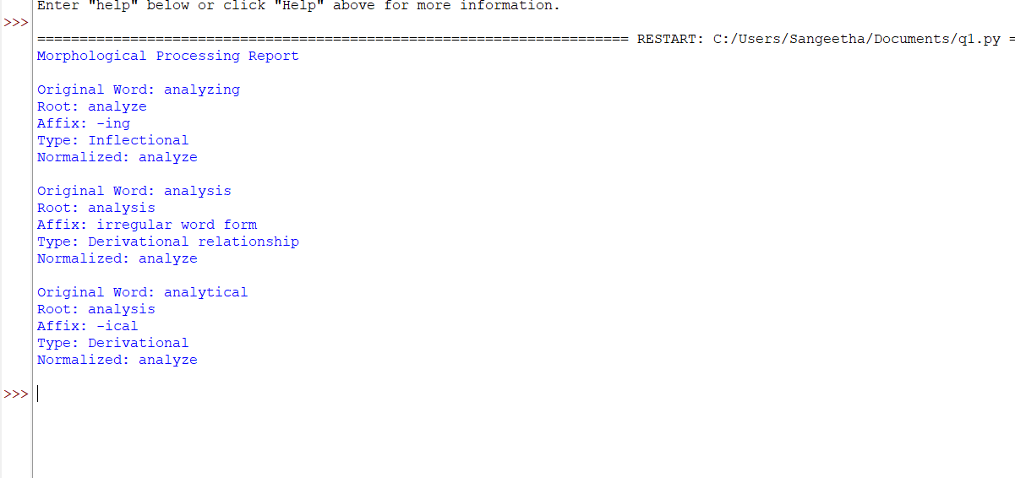

Result: The program identifies morphological relationships and maps the words to a common normalized representation, analyze, for search engine indexing.

Q2. Morphological Parsing of disagree, agreement, and agreeable.
Aim: To identify prefixes, roots, suffixes, transformation types, and semantic changes.
Python Program:
words = {
"disagree": {
"prefix": "dis-",
"root": "agree",
"suffix": "None",
"type": "Derivational",
"meaning": "To have a different opinion",
"normalized": "agree"
},
"agreement": {
"prefix": "None",
"root": "agree",
"suffix": "-ment",
"type": "Derivational",
"meaning": "The state or result of agreeing",
"normalized": "agree"
},
"agreeable": {
"prefix": "None",
"root": "agree",
"suffix": "-able",
"type": "Derivational",
"meaning": "Pleasant or acceptable",
"normalized": "agree"
}
}
for word, info in words.items():
print("Word:", word)
print("Prefix:", info["prefix"])
print("Root:", info["root"])
print("Suffix:", info["suffix"])
print("Type:", info["type"])
print("Meaning:", info["meaning"])
print("Normalized Form:", info["normalized"])
print()
OUTPUT:
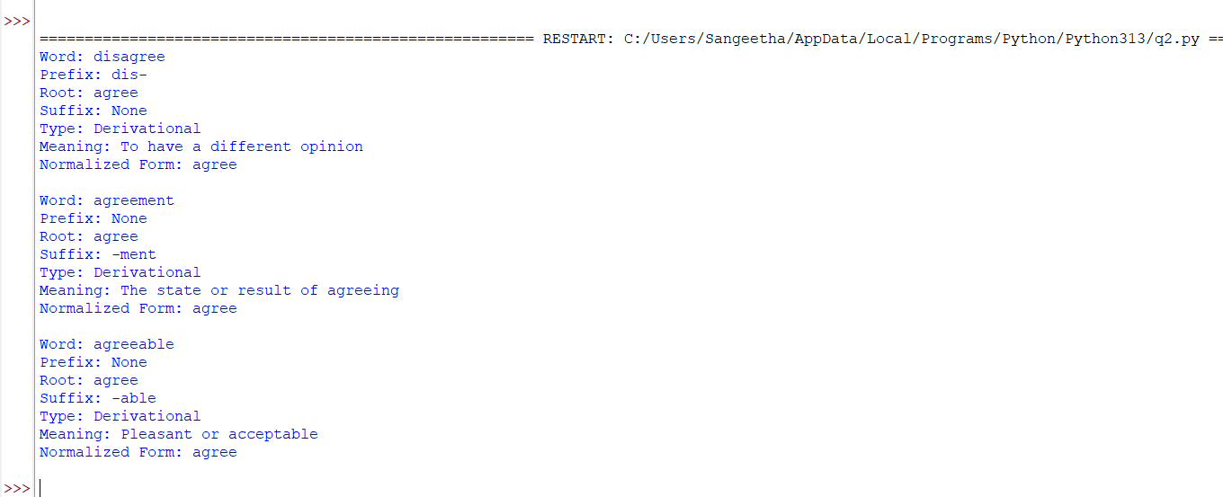 Result: The program separates prefixes and suffixes, identifies the root agree, and normalizes all three words to agree for consistent sentiment analysis.

Q3. Morphology-Based Normalization of “govern”, “government”, and “governance”
Aim: To identify the root words and suffixes and normalize related words for topic modeling and document clustering.
Python Program:
words = ["govern", "government", "governance"]
data = {
"govern": {
"root": "govern",
"affix": "None",
"level": "Level 0",
"normalized": "govern"
},
"government": {
"root": "govern",
"affix": "-ment",
"level": "Level 1",
"normalized": "govern"
},
"governance": {
"root": "govern",
"affix": "-ance",
"level": "Level 1",
"normalized": "govern"
}
}
print("Morphological Normalization Report\n")
for word in words:
print("Original Word:", word)
print("Root Word:", data[word]["root"])
print("Affix:", data[word]["affix"])
print("Derivational Level:", data[word]["level"])
print("Normalized Output:", data[word]["normalized"])
print()
Output:
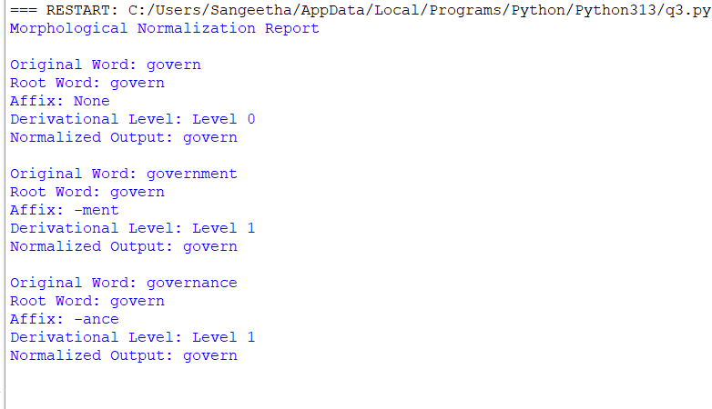
Result: The program identifies roots and suffixes and normalizes the words to govern.

Q4. Morphological Parsing of “activate”, “activation”, and “reactivation”
Aim: To identify prefixes, roots, suffixes, derivational sequences, and word-class changes for document classification.
Python Program:
words = {
"activate": {
"prefix": "None",
"root": "activate",
"suffix": "None",
"sequence": "Base verb",
"word_class": "Verb",
"normalized": "activate"
},
"activation": {
"prefix": "None",
"root": "activate",
"suffix": "-ion",
"sequence": "activate + -ion",
"word_class": "Noun",
"normalized": "activate"
},
"reactivation": {
"prefix": "re-",
"root": "activate",
"suffix": "-ion",
"sequence": "re- + activate + -ion",
"word_class": "Noun",
"normalized": "activate"
}
}
print("Morphological Parsing Report\n")
for word, info in words.items():
print("Original Word:", word)
print("Prefix:", info["prefix"])
print("Root Word:", info["root"])
print("Suffix:", info["suffix"])
print("Derivational Sequence:", info["sequence"])
print("Word Class:", info["word_class"])
print("Normalized Output:", info["normalized"])
print()
Output:
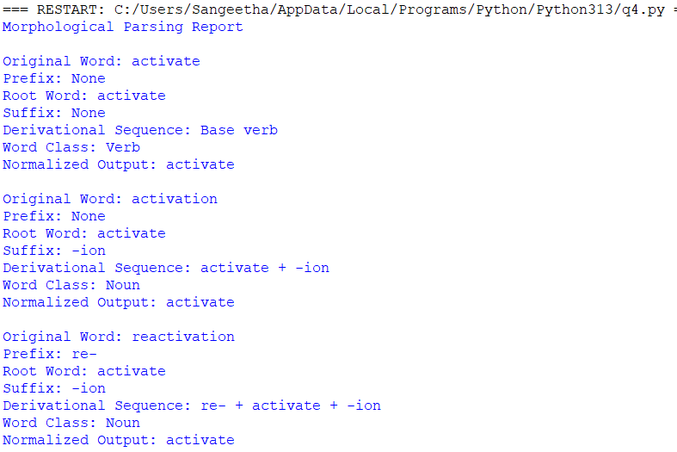
Result: The program identifies derivational changes and normalizes all words to activate.

Q5. Inflectional Normalization of “create”, “creates”, and “creating”
Aim: To identify inflectional suffixes, grammatical categories, and root forms for efficient search optimization.
Python Program:
words = {
"create": {
"suffix": "None",
"category": "Base form",
"root": "create",
"normalized": "create"
},
"creates": {
"suffix": "-s",
"category": "Third-person singular present tense",
"root": "create",
"normalized": "create"
},
"creating": {
"suffix": "-ing",
"category": "Present participle",
"root": "create",
"normalized": "create"
}
}
print("Inflectional Normalization Report\n")
for word, info in words.items():
print("Original Word:", word)
print("Suffix:", info["suffix"])
print("Grammatical Category:", info["category"])
print("Root Word:", info["root"])
print("Normalized Output:", info["normalized"])
print()
Output:
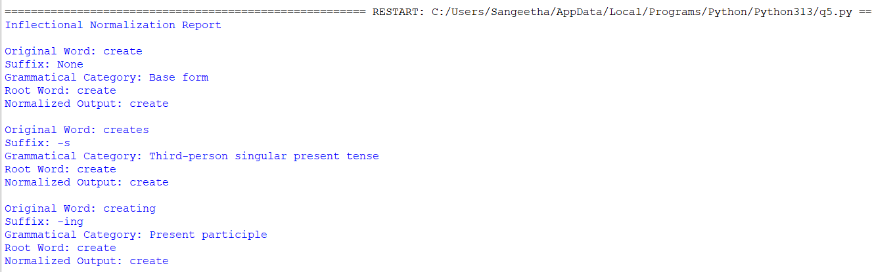
Result: The program identifies inflectional forms and normalizes all three words to create without changing their underlying lexical meaning.

