15/10/2026

CO1-AT3-Coding Challenge
Name: S.Likiteshwar Reddy
Reg No: 192425120

1. Intelligent Email and Password Validator using Regular Expressions
import re
def validate_email(email):
pattern = r'^[A-Za-z][A-Za-z0-9._]*@[A-Za-z]+\.(com|org|edu|net|in)$'
if re.fullmatch(pattern, email):
print("Valid Email")
else:
print("Invalid Email")
def validate_password(password):
pattern = r'^(?=.*[A-Z])(?=.*[a-z])(?=.*\d)(?=.*[@#$%&!]).{8,}$'
if re.fullmatch(pattern, password):
print("Strong Password")
else:
print("Weak Password")
def validate_mobile(mobile):
pattern = r'^[6-9]\d{9}$'
if re.fullmatch(pattern, mobile):
print("Valid Mobile Number")
else:
print("Invalid Mobile Number")

email = input("Enter Email: ")
password = input("Enter Password: ")
mobile = input("Enter Mobile Number: ")
validate_email(email)
validate_password(password)
validate_mobile(mobile)
output:
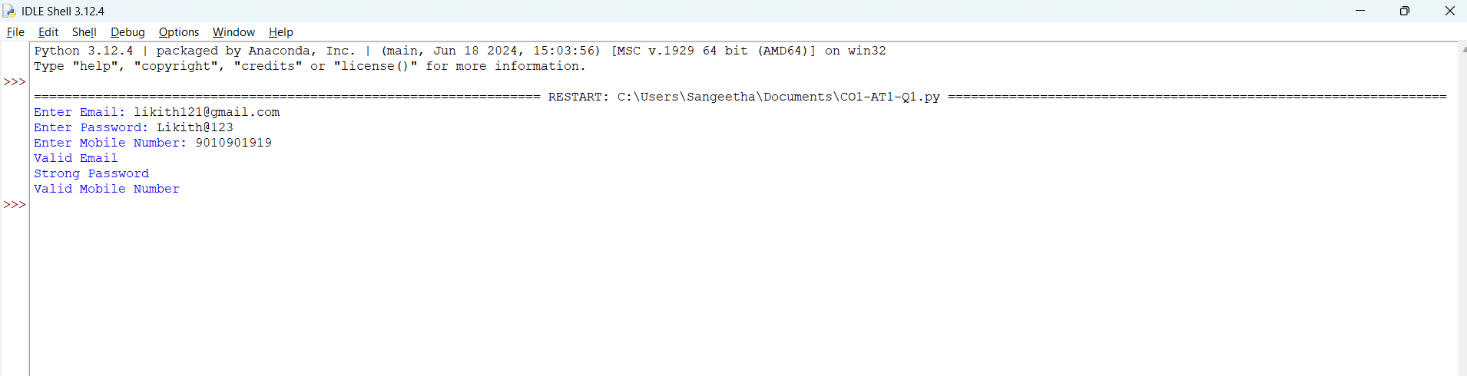
2. Design a Finite State Automata (FSA) Simulator
trans = {
'q0': {'a': 'q1', 'b': 'q0'},
'q1': {'a': 'q1', 'b': 'q2'},
'q2': {'a': 'q1', 'b': 'q0'}
}
s = input("Enter string (a/b): ")
state = 'q0'
path = [state]
for ch in s:
if ch not in 'ab':
print("Invalid input")
break
state = trans[state][ch]
path.append(state)
else:
print("Path:", " -> ".join(path))
print("Accepted" if state == 'q2' else "Rejected")
Output:
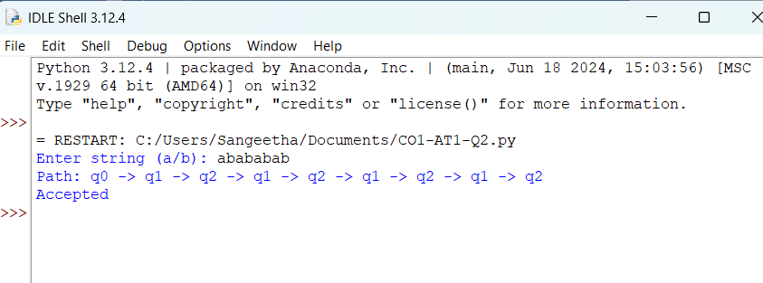

3. Smart Pattern Matching Engine using Regular Expressions
import re
text = """Meeting on 12/09/2026
Call 9876543210
#NLP
@OpenAI
natural language processing"""
def search_pattern(choice):
if choice == 1:
pattern = r'\b\d{2}/\d{2}/\d{4}\b'
name = "Dates"
elif choice == 2:
pattern = r'\b[6-9]\d{9}\b'
name = "Phone Numbers"
elif choice == 3:
pattern = r'(?<!\w)#[A-Za-z0-9_]+'
name = "Hashtags"
elif choice == 4:
pattern = r'(?<!\w)@[A-Za-z0-9_]+'
name = "Mentions"
elif choice == 5:
prefix = input("Enter prefix: ")
pattern = r'\b' + re.escape(prefix) + r'\w*'
name = "Prefix Matches"
elif choice == 6:
suffix = input("Enter suffix: ")
pattern = r'\b\w*' + re.escape(suffix) + r'\b'
name = "Suffix Matches"
elif choice == 7:
word = input("Enter word to search: ")
pattern = r'\b' + re.escape(word) + r'\b'
name = "Word Matches"

else:
print("Invalid choice")
return
matches = re.findall(pattern, text, re.IGNORECASE)
print(name + ":")
if matches:
for match in matches:
print(match)
else:
print("No matches found")
while True:
print("\nSMART PATTERN MATCHING ENGINE")
print("1. Search Date")
print("2. Search Phone Number")
print("3. Search Hashtag")
print("4. Search Mention")
print("5. Search Prefix")
print("6. Search Suffix")
print("7. Search Word")
print("8. Exit")
choice = int(input("Enter your choice: "))
if choice == 8:
print("Exiting program")
break
search_pattern(choice)
OUTPUT:
