import cv2
from google.colab import files
from matplotlib import pyplot as plt
uploaded = files.upload()
img = cv2.imread(list(uploaded.keys())[0], 0)
th = cv2.threshold(img, 127, 255, cv2.THRESH_BINARY)
plt.title("Image Segmentation")
plt.imshow(th, cmap='gray')
plt.axis('off')
plt.show()
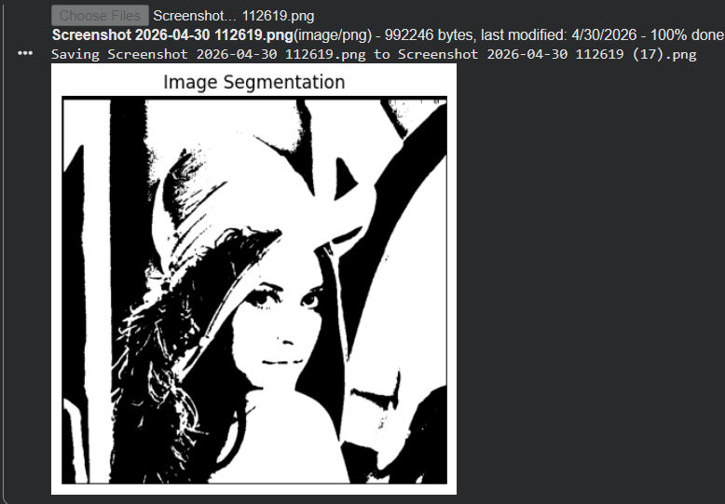N

