SKILL-1A

#include <stdio.h> #include <unistd.h> int main() { pid_t pid = fork(); if(pid == 0) { printf("Child Process\n"); printf("PID = %d\n", getpid()); } else { printf("Parent Process\n"); printf("PID = %d\n", getpid()); } return 0; }

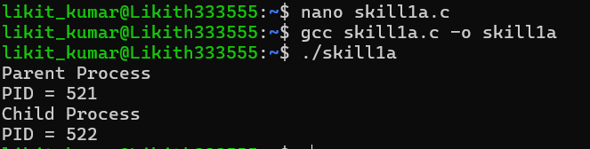

SKILL-1B
#include <stdio.h> #include <unistd.h> int main() { printf("Before exec()\n"); execlp("date","date",NULL); printf("After exec()\n"); return 0; }
