Practical-4
4a
#include <stdio.h>
#include <stdlib.h>
#include <unistd.h>
#include <sys/wait.h>

int main() {
pid_t pid1, pid2;

pid1 = fork();
if (pid1 == 0) {
printf("Child 1: PID=%d, PPID=%d\n", getpid(), getppid());
sleep(2);
exit(0);
}

pid2 = fork();
if (pid2 == 0) {
printf("Child 2: PID=%d, PPID=%d\n", getpid(), getppid());
sleep(3);
exit(0);
}

printf("Parent: PID=%d\n", getpid());

wait(NULL);
printf("Parent: One child finished (wait)\n");

waitpid(pid2, NULL, 0);
printf("Parent: Child 2 finished (waitpid)\n");

return 0;
}
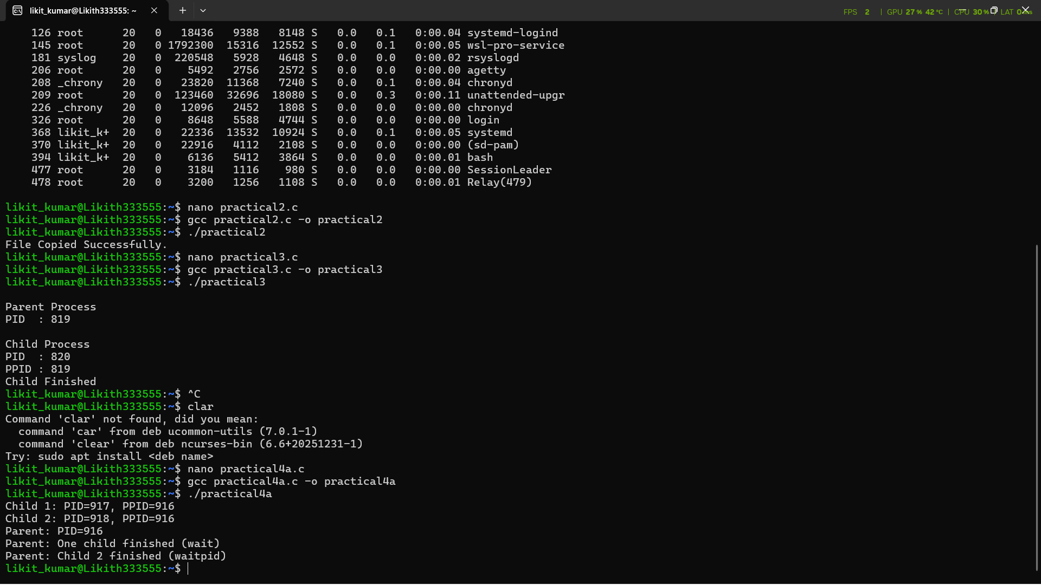
4b.
#include <stdio.h>
#include <stdlib.h>
#include <unistd.h>

int main() {
pid_t pid = fork();

if (pid == 0) {
printf("Child: PID=%d\n", getpid());
exit(0); // child terminates immediately
} else {
printf("Parent: PID=%d, not calling wait()\n", getpid());
sleep(10); // parent sleeps, child becomes zombie
}

return 0;
}
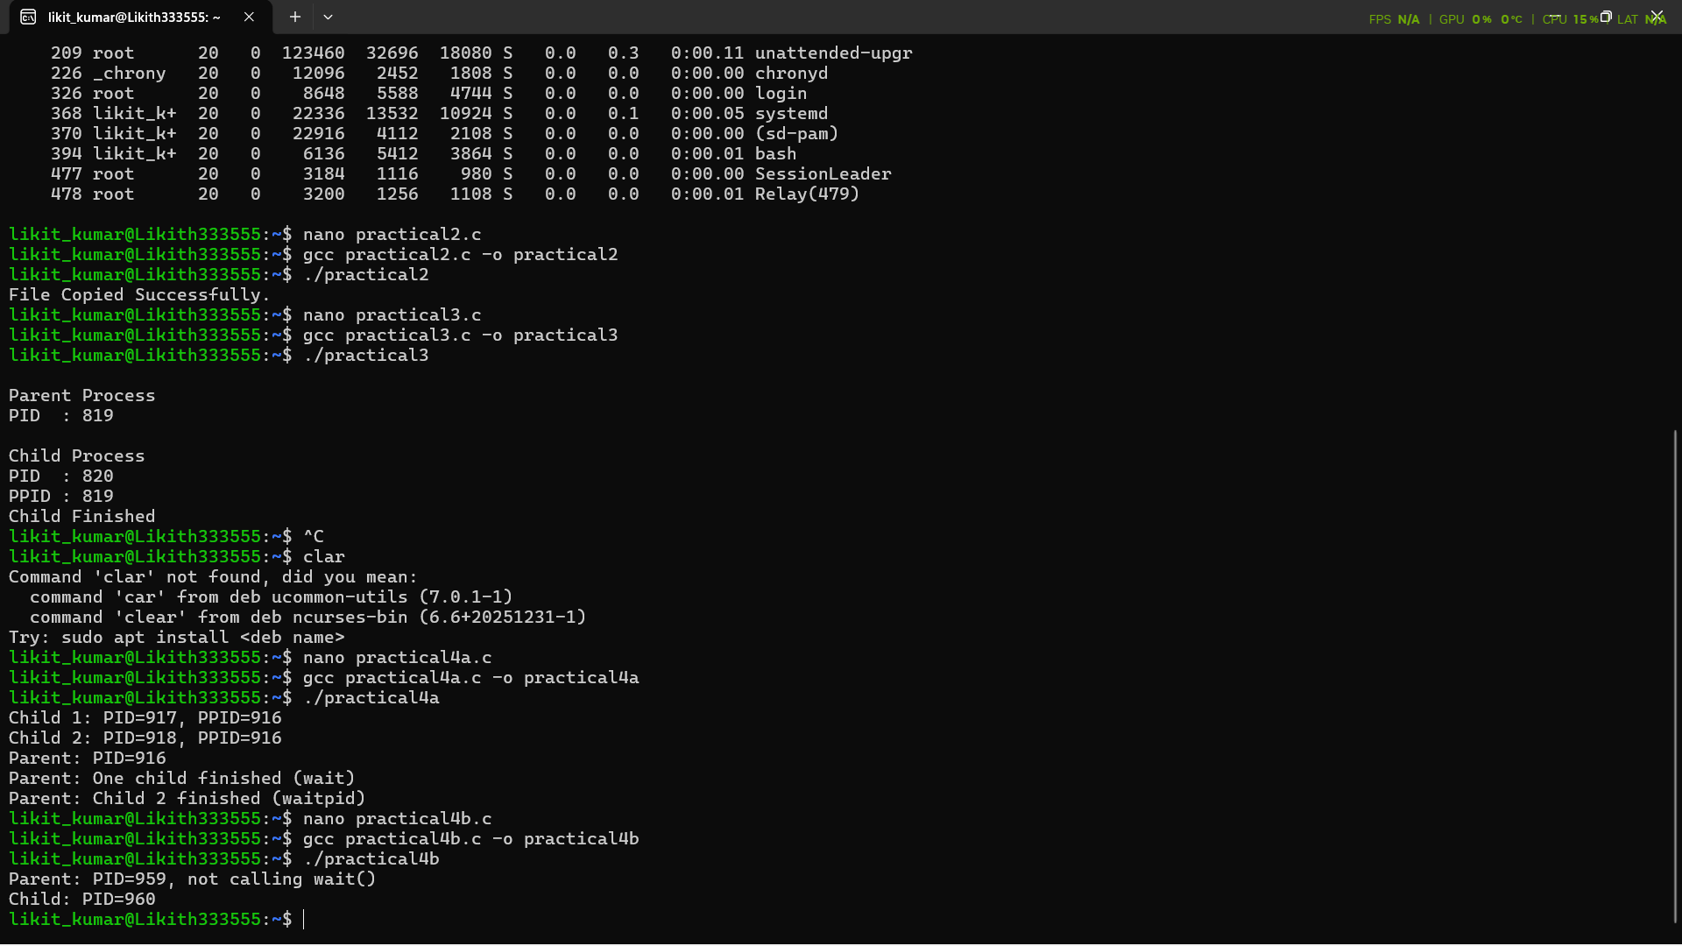

4c.
#include <stdio.h>
#include <stdlib.h>
#include <unistd.h>
#include <sys/wait.h>

int main() {
pid_t pid = fork();

if (pid == 0) {
printf("Child: PID=%d\n", getpid());
exit(0);
} else {
printf("Parent: PID=%d, waiting for child...\n", getpid());
wait(NULL); // collects child’s exit status → no zombie
printf("Parent: Child terminated properly.\n");
}

return 0;
}
