CASE STUDY
TLB Address Translation Simulator: An Interactive Approach to
Virtual-to-Physical Translation and TLB Performance Analysis
Submitted by:
P V Sai Likith (24BCI0174)
M V S Sujan (24BCE2294)
Shrijit (24BCE2469)
Rajnihil (24BCT0191)

CONTENTS
1. Project Title 3
2. Introduction 3
3. Problem Statement 4
4. Objectives 5
5. Survey on Existing Work 5
6. Existing and Proposed Systems 6
7. Methodology with Flowchart 8
8. Software and Hardware Requirements 11
9. System Architecture 12
10. Implementation Timeline 14
11. Expected Outcomes 15
12. Future Scope 17
13. Challenges and Ethical Considerations 18
14. Conclusion 19
References 19

1. Project Title
TLB Address Translation Simulator: An Interactive Approach to Virtual-to-Physical Translation and TLB Performance Analysis
The project builds TLB/Scope, a browser-based "MMU workbench" that simulates how a processor's memory-management unit (MMU) turns a virtual address into a physical address with the help of a Translation Lookaside Buffer (TLB). The key facts about the project are summarised in Table 1.
Table 1: Project at a glance
Field | Details
Project name | TLB/Scope: an interactive MMU workbench
Course | Operating Systems
Topic | Module 5, Memory Management. Mini Project #45: "Simulate virtual-to-physical address translation using TLB"
Project type | Interactive, browser-based educational simulator
Technology | HTML5, CSS3 and JavaScript (no frameworks, no back end); Node.js for automated tests
Deliverables | Ten-page web application, automated test suite (96 engine tests and 29 page tests), printable report

2. Introduction
Modern operating systems use virtual memory. Each process sees its own large, contiguous address space, while the physical memory underneath is limited and shared by many processes. With paging, both spaces are divided into fixed-size blocks: pages in virtual memory and frames in physical memory. Every address the CPU issues must be translated from a virtual address (VA) to a physical address (PA) before memory can be accessed. The VA is split into a virtual page number (VPN) and an offset. The page table maps the VPN to a physical frame number (PFN), and the offset is copied unchanged because a page and a frame are the same size.
The page table itself is stored in main memory. Without extra hardware, every memory reference would need at least one additional memory access to read the page-table entry (PTE), and k additional accesses for a k-level page table. That would at least double the cost of every memory access. To avoid this, the MMU contains a Translation Lookaside Buffer (TLB), a small, fast, associative cache of recently used translations. On a TLB hit, the PFN is available in a few nanoseconds. On a TLB miss, the page table is walked and the translation is inserted into the TLB. If the PTE is not present, a page fault transfers control to the operating system. Programs show strong locality of reference, so a small TLB can serve most accesses. This makes the TLB one of the most important performance structures in a computer system (Figure 1).
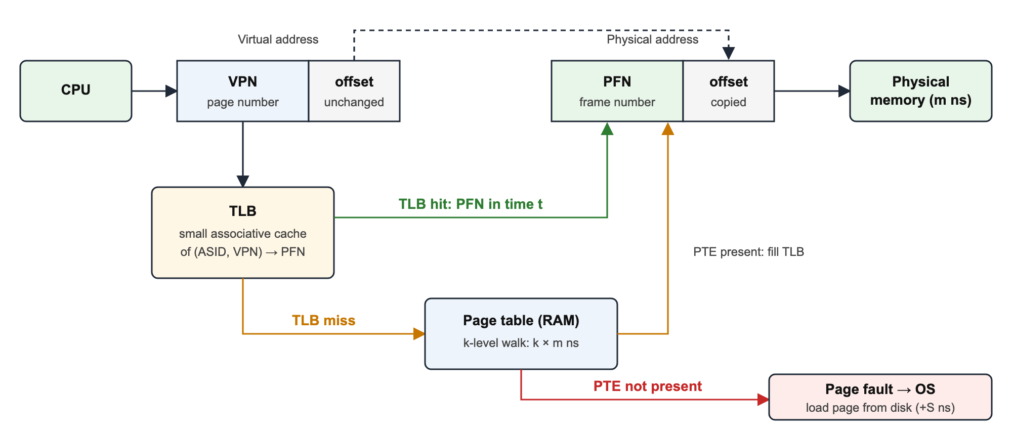
Figure 1: Virtual-to-physical address translation with a TLB
These mechanisms are central to the Operating Systems syllabus. However, they happen inside hardware in nanoseconds and cannot be observed directly. This case study presents TLB/Scope, an interactive simulator that makes every step of translation visible: the bit-level split of the address, TLB lookup and replacement decisions, page-table walks, page faults, protection checks and the resulting effective access time. Students can also compare different design choices on the same workload.

3. Problem Statement
To design and implement an interactive simulator that models virtual-to-physical address translation through a TLB and a page table, shows every intermediate step of each translation, and measures how the size, organisation and replacement policy of the TLB affect the hit ratio and the effective access time.
The need for such a simulator comes from the following difficulties faced by students and teachers:
- Translation is invisible. It happens in hardware within a few nanoseconds, so students only see static textbook diagrams and never watch a real translation step by step.
- Hand calculation is slow and error-prone. Splitting addresses into VPN, offset, set index and tag in binary, tracing a replacement policy over a long reference string and computing the effective access time by hand all take time, and mistakes go unnoticed.
- Design choices are hard to compare. The effect of TLB size, associativity, replacement policy, page-table depth or address-space identifiers (ASIDs) can only be seen by running the same workload under different configurations.
- Counter-intuitive behaviour is hard to believe without seeing it. Examples include Belady's anomaly, thrashing when the working set is larger than the TLB, and conflict misses in a direct-mapped TLB.
- Existing tools are either too simple or too complex. Page-replacement animators do not model a TLB, while research simulators such as gem5 need long setup and produce only statistics.

4. Objectives
The objectives of the project are:
- To show the decomposition of a virtual address into VPN, TLB tag, set index, page-table level indices and offset at bit level, for address widths from 4 to 32 bits.
- To simulate the complete translation path: TLB lookup, hit or miss, multi-level page-table walk (1 to 4 levels), TLB fill and replacement.
- To implement the TLB replacement policies FIFO, LRU, LFU, CLOCK (second chance) and seeded RANDOM, with OPT (Belady's optimal algorithm) as a benchmark.
- To support fully associative, set-associative and direct-mapped TLB organisations.
- To handle page faults in two modes, report only and demand paging (with FIFO, LRU or CLOCK frame replacement, dirty write-back and TLB shootdown), and to detect write-protection faults.
- To model multiple processes with ASID-tagged TLB entries, compared with flushing the TLB on every context switch.
- To measure the hit ratio, misses, faults, evictions and effective access time (EAT), and to compare the analytical EAT model with the value measured from the run.
- To provide time travel (rewind, branch and what-if replay), export and sharing, and to verify correctness with an automated test suite.

5. Survey on Existing Work
We studied textbooks, educational simulators, research simulators and visual tools that deal with address translation and page replacement. Table 2 summarises what each offers and why it does not fully solve the problem stated in Section 3.
Table 2: Survey of existing work
# | Work / tool | What it offers | Limitation for this problem
1 | Silberschatz, Galvin and Gagne, Operating System Concepts | Standard textbook treatment of paging, TLBs, EAT and page replacement, with worked numerical examples. | Static figures; students cannot try their own addresses or configurations.
2 | Arpaci-Dusseau, Operating Systems: Three Easy Pieces (OSTEP) | Clear chapters on TLBs, ASIDs and multi-level page tables, with Python command-line simulators that generate translation exercises. | Text-based. The paging simulators do not model a TLB; TLB behaviour is studied by measuring real hardware instead.
3 | MOSS Memory Management Simulator (companion to Tanenbaum's Modern Operating Systems) | Java GUI that runs a list of memory operations over virtual pages and shows page faults and page replacement. | Focuses on paging and page replacement; no TLB, no set associativity, no ASIDs and no EAT measurement.
4 | CPU-OS Simulator (B. Mustafa) | Integrated educational simulator of a CPU and a simple operating system, including memory views. | Very broad scope; TLB internals and the comparison of replacement policies are not its focus.
5 | gem5 (Binkert et al., 2011) | Full-system research simulator with detailed MMU, TLB and page-table-walker models. | Steep learning curve, long setup and simulation times; output is statistics, not an explanation of each translation.
6 | SimpleScalar (Burger and Austin, 1997) | Cycle-level processor simulator with configurable caches and TLBs. | Command-line tool aimed at architecture research; no visualisation of individual translations.
7 | Dinero IV (Edler and Hill) | Fast trace-driven simulator of cache hierarchies. | Models caches only; no page tables, page faults or protection.
8 | Online page-replacement visualisers | Web pages that animate FIFO, LRU and OPT on a reference string. | Model page frames only; no address split, no TLB and no timing.
9 | Hardware performance counters (e.g. Linux perf dTLB-load-misses) | Measure real TLB misses of real programs. | Black box: they report counts but not why each miss happened, and need real hardware and Linux.

5.1 Research gap
None of the surveyed works combines all of the following in one tool that runs without installation: (a) a bit-level explanation of each individual translation, (b) a choice of TLB organisation and replacement policy, (c) page faults, protection and multiple processes, and (d) quantitative comparison and automated verification. TLB/Scope is designed to fill this gap.

6. Existing and Proposed Systems

6.1 Existing system
In the existing approach, address translation is taught with textbook figures and board numericals, supported at most by a page-replacement animator or a command-line script. Its main drawbacks are:
- Learning is passive: the student cannot change the address, the page size or the TLB and see the effect.
- Every numerical is solved by hand, so long traces and multi-level page tables are rarely attempted.
- The TLB, the page table and page replacement are taught separately, so the link between a TLB miss, a page-table walk and a page fault is not obvious.
- There is no way to measure the EAT of a real trace or to compare policies on the same input.
- Errors in manual calculations go unnoticed because there is nothing to check the answer against.

6.2 Proposed system
The proposed system, TLB/Scope, is a browser-based MMU workbench organised as ten connected pages (Home, Machine, Translate, Timeline, Structures, Analytics, Policy lab, Learn, Self-test and Report). Its main features are:
- Address probe that accepts decimal, hexadecimal (0x), binary (0b) and octal (0o) input and predicts the outcome (hit, miss or fault) before translating.
- Bit surgery view that draws the VA bit by bit: the offset bits drop straight into the PA and the PFN bits are swapped in from the TLB, the page table or the OS.
- MMU datapath with six stages (CPU, TLB, WALK, OS, CHK, RAM) and a step-through mode that explains each stage with the actual numbers.
- Calculation player that animates every formula, for example floor(300 / 256) = 1 and 1 × 256 + 44 = 300.
- Logic-analyzer timeline with rewind, branching and what-if replay of the whole history under a new configuration.
- Live structures: the TLB as sets × ways, a clickable page-table map with a PTE inspector, and physical frames coloured by process.
- Analytics: eight key indicators, a hit-ratio chart and an EAT calculator comparing the model, the measured run and a system with no TLB.
- Policy lab: six policies × seven TLB sizes on the same trace, with automatic detection of Belady's anomaly.
- Ten one-click scenarios, an in-browser self-test page and a printable A4 report.

6.3 Comparison
Table 3: Existing system versus proposed system
Aspect | Existing system | Proposed system (TLB/Scope)
Interaction | Static diagrams and hand calculation | Any address and any configuration, with an instant result
Visibility of steps | Final answer only | Bits, datapath stages, formulas and data structures
TLB organisation | Usually fully associative only | Fully associative, set-associative and direct-mapped
Replacement policies | One at a time, traced by hand | FIFO, LRU, LFU, CLOCK, RANDOM and OPT side by side
Page faults and protection | Discussed separately | Integrated: report-only or demand paging, write protection
Multiple processes | Rarely covered | ASID tagging versus flush on context switch
Performance | EAT formula only | Modelled, measured and no-TLB EAT compared
Correctness | Not checked | 96 automated engine tests and invariant checks
Setup | None, or complex installation | Opens in any modern browser; no installation

7. Methodology with Flowchart

7.1 Development approach
The project followed an iterative approach in six phases:
- Requirement analysis: list the syllabus topics (paging, TLB, EAT, page replacement) and the features the simulator must offer.
- Model design: define the machine configuration, the translation formulas and a deterministic engine interface.
- Engine implementation: write a DOM-free JavaScript engine (engine.js) that runs in both the browser and Node.js.
- Interface design: build pages that each do one job and share a single session.
- Verification: hand-derived test cases, invariant checking, mutation testing and browser testing.
- Documentation: learning notes, viva questions, a printable report and this case study.

7.2 Translation model
Let S be the page size, t the TLB lookup time, m the memory access time, k the number of page-table levels, h the TLB hit ratio, p the page-fault rate and F the page-fault service time. The simulator uses the formulas in Table 4.
Table 4: Formulas used by the simulator
Quantity | Formula
Offset bits | log2(S)
Virtual page number | VPN = floor(VA / S)
Offset | offset = VA mod S
Number of TLB sets | sets = entries / ways
Set index and tag | set = VPN mod sets; tag = floor(VPN / sets)
Physical address | PA = PFN × S + offset
TLB hit time | t + m
TLB miss time (k-level table) | t + k·m + m
Page-fault time | miss time + F
Effective access time | EAT = h(t + m) + (1 − h)(t + (k + 1)m) + p·F

7.3 Algorithm for one memory access
- Validate the virtual address and the process number. Invalid input is rejected without changing any state.
- If the process differs from the current one, record a context switch. In flush mode, empty the TLB.
- Split the VA into VPN, offset, TLB set index, tag and page-table level indices.
- Search the selected TLB set for an entry with a matching (ASID, VPN). On a hit, update the policy data (last use, use count, reference bit) and take the PFN from the entry.
- On a miss, walk the page table (k memory reads). If the PTE is not present, raise a page fault. In report-only mode the fault is recorded and the access stops. In demand-paging mode, a free frame or a victim frame (FIFO, LRU or CLOCK) is chosen; the victim is written back if dirty, its PTE is invalidated, its TLB entry is shot down, and the new page is loaded.
- Insert the translation into the TLB, evicting a victim chosen by the TLB replacement policy if the set is full.
- If the access is a write and the page is read-only, raise a protection fault; no memory access takes place.
- Otherwise form PA = PFN × S + offset, access memory, set the referenced and dirty bits, and update the statistics and the timeline.
Figure 2 shows the same algorithm as a flowchart.
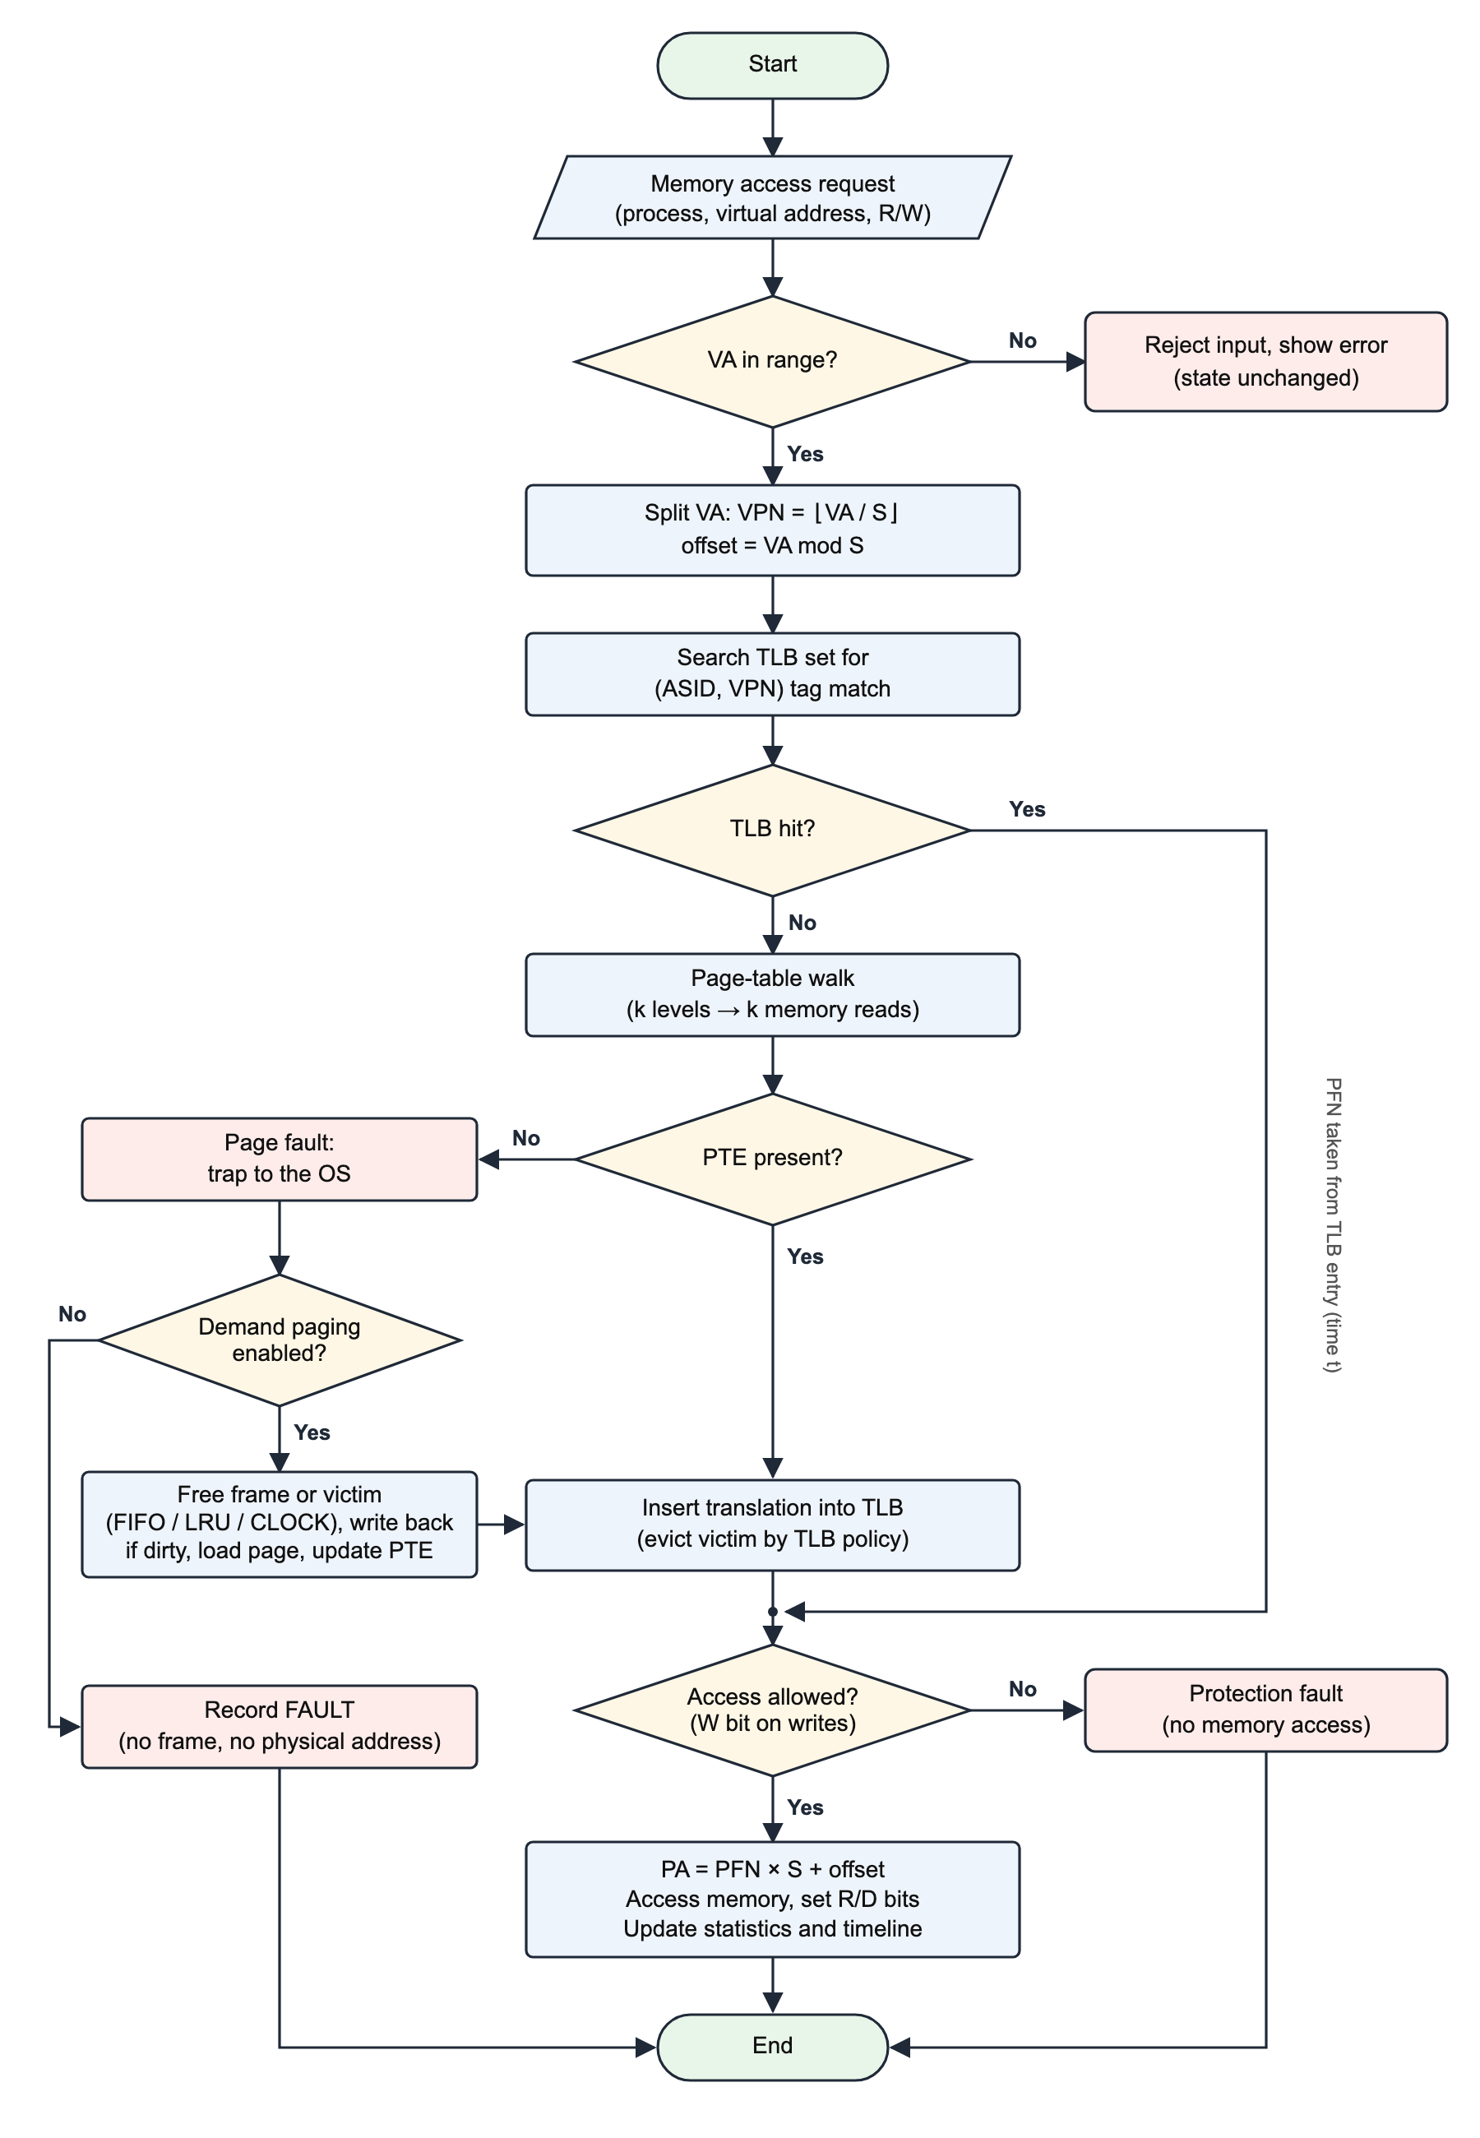
Figure 2: Flowchart of one memory access in the simulator

7.4 TLB replacement policies
Table 5: Replacement policies implemented
Policy | Victim chosen | Remark
FIFO | Entry inserted earliest | Simple; can show Belady's anomaly
LRU | Entry used least recently | Stack algorithm; never shows Belady's anomaly
LFU | Entry with the fewest uses (ties broken by LRU) | Good for skewed workloads; slow to adapt
CLOCK | First entry with reference bit 0; bits are cleared as the hand passes | Cheap approximation of LRU (second chance)
RANDOM | Pseudo-random entry from a seeded generator | Reproducible because the seed is fixed
OPT | Entry whose next use is farthest in the future | Optimal lower bound; needs the future trace (policy lab only)

7.5 Worked example
With the default machine (16-bit VA, 12-bit PA, 256-byte pages, a 4-entry fully associative LRU TLB, t = 10 ns, m = 100 ns, one-level page table, report-only faults), the following inputs were entered in the running simulator. Table 6 shows the outputs it produced.
Table 6: Sample input and output from the simulator
Access | Input VA | VPN, offset | Outcome | PA | Time
1 | 300 | 1, 44 | TLB miss; page walk finds VPN 1 → PFN 1; translation inserted into TLB | 300 | 10 + 100 + 100 = 210 ns
2 | 300 | 1, 44 | TLB hit; PFN 1 read from the TLB | 300 | 10 + 100 = 110 ns
3 | 0x1A2B (6699) | 26, 43 | Page fault: page 26 is not resident (report-only mode) | none | 10 + 100 = 110 ns

For VA 300: VPN = floor(300 / 256) = 1, offset = 300 mod 256 = 44, and PA = 1 × 256 + 44 = 300. With a hit ratio of h = 0.8, the EAT is 0.8 × 110 + 0.2 × 210 = 130 ns, compared with 200 ns if there were no TLB at all.

8. Software and Hardware Requirements

8.1 Software requirements
Table 7: Software requirements
Component | Requirement
Operating system | Windows 10/11, macOS or Linux
Web browser | Recent Google Chrome or Microsoft Edge (recommended, for native page transitions); Firefox and Safari are supported with a fallback animation
Languages | HTML5, CSS3, JavaScript (ES2020)
Test runtime | Node.js 18 or later (optional; runs the automated test suite with npm test)
Local web server | Python 3 (optional; python3 -m http.server 5173). The app also opens directly from index.html
Development tools | Visual Studio Code, Git, Chrome DevTools
External libraries | None: no frameworks, no back end and no database

8.2 Hardware requirements
Table 8: Hardware requirements
Component | Minimum | Recommended
Processor | Dual-core, 1.6 GHz | Quad-core, 2.0 GHz or better
RAM | 4 GB | 8 GB
Storage | 50 MB free space | 100 MB free space
Display | 1366 × 768 | 1920 × 1080 (the layout also adapts to 375-pixel-wide phones)
Network | Not needed after download | Not needed
Input devices | Keyboard and mouse, or touch screen | Keyboard and mouse

9. System Architecture
TLB/Scope uses a layered architecture, shown in Figure 3 and described below. The user works with ten HTML pages. A shared interface shell provides navigation and effects. A session layer stores the history of operations and replays it through a pure simulation engine, which holds all the operating-system and hardware logic.
- Presentation layer: ten pages, each doing one job: configure the machine, translate one address, run a workload, inspect structures, analyse performance, compare policies, learn, self-test and print a report.
- Interface shell: shell.js draws the tabs, context bar, journey stepper and command palette on every page; fx.js adds animations and the live mini-MMU on the home page; calc.js plays the step-by-step calculation; report.js builds the printable report.
- Session and controller layer (app.js): keeps the configuration, the list of operations and the current time cursor, replays them through the engine, and renders the panels of the current page.
- Simulation engine (engine.js): a deterministic module with no user-interface code. It performs address decomposition, TLB lookup and replacement, page-table walks, fault handling, protection checks, statistics and EAT, policy comparison and invariant checking.
- Persistence and sharing: the session is saved in the browser's localStorage, can be shared as a link whose data stays in the URL fragment, and can be exported as CSV or JSON.
- Verification: the same engine code is tested by 96 engine tests (in Node.js and in the browser) and 29 page-level smoke tests.
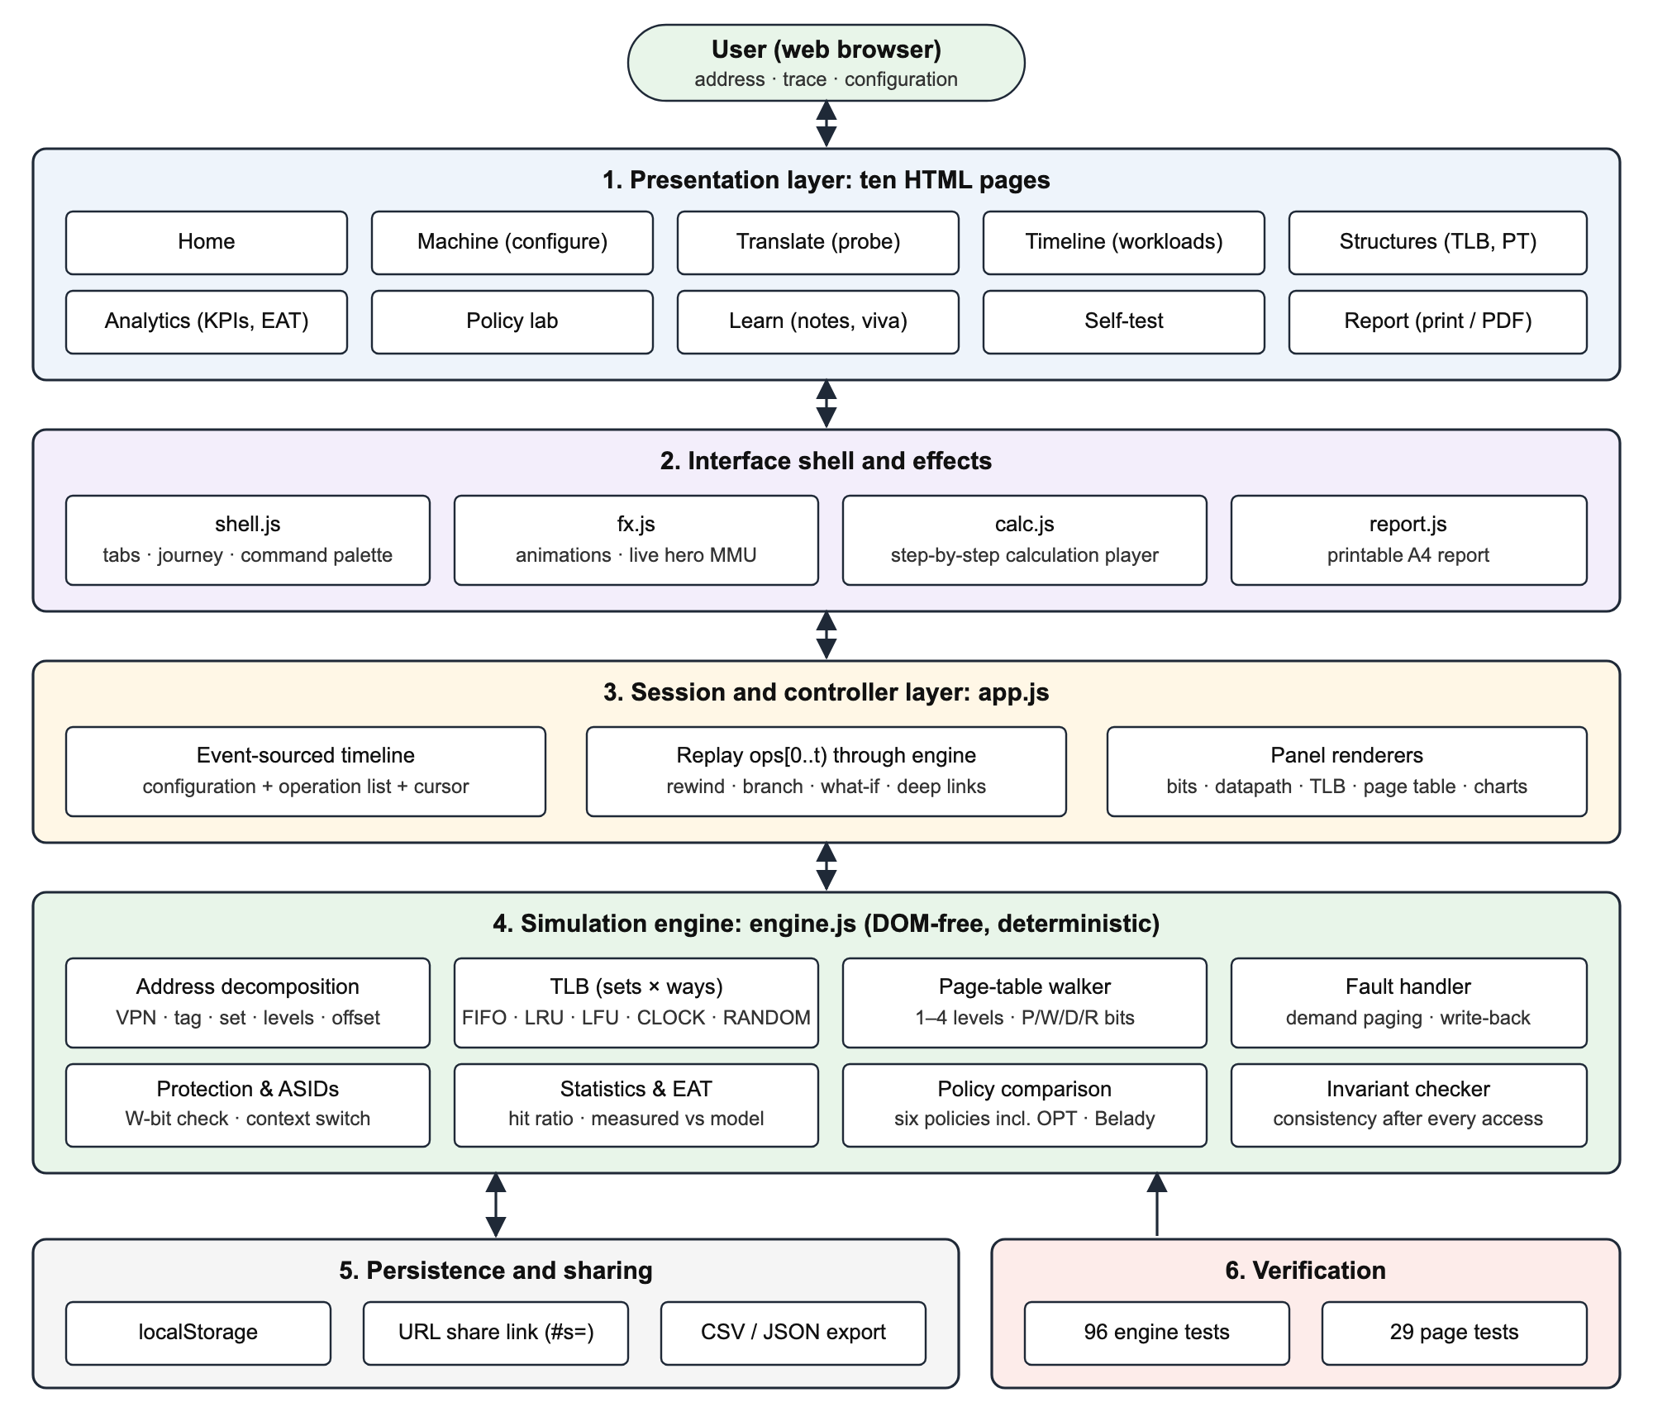
Figure 3: System architecture of TLB/Scope

9.1 Key design decision: an event-sourced timeline
The interface never changes the translation state directly. Every user action (an access, a permission change, an INVLPG or a flush) is appended to a list of operations. Because the engine is deterministic (even the RANDOM policy uses a seeded generator), the state at any time t is simply the replay of operations 0 to t. This one mechanism provides time travel, branching, what-if replay under a new configuration, and shareable links.

9.2 Data structures
Page tables are stored as typed arrays: an Int32Array of PFNs plus a Uint8Array of flag bytes holding the present, writable, dirty and referenced bits. This keeps even a 32-bit address space with 4 KiB pages (2^20 entries) fast. The TLB is an array of sets, each holding an array of ways. Every physical frame records its owner (process, VPN), which acts as an inverted page table so that a victim's TLB entry can be invalidated in constant time.
Table 9: Source modules
File | Responsibility | Lines
js/engine.js | DOM-free MMU engine shared by the browser and Node.js | 721
js/app.js | Shared session, replay, persistence, deep links and panel renderers | 1,406
js/calc.js | Animated calculation player (Translate page) | 398
js/fx.js | Effects, live hero MMU and command palette | 318
js/shell.js | Tabs, context bar, journey and page transitions | 246
js/report.js | Printable report (Report page) | 105
tests/suite.js, run.js, pages.js | 96 engine tests and 29 page-level smoke tests | -

10. Implementation Timeline
The project was planned over twelve weeks, as shown in Table 10.
Table 10: Implementation timeline
Week | Phase | Activities | Deliverable
1 | Requirement analysis | Study the syllabus, survey existing tools, define the feature list | Problem statement and requirements
2 | Model design | Define configuration, formulas, engine interface and test plan | Design document
3–4 | Core engine | Address split, TLB, page-table walk, replacement policies | engine.js with first unit tests
5 | Faults and processes | Demand paging, frame replacement, protection, ASIDs | Extended engine and tests
6–7 | User interface (version 1) | Probe, bit surgery, datapath, timeline, structures | Single-page prototype
8 | Analytics and policy lab | KPIs, charts, EAT calculator, policy comparison, Belady detection | Analytics features
9 | Multi-page version (version 2) | Split into ten pages, shared session, navigation and transitions | Version 2 application
10 | Testing | Engine tests, invariants, mutation testing, page tests, browser checks | Test results
11 | Documentation | Learning notes, viva questions, printable report, README | User guide and report
12 | Review and submission | Final fixes, case study and demonstration | Final submission

11. Expected Outcomes
- A working simulator that translates any virtual address on a configurable machine and explains every step at bit, stage and timeline level.
- Students can check textbook numericals instantly, for example VA 300 → PA 300 with a miss of 210 ns and a hit of 110 ns, and an EAT of 130 ns for h = 0.8.
- Classic phenomena can be demonstrated live: Belady's anomaly (FIFO gives 9 misses with 3 entries but 10 misses with 4 entries), LRU thrashing (a loop over five pages with a four-entry TLB gives 0% hits), conflict misses in a direct-mapped TLB, and ASID tagging versus flushing.
- Replacement policies and TLB sizes can be compared quantitatively on the same trace.
- Correctness is verified: all 96 engine tests (including 38 edge cases) and all 29 page-level tests pass.
- The tool can be reused as a teaching aid in lab sessions and for viva preparation, and it produces a printable report.
Table 11: Selected test cases and results
# | Input / setup | Expected result | Result
1 | Default machine; VA 300 twice | VPN 1, offset 44, PA 300; miss then hit | Pass
2 | VA 4095 and 4096 | PA 4095; then a fault with no frame and no PA | Pass
3 | 0x12C, 0b100101100, 0o454, 0x1_2C | All equal 300 | Pass
4 | FIFO, 3 entries, pages 1 2 3 1 4 1 | Page 1 evicted; outcomes M M M H M M | Pass
5 | Belady string, FIFO with 3 and 4 entries | 9 and 10 misses (anomaly) | Pass
6 | Direct-mapped, 4 entries, pages 0 1 4 0 1 | Pages 0 and 4 conflict in set 0: M M M M H | Pass
7 | Write to a read-only page | Protection fault, no PA, page stays clean | Pass
8 | Two processes, ASID mode, same VPN | M M H; 2 switches; 0 flushes | Pass
9 | EAT with h = 0.8, t = 10, m = 100 | 130 ns | Pass
10 | 3,000 random multi-process demand-paging accesses | All invariants hold | Pass

Figures 4 to 7 show the simulator producing these outcomes.
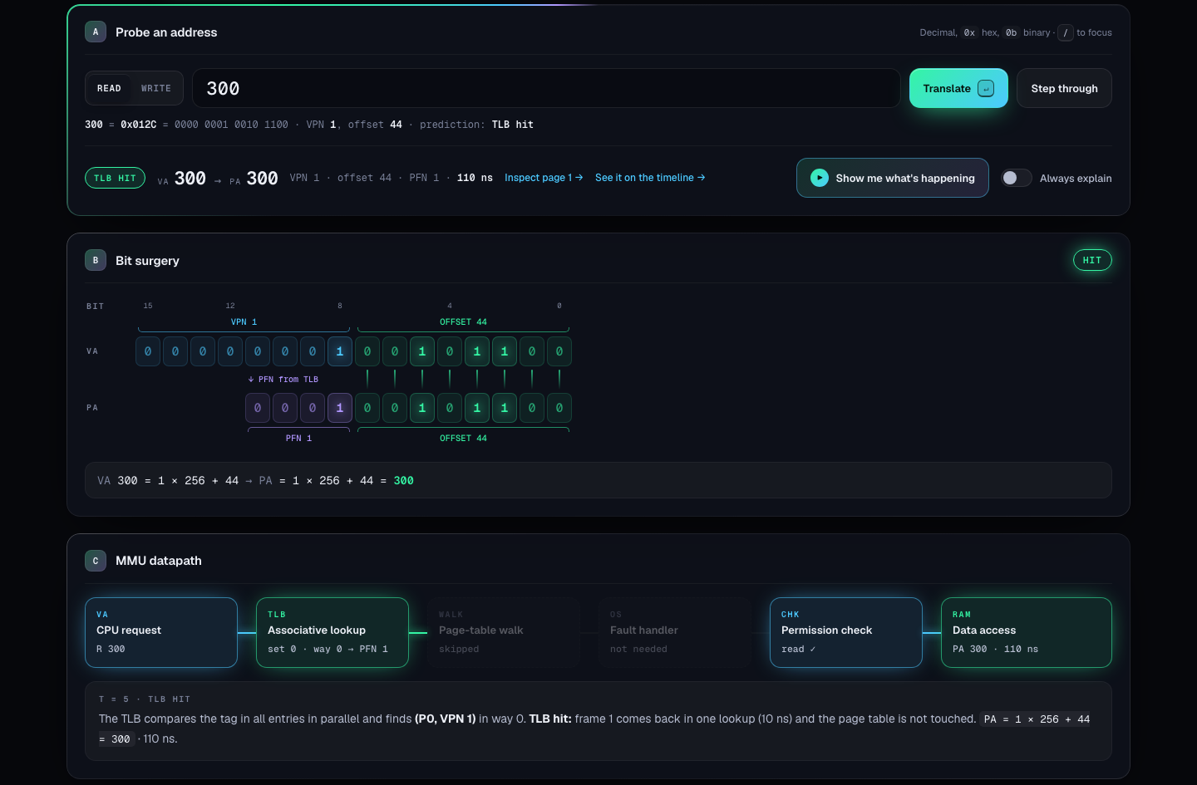
Figure 4: Translate page: VA 300 is a TLB hit, giving PA 300 in 110 ns, with the bit-level view and the MMU datapath
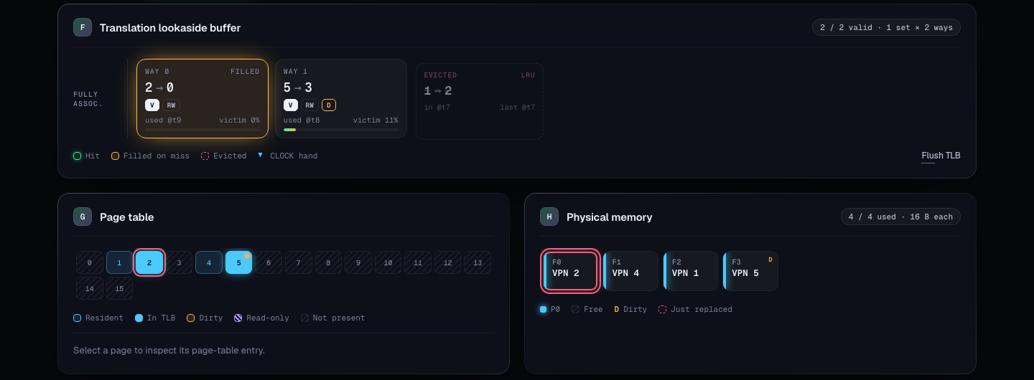
Figure 5: Structures page: TLB ways, page-table map and physical frames during demand paging
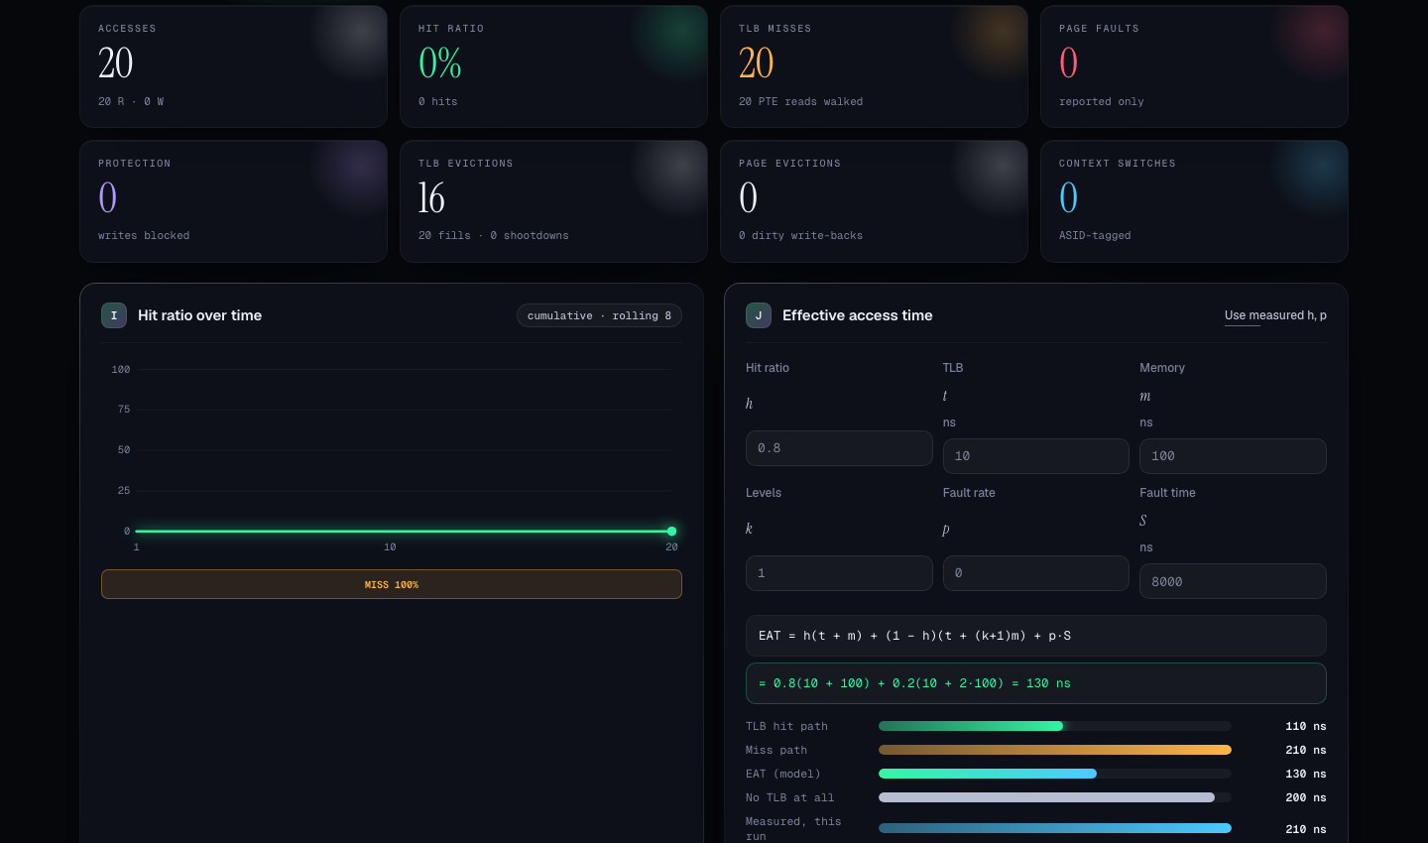
Figure 6: Analytics page: LRU thrashing (0% hit ratio) and the EAT calculator (130 ns model versus 200 ns without a TLB)
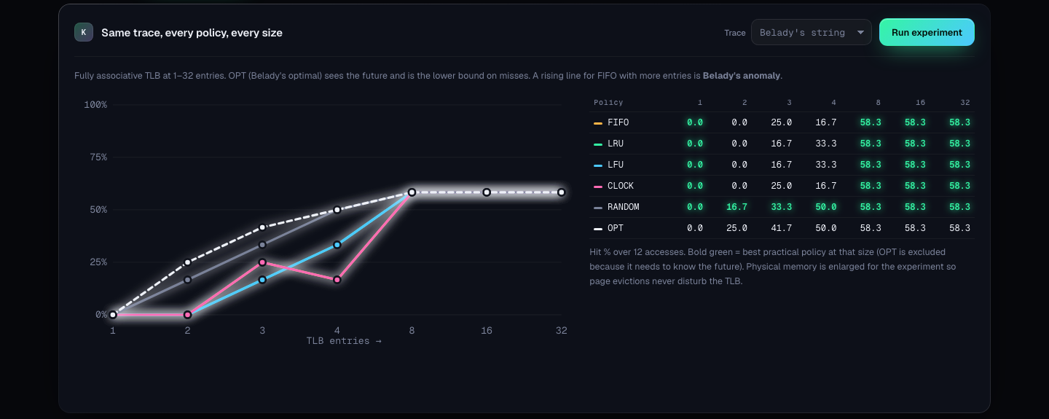
Figure 7: Policy lab: hit ratio of six policies at seven TLB sizes on Belady's string; FIFO drops from 25.0% to 16.7% when the TLB grows from 3 to 4 entries

12. Future Scope
- Huge pages (2 MiB and 1 GiB) with a separate large-page TLB.
- Two-level TLB hierarchy (L1 instruction and data TLBs with a shared L2 TLB) and split instruction/data TLBs.
- Page-walk caches and a more detailed timing model for the hardware page-table walker.
- Multi-core simulation with TLB shootdowns delivered by inter-processor interrupts.
- Other page-table designs such as inverted and hashed page tables, and working-set or page-fault-frequency frame allocation.
- Real address traces recorded from instrumented programs (for example with Valgrind or Intel Pin) and replayed in the simulator.
- Nested paging for virtual machines (guest and host page tables).
- Exercise and quiz mode with automatic grading for instructors.

13. Challenges and Ethical Considerations

13.1 Challenges
Table 12: Challenges faced and how they were addressed
Challenge | How it was addressed
Keeping every view consistent while allowing rewind and what-if changes | Event-sourced timeline: the state at time t is the replay of all earlier operations through a deterministic engine
Making the RANDOM policy reproducible | A seeded pseudo-random number generator, so every session replays identically
Large address spaces (a 32-bit VA with 4 KiB pages has 2^20 PTEs) | Typed arrays for page tables and paged views of 1,024 cells
Proving that the simulator is correct | Expected values derived by hand or from textbooks, invariant checks after every access, and mutation testing with deliberately planted bugs
Belady's string alone could not tell CLOCK apart from FIFO | Two extra CLOCK tests were added after mutation testing exposed the gap
Invalid input (out-of-range addresses, malformed hexadecimal) | A strict parser with specific error messages; invalid input never changes the state
Browser differences (native page transitions only in Chromium) | Feature detection with a JavaScript fade/slide fallback
Readability on small screens | Responsive layout tested at 375 pixels wide with no horizontal scrolling

13.2 Ethical considerations
- Academic integrity: concepts, formulas and worked examples taken from textbooks and lecture notes are cited in the references, and test expectations are taken from these published sources.
- Accuracy and honesty: the simulator is a teaching model, not a cycle-accurate MMU. Its limitations (no huge pages, no split TLBs, no page-walk caches, no multi-core shootdowns) are stated clearly so that students do not over-generalise.
- Privacy: everything runs locally in the browser. There are no accounts, no tracking and no server. Sessions are kept in localStorage, and share links keep their data in the URL fragment, which browsers do not send to servers.
- Accessibility and inclusion: keyboard shortcuts, ARIA live regions, support for reduced motion, text labels in addition to colours, light and dark themes, and support for low-end devices and phones.
- Free and open access: no paid software is required, and the project is released under the MIT licence so other institutions can reuse it.
- Responsible use in learning: the tool is meant to help students understand and check their answers, not to replace learning. Teachers can use the step-through mode and viva questions to test understanding.

14. Conclusion
This case study presented TLB/Scope, an interactive simulator for virtual-to-physical address translation using a Translation Lookaside Buffer. The simulator meets the requirement of Mini Project #45 and goes further. Every translation is shown at bit level, hardware-stage level and timeline level. The TLB organisation, replacement policy, page-table depth, fault handling and context-switch strategy can be changed and compared on the same workload. Performance is measured as well as modelled, and correctness is backed by 96 automated engine tests checked against textbook results, together with 29 page-level tests.
The project shows how a small hardware cache has a large effect on memory performance, and why choices such as replacement policy and associativity matter. By turning an invisible hardware process into something students can see, change and measure, TLB/Scope makes one of the harder topics in Operating Systems easier to learn and to teach. The future work listed in Section 12 would extend it towards the features of modern processors.

References
[1] A. Silberschatz, P. B. Galvin and G. Gagne, Operating System Concepts, 10th ed. Wiley, 2018.
[2] R. H. Arpaci-Dusseau and A. C. Arpaci-Dusseau, Operating Systems: Three Easy Pieces. Arpaci-Dusseau Books, 2018. Available: https://pages.cs.wisc.edu/~remzi/OSTEP/
[3] A. S. Tanenbaum and H. Bos, Modern Operating Systems, 4th ed. Pearson, 2015.
[4] J. L. Hennessy and D. A. Patterson, Computer Architecture: A Quantitative Approach, 6th ed. Morgan Kaufmann, 2017.
[5] L. A. Belady, "A study of replacement algorithms for a virtual-storage computer," IBM Systems Journal, vol. 5, no. 2, pp. 78–101, 1966.
[6] N. Binkert et al., "The gem5 simulator," ACM SIGARCH Computer Architecture News, vol. 39, no. 2, pp. 1–7, 2011.
[7] D. Burger and T. M. Austin, "The SimpleScalar tool set, version 2.0," ACM SIGARCH Computer Architecture News, vol. 25, no. 3, pp. 13–25, 1997.
[8] J. Edler and M. D. Hill, "Dinero IV trace-driven uniprocessor cache simulator," University of Wisconsin–Madison, 1998.
[9] A. Bhattacharjee and D. Lustig, Architectural and Operating System Support for Virtual Memory. Morgan & Claypool, 2017.
[10] R. Ontko and A. Reeder, "MOSS Memory Management Simulator," companion software to Modern Operating Systems.
[11] Colorado State University, CS370 lecture notes on virtual memory. Available: https://www.cs.colostate.edu/~cs370/Fall25/lectures/10virtualmemoryL19.pdf
[12] Mozilla, MDN Web Docs (HTML, CSS and JavaScript). Available: https://developer.mozilla.org/

