PROJECT REPORT
TLB Address Translation Simulator: An Interactive Approach to
Virtual-to-Physical Translation and TLB Performance Analysis
Submitted by:
P V Sai Likith (24BCI0174)
M V S Sujan (24BCE2294)
Shrijit (24BCE2469)
Rajnihil (24BCT0191)

CONTENTS
1. Problem Statement 3
2. Objectives 4
3. System Design 4
4. Algorithm and Pseudocode 8
5. Implementation 10
6. Screenshots and Results 13
7. Testing and Validation 18
8. Conclusion and Future Enhancements 21
9. References 21

1. Problem Statement
Every program runs in its own virtual address space, but main memory understands only physical addresses. With paging, a virtual address (VA) is split into a virtual page number (VPN) and an offset. A page table stored in main memory maps each VPN to a physical frame number (PFN), and the physical address is PA = PFN × page size + offset.
Reading the page table on every memory reference would make each access cost at least two memory trips, and k + 1 trips for a k-level page table. Processors therefore use a Translation Lookaside Buffer (TLB), a small, fast cache of recent translations. On a TLB hit the PFN is available in about 10 ns; on a TLB miss the page table must be walked; and if the page is not in memory, a page fault hands control to the operating system.
All of this happens inside the hardware in nanoseconds, so it cannot be observed. Textbooks show only static diagrams, and hand-solving translation problems is slow and error-prone. Students therefore find it hard to see why a hit or a miss happens, how the replacement policy chooses a victim, or how much the TLB actually speeds up memory access.
Problem statement: To design and implement a simulator that models virtual-to-physical address translation using a TLB and a page table, shows every step of each translation (address split, TLB lookup, page-table walk, page fault, protection check and physical-address formation), and measures how the TLB size, organisation and replacement policy affect the hit ratio and the effective access time (EAT).
Scope. The simulator supports 4- to 32-bit virtual and physical addresses, power-of-two page sizes, 1 to 4 page-table levels, TLBs of 1 to 64 entries (fully associative, set-associative or direct-mapped), the replacement policies FIFO, LRU, LFU, CLOCK, RANDOM and OPT, page faults in report-only or demand-paging mode, read/write protection, and up to four processes. It is a teaching model and is not cycle-accurate.

2. Objectives
The project has five objectives:
- Translate addresses step by step. Split any virtual address into VPN and offset (and set index, tag and page-table level indices), and compute the physical address, showing each step at bit level.
- Simulate the TLB and page table. Model TLB hits, misses, fills and evictions with six replacement policies (FIFO, LRU, LFU, CLOCK, RANDOM and OPT), for fully associative, set-associative and direct-mapped TLBs, together with page-table walks of 1 to 4 levels.
- Handle page faults and protection. Detect page faults (report-only or demand paging with frame replacement and dirty write-back) and write-protection faults.
- Measure performance. Compute the hit ratio, misses, faults and evictions, and compare the measured effective access time with the textbook EAT formula and with a system that has no TLB.
- Compare policies and verify correctness. Run the same trace under every policy and TLB size, detect Belady's anomaly automatically, and validate every result with automated tests derived from textbook examples.

3. System Design
The design is described with an architecture diagram, a flowchart and three UML diagrams (use-case, class and sequence).

3.1 System architecture
The system has a layered architecture (Figure 1). The user works with ten web pages. A shared interface shell provides navigation, and a session layer keeps the history of operations and replays it through a deterministic simulation engine that contains all of the memory-management logic. The same engine logic is also implemented in Python as a command-line program (Section 5).
- Presentation layer: ten pages, each with one job: Home, Machine, Translate, Timeline, Structures, Analytics, Policy lab, Learn, Self-test and Report.
- Interface shell: navigation tabs, the journey stepper, the command palette, animations, the calculation player and the printable report.
- Session layer: stores the configuration, the list of operations and the time cursor, and replays them through the engine. This gives rewind, branching and "what-if" replay.
- Simulation engine: address decomposition, TLB lookup and replacement, page-table walk, fault handling, protection, statistics and EAT, policy comparison and invariant checks.
- Persistence and verification: browser localStorage, share links and CSV/JSON export; 96 automated engine tests and 29 page tests.
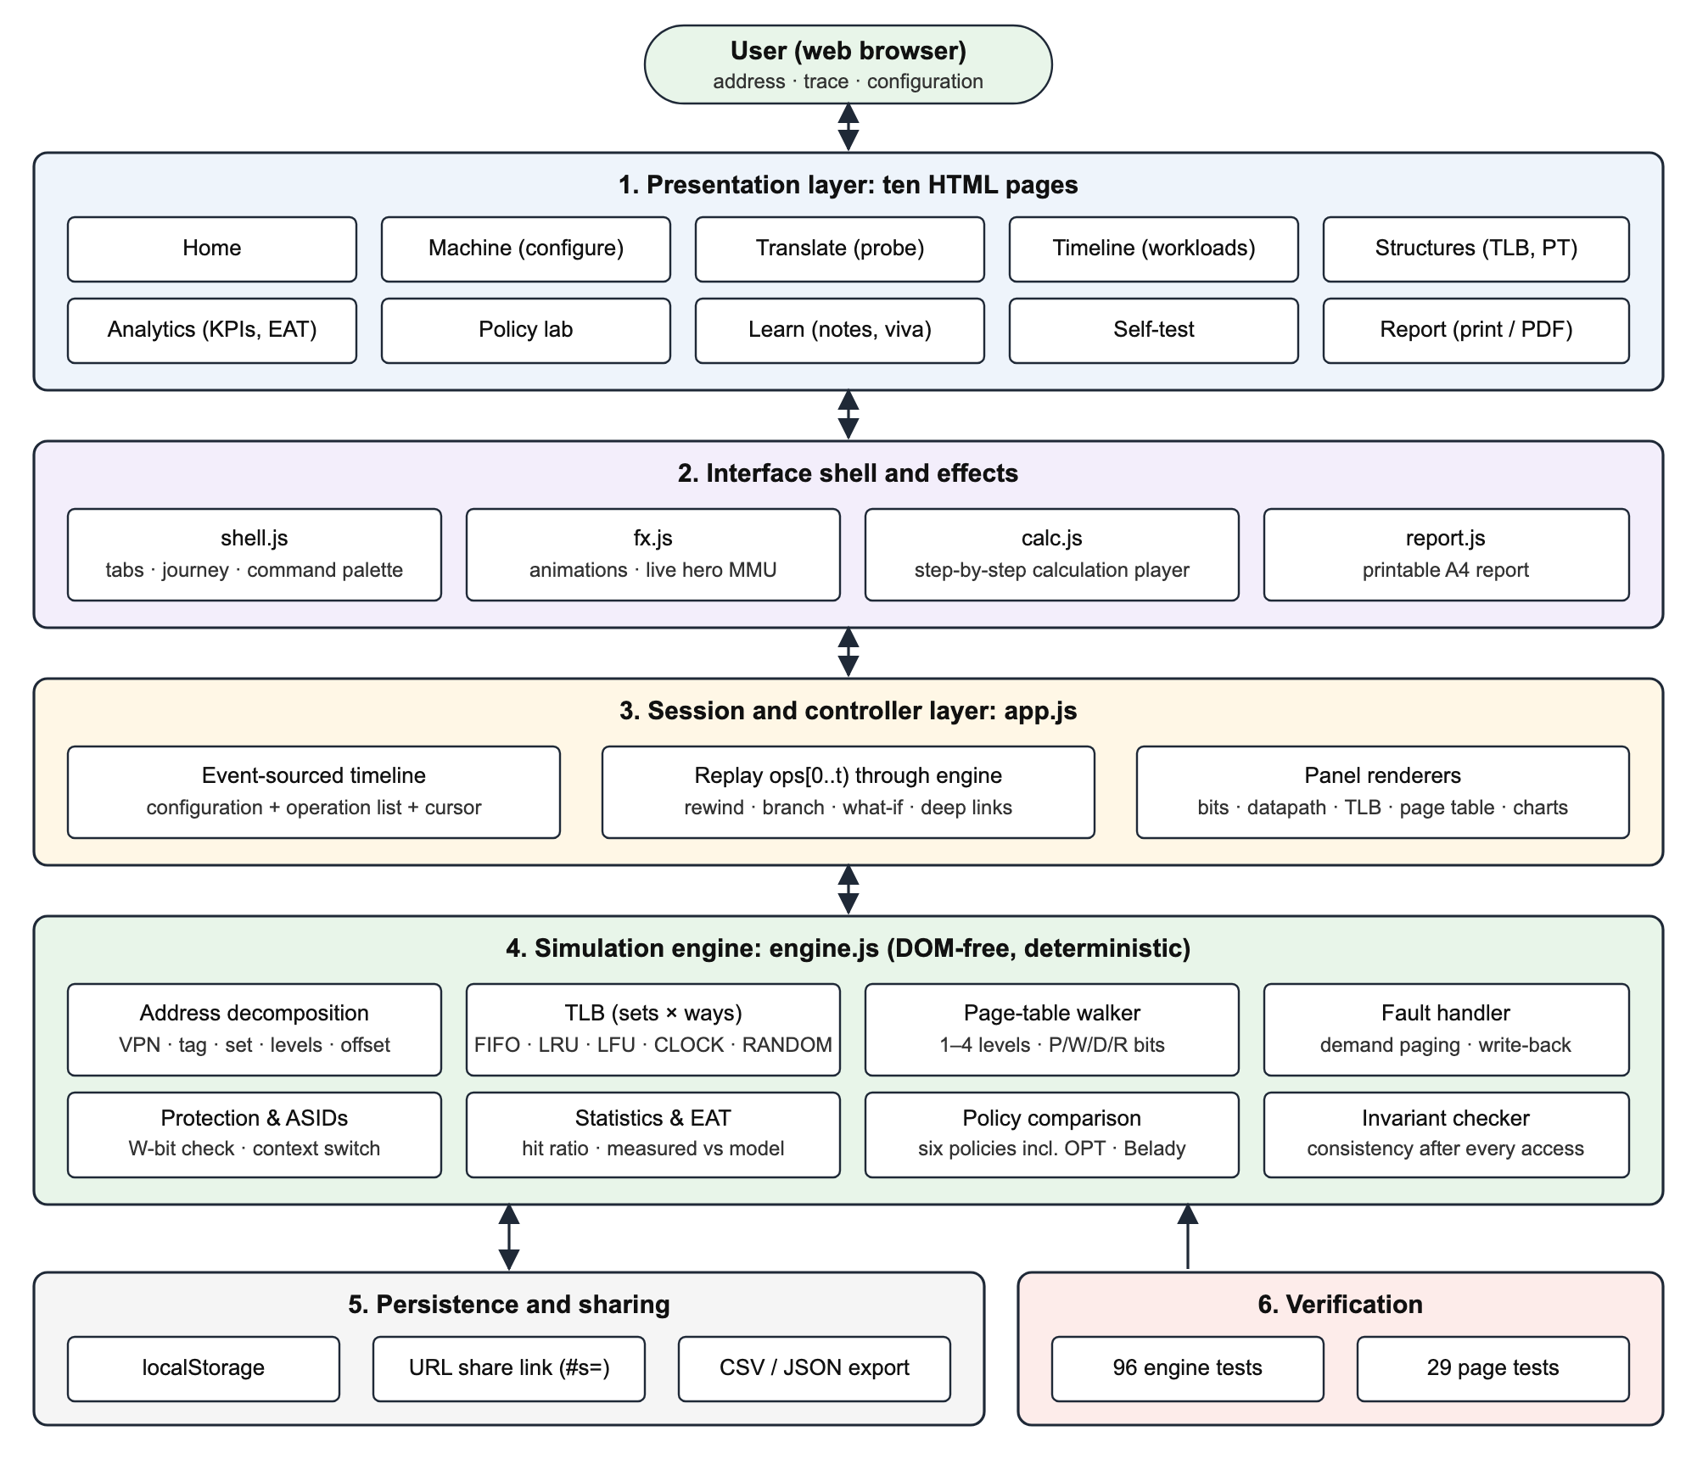
Figure 1: System architecture

3.2 Flowchart
Figure 2 shows how one memory access is processed.
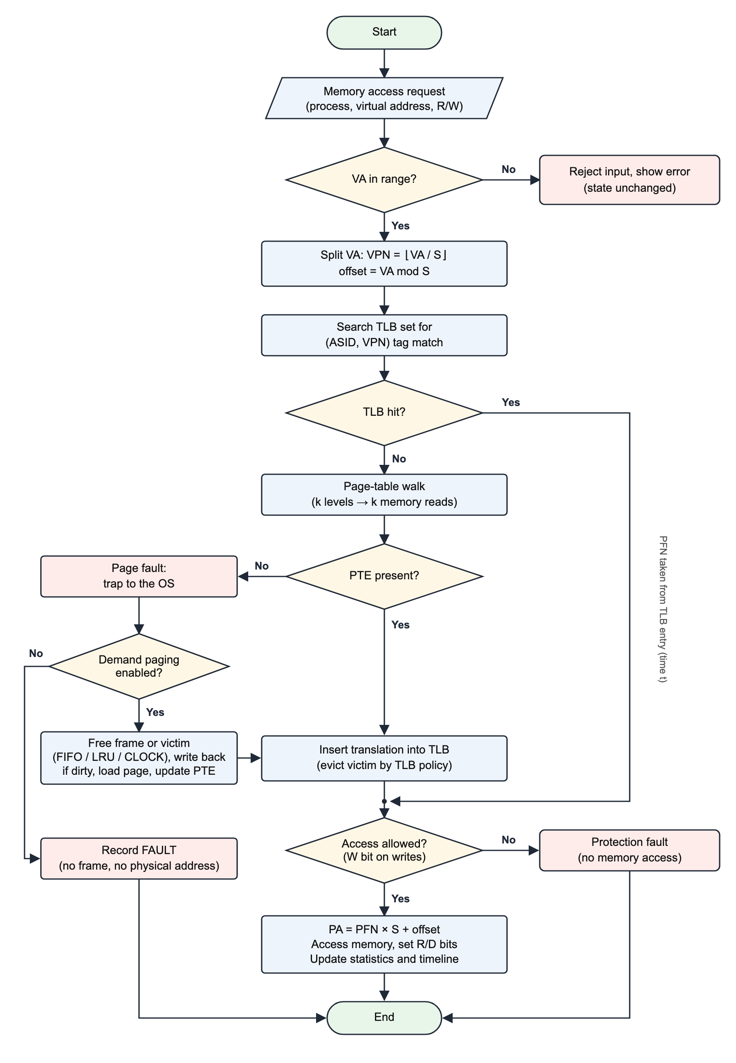
Figure 2: Flowchart of one memory access

3.3 UML use-case diagram
Figure 3 shows what the two kinds of user can do with the system. Students configure the machine, translate addresses, run traces and study the results; teachers and examiners use scenarios, policy comparison, the self-test and the report.
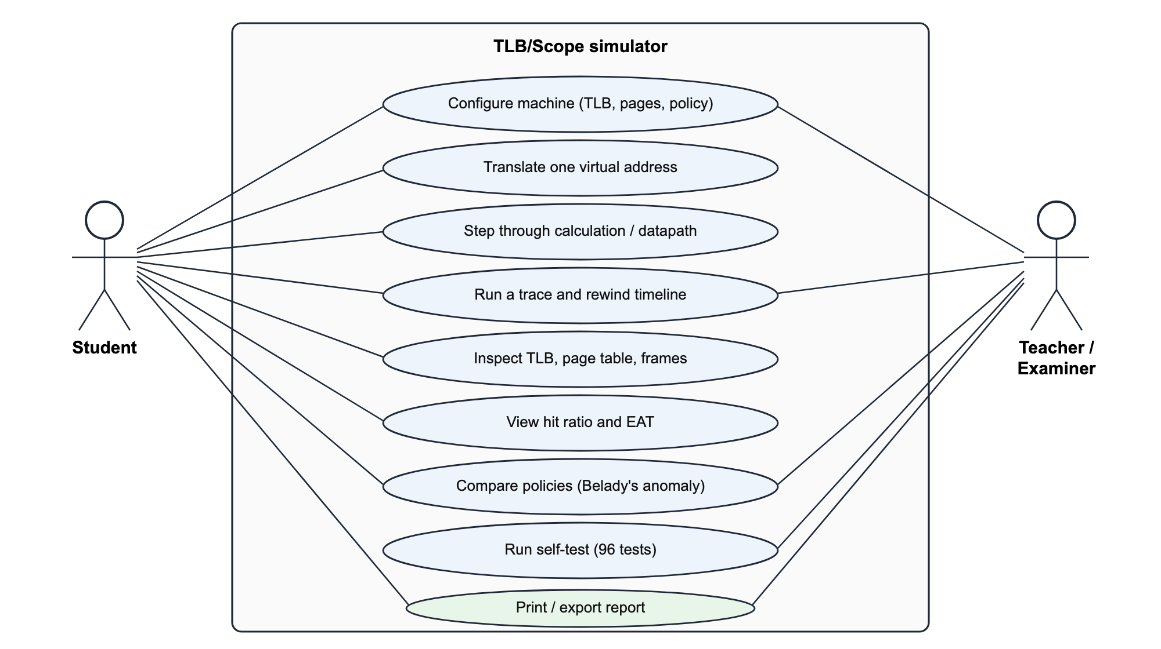
Figure 3: UML use-case diagram

3.4 UML class diagram
Figure 4 shows the classes of the Python implementation. MMU owns the TLB (a list of sets, each holding TLBEntry objects), the page table (a list of PTE objects) and the log of Record objects. Config holds the machine parameters and derives the number of pages, frames and TLB sets.
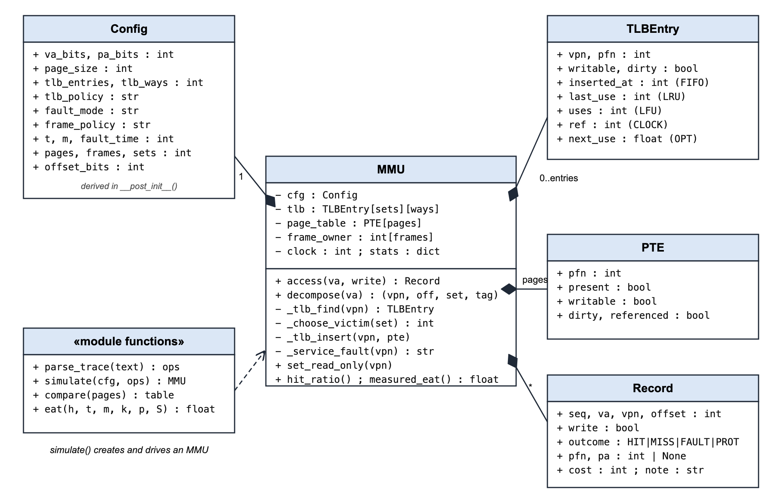
Figure 4: UML class diagram (Python implementation)

3.5 UML sequence diagram
Figure 5 shows the messages exchanged when a student translates the address 300. The alternative frame shows the hit path and the miss path.
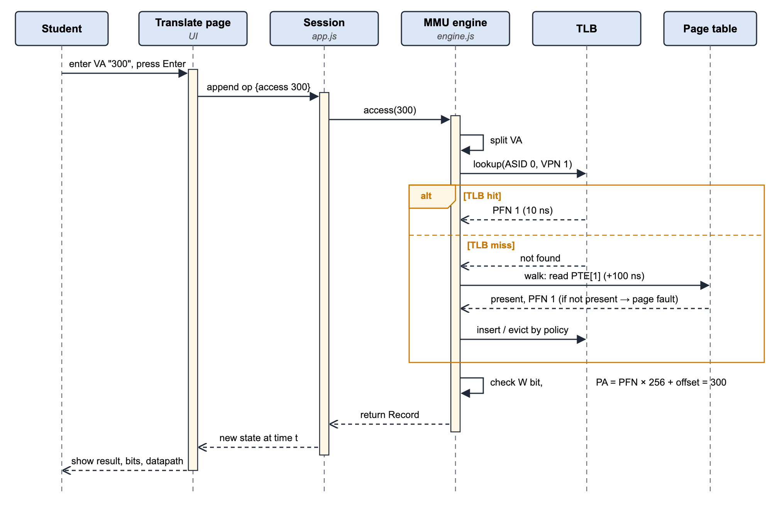
Figure 5: UML sequence diagram for translating one address

3.6 Key design decisions
- Event-sourced timeline: every user action is stored as an operation, and the state at time t is obtained by replaying operations 0 to t. Because the engine is deterministic (RANDOM uses a fixed seed), this gives time travel, branching and what-if replay from one mechanism.
- Separate engine: the engine has no user-interface code, so it can be tested on its own in Node.js and reimplemented in Python.
- Compact data structures: the page table uses typed arrays (one PFN and one flag byte per page), so even a 32-bit address space with 4 KiB pages (2^20 entries) stays fast. Each frame records its owner page, which acts as an inverted page table for fast eviction.

4. Algorithm and Pseudocode

4.1 Formulas
Let S be the page size, t the TLB lookup time, m the memory access time, k the number of page-table levels, h the hit ratio, p the page-fault rate and F the fault service time.
Table 1: Formulas used by the simulator
Quantity | Formula
Offset bits | log2(S)
Virtual page number / offset | VPN = floor(VA / S); offset = VA mod S
TLB sets, set index and tag | sets = entries / ways; set = VPN mod sets; tag = floor(VPN / sets)
Physical address | PA = PFN × S + offset
Cost of a TLB hit / miss | t + m / t + k·m + m
Effective access time | EAT = h(t + m) + (1 − h)(t + (k + 1)m) + p·F

4.2 Pseudocode: one memory access
Pseudocode 1: ACCESS
ALGORITHM ACCESS(VA, write)
INPUT : virtual address VA, flag write (true for a store)
OUTPUT: outcome (HIT, MISS, FAULT or PROT), physical address PA, cost

1 if VA < 0 or VA > 2^vaBits - 1 then
2 reject "address out of range" // state is not changed
3 clock <- clock + 1
4 VPN <- floor(VA / S); offset <- VA mod S; set <- VPN mod sets
5 cost <- t // TLB lookup
6 entry <- search TLB[set] for VPN
7 if entry found then // ---- TLB HIT
8 update entry.lastUse, entry.uses, entry.ref
9 outcome <- HIT
10 else // ---- TLB MISS
11 cost <- cost + k * m // page-table walk
12 if PageTable[VPN].present = false then // ---- PAGE FAULT
13 if faultMode = REPORT then
14 return (FAULT, no PA, cost)
15 frame <- free frame, else victim by FIFO / LRU
16 if victim is dirty then write it back to disk
17 invalidate victim PTE and its TLB entry
18 load page into frame; update PageTable[VPN]
19 cost <- cost + F
20 way <- empty way in TLB[set], else CHOOSE_VICTIM(set)
21 TLB[set][way] <- (VPN, PageTable[VPN].pfn, bits, clock)
22 outcome <- MISS (or FAULT if the fault was serviced)
23 if write and entry is read-only then
24 return (PROT, no PA, cost) // protection fault
25 if write then mark page and entry dirty
26 PA <- entry.pfn * S + offset
27 cost <- cost + m // data access
28 record (outcome, PA, cost) and update statistics
29 return (outcome, PA, cost)

4.3 Pseudocode: choosing a TLB victim
Pseudocode 2: CHOOSE_VICTIM
ALGORITHM CHOOSE_VICTIM(set)
row <- TLB[set]
if row has an empty way then return that way
switch policy
FIFO : return the way with the smallest insertedAt
LRU : return the way with the smallest lastUse
LFU : return the way with the smallest uses (ties -> smallest lastUse)
OPT : return the way whose next use is farthest in the future
RANDOM: return a seeded pseudo-random way
CLOCK : loop
if row[hand].ref = 1 then row[hand].ref <- 0; hand <- hand + 1
else victim <- hand; hand <- hand + 1; return victim

4.4 Replacement policies
Table 2: TLB replacement policies
Policy | Victim | Property
FIFO | Entry inserted earliest | Simple; can show Belady's anomaly
LRU | Entry used least recently | Stack algorithm; no Belady's anomaly
LFU | Entry used least often | Good for skewed workloads; slow to adapt
CLOCK | First entry with reference bit 0 | Cheap approximation of LRU (second chance)
RANDOM | Seeded random entry | No bookkeeping; reproducible because of the seed
OPT | Entry used farthest in the future | Optimal lower bound; needs the future trace

4.5 Worked example
Default machine: 16-bit VA, 12-bit PA, 256-byte pages (256 pages, 16 frames, 8 offset bits), 4-entry fully associative LRU TLB, t = 10 ns, m = 100 ns.
- VA 300: VPN = floor(300 / 256) = 1, offset = 300 mod 256 = 44. The first access is a miss: the page table gives PFN 1, so PA = 1 × 256 + 44 = 300, cost = 10 + 100 + 100 = 210 ns.
- VA 300 again: the translation is now in the TLB, so it is a hit costing 10 + 100 = 110 ns.
- VA 0x1A2B (6699): VPN = 26, offset = 43. Only pages 0 to 15 are in memory, so this is a page fault.
- EAT with h = 0.8: 0.8 × 110 + 0.2 × 210 = 130 ns, compared with 200 ns without a TLB.

5. Implementation

5.1 Technologies
The simulator was implemented twice with the same logic:
- Python implementation (tlb_sim.py, Python 3): a command-line simulator of the MMU, with a unit-test suite (test_tlb_sim.py). It needs only the Python standard library.
- Interactive web implementation (TLB/Scope): HTML5, CSS3 and JavaScript, with no frameworks and no back end. It provides the visual interface: bit-level view, datapath, timeline, structures, analytics, policy lab and report.
Both implementations produce identical results on the same input (Section 7.4).
Table 3: Project structure
File / folder | Purpose
python-implementation/tlb_sim.py | Python MMU simulator: Config, TLBEntry, PTE, Record, MMU, simulate(), compare(), eat()
python-implementation/test_tlb_sim.py | 16 Python unit tests
tlb-simulator/js/engine.js | JavaScript MMU engine used by the web pages (721 lines)
tlb-simulator/js/app.js | Session, replay, persistence and panel renderers (1,406 lines)
tlb-simulator/js/shell.js, fx.js, calc.js, report.js | Navigation, animations, calculation player, printable report
tlb-simulator/*.html | Ten pages: index, machine, translate, timeline, structures, analytics, lab, learn, verify, report
tlb-simulator/tests/ | 96 engine tests and 29 page-level smoke tests

5.2 Core Python code
The following listings are taken directly from tlb_sim.py. Listing 1 is the main translation routine and Listing 2 chooses which TLB entry to replace.
Listing 1: MMU.access() — one memory access
def access(self, va, write=False, next_use=float("inf")):
cfg, st = self.cfg, self.stats
if not isinstance(va, int) or not 0 <= va <= cfg.va_max:
raise ValueError(f"address {va} is outside the {cfg.va_bits}-bit "
f"virtual space (0-{cfg.va_max})")
self.clock += 1
st["accesses"] += 1
st["writes" if write else "reads"] += 1
vpn, offset, _, _ = self.decompose(va)
pte = self.page_table[vpn]
cost, note, fault = cfg.t, "", False

entry = self._tlb_find(vpn)
if entry: # TLB HIT
st["hits"] += 1
entry.last_use, entry.ref, entry.next_use = self.clock, 1, next_use
entry.uses += 1
outcome = "HIT"
else: # TLB MISS -> page walk
st["misses"] += 1
cost += cfg.m
if not pte.present: # PAGE FAULT
st["page_faults"] += 1
fault = True
if cfg.fault_mode == "report":
return self._log(va, write, vpn, offset, "FAULT", None, None,
cost, "not serviced")
note = self._service_fault(vpn)
pte = self.page_table[vpn]
cost += cfg.fault_time
entry, old = self._tlb_insert(vpn, pte, next_use)
if old:
note = f"TLB evict page {old.vpn}"
outcome = "FAULT" if fault else "MISS"

pte.referenced = True
self.frame_used[entry.pfn] = self.clock
if write and not entry.writable: # PROTECTION FAULT
st["prot_faults"] += 1
return self._log(va, write, vpn, offset, "PROT", entry.pfn, None,
cost, "write to read-only page")
if write:
pte.dirty = entry.dirty = True
cost += cfg.m # data access
pa = entry.pfn * cfg.page_size + offset
return self._log(va, write, vpn, offset, outcome, entry.pfn, pa, cost, note)

Listing 2: MMU._choose_victim() — TLB replacement policies
def _choose_victim(self, s):
row = self.tlb[s]
if None in row:
return row.index(None)
policy = self.cfg.tlb_policy
if policy == "CLOCK": # second chance
while True:
h = self.clock_hand[s]
if row[h].ref:
row[h].ref = 0
self.clock_hand[s] = (h + 1) % len(row)
else:
self.clock_hand[s] = (h + 1) % len(row)
return h
if policy == "RANDOM":
return self.rng.randrange(len(row))
key = {
"FIFO": lambda e: (e.inserted_at,),
"LRU": lambda e: (e.last_use,),
"LFU": lambda e: (e.uses, e.last_use),
"OPT": lambda e: (-e.next_use, e.inserted_at),
}[policy]
return min(range(len(row)), key=lambda w: key(row[w]))

Listing 3: effective access time
def eat(h, t=10, m=100, levels=1, p=0.0, fault_time=0):
"""Effective access time: h(t+m) + (1-h)(t+(k+1)m) + p*S."""
return h * (t + m) + (1 - h) * (t + (levels + 1) * m) + p * fault_time

5.3 How to run
Table 4: Commands
Task | Command
Run the Python demo | python3 tlb_sim.py
Run your own trace | python3 tlb_sim.py --trace "300 300 0x1A2B 300:W"
Change policy and TLB size | python3 tlb_sim.py --trace "..." --policy FIFO --entries 3
Compare all policies | python3 tlb_sim.py --compare "1 2 3 4 1 2 5 1 2 3 4 5"
Run the Python tests | python3 -m unittest -v test_tlb_sim
Start the web app | python3 -m http.server 5173 --directory tlb-simulator, then open http://localhost:5173
Run the JavaScript tests | npm test (inside tlb-simulator)

5.4 Web application pages
Table 5: Pages of the web application
Step | Page | What it does
1 | Machine | Configure address widths, page size, TLB size, organisation, policy, faults, processes and timing; ten one-click scenarios
2 | Translate | Translate one address; show the result, bit-level view, MMU datapath and animated calculation
3 | Timeline | Run a trace; logic-analyzer view; rewind, branch and replay; event table
4 | Structures | TLB sets and ways, page-table map, physical frames
5 | Analytics | Hit ratio, misses, faults, evictions, hit-ratio chart, EAT calculator
6 | Policy lab | Six policies × seven TLB sizes; Belady's anomaly detection
7 | Learn | Concept notes, viva questions, real-world mapping
8 | Self-test | Runs the 96 engine tests in the browser
9 | Report | Printable A4 report of the session

6. Screenshots and Results

6.1 Python implementation output
Figure 6 shows the output of python3 tlb_sim.py. It runs the sample trace 300 300 301 1200 0x1A2B 0 256 512 768 0 300:W on the default machine, then compares all policies on Belady's reference string.
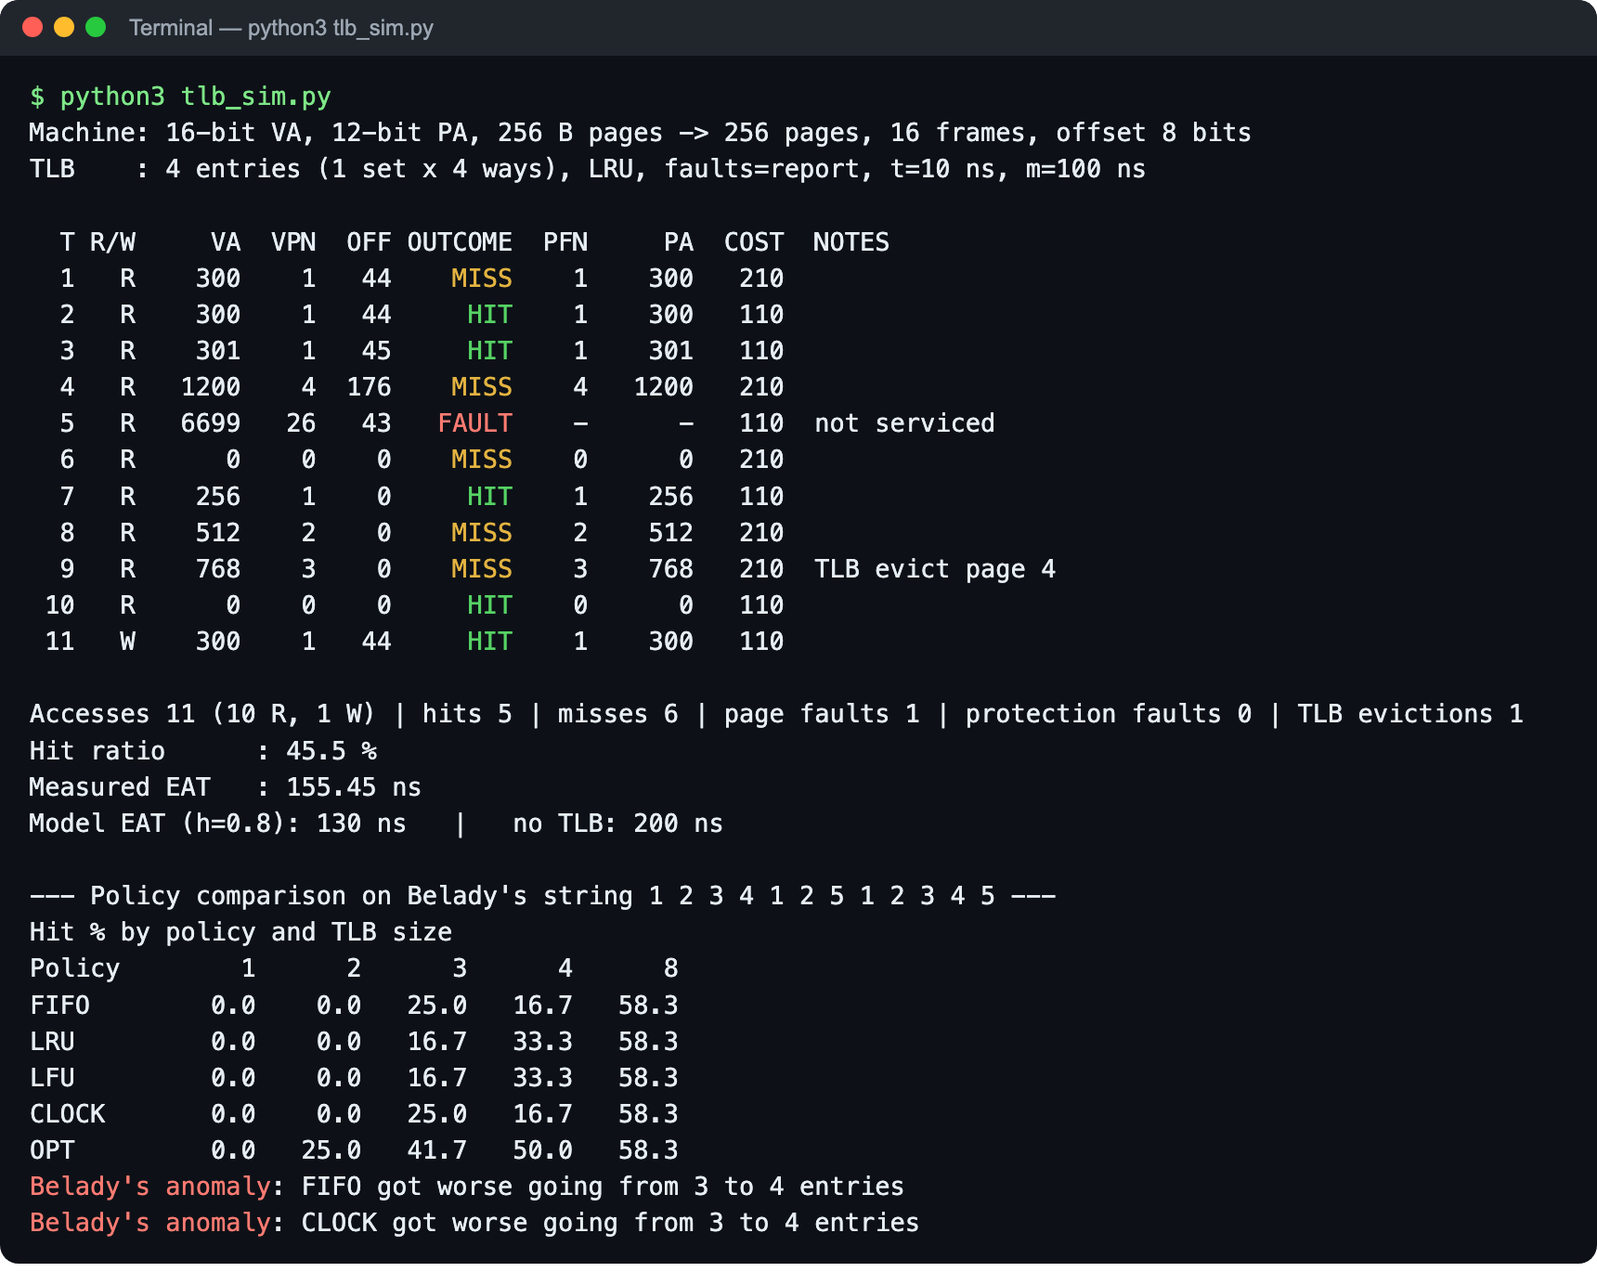
Figure 6: Output of the Python simulator

6.2 Web application
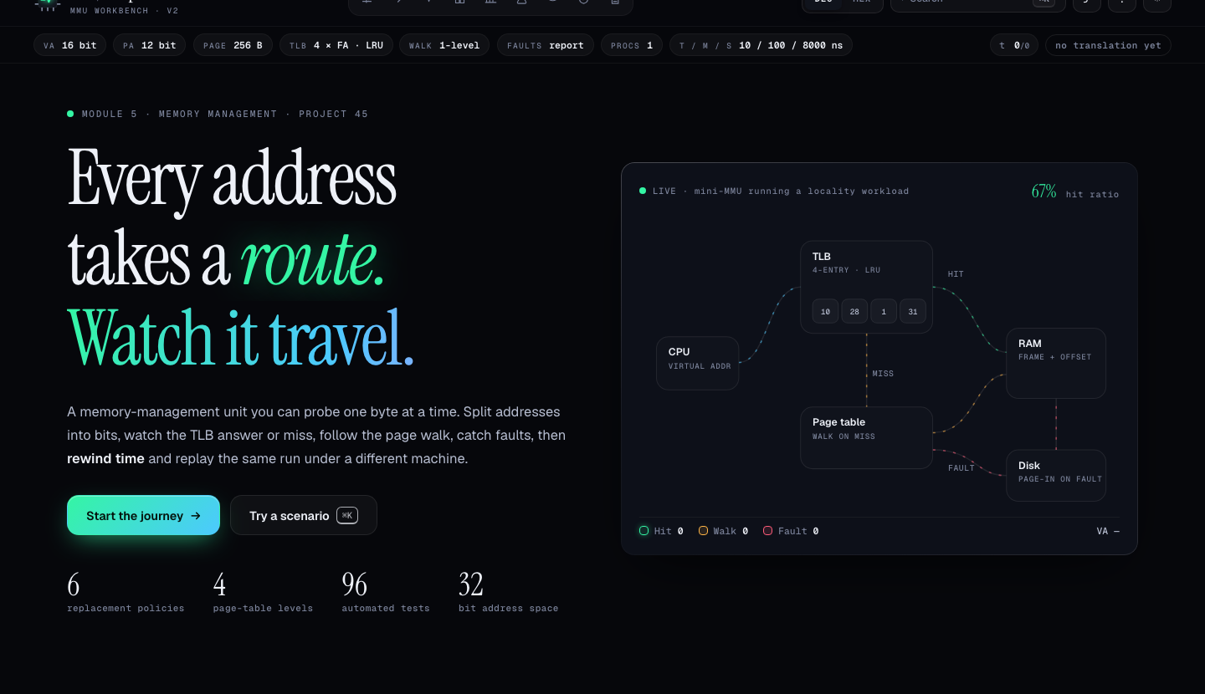
Figure 7: Home page with the live mini-MMU
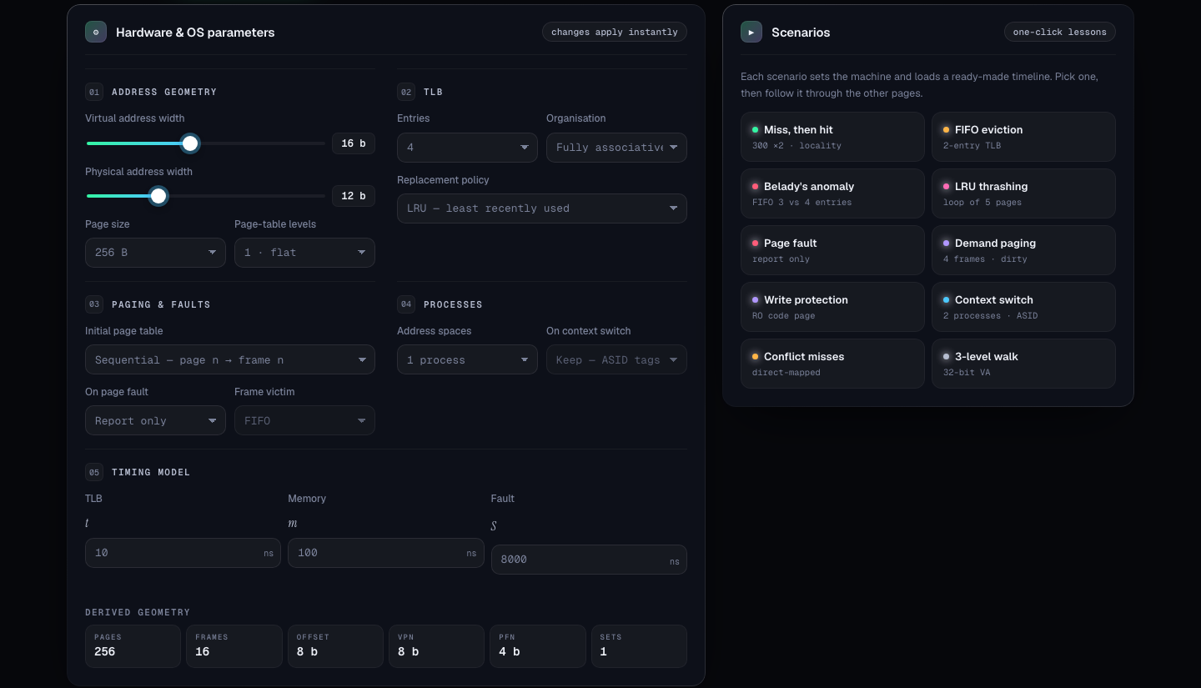
Figure 8: Machine page: configuration, derived geometry and scenarios
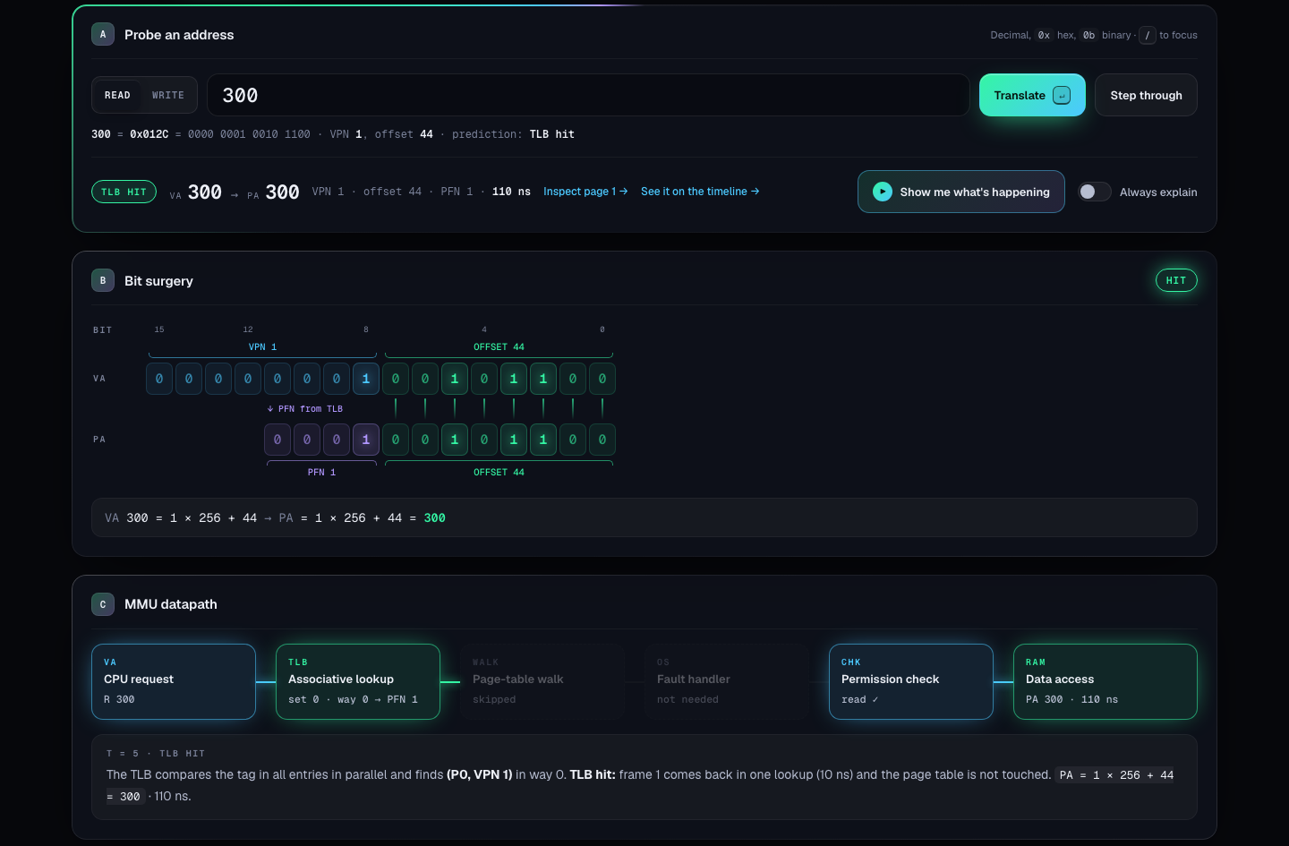
Figure 9: Translate page: VA 300 is a TLB hit, PA 300 in 110 ns, with the bit-level view and datapath
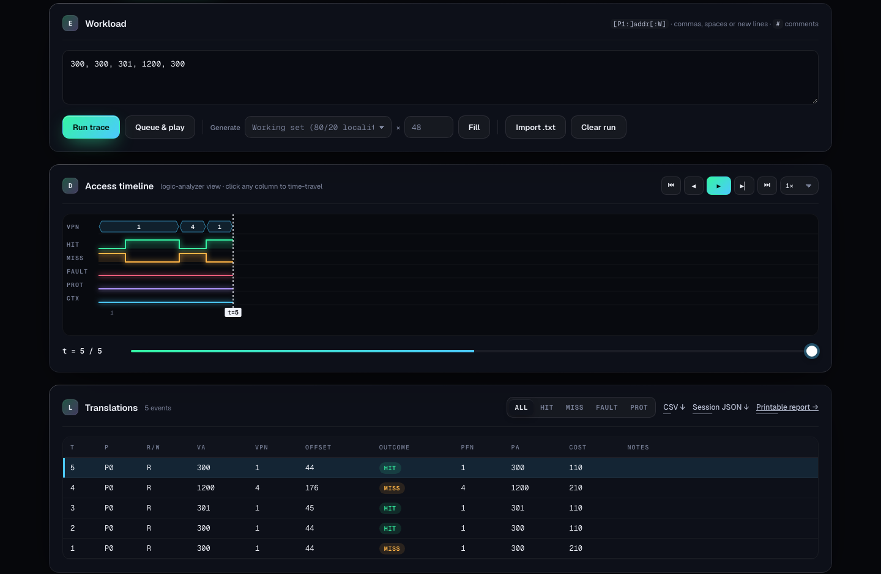
Figure 10: Timeline page: trace, logic-analyzer lanes and event table
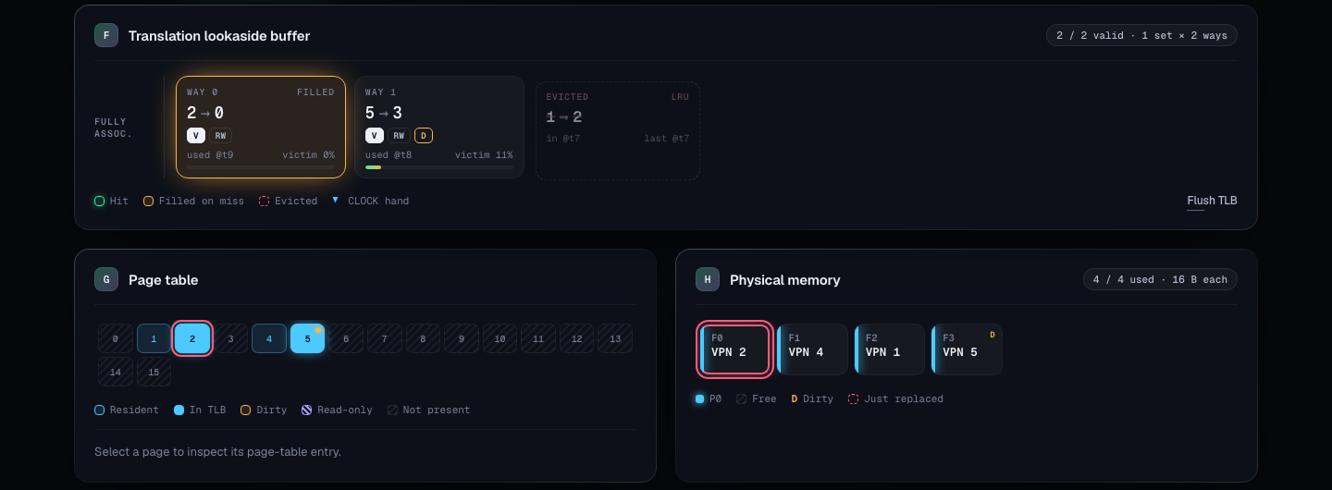
Figure 11: Structures page: TLB ways, page-table map and physical frames
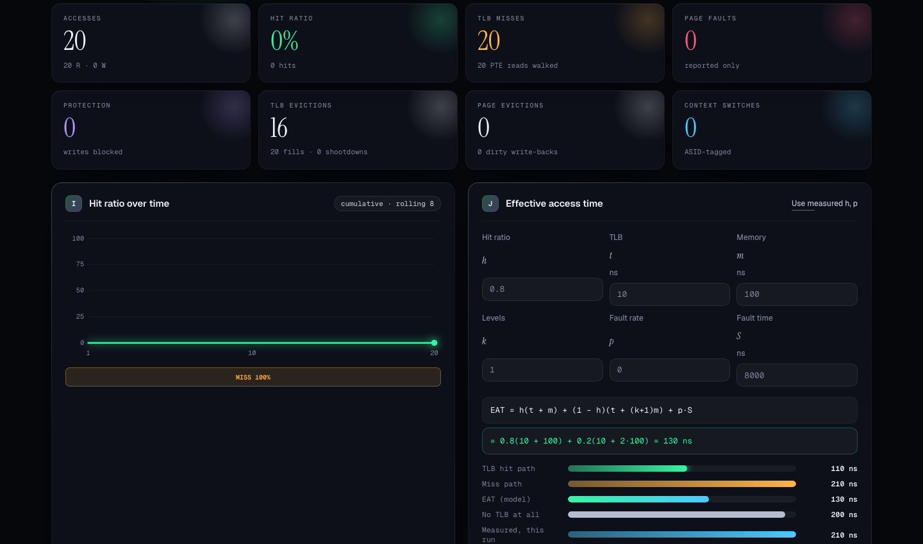
Figure 12: Analytics page (LRU-thrashing scenario): 0 % hit ratio, and the EAT calculator: 130 ns with a TLB versus 200 ns without
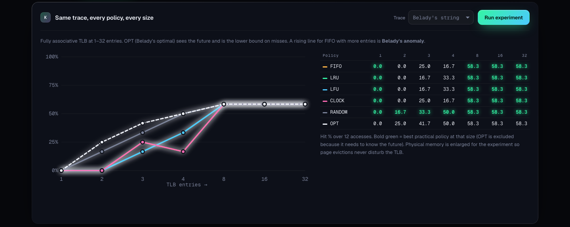
Figure 13: Policy lab: hit ratio of six policies at seven TLB sizes on Belady's string

6.3 Results
Table 6: Results of the sample trace (default machine)
T | VA | VPN | Offset | Outcome | PA | Cost (ns) | Note
1 | 300 | 1 | 44 | MISS | 300 | 210
2 | 300 | 1 | 44 | HIT | 300 | 110
3 | 301 | 1 | 45 | HIT | 301 | 110
4 | 1200 | 4 | 176 | MISS | 1200 | 210
5 | 6699 | 26 | 43 | FAULT | — | 110 | not serviced
6 | 0 | 0 | 0 | MISS | 0 | 210
7 | 256 | 1 | 0 | HIT | 256 | 110
8 | 512 | 2 | 0 | MISS | 512 | 210
9 | 768 | 3 | 0 | MISS | 768 | 210 | TLB evicts page 4 (LRU)
10 | 0 | 0 | 0 | HIT | 0 | 110
11 | 300 (W) | 1 | 44 | HIT | 300 | 110 | write: page 1 dirty

Table 7: Summary of the sample run
Measure | Value
Accesses | 11 (10 reads, 1 write)
TLB hits / misses / page faults | 5 / 6 / 1
Hit ratio | 45.5 %
TLB evictions | 1 (page 4, chosen by LRU)
Measured average access time | (5 × 110 + 5 × 210 + 110) / 11 = 155.45 ns
Model EAT at h = 0.8 | 130 ns
Access time without a TLB | 200 ns

Table 8: Hit ratio (%) on Belady's string 1 2 3 4 1 2 5 1 2 3 4 5
Policy | 1 entry | 2 | 3 | 4 | 8
FIFO | 0.0 | 0.0 | 25.0 | 16.7 | 58.3
LRU | 0.0 | 0.0 | 16.7 | 33.3 | 58.3
LFU | 0.0 | 0.0 | 16.7 | 33.3 | 58.3
CLOCK | 0.0 | 0.0 | 25.0 | 16.7 | 58.3
OPT | 0.0 | 25.0 | 41.7 | 50.0 | 58.3

6.4 Discussion of results
- Locality pays off. Repeated use of the same page (accesses 1 to 3) turns a 210 ns miss into 110 ns hits.
- The TLB cuts the access time. Even at the low hit ratio of this short trace (45.5 %), the average is 155.45 ns instead of 200 ns; at h = 0.8 the model gives 130 ns.
- LRU chooses the right victim. At T = 9 the TLB held pages 1, 4, 0 and 2; page 4 had not been used since T = 4, so LRU evicted it.
- Belady's anomaly. With FIFO (and CLOCK) the hit ratio fell from 25.0 % to 16.7 % when the TLB grew from 3 to 4 entries (9 misses became 10). LRU and OPT never got worse with more entries, and OPT was always the best.

7. Testing and Validation

7.1 Method
- Unit tests with known answers. Expected values were derived by hand or taken from textbook examples (such as Belady's 9 versus 10 misses and the EAT of 130 ns), not copied from the program's own output.
- Two independent implementations. The Python and JavaScript versions were run on the same inputs and their outputs compared.
- Invariant checking. After every access the JavaScript engine checks that hits + misses = accesses, that the TLB never exceeds its size or holds duplicates, and that every TLB entry agrees with a present page-table entry.
- Mutation testing. Bugs were planted on purpose (for example FIFO using the LRU key, or CLOCK ignoring reference bits) to confirm that the tests catch them.
- Input validation. Out-of-range and malformed addresses were entered to check that they are rejected with a clear message and without changing the state.

7.2 Python unit tests
All 16 Python tests pass (Figure 14).
Table 9: Python unit tests
# | Test | Expected result | Result
1 | Split VA 300 | VPN 1, offset 44, PFN 1, PA 300 | Pass
2 | VA 300 twice | MISS then HIT; costs 210 and 110 ns | Pass
3 | VA 4095 and 4096 | PA 4095; then FAULT with no PA | Pass
4 | 300, 0x12C, 0b100101100, 0o454, 0x1_2C | All equal 300 | Pass
5 | VA 65536 (out of range) | Rejected; state unchanged | Pass
6 | FIFO, 3 entries, pages 1 2 3 1 4 1 | M M M H M M | Pass
7 | LRU, 3 entries, pages 1 2 3 1 4 1 | M M M H M H | Pass
8 | Belady's string, FIFO 3 and 4 entries | 9 and 10 misses | Pass
9 | Belady's string, LRU and OPT | LRU 10 / 8, OPT 7 / 6 misses | Pass
10 | CLOCK on 1 2 3 4 2 5 | Evicts page 3 (second chance for 2) | Pass
11 | compare() on Belady's string | Anomaly reported for FIFO 3 → 4 | Pass
12 | Direct-mapped TLB, pages 0 4 0 4 1 1 | Conflict misses: M M M M M H | Pass
13 | Demand paging, 2 frames, pages 0(W) 1 2 | 3 faults, 1 eviction, 1 write-back | Pass
14 | Write to read-only page | PROT, no PA, page stays clean | Pass
15 | EAT(h = 0.8, t = 10, m = 100) | 130 ns | Pass
16 | Sample trace (11 accesses) | Hit ratio 5/11, average 1710/11 ns | Pass

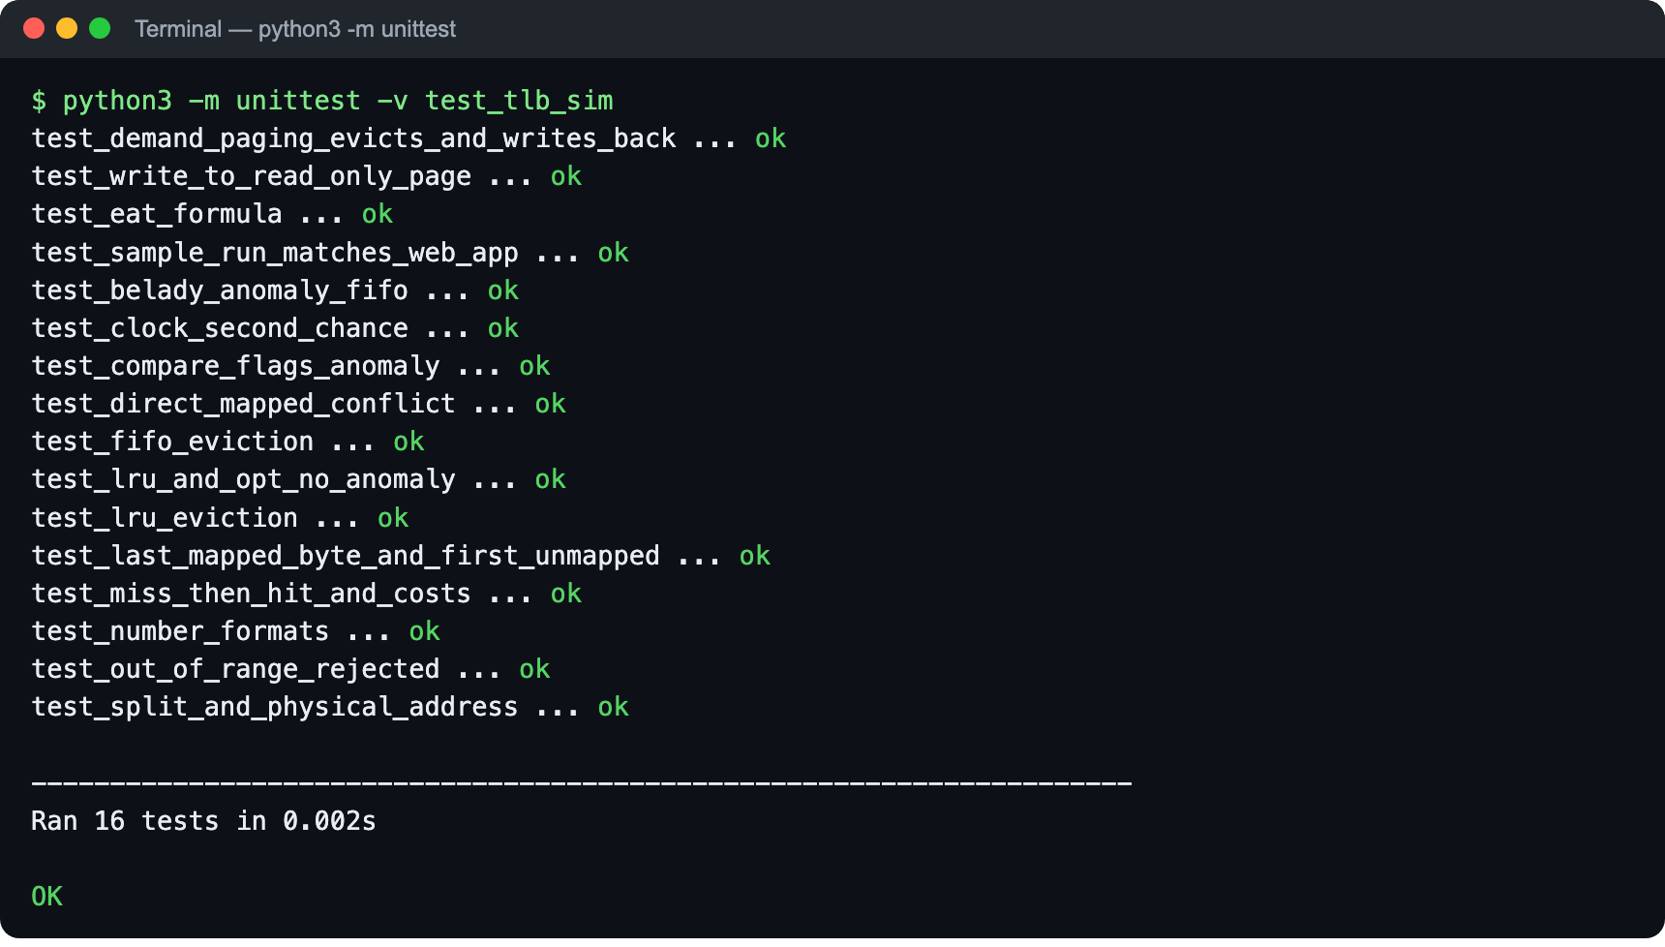
Figure 14: Python unit tests: 16 of 16 pass

7.3 JavaScript engine tests
The web engine has 96 automated tests (38 of them edge cases), run with npm test and on the Self-test page. All 96 pass (Figures 15 and 16).
Table 10: JavaScript engine tests by group
Group | Passed
Configuration and geometry | 20 / 20
Address and trace parsing | 11 / 11
Translation arithmetic | 12 / 12
TLB replacement policies | 19 / 19
Page faults and demand paging | 10 / 10
Protection and dirty bits | 5 / 5
Processes, ASIDs and context switches | 5 / 5
Statistics and effective access time | 8 / 8
Workload generators and utilities | 6 / 6
Total | 96 / 96

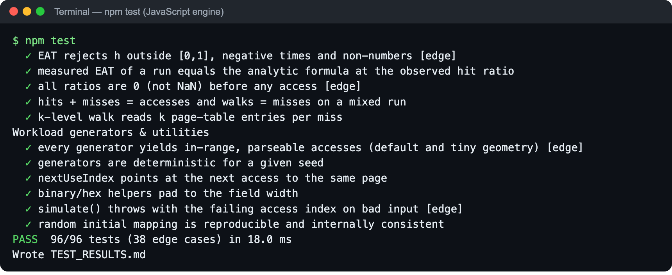
Figure 15: JavaScript engine tests: 96 of 96 pass
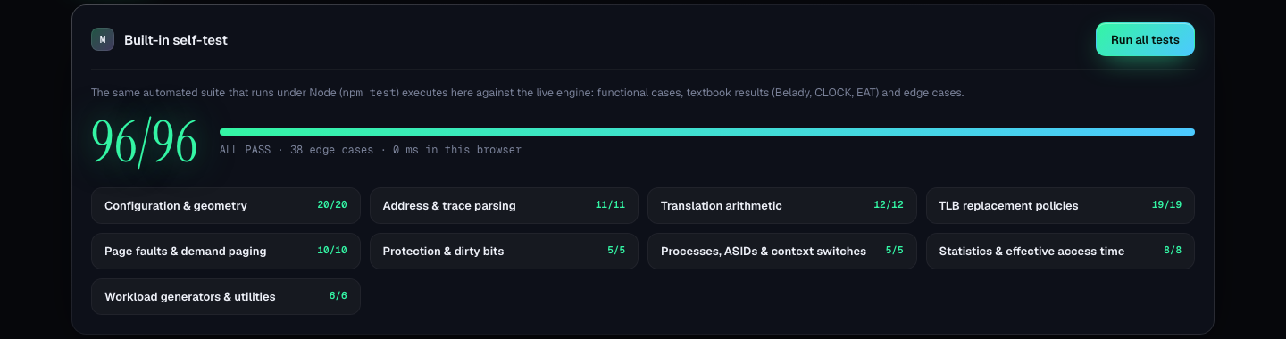
Figure 16: Self-test page in the browser

7.4 Cross-validation and input validation
Table 11: Python versus web application on the same input
Check | Python | Web app | Match
Outcomes of the 11-access sample trace | MHHMFMHMMHH | MHHMFMHMMHH | Yes
Hit ratio | 45.5 % | 45.5 % | Yes
Measured average access time | 155.45 ns | 155.45 ns | Yes
TLB eviction at T = 9 | page 4 | page 4 | Yes
FIFO hit % at 3 / 4 entries | 25.0 / 16.7 | 25.0 / 16.7 | Yes
OPT hit % at 3 / 4 entries | 41.7 / 50.0 | 41.7 / 50.0 | Yes

Table 12: Invalid input handling
Input | Response | State changed?
Address 66990 (16-bit machine) | "address 66990 is outside the 16-bit virtual space (0–65,535)" | No
Address 65536 (Python) | ValueError: outside the 16-bit virtual space | No
Write to a read-only page | Protection fault; no physical address | Only the fault is counted

8. Conclusion and Future Enhancements

8.1 Conclusion
The project met its objectives. The simulator translates any virtual address step by step, models the TLB with six replacement policies and three organisations, walks page tables of up to four levels, handles page faults and protection, and measures the hit ratio and effective access time. It was implemented in Python as a command-line program and in JavaScript as an interactive ten-page web application, and both give identical results.
The results show the value of the TLB clearly: a repeated access costs 110 ns instead of 210 ns, and at an 80 % hit ratio the average access time falls from 200 ns to 130 ns. The policy comparison reproduces Belady's anomaly for FIFO and confirms that LRU and OPT never get worse with a larger TLB. Correctness is supported by 16 Python tests and 96 JavaScript tests, all passing. By making an invisible hardware process visible and measurable, the project makes a hard Operating Systems topic easier to learn and to teach.

8.2 Future enhancements
- Huge pages (2 MiB and 1 GiB) with a separate large-page TLB.
- Two-level TLB hierarchy (L1 instruction and data TLBs with a shared L2 TLB).
- Page-walk caches and a more detailed timing model of the hardware walker.
- Multi-core simulation with TLB shootdowns by inter-processor interrupts.
- Inverted and hashed page tables, and working-set frame allocation.
- Real address traces captured from programs (for example with Valgrind) and replayed.
- Nested paging for virtual machines.
- Quiz mode with automatic grading for laboratory use.

9. References
[1] A. Silberschatz, P. B. Galvin and G. Gagne, Operating System Concepts, 10th ed. Wiley, 2018.
[2] R. H. Arpaci-Dusseau and A. C. Arpaci-Dusseau, Operating Systems: Three Easy Pieces. Arpaci-Dusseau Books, 2018. Available: https://pages.cs.wisc.edu/~remzi/OSTEP/
[3] A. S. Tanenbaum and H. Bos, Modern Operating Systems, 4th ed. Pearson, 2015.
[4] J. L. Hennessy and D. A. Patterson, Computer Architecture: A Quantitative Approach, 6th ed. Morgan Kaufmann, 2017.
[5] L. A. Belady, "A study of replacement algorithms for a virtual-storage computer," IBM Systems Journal, vol. 5, no. 2, pp. 78–101, 1966.
[6] A. Bhattacharjee and D. Lustig, Architectural and Operating System Support for Virtual Memory. Morgan & Claypool, 2017.
[7] Python Software Foundation, The Python Standard Library (dataclasses, unittest, argparse). Available: https://docs.python.org/3/library/
[8] Mozilla, MDN Web Docs (HTML, CSS and JavaScript). Available: https://developer.mozilla.org/
[9] Object Management Group, Unified Modeling Language (UML) Specification, version 2.5.1, 2017.

