CREATE TABLE matches_raw (
match_date DATE,
home_team TEXT,
away_team TEXT,
home_goals INTEGER,
away_goals INTEGER,
home_shots INTEGER,
away_shots INTEGER,
home_shots_on_target INTEGER,
away_shots_on_target INTEGER
);
create table team_match_stats as
select
mr.match_date as match_date,
mr.home_team as team,
mr.away_team as opponent,
'Home' as venue,
mr.home_goals as goals,
mr.home_shots as shots,
mr.home_shots_on_target as shots_on_target
from matches_raw mr

union all

select
mr.match_date as match_date,
mr.away_team as team,
mr.home_team as opponent,
'Away' as venue,
mr.away_goals as goals,
mr.away_shots as shots,
mr.away_shots_on_target as shots_on_target
from matches_raw mr
SELECT COUNT(*)
FROM team_match_stats;
Какие 10 команд забили больше всего голов за сезон?
select team, sum(goals) as goals_scored
from team_match_stats
group by team
order by goals_scored desc
limit 10
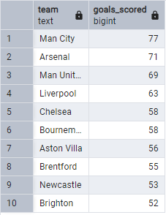
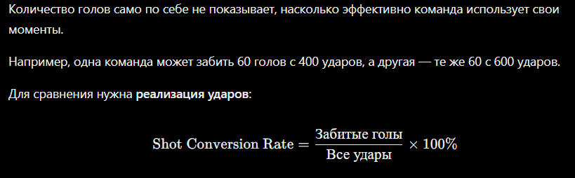
select team, sum(goals) as total_goals, sum(shots) as total_shots, ROUND((sum(goals)::numeric / sum(shots)) * 100,2) as conversion_rate
from team_match_stats
group by team
order by conversion_rate desc
limit 10
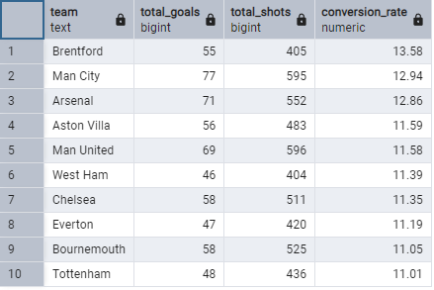

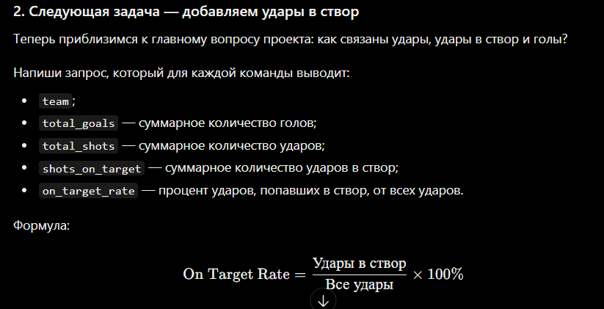
select team, sum(goals) as total_goals, sum(shots) as total_shots, sum(shots_on_target) as total_shots_on_target , ROUND(sum(shots_on_target)::numeric / sum(shots) * 100,3) as target_rate
from team_match_stats
group by team
order by target_rate desc
limit 10
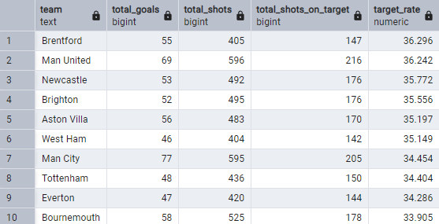

select
team,
sum(goals) as total_goals,
sum(shots) as total_shots,
sum(shots_on_target) as total_shots_on_target ,
ROUND(sum(shots_on_target)::numeric / sum(shots) * 100,2) as target_rate,
ROUND((sum(goals)::numeric / sum(shots)) * 100,2) as conversion_rate,
ROUND((sum(goals)::numeric / sum(shots_on_target)) * 100,2) as goals_per_shot_on_target
from team_match_stats
group by team
order by total_goals desc
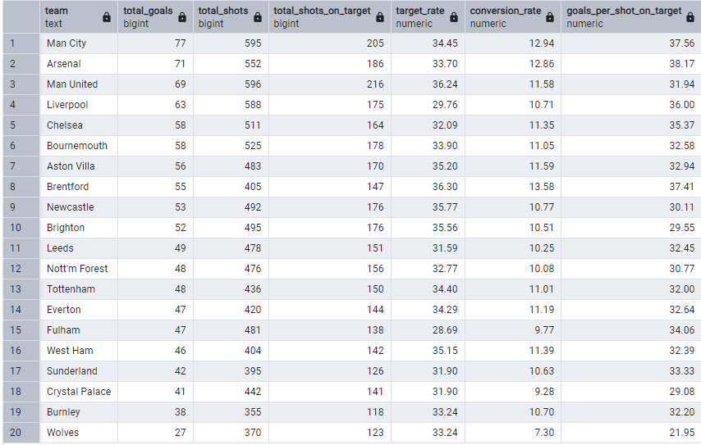

with shots_tabel as(
select
team,
sum(shots) as total_shots,
sum(shots_on_target) as total_target
from team_match_stats
group by team
)

select
team,
(total_shots - total_target) as miss_shots
from shots_tabel
order by miss_shots desc
limit 5
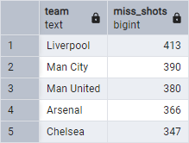
with shots_tabel as(
select
team,
sum(shots) as total_shots,
sum(shots_on_target) as total_target
from team_match_stats
group by team
)

select
team,
(total_shots - total_target) as miss_shots,
ROUND((total_shots - total_target)::numeric / total_shots * 100,2) as percent_miss
from shots_tabel
order by percent_miss desc
limit 5
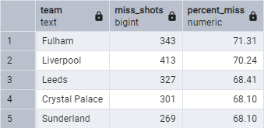
Почему команда с большим количеством ударов не в створ не обязательно хуже атакует, чем команда с меньшим количеством таких ударов?
Всё дело в том, что у команды с большим кол-во ударов НЕ в створ больше ударов в принципе, и может быть больше голов

