**LBJ Case Study-1**

**Submitted by**

**Lokesh S**

**2021Oct@00003**

**Case Study on Java/C#/Python – LBJ 2021**

1. **Develop a standalone console based Java/C#/Python application which will manage various Colleges across the state.**

* **Language Used**:Python 3
* **Editor Used**:Visual Studio Code

**APPROACH TAKEN :-**

1. First a Class is created with the given attributes.
2. Then a Csv file is created with the given initial data.
3. Using the csv library, the file is read and stored in a list
4. The User can Choose any operation given
5. Register Operation creates an new college object and appends the data to the csv file.
6. The Display Operation displays all Colleges in Mumbai teaching Engineering.
7. The Delete Operation searches for the College id and Deletes the college data from the csv file

**Source Code:** Main.py

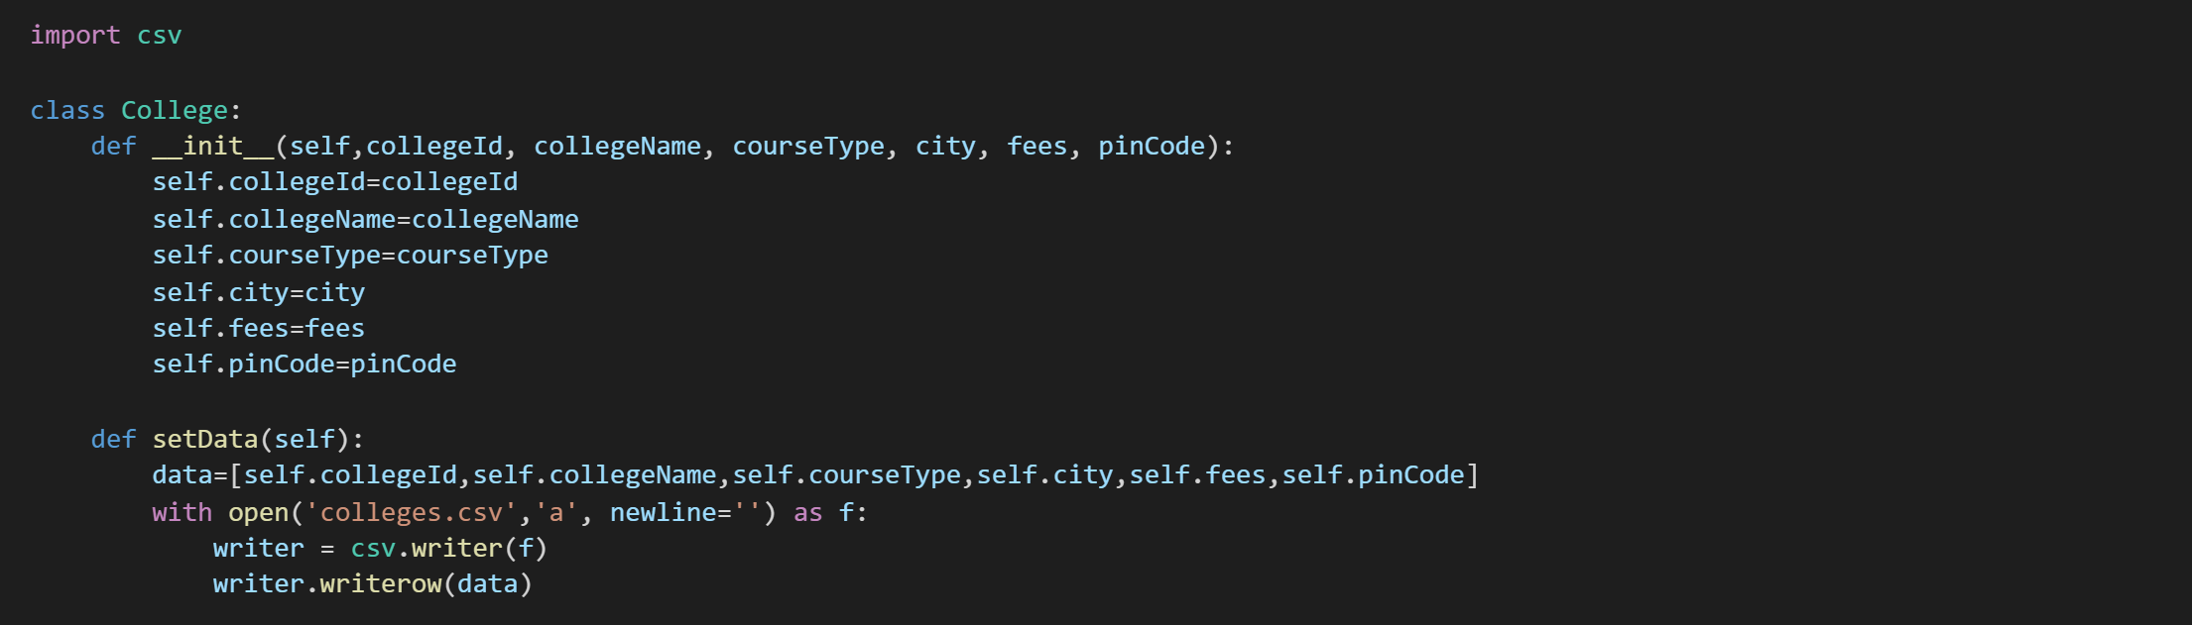

A class is created with the given attributes and the helper functions are also Created.

Main Loop

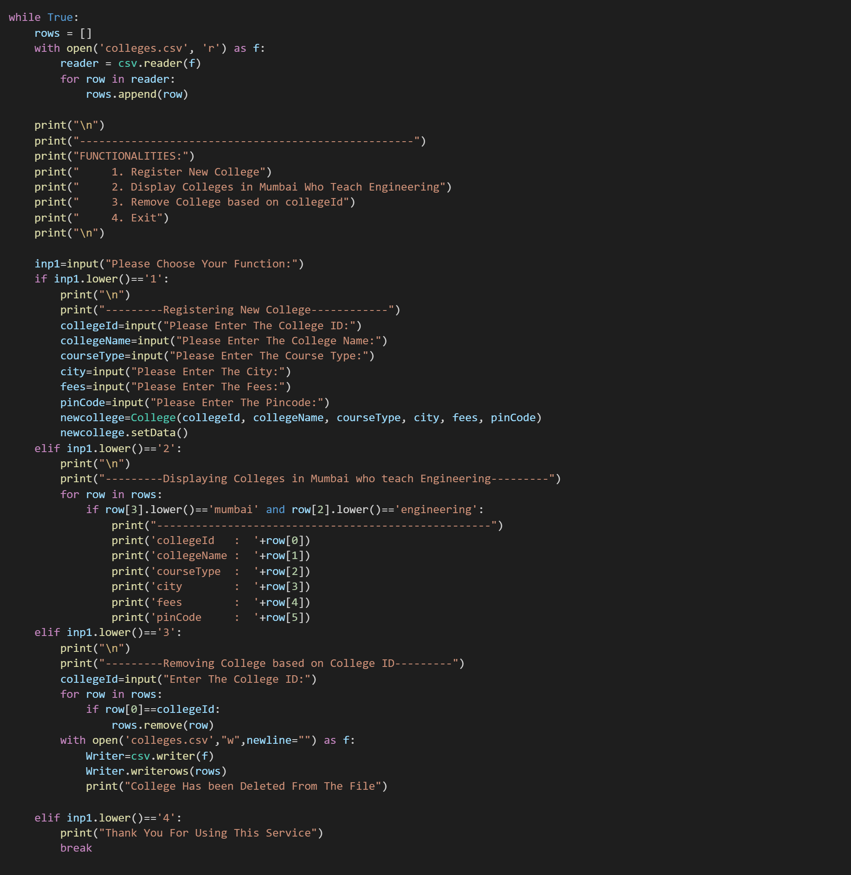

The User Can Choose given Operations in the console to perform the action .

**OUTPUT:**

**Console**

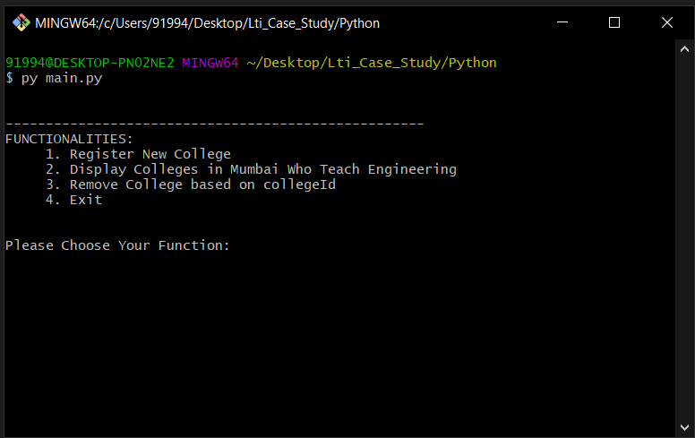

**1.a)Registration**

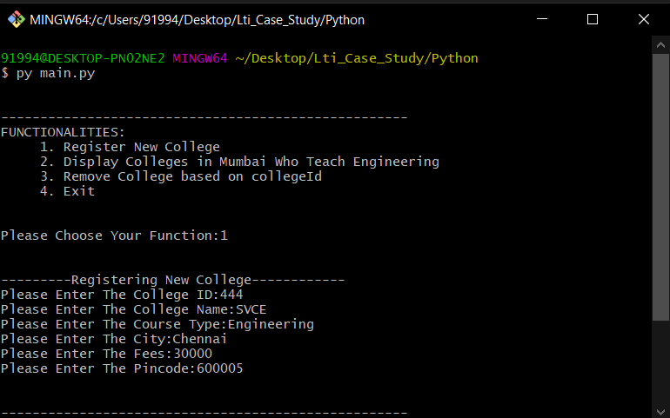

**1.b)Modified Csv file**

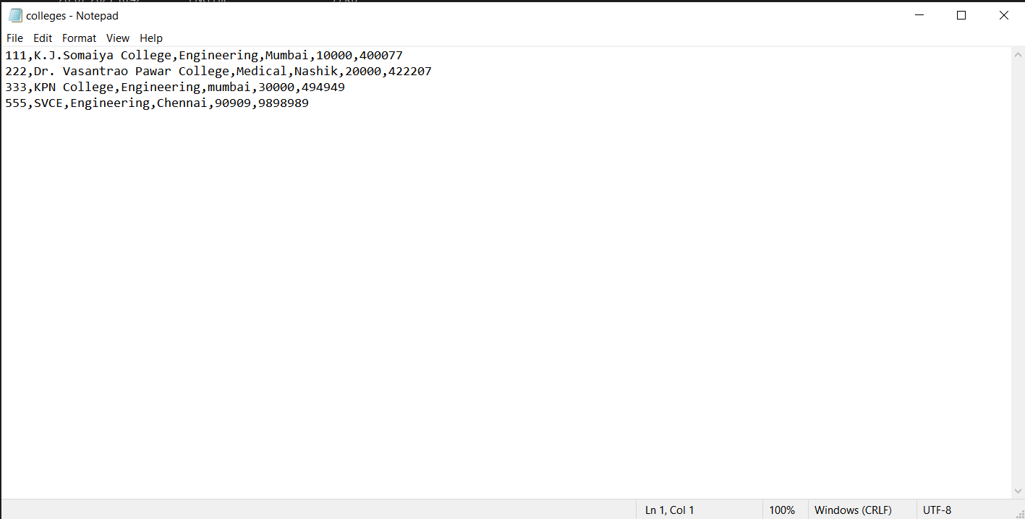

**2)Displaying Colleges**

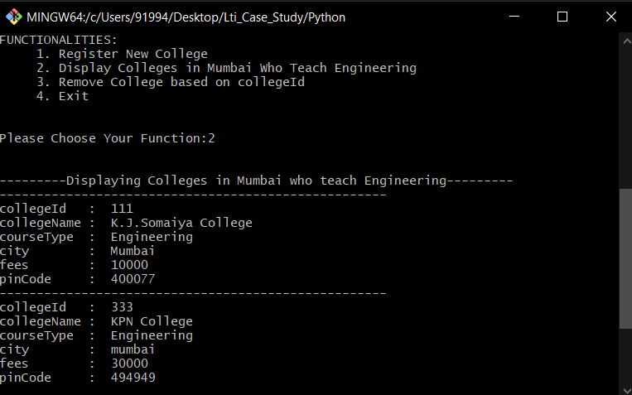

**3)Deleting Colleges**

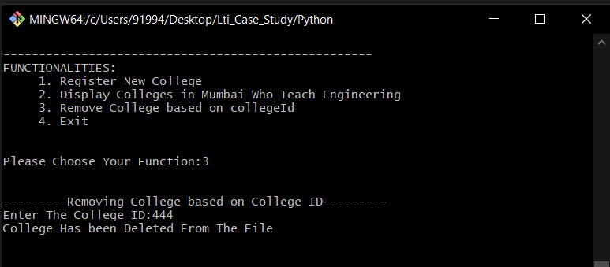

**4)Exit Loop**

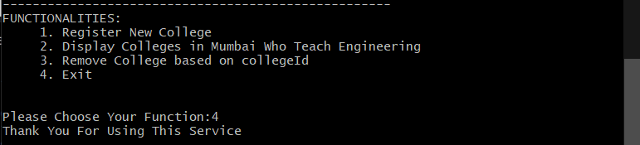

**Case Study on WEB – LBJ 2021**

* **Language Used**:HTML,CSS,JavaScript
* **Editor Used**:Visual Studio Code

**APPROACH TAKEN :-**

1. First the login page was created according to the image shown in the PDF using HTML and CSS.
2. Then Username and Password validation logic is written.
3. If the Username and Password is Valid ,The Username and Password is Encrypted and the Username is stored in session storage and the user is transferred to the welcome page.
4. The welcome page gets the username from the session storage and displays the greeting message with the Decrypted Username .
5. If the Username and Password is Not Valid ,An Error message is thrown.
6. If the remember me checkbox was selected, A cookie is created and the Encrypted Username and Password are stored in it for 1 day.
7. The login page checks for the cookie on load and if the cookie is present, It takes us to the welcome page
8. Since the storage is temporary the Session storage is used.

**Source Code:** Login Page(Index.html)

**HTML**

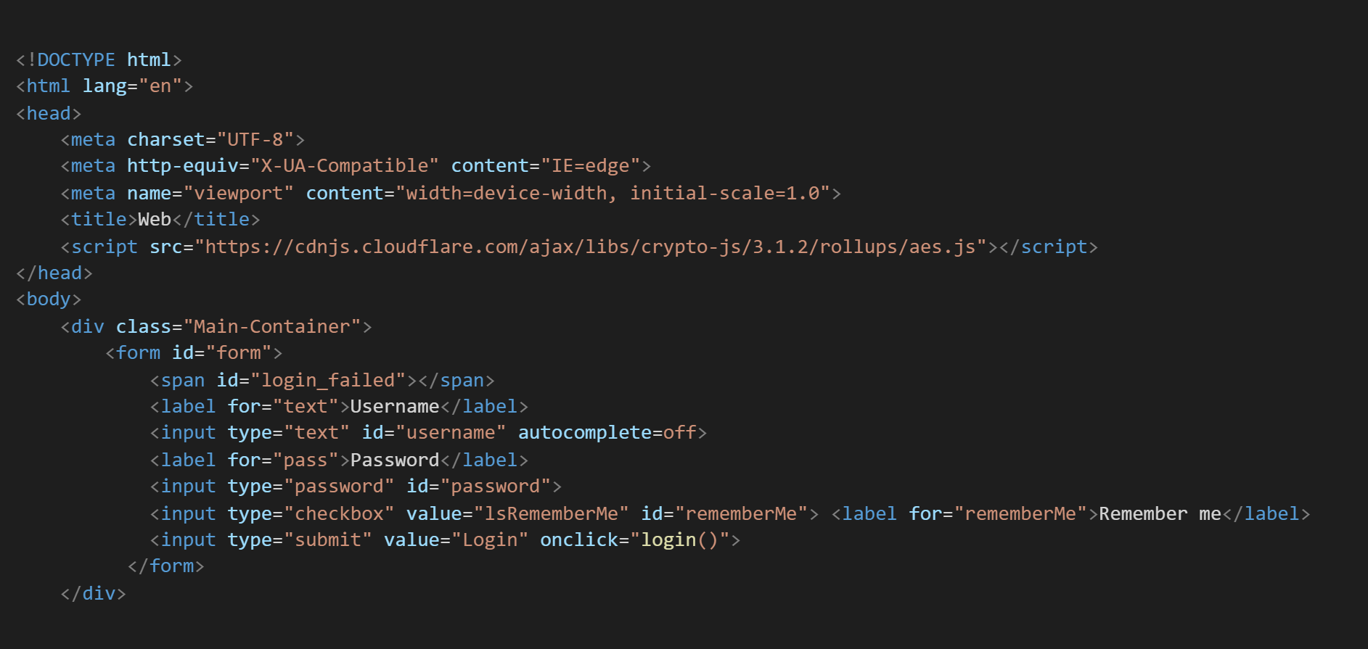

**CSS**

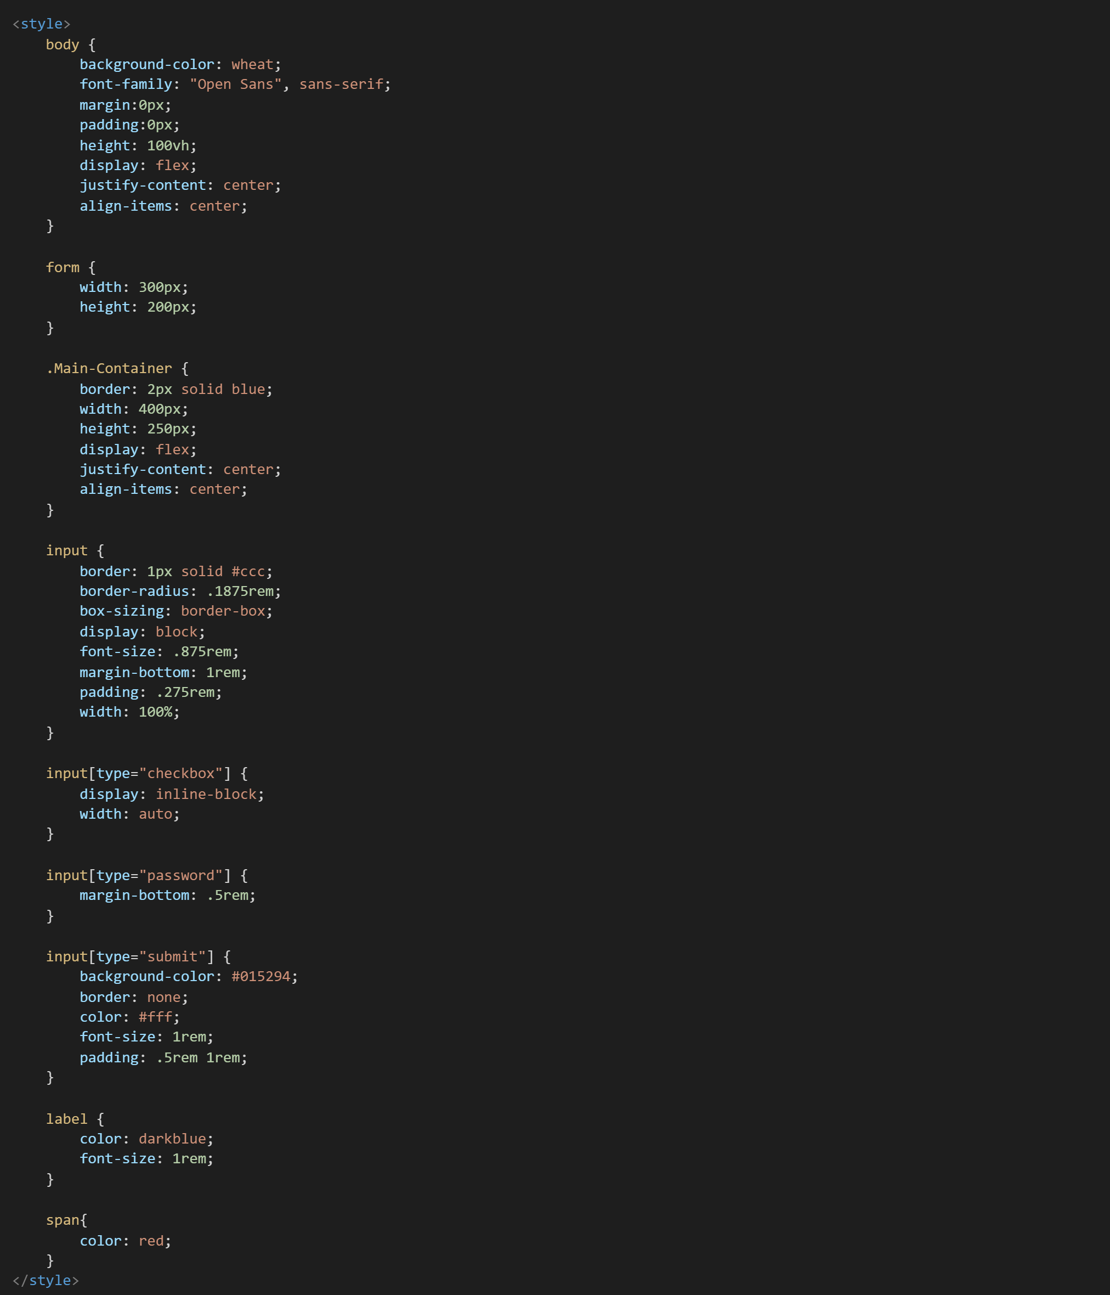

**JAVASCRIPT**

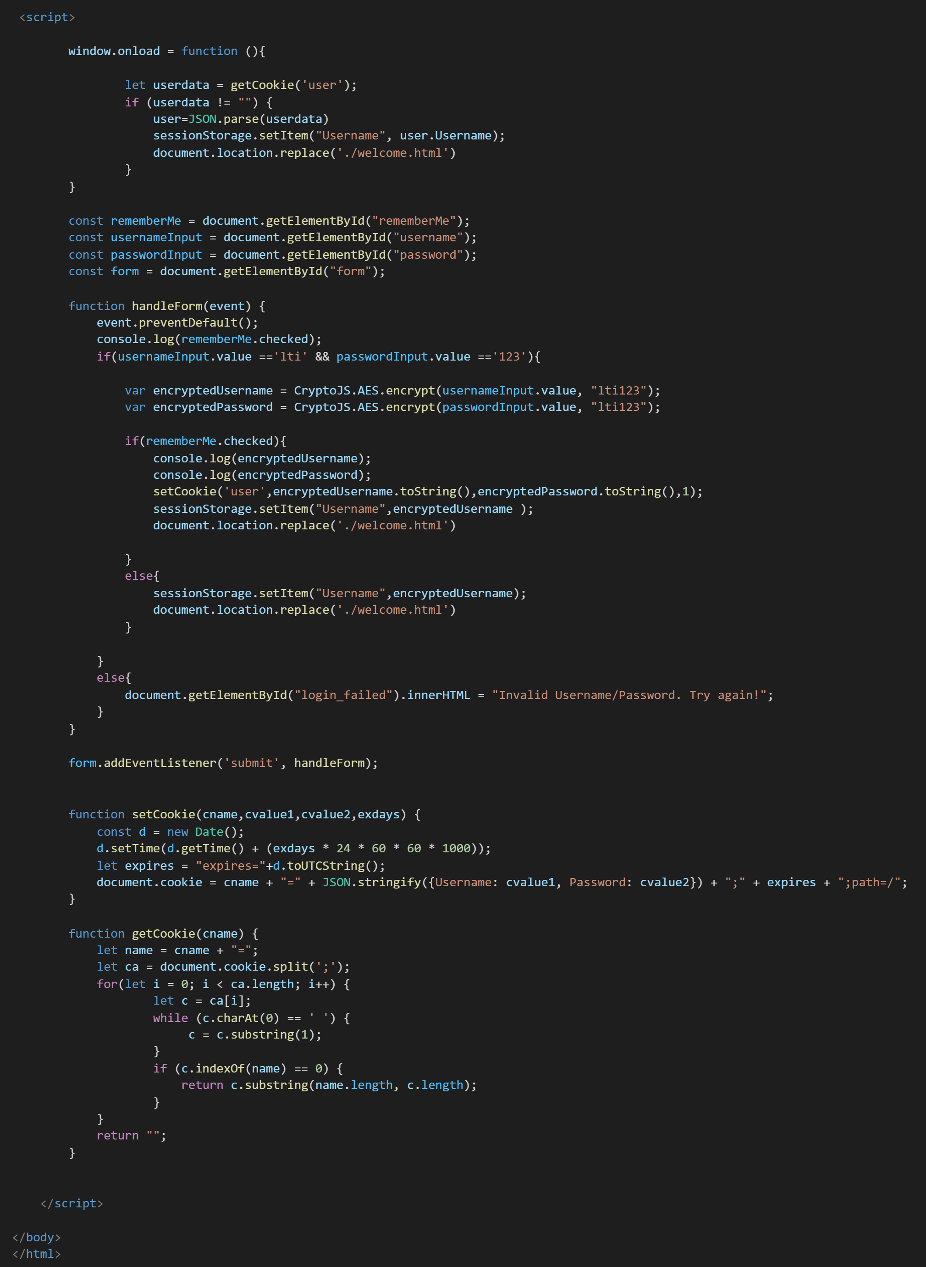

**Source Code:** Welcome Page(welcome.html)

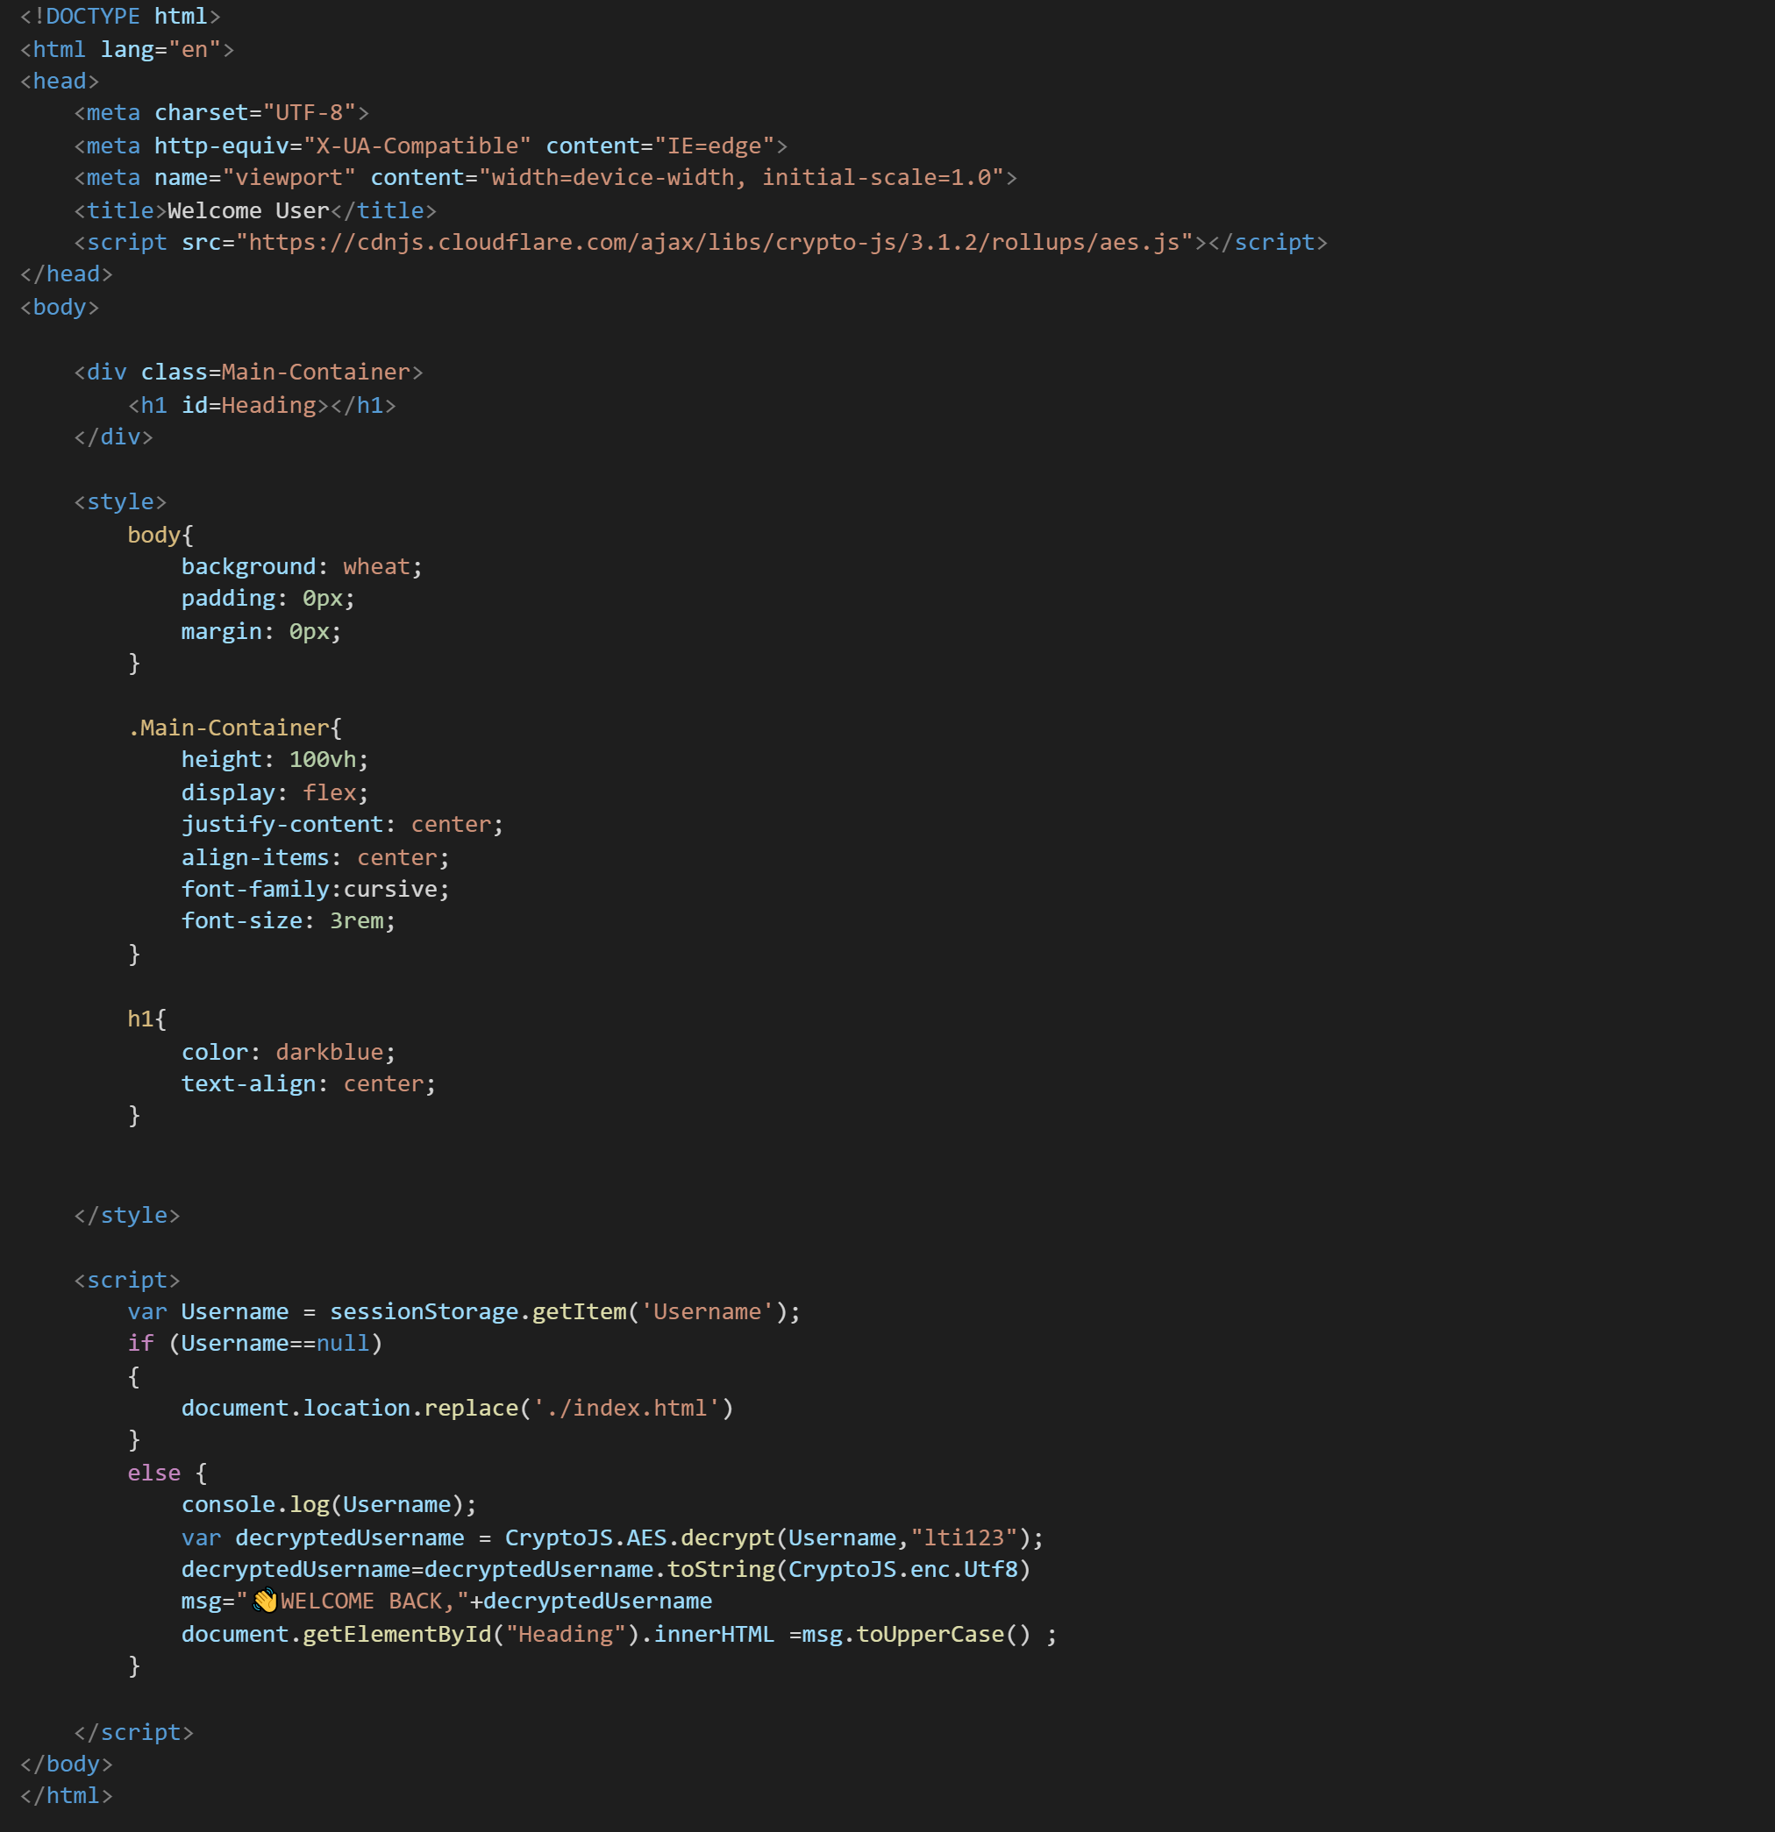

**OUTPUT:**

1. LOGIN PAGE

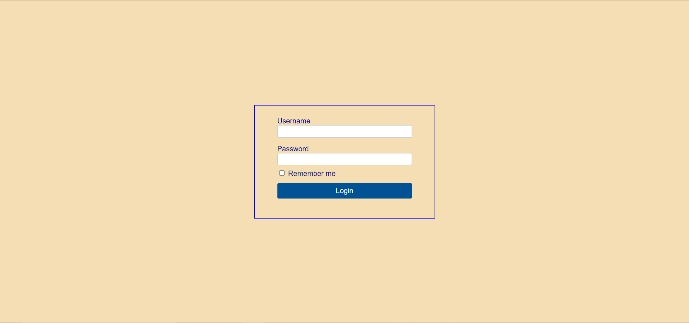

This is the Default Landing Page.

1. LOGIN PAGE WITH ERROR

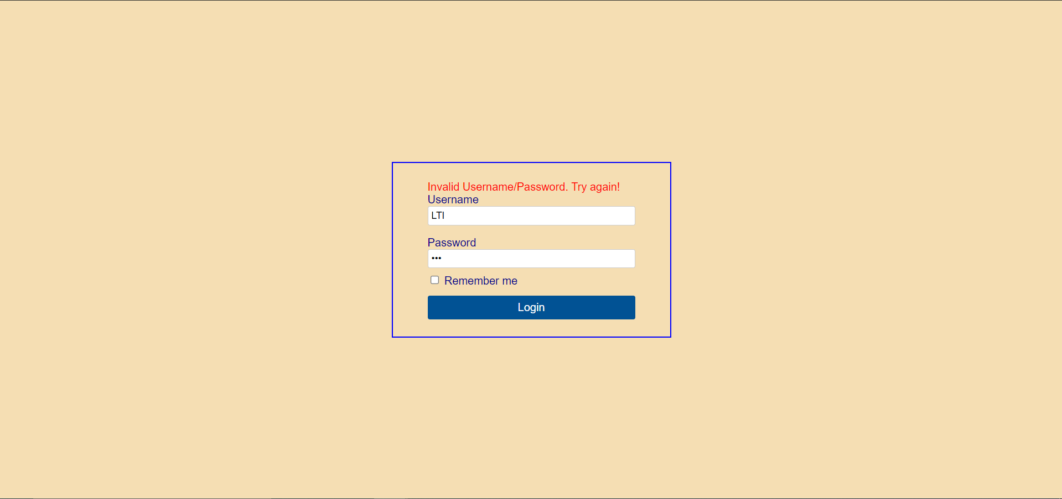

When The Username and Password are not Valid

1. WELCOME PAGE



When The Username and Password are Valid.

1. SESSION STORAGE

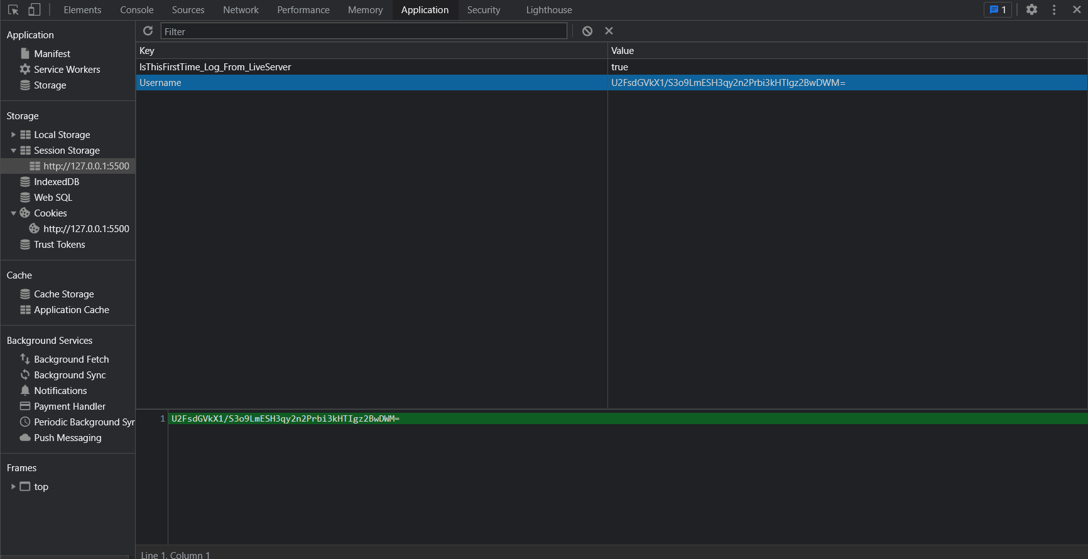

The Encrypted Username is Stored in the Session Storage.

1. COOKIES

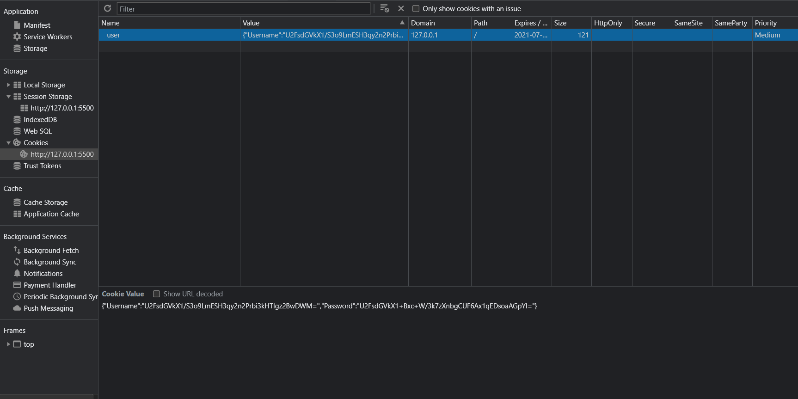

The Encrypted Username and Password is Stored in the cookies when remember me is Pressed .

The Source Code for Both Case Study LBJ 2021 Is Uploaded in the link given

Below: