**LBJ Case Study-2**

**Submitted by**

**Lokesh S**

**2021Oct@00003**

**Case Study on WEB – LBJ 2021**

* **Language Used**:HTML,CSS,PYTHON
* **Framework Used**:Flask(Back end)
* **Editor Used**:Visual Studio Code

**APPROACH TAKEN :-**

1. First

**Source Code:** Main Page(Index.html)

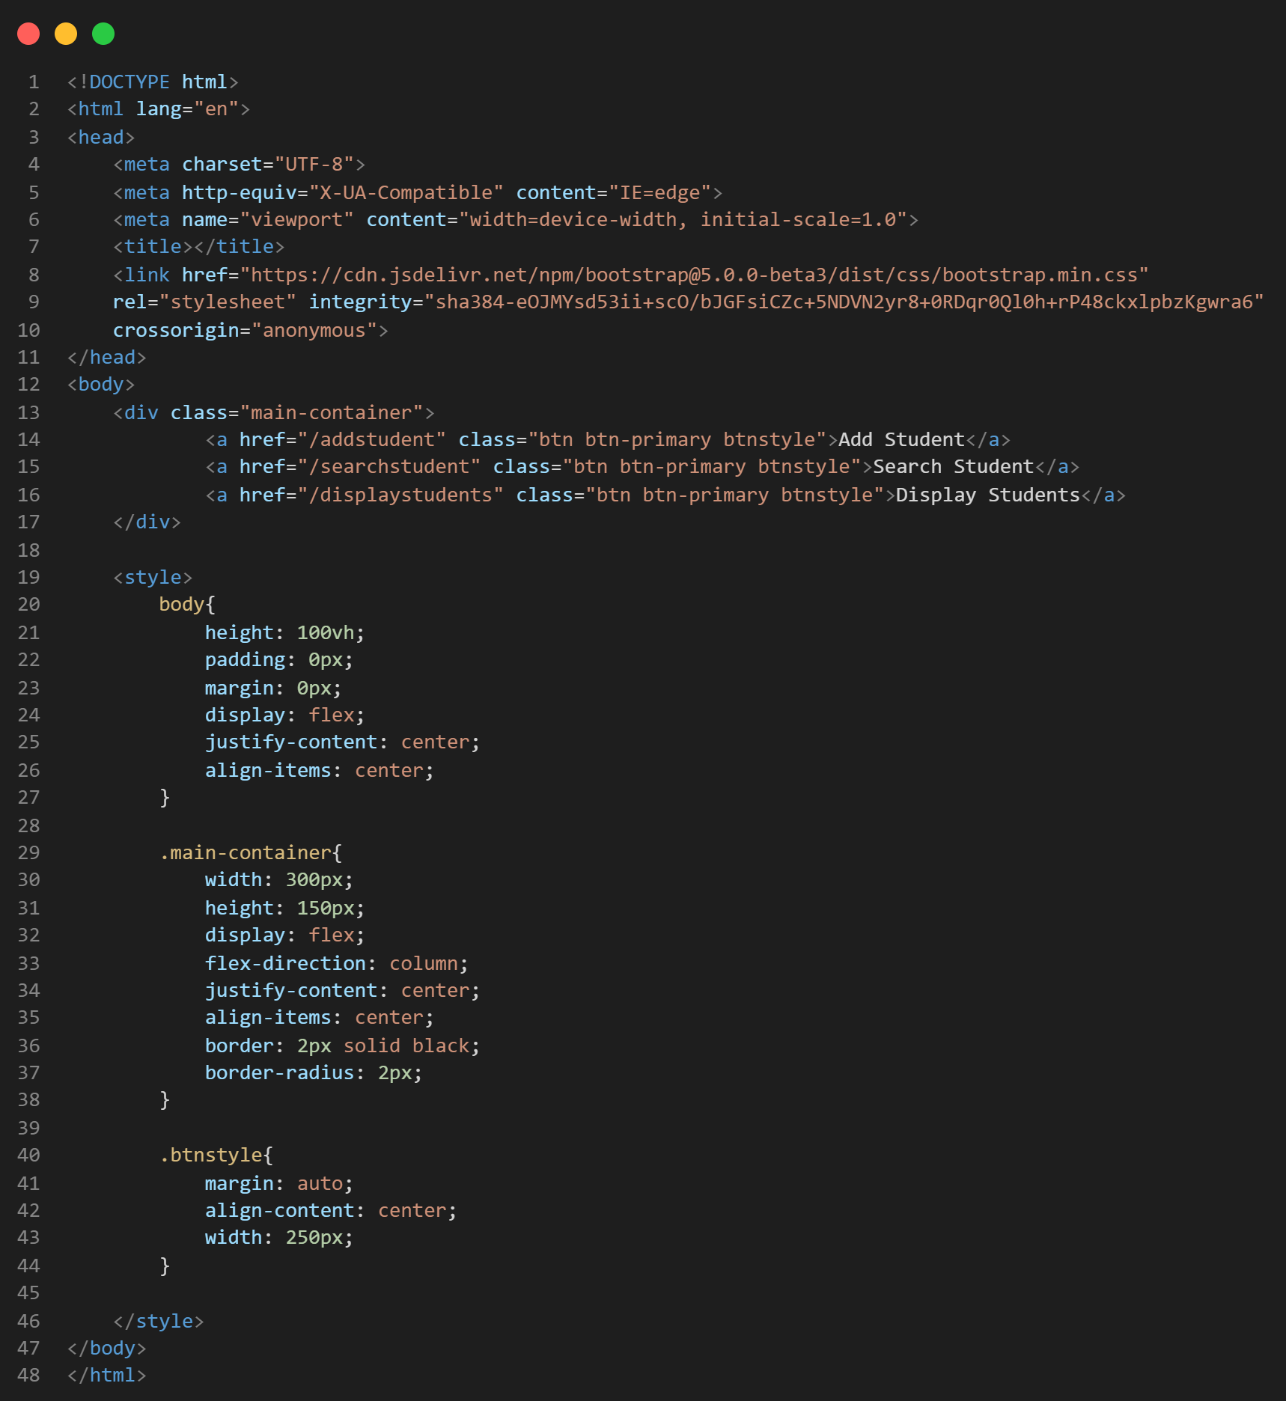

**Source Code:** Add-Student Page(add-student.html)

**HTML**

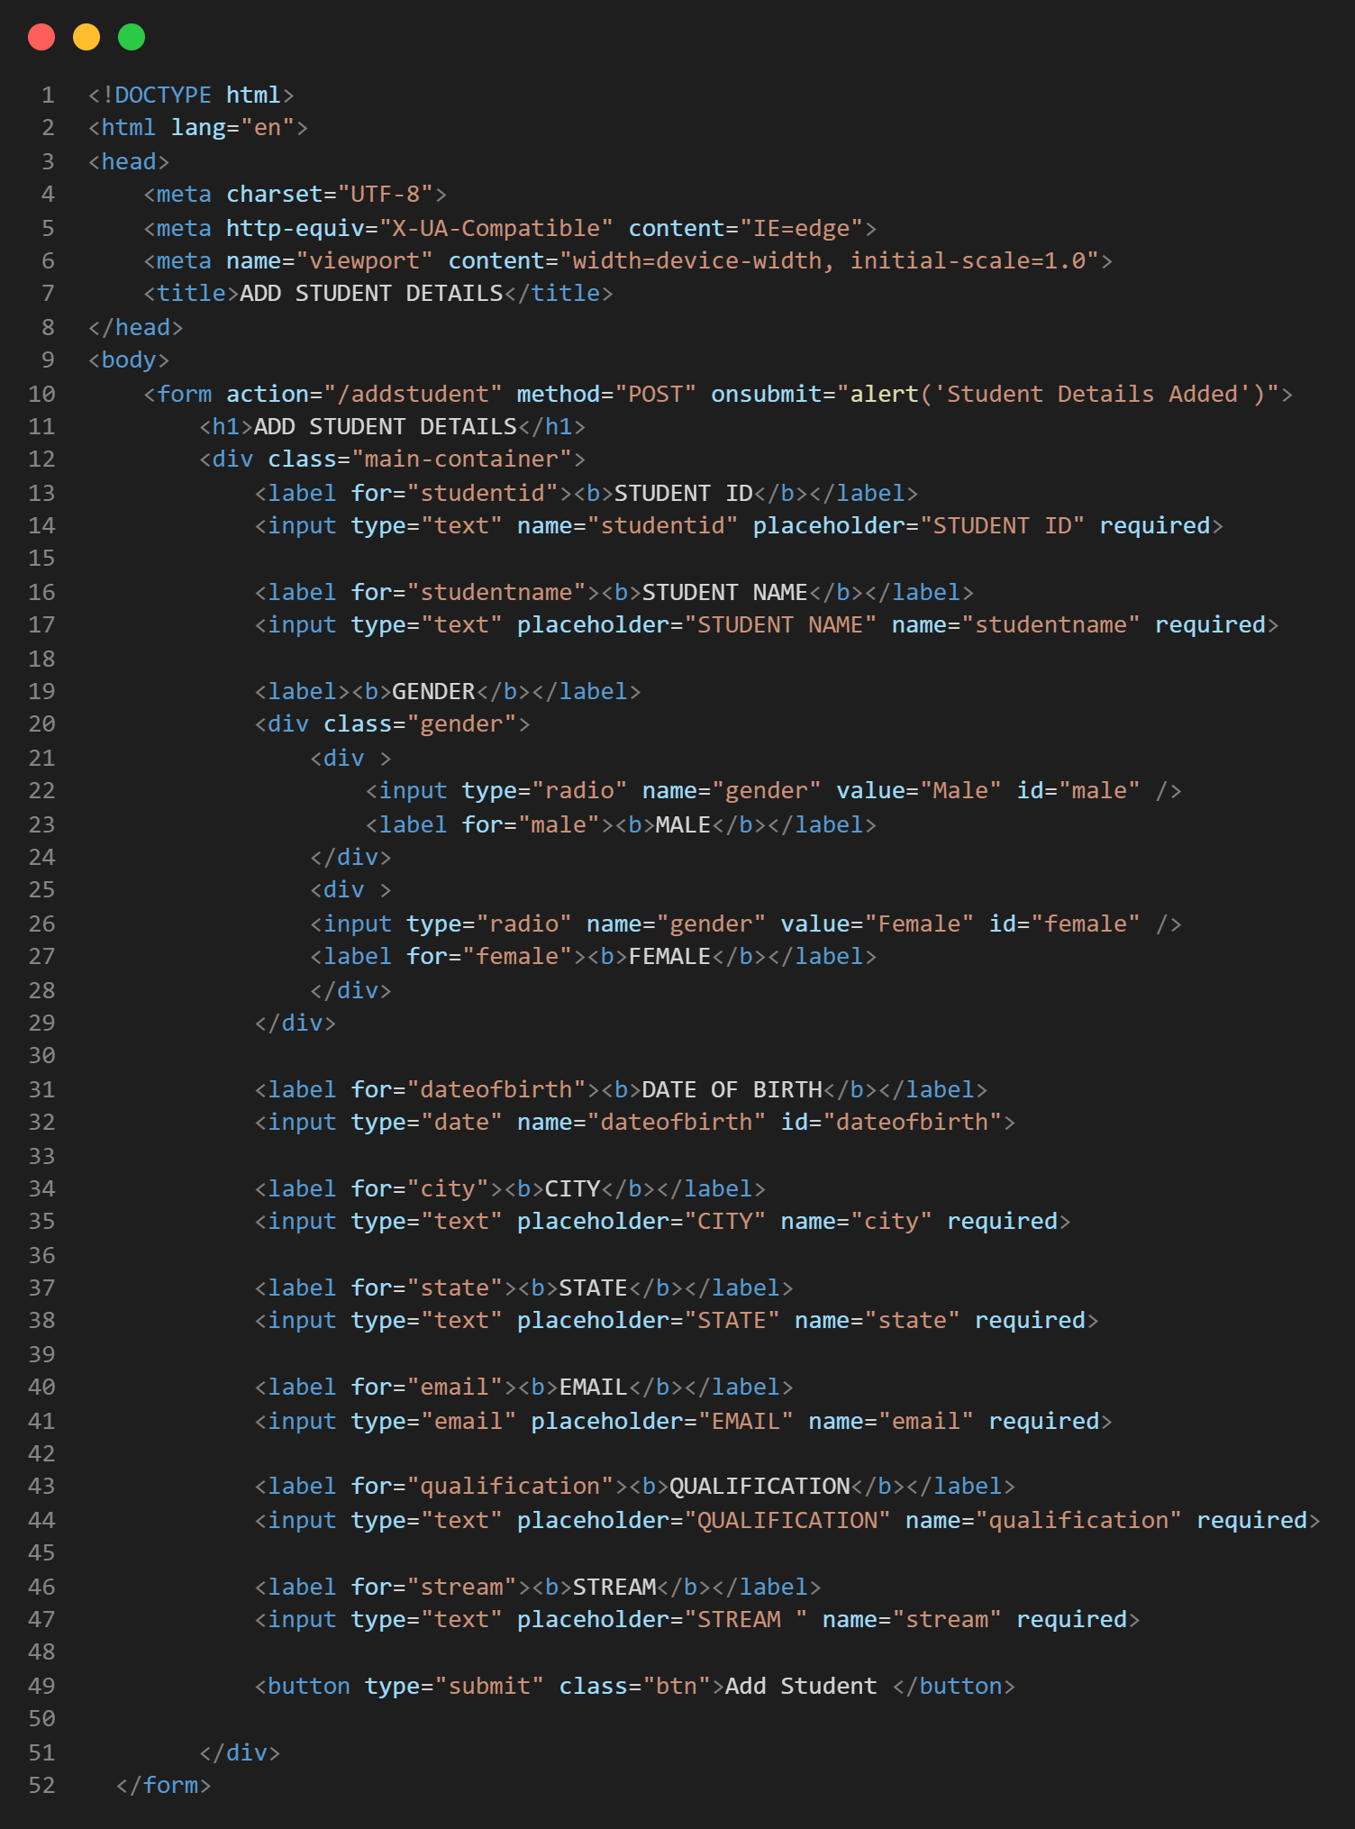

**CSS**

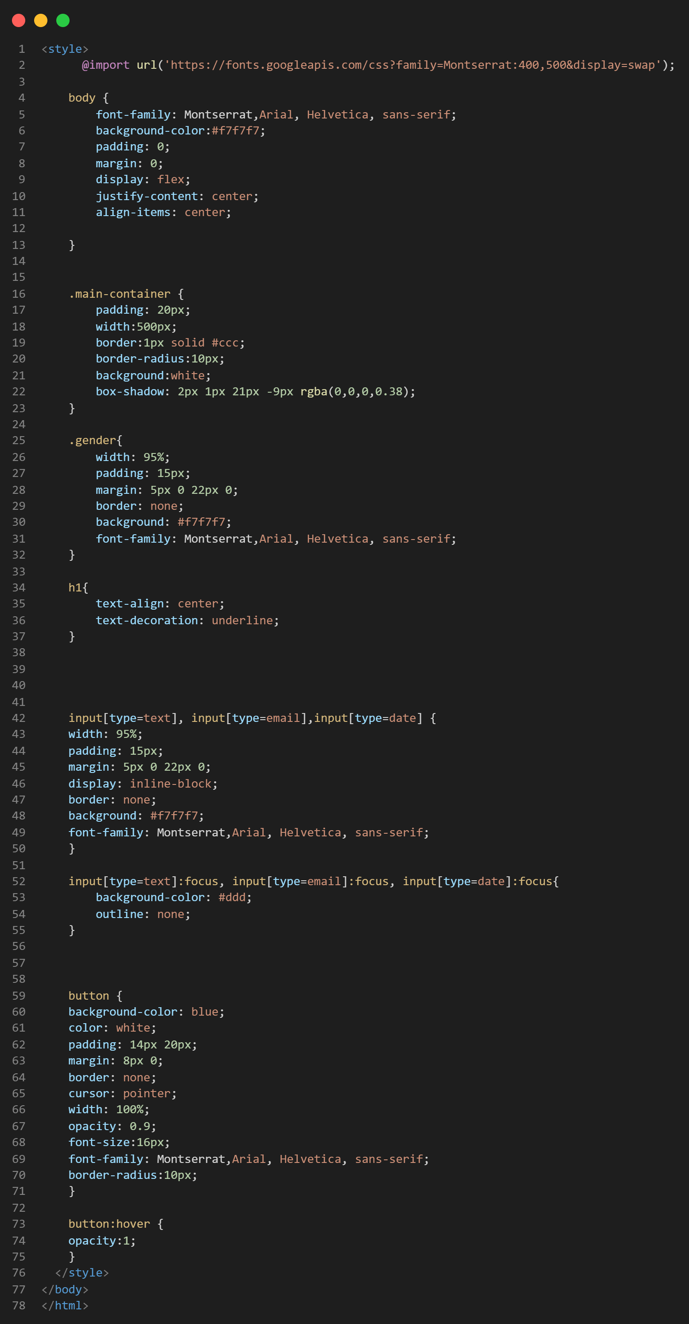

**Source Code:** Search Student Page(search-student.html)

**HTML**

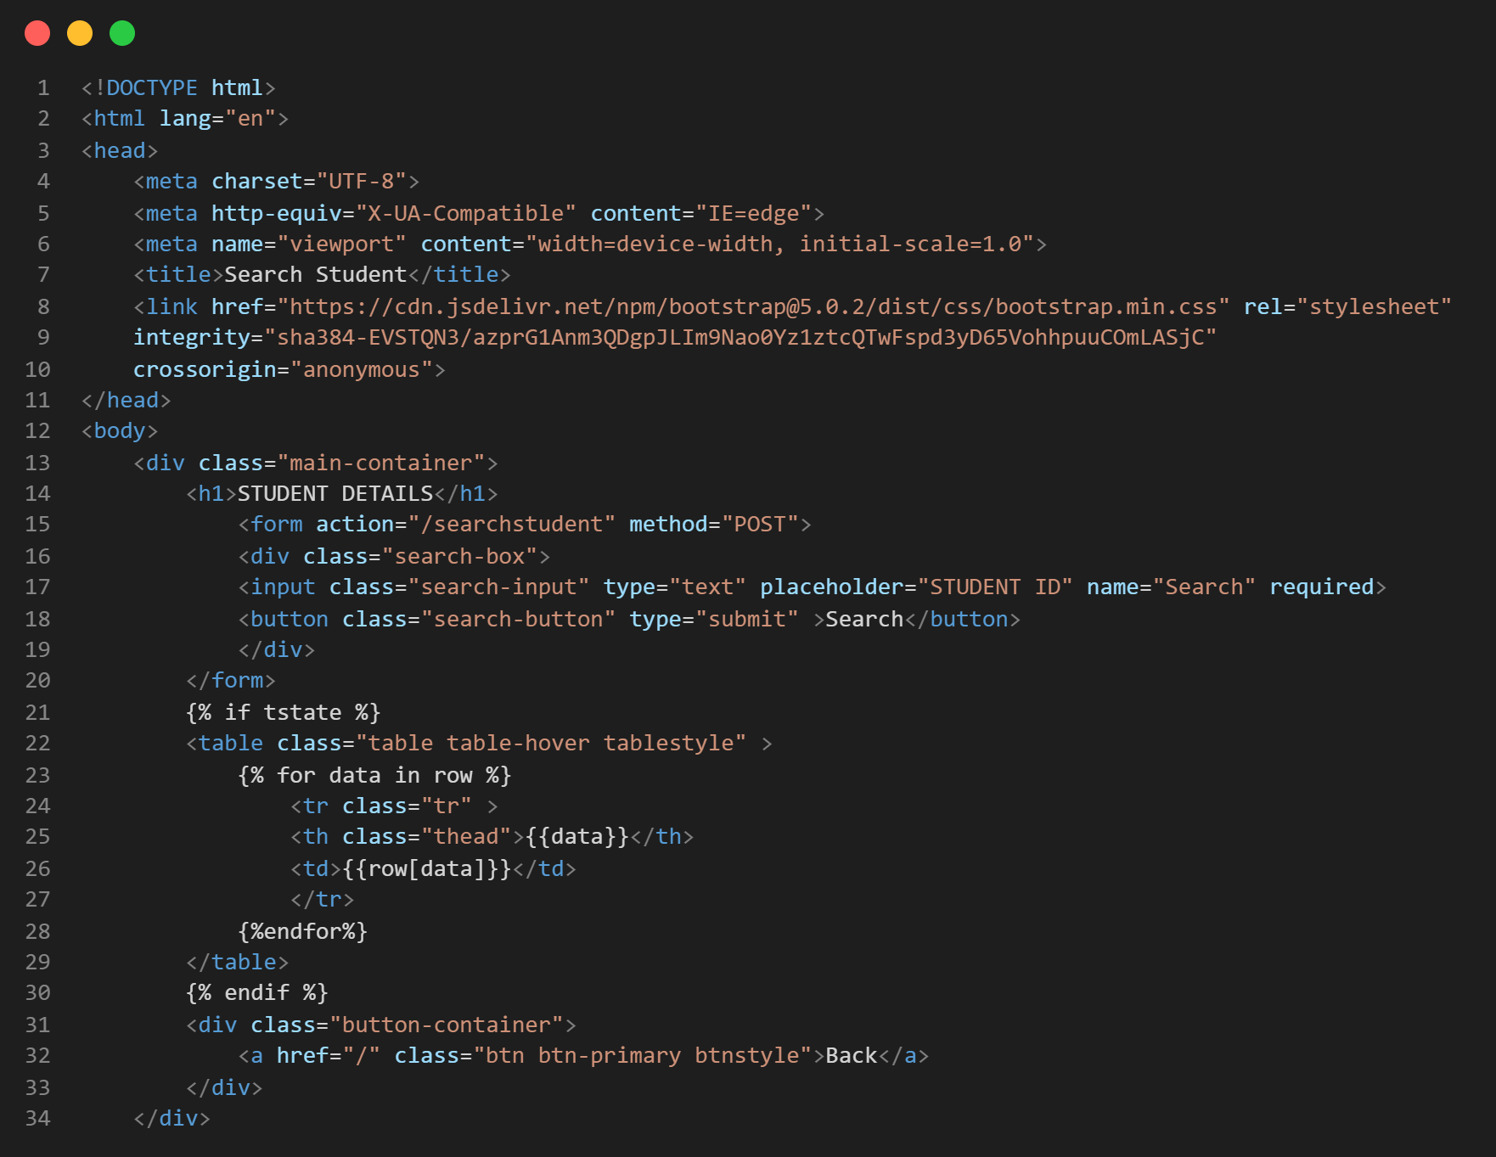

**CSS**

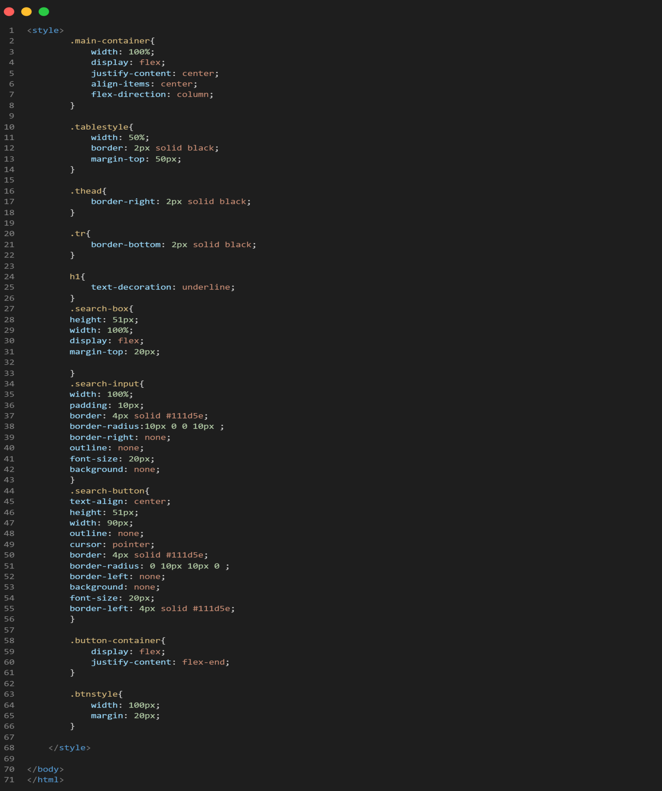

**Source Code:** Search Student Page(search-student.html)

**HTML**

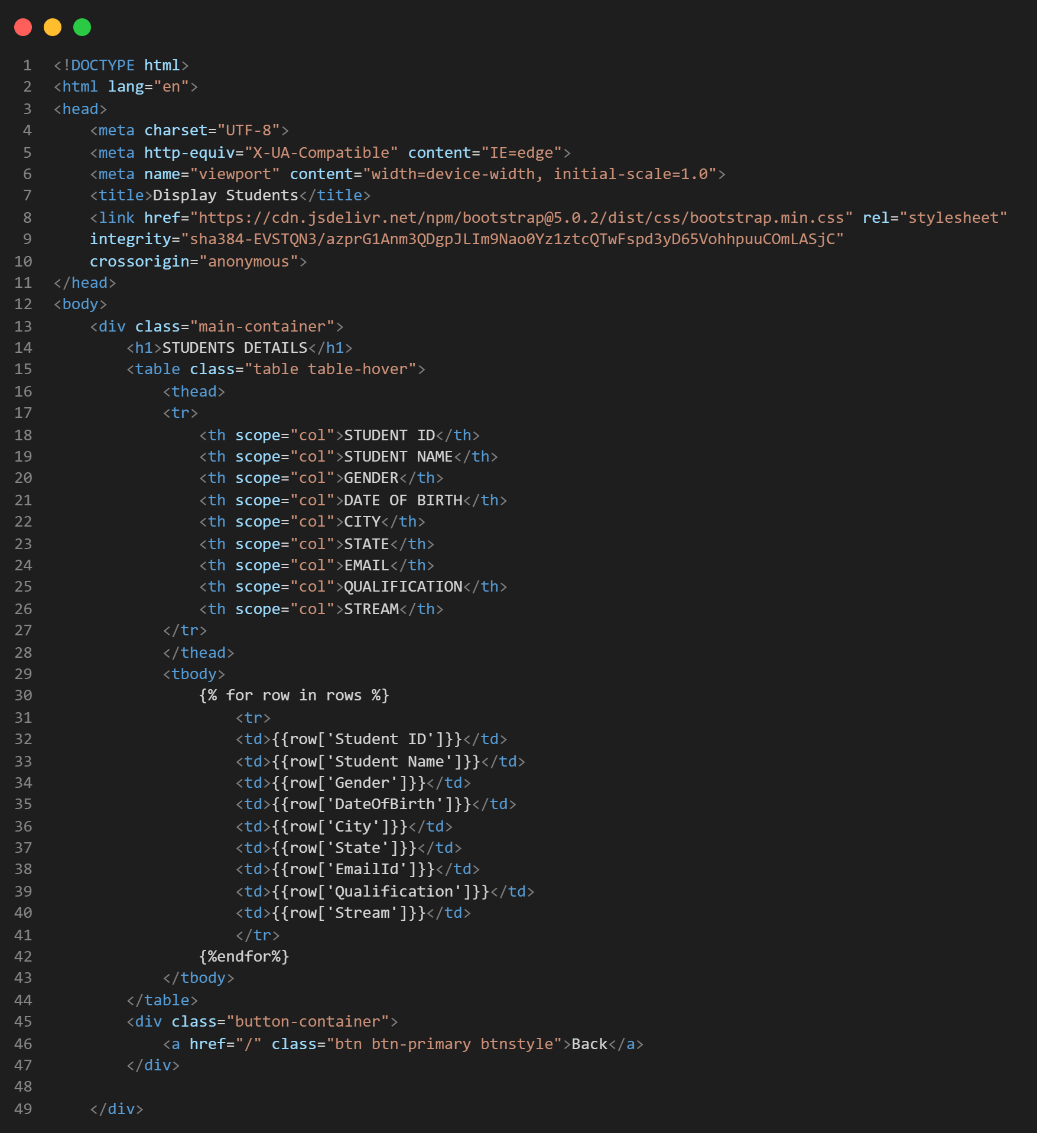

**CSS**

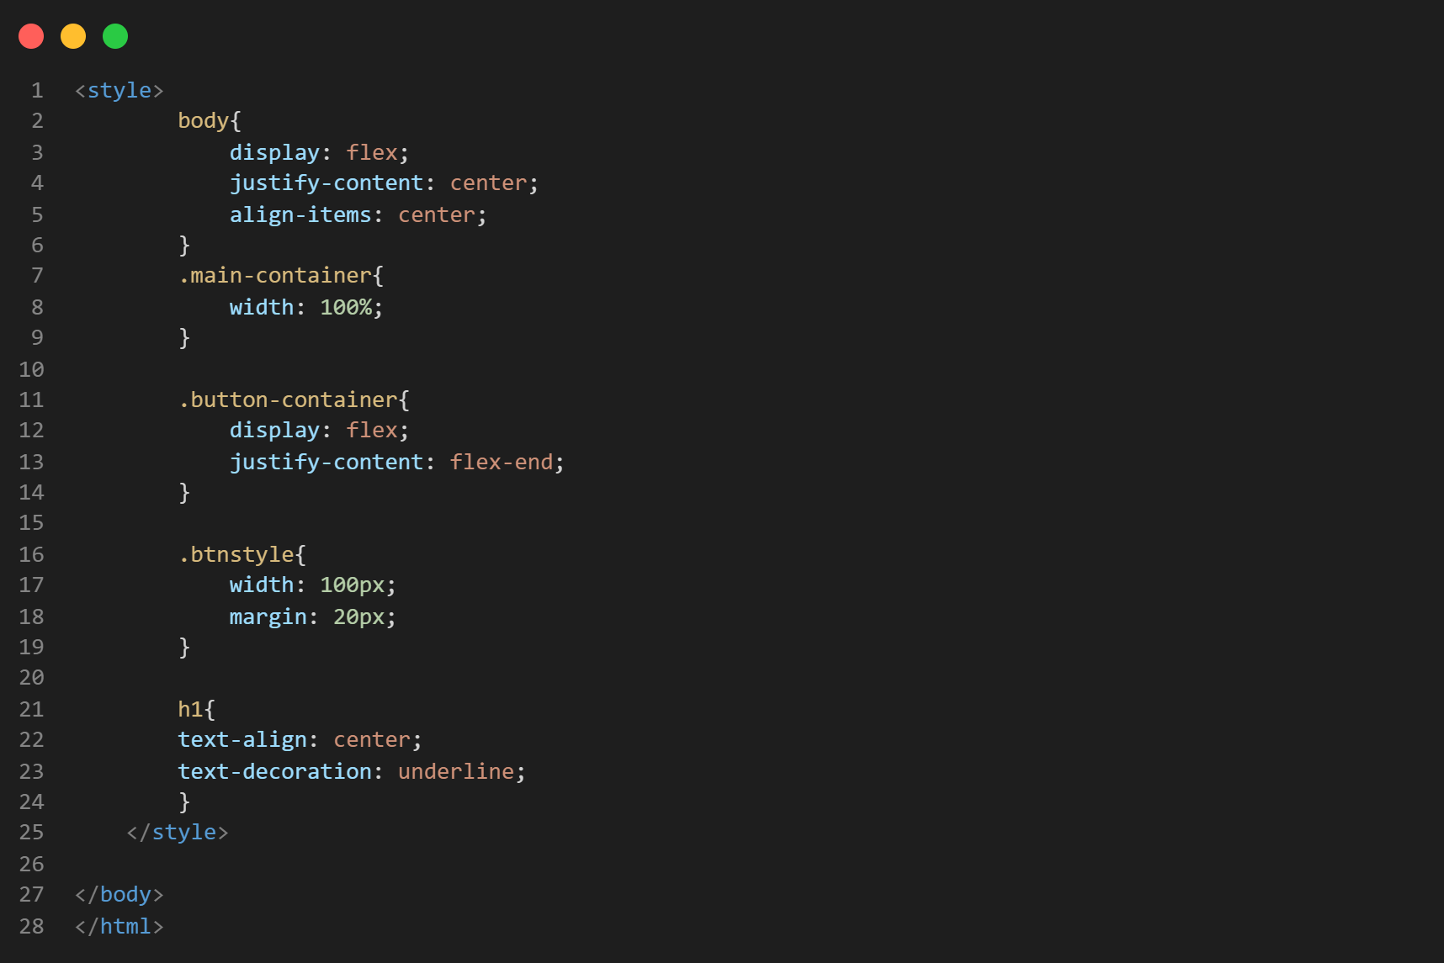

**Source Code:** Backend Server (backend.py)

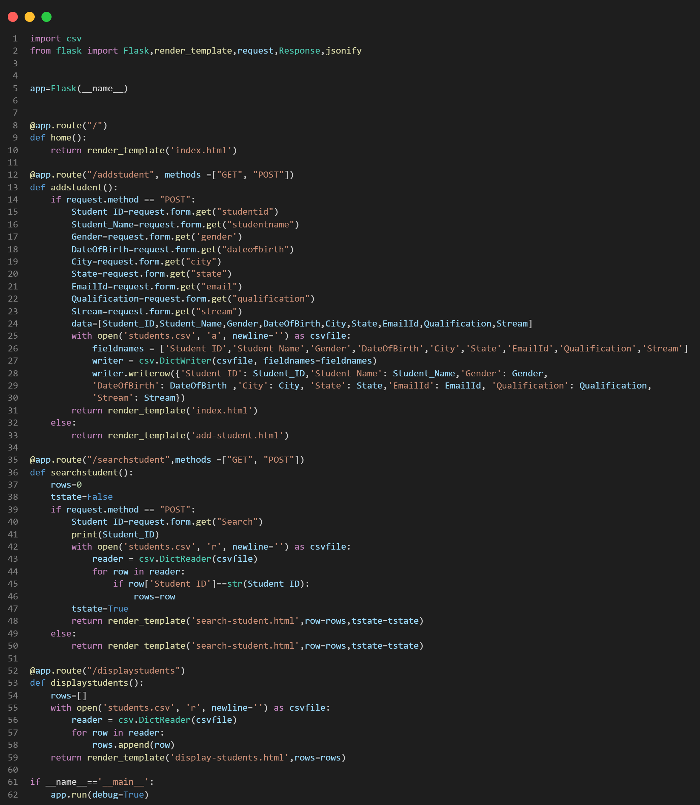

**OUTPUT:**

1. MAIN PAGE

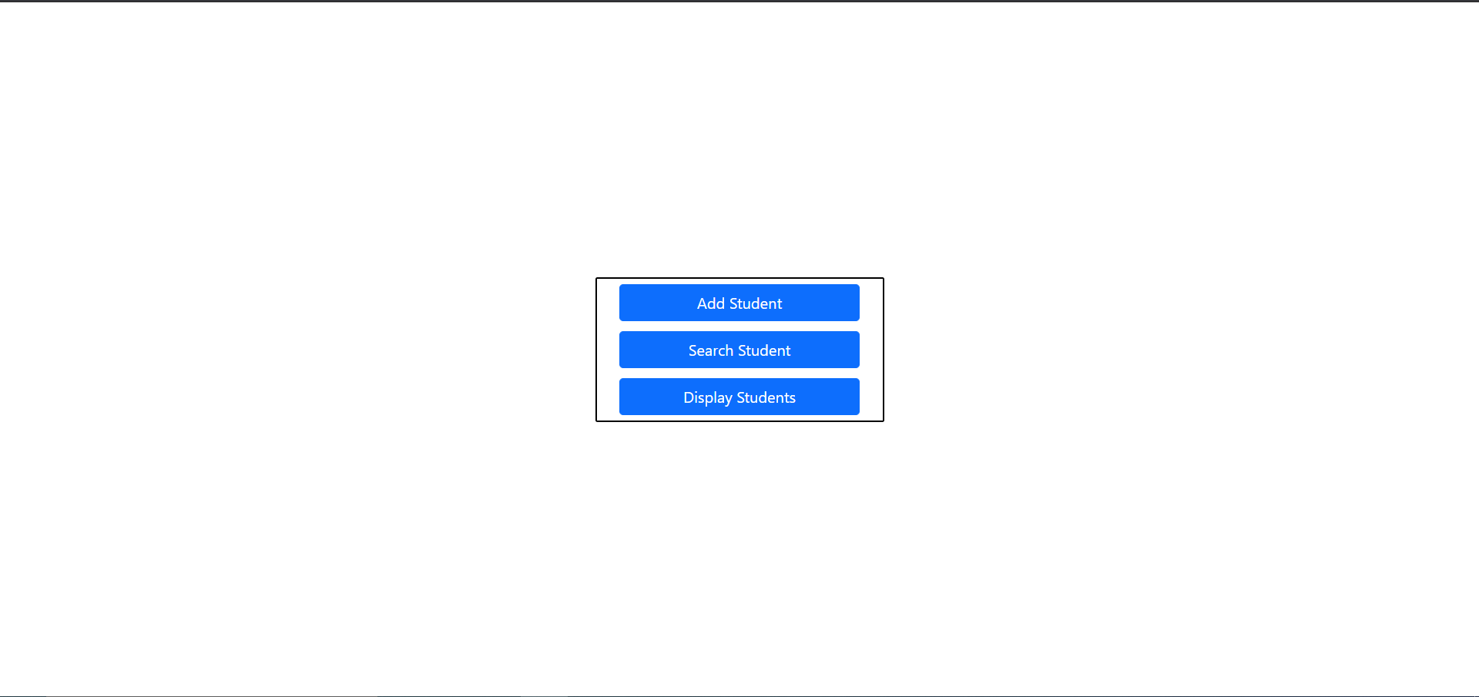

1. ADD STUDENT PAGE

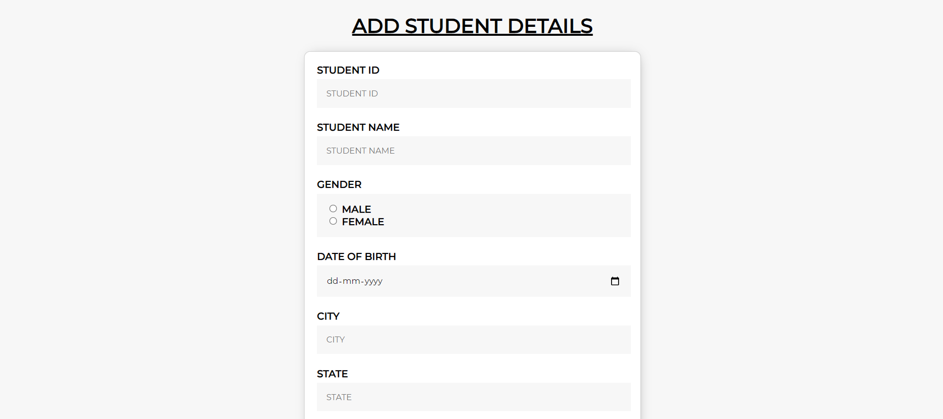



1. ADD STUDENT PAGE

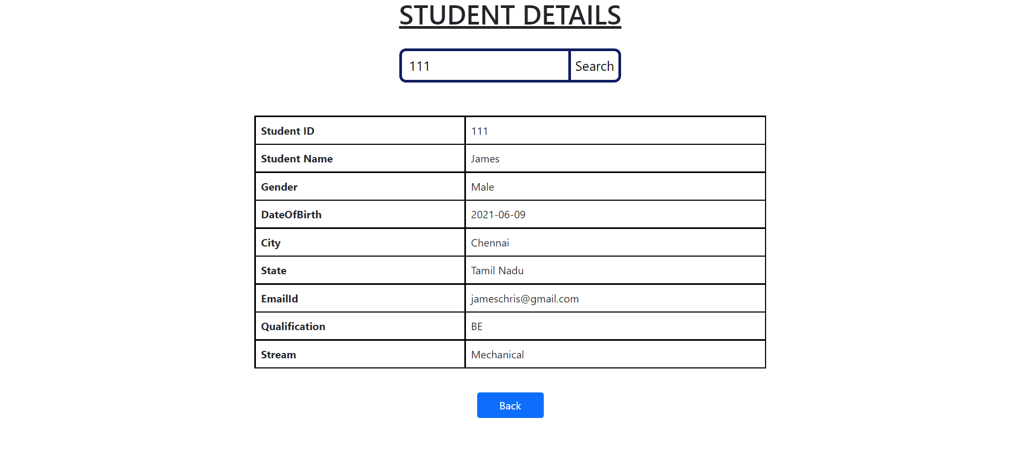

1. VIEW STUDENTS PAGE

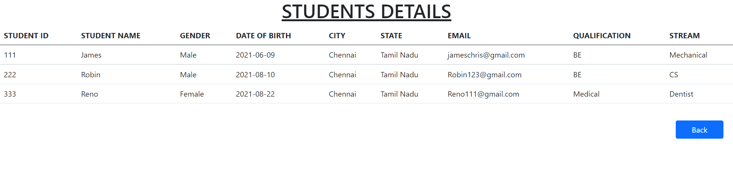

1. CSV FILE

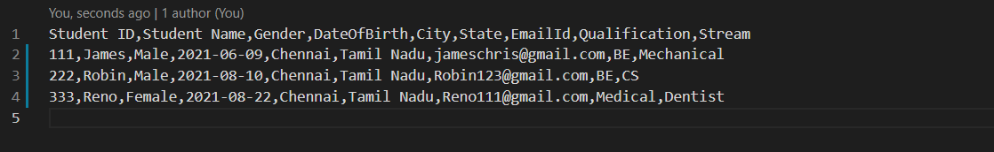

The Source Code for The Case Study LBJ 2021 Is Uploaded in the link given

Below:https://github.com/lil-loki/LBJ-casestudy1