Here is how I completed the database course project.

**Part 1**

1.1

First I imported the csv dataset into a temprorary table in DBeaver that had 505 rows of books a lot of which were duplicates.

Then I created another table where I imported only the unique books. And it had 224 rows out of 505 initial rows. [See Clean_Table.sql]

And then I created 10 tables according to the logical model:

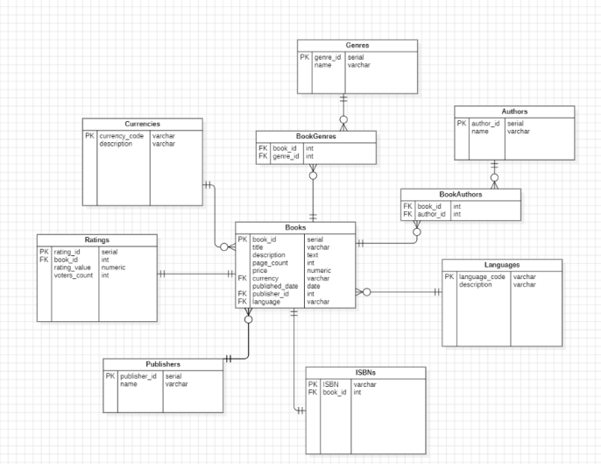

[See create_scripts.sql]

1.2 Created a separate database called book_store_db and a schema called book-inventory.

Also created several check constraints that restrict certain values when inserting new data into tables.

[See 1.2_Separate_Database_and_Schema.sql]

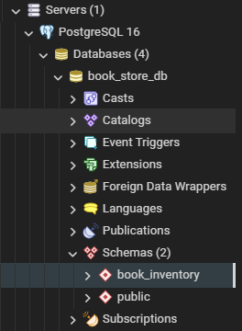

1.3 Next I imported the original dataset into my new database schema and made another table that removes the duplicates from the original table using the same script

[see Clean_Table.sql]

So now I have 12 tables including 2 datasets where I will take data from.

After that I imported all of the data and populated them across 10 tables with INSERT scripts [see insert_scripts.sql]

1.4 I then also created a function that can update any book in the books table. It receives 3 arguments: id of the book, column you want to update and the new value you want to replace with [see 1.4_Function_update.sql]

1.5 Created a view for analyzing the last quarter of books that were inserted into the table [see 1.5_Analytics_view.sql]

**Part 2**

2.1