Here is how I completed the database course project.

**Part 1**

1.1

First I imported the csv dataset into a temprorary table in DBeaver that had 505 rows of books a lot of which were duplicates.

Then I created another table where I imported only the unique books. And it had 224 rows out of 505 initial rows. [See Clean_Table.sql]

And then I created 10 tables according to the logical model:

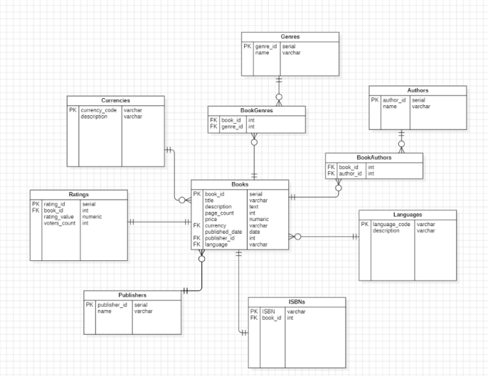

[See create_scripts.sql]

1.2 Created a separate database called book_store_db and a schema called book-inventory.

Also created several check constraints that restrict certain values when inserting new data into tables.

[See 1.2_Separate_Database_and_Schema.sql]

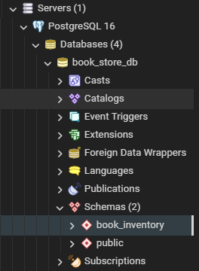

1.3 Next I imported the original dataset into my new database schema and made another table that removes the duplicates from the original table using the same script

[see Clean_Table.sql]

So now I have 12 tables including 2 datasets where I will take data from.

After that I imported all of the data and populated them across 10 tables with INSERT scripts [see insert_scripts.sql]

1.4 I then also created a function that can update any book in the books table. It receives 3 arguments: id of the book, column you want to update and the new value you want to replace with [see 1.4_Function_update.sql]

1.5 Created a view for analyzing the last quarter of books that were inserted into the table [see 1.5_Analytics_view.sql]

**Part 2**

2.1 Next I created a separate schema in the database I created earlier and named it denormalized. I also set the default search path to the new schema so we don’t have to specify the schema when working with denormalized tables. [See 2.1_denormalize_create.sql]

2.2 Created and populated a layer of 8 tables that makes the whole database denormalized so we can access it faster. [See 2.2_denormalized_insert.sql]

2.3 Created a role that allows managers to read data from any tables and run any select queries from the denormalized database. [See 2.3_manager_readonly.sql]

2.4 Made a query for each of 5 business question that I prepared:

1. Top 3 bestselling authors this year compared to last year
2. Cumulative sum of book sales by genre
3. Moving average of monthly book prices
4. Compare book ratings with the publisher's average
5. Analyze price changes between consecutive books by author

[See 2.4_business_queries.sql]

2.5 And finally, I made the backup of my database using the command

"C:\Program Files\PostgreSQL\16\bin\pg_dump.exe" -h localhost -U postgres -F c -f D:\sh.backup