**PWS | A | LAILATUL RAMADHANI | 20230140041**

**- KEC. KASIHAN**

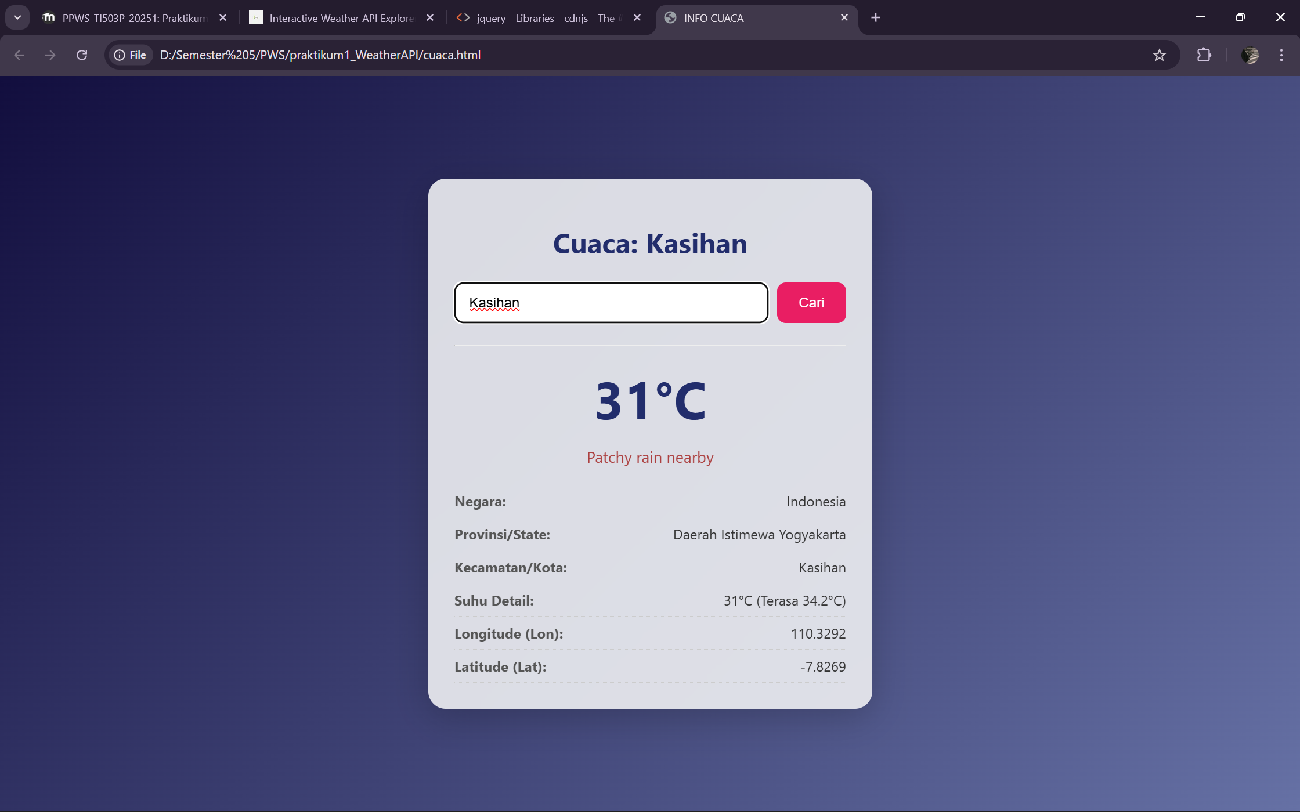

**- KEC. PAALLIMA**

