SPM@Unipi 17/18 Project [Histogram Thresholding]

by : Lanpei Li ( Matricola: 533772)

Usage Manual

Code repository:

How to compile the code :

How to run the code :

Major Design and Implementation Choices

Sequential :

C++Threads :

Fastflow -> Pipeline :

Fastflow -> Farm :

Fastflow -> Pipeline embedded in Farm :

Performance Plots

Speed Up :

Scalability :

Efficiency :

Conclutions

References

# Usage Manual

## Code repository:

<https://github.com/lilanpei/SPM_HistogramThresholding.git>

## How to compile the code :

1. Dowload fastflow :

* cd ~
* svn co https://svn.code.sf.net/p/mc-fastflow/code/fastflow

1. Download source code from github repository and unzip it to the work folder.
2. Enter the work folder, Compile the code :

* source /opt/intel/compilers_and_libraries/linux/bin/compilervars.sh intel64
* make

## How to run the code :

1. Sequential code :

* ./Sequential nImages threshold

1. C++Threads code :

* ./Threads nImages nWorkers threshold

1. Pipeline code :

* ./Pipeline nImages threshold

1. Farm code :

* ./Farm nImages nWorkers threshold

1. Farm with Pipeline code :

* ./Farm_Pipeline nImages nWorkers threshold

1. For test different number of works in the farm :

* bash ./test.sh
* Note:
* nImages : Number of images in the Input stream.
* nWorkers : Number of works in the farm.
* threshold : target percentage for thresholding

# Major Design and Implementation Choices

## Sequential :

* 1. A while-loop looping the images one by one (as a stream) to do Histogram-Thresholding.
  2. Histogram-Thresholding process has 3 steps :
     1. Convert image from RGB to GrayScale.
     2. Calculating Histogram.
     3. Perform Thresholding.

## C++Threads :

* 1. Inside the while-loop, fork a vector of threads, each thread process a single image.
  2. Because the image read and write can’t be paralleled, so just perform once and using only a single input image, copy it to do image processing n times.

## Fastflow -> Pipeline :

* 1. Consider the time usage of each step of Histogram-Thresholding for the input image from 1), RGB to GrayScale is the bottleneck, in order to get the minimum service-time, so put RGB to GrayScale step as a single stage and combine Histogram Calculating and Thresholding together into the second stage.

## Fastflow -> Farm :

* 1. Using the idea from 2), built a farm that each worker process a single image.
  2. A Emitter for scheduling the given number of image as a stream input.
  3. removing the unused default collector.

## Fastflow -> Pipeline embedded in Farm :

* 1. Combine the idea from 3) and 4) together, embed a two stage Pipeline from 3) into each worker of the Farm from 4).
  2. Need to check the overhead introduced compared to 4).

# Performance Plots

* Note : In my all implementations, the input parameter nWorks denotes the number of works used in the farm, so for easy plotting, I use this input parameter to present the parallelism degree n, but for the case of Pipeline embedded in Farm, actually the parallelism degree should also consider the two-stage-pipeline ’s contribution(nWorks*2).

## Speed Up :

* 1. s(n) = Tseq / Tpar(n)
  2. Speedup gives a measure of how good is our parallelization with respect to the “best” sequential computation.
  3. When 28 threads used for “Farm” and “Pipeline embedded in Farm” implementations, we can achieve the best SpeedUp, but for “C++Threads” case seems when use 198 threads can achieved the best SpeedUp.
  4. After about the number of threads exceeds 61, both “Farm” and “Pipeline embedded in Farm” implementations starts the first drop due to the overheads introduced.
* Note: For “Pipeline embedded in Farm” when at the number of works equal to n, but consider the pipeline’s contribution to the parallelism degree, actually the number of threads used already exceeds 2n.

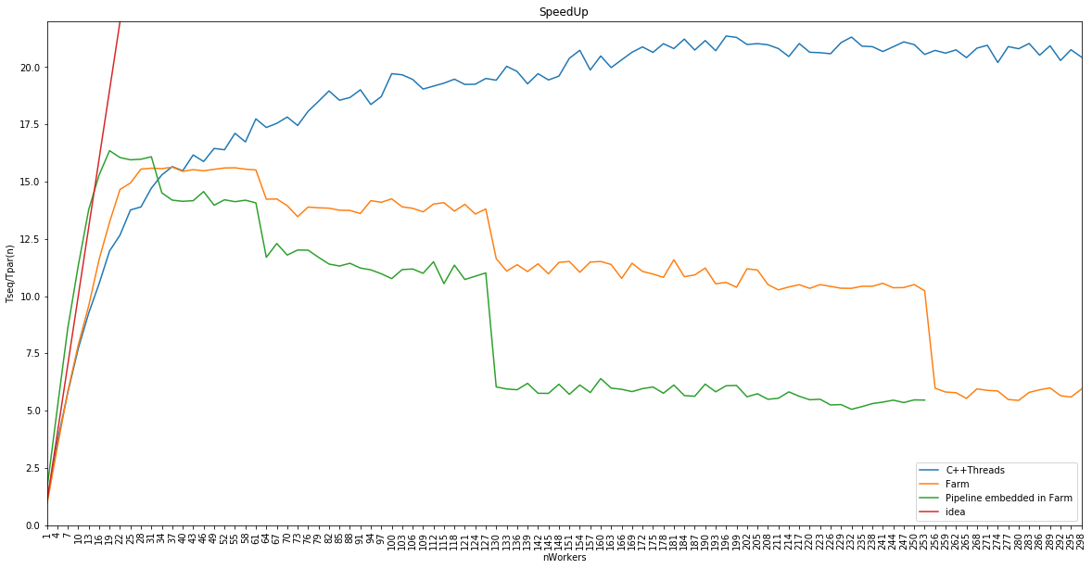

## Scalability :

* 1. scalab(n) = Tpar(1) / Tpar(n)
  2. Scalability should looks slightly different than speedup. It measures how efficient is the parallel implementation in achieving better performances on larger parallelism degrees.
  3. But in my implementations, due to the image read and write just perform once for each parallel implementation no matter how many number of threads used, so Tpar(1) is more or less similar to the Tseq in all parallel implementations.
  4. So consider the plots of Scalability is quite similar to the plots of SpeedUp, we can get the same conclusion as the Speed Up plots analysis.

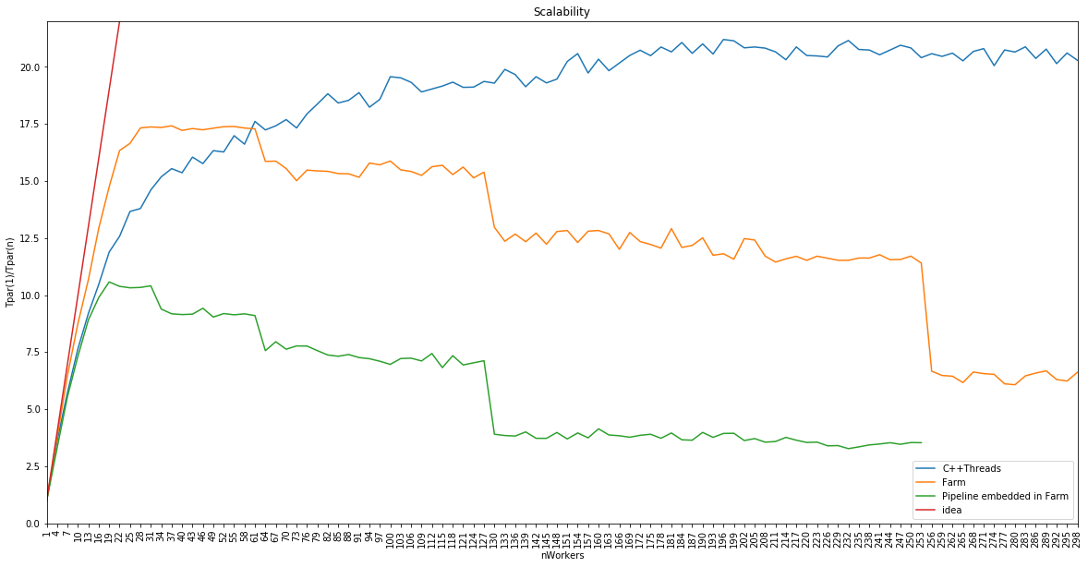

## Efficiency :

* 1. ϵ(n) = Tseq / ( n * Tpar(n) )
  2. Efficiency measures the ability of the parallel application in making a good usage of the available resources.
  3. In the plots, we can observe that between 10 to 30 number of threads used, “Farm” implementation has a better Efficiency, after 30 threads, the “C++Threads” implementation has a better Efficiency.

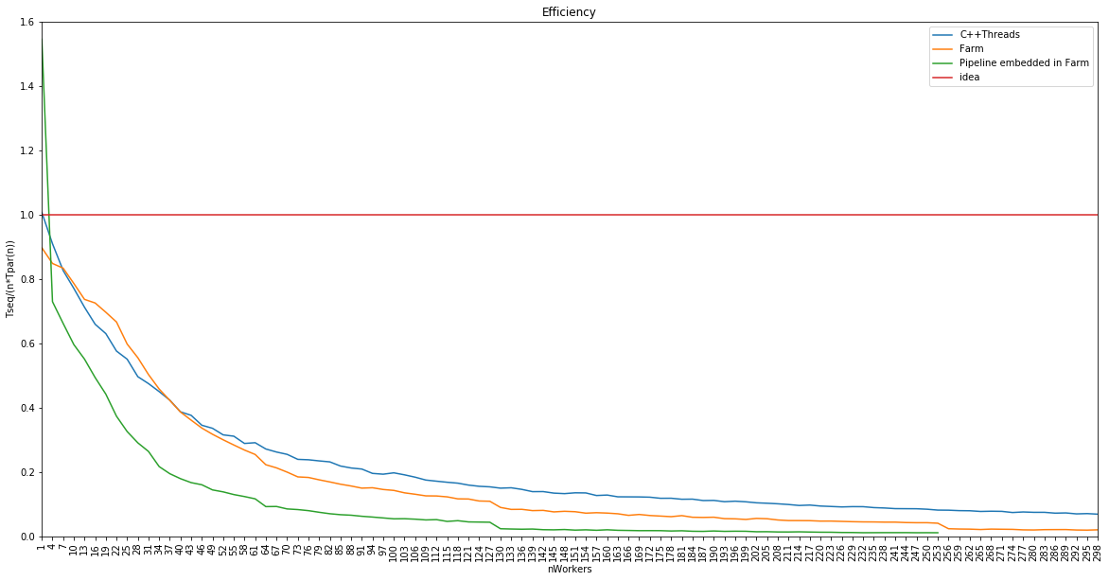

# Conclutions

Consider my implementation choices and their plots shown above :

1. The “Farm” implementation with 28 number of works has the best performance.
2. After using 61 number of works, “Farm” and “Pipeline embedded in Farm” implementations tend to have a worse performance due to the overhead introduced become larger than the performance gained.
3. “Farm” and “Pipeline embedded in Farm” implementations have quite similar performance, so the pipeline embedded seems does not showing much benefit.

# References

1. SPM lecture and notes : <http://didawiki.cli.di.unipi.it/doku.php/magistraleinformaticanetworking/spm/start>
2. FastFlow tutorials and examples : <http://calvados.di.unipi.it/dokuwiki/doku.php/ffnamespace:tutorial>
3. CImg tutorials and examples : <http://cimg.eu/reference/group__cimg__tutorial.html>
4. C++ Spec and examples : <http://www.cplusplus.com/reference/>
5. RGB to Grayscale using CImg : <http://obsessive-coffee-disorder.com/rgb-to-grayscale-using-cimg/>
6. Histogram Calculating program : <https://stackoverflow.com/questions/7428657/histogram-calculating-program>
7. Ahmad-Alleboudy’s submission for the SPM video filter project : <https://github.com/alleboudy/spm>