Egypt's Slowest ISP's during November 2009 - September 2011

Kinga

Monday, April 06, 2015

### The Data:

The data set used in this project were downloaded from Measurement Lab's Google BigQuery dataset using the BigQuery graphic user interface and were saved as .csvfiles. Each file's name is of the form Egypt[YearMo]RTTComplete.csv, where Year $∈$ {2009, 2010, 2011 } and Mo $∈$ {Jan, Feb, Mar, Apr,May,June,July,Aug, Sept, Oct, Nov, Dec}.

I used regular expressions to find the files whose names had the words "Egypt" "RTTComplete" and "csv" in them and saved them into the list, file_list_Egypt. I read these files in as data frames and I immediately discarded all the unwanted information, keeping only the relevant (for this project) variables. I accomplished this by applying the function dataConverter, which I have written specifically for this purpose. Then I stored these files as data frames into the list egyptDFList, where the data frames' names are of the form: Egypt[YearMO]. These names are stored in the vector dfNames.

setwd("~/M_LabProject")  
library(dplyr)

##   
## Attaching package: 'dplyr'  
##   
## The following object is masked from 'package:stats':  
##   
## filter  
##   
## The following objects are masked from 'package:base':  
##   
## intersect, setdiff, setequal, union

source("dataConverterFunction.R")  
source("ipAddressLocatorFunction.R")  
#used to change the class of lat. and long. later on  
as.numeric.factor <- function(x) {as.numeric(levels(x))[x]}   
file_list_Egypt <- list.files(pattern="Egypt.*RTTComplete.*csv")  
  
monthCount_Egypt <- length(file_list_Egypt) #number of files   
egyptDFList <- list()  
dfNames <- c()  
for (i in file_list_Egypt){  
 x <- substring(i, 1, nchar(i)-15)  
 dummy<- read.csv(i, colClasses="character")  
 egyptDFList[[x]] <- dataConverter(dummy)   
 dfNames<-c(dfNames, x)  
}

### Finding the Extreme RTT Values and the corresponding ISP's

Next, I found the monthly five number summaries and the inter quartile ranges for the roundtrip times, RTT's. I also kept track of the top (right) outlier boundary for each data frame, i.e. each month, where an RTT would be classified as an outlier if it is greater than or equal to that months median + 1.5*IQR. I then split up each monthly data frame into two parts, one with the outlier RTT values, the other with the rest of the data, and I saved the resulting data frames into the two lists: outlierDFList and normalDFList.

topOutlierBndry <-rep(0,monthCount_Egypt)  
outlierDFList<-list()  
normalDFList <- list()  
for (i in dfNames){  
 x<-fivenum(egyptDFList[[i]]$RTT)  
 iqr<-IQR(egyptDFList[[i]]$RTT)  
 topOutlierBndry[i]<- x[4] + 1.5*iqr  
 the_condition <- egyptDFList[[i]]$RTT >= topOutlierBndry[i]  
 outlierDFList[[i]]<- egyptDFList[[i]][the_condition, ]  
 normalDFList[[i]]<-egyptDFList[[i]][-the_condition, ]  
 normalDFList[[i]]$date <- as.character(normalDFList[[i]]$date)  
 outlierDFList[[i]]$date <- as.character(outlierDFList[[i]]$date)  
}

Next, I took the each "outlier" and "normal" data frame and I grouped each by server IP addressess (serverIP) then summarized the mean, median and the number of entries of each group and saved them as data frames in the byServerIPSummaryLIstand byServerNormalIPSummaryList respectively.

byServerIPSummaryList<-list()  
byServerNormalIPSummaryList <- list()  
for (i in dfNames){  
 x <- group_by(outlierDFList[[i]], serverIP)  
 byServerIPSummaryList[[i]]<- data.frame(summarise(x, count=n(), meanRTT = mean(RTT),  
 medianRTT = median(RTT)))  
 y <- group_by(normalDFList[[i]], serverIP)  
 byServerNormalIPSummaryList[[i]]<-data.frame(summarise(y, count=n(),  
 meanRTT=mean(RTT), medianRTT=median(RTT)))  
}

### Locating the ISP's on the Map

#### Getting all the Data Ready

Now, in order to be able to examine the resulting summaries, I wanted to plot each ISP on the map.  
Therefore I needed to figure out their locations given and IP address, since the data I got from Measurement Labs was often incomplete when it came to specifying the locations. I ended up using Heuristic Andrew's script for locating IP addresses using R, as it can be found at [**https://heuristically.wordpress.com/2013/05/20/geolocate-ip-addresses-in-r/**](https://heuristically.wordpress.com/2013/05/20/geolocate-ip-addresses-in-r/). That is the scirpt now saved and sourced as ipAddressLocatorFunction.R.

Then I applied the address locator function to the distinct serverIP values of data frames in the lists byServerIPSummaryLIstand byServerNormalIPSummaryList and saved the resulting locations in the outlierServerIPLocationList and normalServerIPLocationList lists. By the way the output of the ipAddressLocatorFunction is a data frame with the following column names: ip , country_code, country_name, region_code, region_name, city zipcode,latitude,longitude, metro_code, areacode.

outlierServerIPLocationList <- list()  
normalServerIPLocationList <- list()  
for (i in dfNames){  
 x <- unique(byServerIPSummaryList[[i]]$serverIP)  
 outlierServerIPLocationList[[i]]<- freegeoip(x)  
  
   
}

## Loading required package: rjson

## Warning: package 'rjson' was built under R version 3.1.3

for (i in dfNames){  
 y <- unique(byServerNormalIPSummaryList[[i]]$serverIP)  
 normalServerIPLocationList[[i]]<-freegeoip(y)  
   
}

Since all I wanted is the locations of all the servers, irrespectively (for now) of which month's data they came from, I collected the monthly informations per list into two distinct data frames, one for the "outlier" servers, one for the rest.

aggregateOutlierServerLocationDF <- data.frame()  
aggregateNormalServerLocationDF <- data.frame()  
for (i in dfNames){  
 aggregateOutlierServerLocationDF <- rbind(aggregateOutlierServerLocationDF,  
 outlierServerIPLocationList[[i]] )  
 aggregateNormalServerLocationDF <- rbind(aggregateNormalServerLocationDF,   
 normalServerIPLocationList[[i]])  
}

In order to not have to replot the same locations over and over again, I grouped the aggregated data by longitude and latitude and then summarized them and found the count per given longitude and latitude.

temp <- group_by(aggregateOutlierServerLocationDF, longitude, latitude)  
byLongLatOutlierServerDF <- data.frame(summarise(temp, count=n()))  
temp <- group_by(aggregateNormalServerLocationDF, longitude, latitude)  
byLongLatNormalServerDF <- data.frame(summarise(temp, count=n()))

#### Plotting the Locations on the Map

After a cursory examination of the locations, I found that the ISP's were located either in Europe or in the US (oh and one was located in Australia I beleive, but I did not graph that one.) The locations were not easily discernable on a word map so I chose to plot the European and US servers on separate maps.

###### Plotting European Servers

First, I had to find all the ISP's whose longitude and latitude landed them in Europe. After I examined a world map with longitudes and latitudes I decided on the cutoff values for Europe (which later I modified so that Greece would be included too, but then I did not expect to get it perfect on the first try...)

#finding unique longitudes and latitudes in Europe  
outlierEuropeCondition <- as.numeric.factor(byLongLatOutlierServerDF$longitude) <= 30 &  
 as.numeric.factor(byLongLatOutlierServerDF$longitude)> -50  
normalEuropeCondition <- as.numeric.factor(byLongLatNormalServerDF$longitude) <= 30 &  
 as.numeric.factor(byLongLatNormalServerDF$longitude)> -50  
  
EuropeOutlierDF <- byLongLatOutlierServerDF[outlierEuropeCondition,]  
  
EuropeNormalDF <- byLongLatNormalServerDF [normalEuropeCondition,]

Once I decided on the list of serves that I wanted plotted on the map of Europe, I had to pick a center point for my map (using longitudes and latitudes). For this task I used the website found at [*http://www.mapcoordinates.net/en*](http://www.mapcoordinates.net/en), where a single click on the map would give me the longitude and latitude of the point of interest. So I pointed and clicked and saved the values in the Eu_lat and Eu_long variables, then I used the get_googlemap() function to create the map. Oh, and for my maps I needed the ggmap and ggplot2 packages, so I loaded those as well.

library(ggplot2);library(ggmap)

## Warning: package 'ggmap' was built under R version 3.1.3

Eu_lat<- 47.5172007 #generic Europe latitude  
Eu_lon<- 19.07226563 #generic Europe longitude  
googMap <- get_googlemap(center = c(lon = Eu_lon , lat = Eu_lat ), zoom =4,   
 maptype='hybrid', scale=2)

## Map from URL : http://maps.googleapis.com/maps/api/staticmap?center=47.517201,19.072266&zoom=4&size=640x640&scale=2&maptype=hybrid&sensor=false

Now, all is left is to actually plot the maps:

These are the locations of the "outlier" servers in Europe, where count represents the number of times the server has appeared in the data frame - more or less...

#plotting servers form Europe  
   
  
  
ggmap(googMap)+geom_point(  
 aes(x =as.numeric.factor(longitude), y =as.numeric.factor(latitude),  
 size = count),pch=8, data=EuropeOutlierDF , colour= "red")

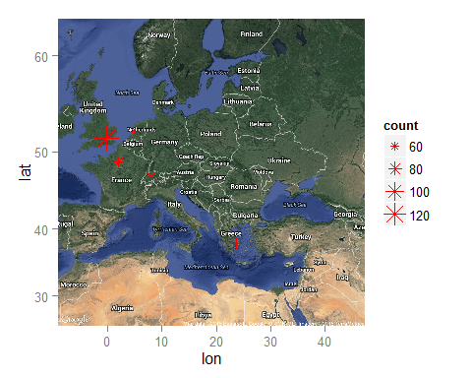

And these are the locations of the "normal" ISP's in Europe:

ggmap(googMap) +geom_point(  
 aes(x =as.numeric.factor(longitude), y =as.numeric.factor(latitude),  
 size = count),pch=8, data=EuropeNormalDF , colour= "green")

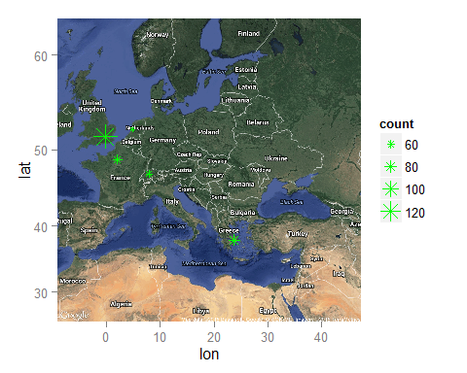

#### Plotting the US Servers

#centering map on US  
googMapUS <- get_googlemap(center=c(lon=-100.1953125, lat=37.16031655), zoom=4,  
 maptype="hybrid", scale=2)

## Map from URL : http://maps.googleapis.com/maps/api/staticmap?center=37.160317,-100.195312&zoom=4&size=640x640&scale=2&maptype=hybrid&sensor=false

#finding unique longitudes and latitudes not in Europe  
USOutlierDF <- byLongLatOutlierServerDF[!outlierEuropeCondition,]   
USNormalDF <- byLongLatNormalServerDF [!normalEuropeCondition,]  
  
#plotting server locations from the US  
  
#the servers locations include one ISP not in north America, which will be ignored by  
#ggmap - fortunately for me  
  
  
###Plotting the "outlier" servers in the US  
ggmap(googMapUS)+geom_point(  
 aes(x =as.numeric.factor(longitude), y =as.numeric.factor(latitude), size=count),   
 pch=8, data=USOutlierDF , colour="red")

## Warning: Removed 1 rows containing missing values (geom_point).

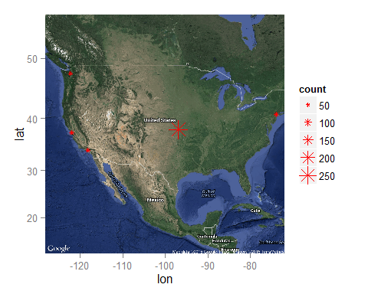

#plotting the "normal" ISP's in the US  
ggmap(googMapUS) +geom_point(  
 aes(x =as.numeric.factor(longitude), y =as.numeric.factor(latitude),  
 size = count),pch=8, data=USNormalDF , colour= "green")

## Warning: Removed 1 rows containing missing values (geom_point).

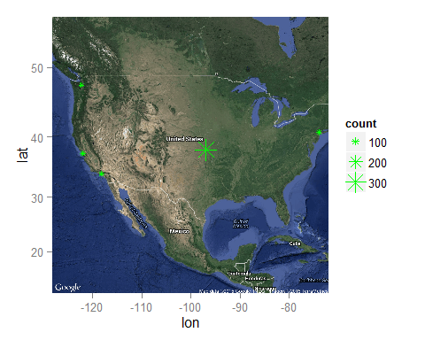

### Conclusions

All the ISP's that have served Egypt during the time period of November 2009 and September 2011 have, at one point or another, had RTT's that were in the outlier range of the RTT's of the month during which the measurement was taken since the locations of the "outlier" servers (in red) match up perfectly with the locations of the "normal" servers (in green.)

The count's on the maps are ambigous at this point, since I did not carefully keep track of the number of times a particular ISP has appeared in the "outlier" list.  
And, at any rate, I would need to use percentages out of the total number of measurements as opposed to the actual counts to get a reasonable picture of what was happening.