Nagios安装部署文档

1. **安装前准备：**
2. yum安装：

yum install -y httpd php gcc glibc glibc-common gd gd-devel perl make

yum install sendmail –y

yum install -y openssl openssl-devel

1. 软件下载：

httpd-2.0.63.tar.gz、nagios-plugins-1.4.16.tar.gz、nrpe-2.13.tar.gz、php-5.3.27.tar.gz、nagios-3.4.3.tar.gz

1. **监控端安装：**
2. 创建nagios用户和用户组：

useradd nagios

passwd nagios

/usr/sbin/groupadd nagcmd   
/usr/sbin/usermod -G nagcmd nagios   
/usr/sbin/usermod -G nagcmd apache

1. 安装nagios.3.4.3:

tar zxvf nagios-3.4.3.tar.gz

cd nagios

./configure --with-command-group=nagcmd

make all

make install

make install-init

make install-config

make install-commandmode

1. 把nagios加入到服务列表中以使之在系统启动时自动启动：

chkconfig --add nagios

chkconfig --level 35 nagios on

chkconfig --list nagios

1. 编辑/usr/local/nagios/etc/objects/contacts.cfg，修改邮件接收人，如下图所示：

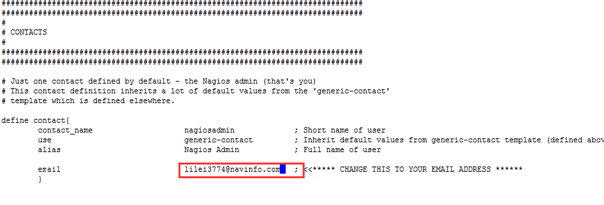

1. 配置WEB接口：

进入nagios解压后目录：

cd /data/lilei/monitor/nagios

make install-webconf

查看执行结果，查看是否出现nagios.conf：

ls /etc/httpd/conf.d/

1. 安装nagios插件：

tar zxvf nagios-plugins-1.4.16.tar.gz

cd nagios-plugins-1.4.16

./configure --with-nagios-user=nagios --with-nagios-group=nagios

make && make install

1. 安装Apache和php

tar zxvf httpd-2.0.63.tar.gz

cd httpd-2.0.63

./configure --prefix=/usr/local/apache2

make

make install

tar zxvf php-5.3.27.tar.gz

cd php-5.3.27

./configure --prefix=/usr/local/php --with-apxs2=/usr/local/apache2/bin/apxs

make

make install

1. 配置apache

修改/usr/local/apache2/conf/httpd.conf

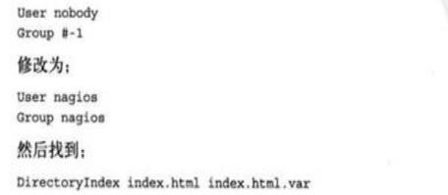

1. 启动Apache服务：

htpasswd -c /usr/local/nagios/etc/htpasswd.users nagiosadmin

/usr/local/nagios/bin/nagios -v /usr/local/nagios/etc/nagios.cfg

service nagios start

service httpd start

1. 访问监控：

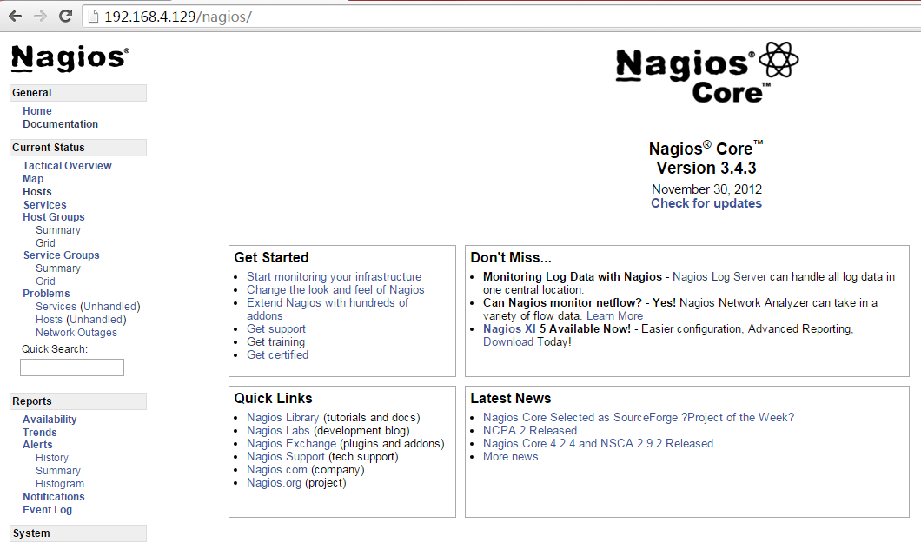

1. **使用NRPE监控Linux主机：**
2. 在被监控端安装nagios-plugin和nrpe

useradd nagios

yum -y install gcc gcc-c++ make openssl openssl-devel

tar zxvf nagios-plugins-1.4.16.tar.gz

cd nagios-plugins-1.4.16

./configure  --with-nagios-user=nagios --with-nagios-group=nagios

make && make install

tar zxvf nrpe-2.13.tar.gz

cd nrpe-2.13

./configure --with-nrpe-user=nagios --with-nrpe-group=nagios --with-nagios-user=nagios --with-nagios-group=nagios --enable-command-args --enable-ssl

make all

make install-plugin

make install-daemon

make install-daemon-config

配置NRPE

编辑/usr/local/nagios/etc/nrpe.cfg，结果如下：

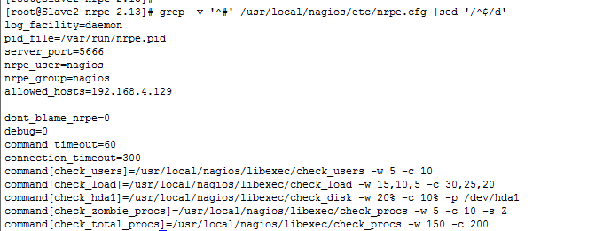

启动NRPE

/usr/local/nagios/bin/nrpe -c /usr/local/nagios/etc/nrpe.cfg –d

配置NRPE加入到服务列表：

编辑/etc/init.d/nrped，添加如下内容：

1. #!/bin/bash
2. # chkconfig: 2345 88 12
3. # description: NRPE DAEMON
5. NRPE=/usr/local/nagios/bin/nrpe
6. NRPECONF=/usr/local/nagios/etc/nrpe.cfg
8. case "$1" **in**
9. start)
10. echo -n "Starting NRPE daemon..."
11. $NRPE -c $NRPECONF -d
12. echo " done."
13. ;;
14. stop)
15. echo -n "Stopping NRPE daemon..."
16. pkill -u nagios nrpe
17. echo " done."
18. ;;
19. restart)
20. $0 stop
21. sleep 2
22. $0 start
23. ;;
24. *)
25. echo "Usage: $0 start|stop|restart"
26. ;;
27. esac
28. exit 0

chmod +x /etc/init.d/nrped

chkconfig –add nrped

chkconfig nrped on

service nrped start

1. 监控端安装NRPE

tar zxvf nrpe-2.13.tar.gz

./configure --with-nrpe-user=nagios --with-nrpe-group=nagios --with-nagios-user=nagios --with-nagios-group=nagios --enable-command-args --enable-ssl

make all

make install-plugin

1. 测试安装：

cd /usr/local/nagios/libexec

./check_nrpe -H 192.168.4.105 -c check_load

有以下结果证明没有问题：

OK - load average: 0.37, 0.40, 0.32|load1=0.370;15.000;30.000;0; load5=0.400;10.000;25.000;0; load15=0.320;5.000;20.000;0;

1. 定义命令：

cd /usr/local/nagios/etc/objects/

添加以下内容到commands.cfg:

1. define command{
2. command_name    check_nrpe
3. command_line    $USER1$/check_nrpe -H "$HOSTADDRESS$"  -c "$ARG1$"
4. }
5. 定义服务：

添加以下内容到/usr/local/nagios/etc/objects/test.cfg

define host{

use linux-server

host_name Slave

alias My Linux Server

address 192.168.4.105

}

define service{

use generic-service

host_name Slave

service_description CHECK USER

check_command check_nrpe!check_users

}

define service{

use generic-service

host_name Slave

service_description Load

check_command check_nrpe!check_load

}

define service{

use generic-service

host_name Slave

service_description sda

check_command check_nrpe!check_hda1

}

define service{

use generic-service

host_name Slave

service_description zombie_procs

check_command check_nrpe!check_zombie_procs

}

define service{

use generic-service

host_name Slave

service_description total_procs

check_command check_nrpe!check_total_procs

max_check_attempts 1

normal_check_interval 1

notification_interval 1

}

1. 启动所定义的命令和服务：

编辑/etc/local/nagios/etc/nagios.cfg，增加一行：

cfg_file=/usr/local/nagios/etc/objects/test.cfg

1. 重新启动nagios服务，然后每个一分钟会收到邮件告警

service nagios restart

1. 最后附上服务监控web页面：

