创建或更改表，要吧view sql 里面的语句全部拿过去执行。包装约束，索引，注释都能更新过去

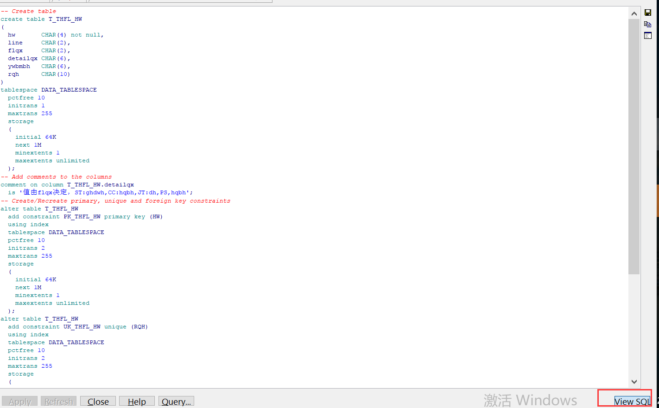

2017-8-5

t_dh_yfsj 增加check约束

t_fjrwb.sjsl default=0

t_fjrwb.gbth 变6位

t_fjrwb_bf.gbth 变6位

PROC_SX_JSKHTH_XTW2

t_thflorder

t_thfl_hw

t_pmsjrwb

t_pmsjrwb_bak

drop procedure PROC_WLFL_ALL

drop procedure PROC_WLFL_ALL_NEW

t_pmsjrwb,t_pmsjrwb_bak

RF_XJHG

RF_XJJH_OK

PROC_FYJH_ZDTJ_NIE

PROC_SJRW_DEVIDERQH

PROC_GOO_DHLR_YX_DJTJ_LV

RF_XJJH_ONEFLOWID

RF_SRDHRQCL

PROC_SX_TH_SJ

PROC_SX_TH_SJ_ZJXJ

PROC_GOO_DHLR_YX_DJTJ_YY

PROC_SX_DHGZ_YY

PROC_SX_DHGZ_XTW

PROC_KHTH_BTP2

PROC_OCCUPYTHFL

PROC_THFLCHANGERQH

PROC_THFLPACK

PROC_THFL

PROC_SX_THFL_TJ_XTW2

8-30

PROC_SX_JSCKZL_XTW 1380行，735

drop table t_xjrwb_temp

PROC_KFZYDD_XTW

RF_KFRWSL

9-2

T_hqdy

t_agvhz

t_agv_rw_xt

t_agv_rw_xt_bak

RF_SJHG

RF_XJHG_NEW -停用

RF_XJHG ---停用

RF_XJHG_HX --停用

PROC_OCCUPY_XJRW --停用

修改agv_bak_trigger

---

PROC_OCCUPYXJRW2

RF_XJHG2

RF_XJHG_HX2

RF_XJJH_ONEFLOWID

create table T_AGV_RW_XT_bak2

as select * from T_AGV_RW_XT where 1=2

create table t_hqpickclass as

select distinct jllx ,jlmc from t_hqdy where jllx is not null

TRIGGER_UPDATE_LTKF

9-7

RF_HWTZ_HW

RF_HWTZ_KC

9-12

t_dhfltask.zjs

RF_CBDD_Confirm

RF_HY

RF_XJHG2

RF_XJHG_HX2

9-17

Drop table t_pmsjrwhz

Create table t_pmsjhz

t_pmsjrwb_bak

t_pmsjrwb

PROC_GOO_DHLR_FL_ZJS4

RF_SRDHRQCL

RF_SJHG

PROC_WLFL_ALL_NEW_SX_YANGYI

PROC_OccupyPmsjrwb  
--PROC_SJRW_DEVIDERQH

PROC_PILIANG_SJ

新

2017-9-21

PROC_GOO_DHLR_FL_ZJS4

RF_SRDHRQCL

RF_SJHG

--PROC_GOO_DHLR_YX_DJTJ_YY

PROC_GOO_DHLR_YX_DJTJ_LV

9-26

RF_RQXXCX

RF_CBDD_Confirm

10-9

PROC_OCCUPYXJRW2

10-10

T_TLDJHZ_STATE

PROC_ADDTLDJHZ

PROC_UPDATETLDJHZ

PROC_OCCUPYTHFL 贵州改

PROC_THFLPACK 贵州改

PROC_OccupyPmsjrwb 贵州已替

10-25

PROC_GOO_DHLR_FL_ZJS4 贵州已替

RF_SRDHRQCL 贵州已替

PROC_THFL 贵州改

11-5

RF_HWTZPILIANG

PROC_GOO_DHLR_YX_DJTJ_LV;

11-25

PKG_PUBLIC_FUNC

PROC_KFZYDD_DSFP_XTW

12-8

RF_XJHG_HX2 增加记录下架件数工作量

RF_XJHG2 增加记录下架件数工作量

12-12

商流 T_YTPCH 增加字段 bindrq DATE

PROC_KHTH_BTP

12-27

PROC_OCCUPYXJRW2

2018-1-4

Create table T_TASKLACK

Create table t_lkchecktask

RF_SJHG

2018-1-7

t_ltkf_change

RF_XJHG2

2018-1-8

RF_XJHG_HX2

RF_HX_BZ2

RF_XJHG2

T_dfbj. fyth_date-> T_dfbj.wcrq

PROC_WRITE_FHMX_XTW

RF_KFCYCL

PROC_OCCUPYCYCL

2018-1-11

PROC_KFZYDD_DSFP_XTW

T_AGV_RW_XT dbbz,xbbz 可空

T_PF_TEMP_LVB dbbz,xbbz 可空

T_PF_TEMP dbbz,xbbz 可空

t_agv_rw_xt_bak dbbz,xbbz 可空

2018-1-12

RF_HWTZ

2018-1-15

PROC_THFL 贵州

2018-1-16

RF_CBQY

RF_CBTY

RF_CBDD_Confirm2

PROC_OccupyTY

2018-1-18

PROC_JOB_TLDJHZ

PROC_GOO_DHLR_FL_ZJS4

Create table T_FLRecord

2018-2-22

PROC_OccupyTY

2018-4-23

RF_KFCYCL

PROC_SX_JSCKZL_XTW

PROC_SX_JSDHSJ_ZFZDCL

PROC_KFZYDD_OCCUPY

增加临时表

create global temporary table T_NEEDRUNYWBM

(

ywbmbh CHAR(6)

)

on commit preserve rows;

增加t_autocreatexj

t_autocreatexjrecord

T_KFZYDD

t_autocreatexjerrmsg

PROC_AUTOCREATEXJ2

T_wl_exe 增加 ‘PROC_AUTOCREATEXJ2’

T_SYSSET 增加字段

增加类型CREATEXJ

select * from T_SYSSET t where lx ='CREATEXJ'

T_THJH, T_THJH_PRE , T_THJH_PRE_BAK 增加yxj字段

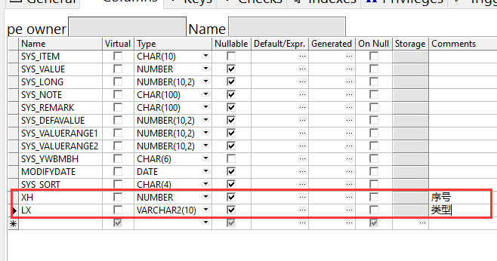

T_thjh_bak 修改dj字段为yxj

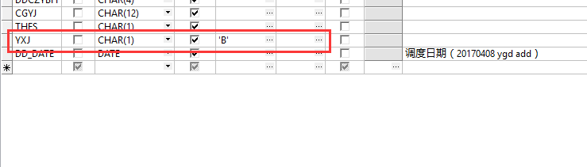

PROC_FHDD_XD_HF

PROC_KFZYDD_DSFP_XTW

删除t_thjh_bak 的触发器

2018-5-3

RF_XJHG2

PROC_OCCUPYXJRW2

2018-5-7

CREATE OR REPLACE VIEW V_AGV

PROC_OCCUPYXJRW2

T_THJH_LV 增加YXJ 字段

2018—5-21

select sys_value from T_SYSSET t where sys_item='RESUME' 增加记录

2018-6-7

T_MENU 增加form字段

t_user_menu 增加form字段

t_group_operator 增加form字段

修改V_CDXZ

增加 table t_loginrecord

2018-6-8

修改t_user表结构

增加科室表 t_office

增加班组表t_officeteam

增加序列 SEQ_OFFICE

2018-6-13

增加 t_gzl2

增加 t_gzltimes

增加 T_JOB

RF_CBDD_Confirm2

PROC_GOO_DHLR_FL_ZJS4

proc_goo_dhlr_tj_zjs2

RF_RFBZ2

T_pxmx 增加ysczy字段

RF_HX_BZ2

RF_XJHG2

RF_CBTY

RF_CBQY

RF_HY

T_PMSJRWB_BAK增加索引 IDX_ID_PMSJHZ

增加RF_SJHG2

增加字段hqlx

PROC_CONFIRMTLDJHZ

PROC_DELTLDJHZ

PROC_SX_JSKHTH_XTW2

T_KHTHBJ 增加ZCS 字段

PROC_SX_THFL_TJ_XTW

PROC_WLFL_NEW_YANGYI

T_wl_exe 增加定时任务PROC_DAILY_LOGINSPAN

PROC_FYJH_ZDTJ_NIE

rf_xjjh_ok

rf_xjjh_hykcsl

rf_xjjh_pxmx

PROC_SX_TH_SJ_ZJXJ

PROC_KFZYDD_XTW

修改TG_T_DFBJ

PROC_TH_XJ

T_FJRWSJB，T_FJRWSJB_BAK字段gh改成number类型

增加PROC_OccupyFJRWSJ

PROC_GOO_DHLR_YX_DJTJ_LV

PROC_SX_DFBJ_JJ_XTW_TP

PROC_GOO_DHLR_YX_DJTJ_YY

2018-7-15

增加表t_slwlczybh商流物流录样书操作员工号对照

PROC_SAMPLEGZL

PKG_PURCHASE_ORDER_BEFOREHAND.PROC_STYLEBOOK_INSERT 商流

PKG_PURCHASE_ORDER_BEFOREHAND. PROC_STYLEBOOK_DELETE 商流

PKG_PURCHASE_ORDER_BEFOREHAND. PROC_DHDJ_SAVE 商流

proc_interface_dbsl3

PROC_SX_JSDHSJ_ZFZDCL

PROC_SX_DFBJ_JJ_XTW_TP

PROC_SX_DFBJ_JJ_XTW

proc_lt_jk_bz

2018-7-28

TG_T_DFBJ

RF_XJHG2

2018-8-1

PROC_JOB_TLDJHZ

2018-8-6

RF_HY-青海改

RF_CBDD_Confirm2-青海改

PROC_SX_JSCKZL_XTW -青海改

2018-8-7

PROC_KFZYDD_DSFP_XTW 改bug

2018-8-15

t_zprwhz 增加字段ZPCZY，ZPCZYNAME

t_zprwhz 增加主键

RF_ZPOCCUPY

RF_RFBZ2

RF_HX_BZ2

proc_goo_dhlr_tj_zjs2

2018-8-30

RF_XJJH_PXMX

RF_XJJH_HYKCSL

2018-9-30

RF_KFCYCL

河北样本室用，增加RF_RW_XD 、PROC_GETMESS

2018-10-11

PKG_PUBLIC_FUNC. PROC_GET_KYKC_NO

fun_getkykc_sl

PROC_SD_JSCKZL_XTW

2018-10-12

T_dfbj.cyr_tele 改数字类型。用作下架任务编号

RF_XJHG2

T_dfbj.CYR_TELE 增加索引

2018-10-13

通版83

**t_line_zp_hw2.counter 不可空，默认0**

**T_LINE_ZP_HW2.line 不可空**

**t_line_zp_hw2 增加xh字段**

**t_line_zp_hw2**增加唯一索引IDX_LINE_ZP_HW2_XH

**t_line_zp_hw2**增加索引IDX_LINE_ZP_HW2_YWBMBHDH

PROC_GOO_DHLR_FL_ZJS4

**PROC_CREATE_WLFL_XTW4**

2018-11-7

122.14.202.136 D:\物流通版数据库

增加T_KHTHLRMX

增加PROC_XTLR

2018-11-13

ALTER TABLE T_PKLS_SL_LV RENAME TO T_PKLS_SL_record

T_PKLS_SL_RECORD增加索引 IDX_PKLS_SL_RECORD

RF_PKLR 重庆

create table t_pkjhtask 重庆

RF_PKJH 重庆

PROC_BFJH_AUTO_ONEHW20 重庆

PROC_PKTZ_WL 重庆

2018-11-29

PROC_THFL 贵州改bug

2018-12-12

T_LINE_GROUP 增加字段DEST

T_ZPRWHZ增加字段zt

T_ZPRWHZ增加唯一索引IDX_ZPRWHZ

**增加序列SQ_TRANSRECORD**

**PROC_GOO_DHLR_FL_ZJS4**

44行增加v_flowid number;

371行 增加

select min(flowid) into v_flowid from t_zprwhz where rqh=p_xhao and zt='0';

if v_flowid is null then

select all_flowid.Nextval into v_flowid from dual;

insert into T_ZPRWHZ

(flowid, rqh, lxbh, kfbh, ywbmbh, yssl, zpz, createdate, ysczybh, ysname )

values

(v_flowid, p_xhao, 'FL', v_dhdj.kfbh, v_dhdj.ywbmbh,0, 0,

sysdate, p_czybh, (select trim(name) from t_user where usr_id = p_czybh) );

update t_transrecord set finished='9' where rqh=p_xhao and finished='0';

insert into t_transrecord

(taskid, rqh, dest, finished, tablepk, tablename, procname)

values

(SQ_TRANSRECORD.Nextval, p_xhao,

(select dest from t_line_group where GROUPNUM=trim(v_dh_yfsj.detailqx) ),

'0', v_flowid, 't_zprwhz', 'PROC_GOO_DHLR_FL_ZJS4');

end if;

432行增加

update T_ZPRWhz set ( yssl, zpz, linesnum )=(select sum(yssl),count(distinct id),count(distinct ln_zp_no)

from t_zprw where ID_ZPRWHZ=v_flowid)

where flowid=v_flowid;

RF_ZPOCCUPY

98行增加

update t_zprwhz set zt='1' ,exedate=sysdate,zpczy= p_czybh where rqh=p_ysrqh and zt='0';

if sql%notfound then

errno := -1;

errtext := '占用任务失败';

rollback;

Return;

end if;

注释此语句和之后的内容

*select count(*) into v_rows from t_zprw where zpxyrqh=p_ysrqh and ID_ZPRWHZ is not null;*

RF_RFBZ2

366行增加

update t_zprwhz set sjsl=sjsl+p_sjsl

where flowid=v_zp.Id_zprwhz;

396行

修改update t_zprwhz

改为update t_zprwhz set finishdate=sysdate,finished=1,zt='2'

where flowid=v_zp.Id_zprwhz;

增加PROC_SETJHCSBYWEIGHT_PT 西安测试

**2018-12-17**

PROC_GOO_DHLR_FL_ZJS4

PROC_SETJHCSBYWEIGHT_PT

t_weightrecord

t_transrecord

2019-3-19

重庆改

T_TLDJHZ_STATE增加字段 HYDATE ，CBFINISHDATE

RF_HY 增加

update t_tldjhz_state set hydate=sysdate where flowid_tldjhz=p_flowid_tldjhz;

RF_CBDD_Confirm2 增加

update t_tldjhz_state set cbfinishdate=sysdate where flowid_tldjhz=p_flowid_tldjhz;

2019-3-22

t_dh_yfsj增加字段flowid_tldjhz

t_dh_yfsj_bak增加字段flowid_tldjhz

增加字段后proc_goo_dhlr_tj_zjs2 会有报错，解决下

t_dhfltask增加字段 device 默认PC, 分流设备，PC,RF

T_FLRecord 增加字段detailqx

增加RF_DHFL，RF_OCCUPY_DHFL，RF_DHFL_TJ

2019-4-12

RF_XJHG2 260行 Insert Into T_DFBJ 语句，fhyxj使用v_agvhz.yxj插入

PROC_DYTT_FH_LN 增加参数 p_yxj out varchar2,

33行 增加

if v_dfbj.fhyxj='A' then

p_yxj:='加急';

end if ;

2019-4-13

修改RF_HY 在 errno := 0;语句前增加

update t_dhfltask t set device='RF' where flowid_tldjhz= p_flowid_tldjhz and

(select count(distinct s.dh) from T_SL_YFSJ s,tmp_dhdj j where t.flowid_tldjhz=j.flowid_tldjhz

and s.flowid_dj=j.flowid_dj ) <4

RF_CBDD_Confirm2 增加

update t_dhfltask t set device='RF' where flowid_tldjhz= p_flowid_tldjhz and

(select count(distinct s.dh) from T_SL_YFSJ s,tmp_dhdj j where t.flowid_tldjhz=j.flowid_tldjhz

and s.flowid_dj=j.flowid_dj ) <4

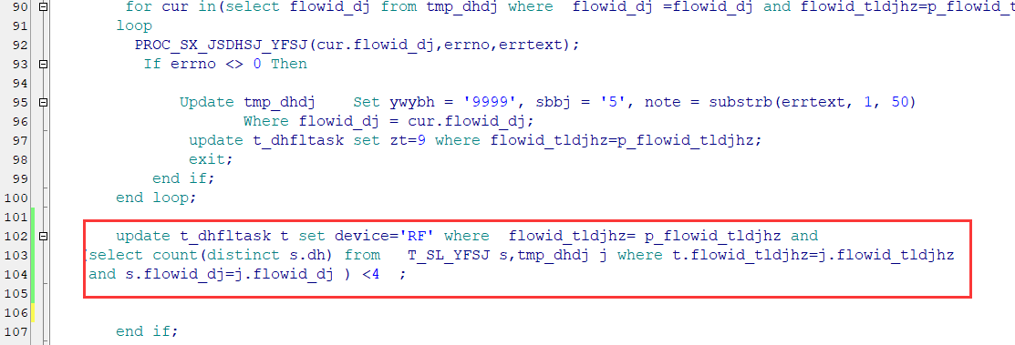

2019-5-15

修改RF_OCCUPY_DHFL，增加

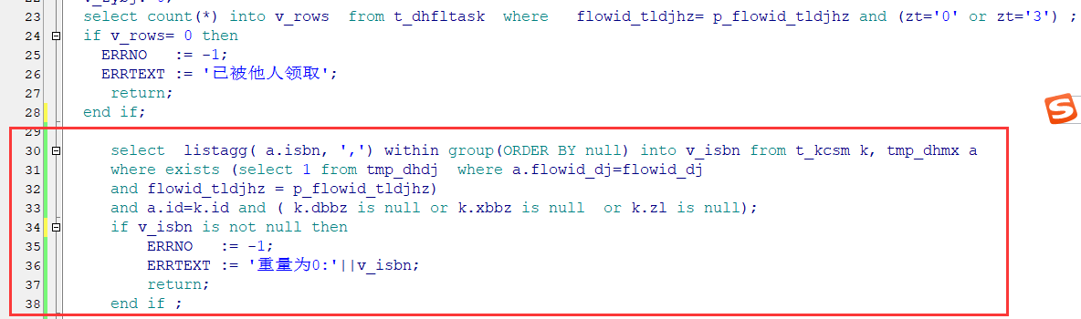

select listagg( a.isbn, ',') within group(ORDER BY null) into v_isbn from t_kcsm k, tmp_dhmx a

where exists (select 1 from tmp_dhdj where a.flowid_dj=flowid_dj

and flowid_tldjhz = p_flowid_tldjhz)

and a.id=k.id and ( k.dbbz is null or k.xbbz is null or k.zl is null);

if v_isbn is not null then

ERRNO := -1;

ERRTEXT := '重量为0:'||v_isbn;

return;

end if ;

2019-6-14

修改PROC_SX_DHGZ_XTW（西安市店）

2019-7-9 西安市店已改

修改PROC_GOO_DHLR_FL_ZJS4

241行

Update T_DFBJ

Set ZCS = zcs + v_bccs, ZMY = zmy + v_bccs * v_dhmx.dj,

ZSY = ZSY + v_sys, ZZL = zzl + v_bccs * v_dhmx.zl

Where rqh = p_xhao and ywbmbh=v_dhdj.ywbmbh and dh=cur.dh and wcbj='1' and ybzbj='0';

387行

select min(flowid) into v_flowid from t_zprwhz where rqh=p_xhao and ywbmbh=v_dhdj.ywbmbh and zt='0';

492行

select min(flowid) into v_idpmsjhz from t_pmsjhz where rqh=p_xhao and ywbmbh=v_dhdj.ywbmbh and finished='0';

修改RF_DHFL

247行

select min(bjlsh) into v_bjlsh from T_DFBJ Where rqh = p_xhao and dh=v_dh_yfsj.dh and ywbmbh=v_dhdj.ywbmbh and wcbj='1' and ybzbj='0';

350行

select min(flowid) into v_idpmsjhz from t_pmsjhz where rqh=p_xhao and ywbmbh=v_dhdj.ywbmbh and finished='0';

修改T_PMSJHZ的索引IDX_PMSJHZ

修改T_ZPRWHZ的索引IDX_ZPRWHZ