上架——RF\_SJHG

下架——RF\_XJHG\_NEW

调度下架——proc\_fhdd\_xd\_ready，PROC\_FHDD\_XD\_HF

特殊发货下架-- PROC\_TSFHDD\_XD\_READY PROC\_KFZYDD\_READY\_XTW

PROC\_KFZYDD\_DSFP\_XTW\_TS PROC\_KFZYDD\_XTW

校核提交 校核确认 PROC\_FYJH\_ZDTJ\_NIE

包件交接——PROC\_SX\_DFBJ\_JJ\_XTW

绑托盘——PROC\_SX\_DFBJ\_JJ\_XTW\_TP

播种——RF\_RFBZ

t\_line\_zp\_hw, T\_LINE\_ZP

——PROC\_GOO\_YH\_WDB\_SAVE

拆包调度——Form\_Sch\_CBDD ——PROC\_Sch\_CB

拆分台分流——frm\_Goo\_CBTLR\_DHFL\_EDIT\_SD——提交proc\_goo\_dhlr\_tj\_zjs, PROC\_GOO\_DHLR\_FL\_ZJS

PROC\_GOO\_DHLR\_MX\_SAVE\_ZJS, proc\_create\_wlfl\_xtw

create table t\_linezp\_datarecord(hw char(4),dh char(6),flowid\_dj number(10))

PROC\_GOO\_DHLR\_FL\_ZJS2

PROC\_CREATE\_WLFL\_XTW2

收容 RF\_SRDHRQCL

拒退包装PROC\_JT\_BZ

Rf领取拆包任务 RF\_CBDD\_ZY2

货源退货货位解绑 PROC\_HYTHQHW\_SAVE

连锁店退货包件绑定查询proc\_searchkhthbj

Form\_Sys\_jtchwMain\_ljy

Select JXFS From T\_YWBMJXFS

TG\_T\_SYSSET

退货分流PROC\_WLFL\_NEW\_YANGYI,提交PROC\_SX\_THFL\_TJ\_XTW

Server\_GoosArrival

RF\_ZDTHXJ

insert into t\_hwdy

select '061111111', kfbh, lc, hqbh, hwrl, hwlx, hwyxj, pxhw, xdfl, yxhw, zybj, thhwbj, zyhwbj, dhwbj, dxhwbj, fjxd, xd, hh, jh, ch, syrl, xqbh

from t\_hwdy where hw='060032311'

Select (Select Name From t\_user Where usr\_id = czybh) 姓名, czybh,Count(Distinct id) 品种数,

Count(\*) 次数, Sum(pkcs) 总册数

From t\_pkls\_sl

WHERE

PKRQ< to\_date('2016/10/6 00:00:00','yyyy/mm/dd hh24:mi:ss')

Group By czybh order by 总册数

insert into t\_fjrwb

select flowid\_fjrwb, ywlx, ysxm, ghdwh, hqbh, ywbmbh, cybh, kfbh, id, dbbz, xbbz, gkh, mdxm, ywsl, sylx, zjxs, thzk, flqxmc, hw, sjsl, flqx, ywpch, sl, yflbj, flowid\_xhdytsj\_qdb, dh, gbth, zl, cgyj, kts, pch, fjfs, yclbj, xtpch, ytpch, bh, zrkfbh, xszk, dbdh, xszjxs, gbsl, pssl, tjrq, gbczybh, rece\_rq, reason, isbn, sm, dj, ydcs, sylx\_xt, flowid\_fjrwb\_sl, xxsl, pk

from T\_FJRWB\_bak

退货上架 PROC\_SX\_TH\_SJ

退货下架,换箱 PROC\_TH\_XJ

PROC\_GOO\_DHLR\_YX\_MX\_SAVE\_YY

PROC\_SX\_ZDFYJH\_NEW\_XTW

确认发运计划 proc\_sx\_qrfyjh\_yy

制定发运计划查询——PROC\_SX\_DFBJ\_FY\_XTW

dbsl.t\_xhd\_xhqpmx.flowid\_mx= dbsl.t\_dpls.ysddlsh

dbsl.t\_dpls.dbdh=t\_fhrwb\_bak.cgyj

加库存的存储过程 srkc

批量货架调整PROC\_HJTZ

t\_jobtype

t\_location2node

t\_ghdw\_hythq

---------------------------

Microsoft Visual Studio

---------------------------

无法自动进入并单步执行服务器。未能调试远程过程。这通常说明未在服务器上启用调试。有关详细信息，请参阅“帮助”。

---------------------------

确定 帮助

C:\Users\Administrator\Documents\Tencent Files\524612604\Image\C2C\9[O~_80W4W%ZJA{LERYN6$K.png

Select Count(\*)

Into v\_rows

From t\_agv\_rw\_xt\_bak

Where flowid\_xj = v\_zp.flowid\_zp;

RF\_ZPOCCUPY

insert into t\_line\_zp\_hw2 select h.ln\_zp\_no||substr(ln\_zp\_hw,7,2),

h.ln\_zp\_no,ln\_zp\_dh,ln\_zp\_xhao,0,'1',l.ln\_zp\_mc,'000001','0' from t\_line\_zp\_hw h, t\_line\_zp l

where h.ln\_zp\_no=l.ln\_zp\_no

PROC\_BACKDATA\_COMPUTEHW

T\_ADD\_TRANSPORT\_TASK

T\_TRANSPORT\_TASK\_FAIL

主配绑箱子PROC\_BINDRQH

PROC\_BINDRQH

PROC\_PCPROFILE

商流可用库存

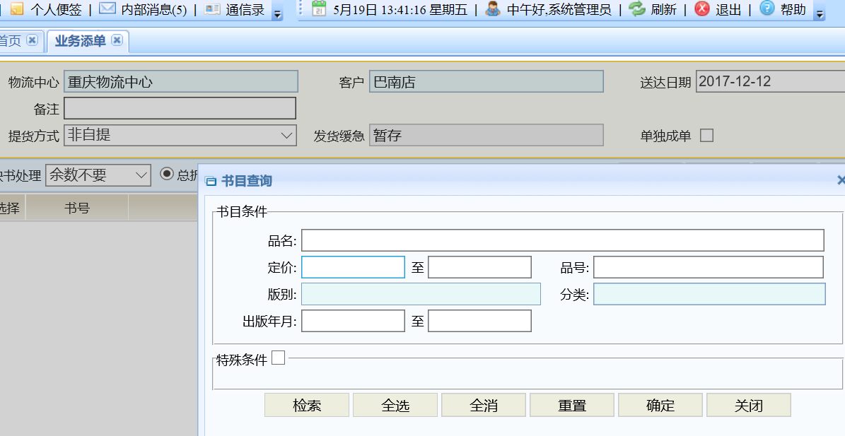

PKG\_PUBLIC\_FUNC。PROC\_GET\_KYKC

PKG\_PUBLIC\_FUNC。PROC\_GET\_KYKC\_NO

RF\_HWTZ\_HW

退货计划筛选 PKG\_XTMXSZ 。PROC\_INSERT\_TMP\_ZNJHTH

Insert Into t\_tmp\_znjhth1

退货计划保存 PKG\_XTMXSZ 。PROC\_SAVE\_JHTH

Update t\_tmp\_znjhth

退货计划提交 PKG\_XTMXSZ 。PROC\_MAKE\_TMP\_THJH

Insert Into t\_tmp\_thjh From t\_tmp\_znjhth

*定时处理过程 proc\_sx\_main\_xtw中会调用:PKG\_AUTO\_EXEC.PROC\_THJH\_AUTOCL(errno,errtext);*

*Insert tm\_thjh from* t\_tmp\_thjh

*Insert t\_dpls*

特殊发货调度

循环每个选择的单据

update t\_fhrwb set ddczybh = '" + Pama.WORKER.Trim() + "' WHERE YSDJH = '"+Pama.YSDJH.Trim()+"'

PROC\_KFZYDD\_READY\_XTW 计算库存是否满足，不满足取消勾选

退货计划-循环每个原始单

PROC\_THJH\_XD\_READY

PROC\_KFZYDD\_DSFP\_XTW