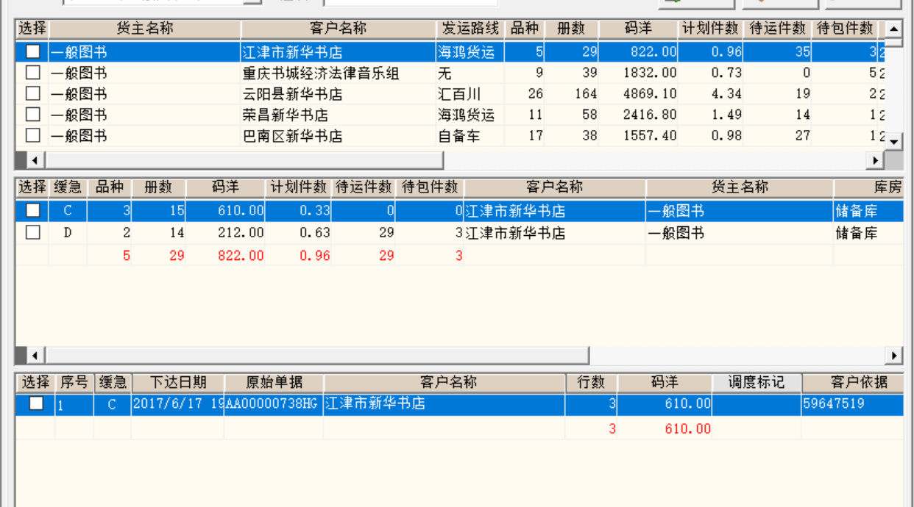

窗口1 选店

FROM T_FHRWB

WHERE T_FHRWB.QSCLFS <> '2'

AND T_FHRWB.QSCLFS <> '3'

and ddczybh is null

and bdbj = '0'

and qsclfs in ('1', '0')

and :ls_ywbmbh like '%' || trim(ywbmbh) || '%'

GROUP BY T_FHRWB.CYBH, T_FHRWB.YWBMBH, T_FHRWB.DH, T_FHRWB.KFBH

order by fhyxj

窗口2 选优先级

FROM T_FHRWB

where T_FHRWB.QSCLFS <> '2'

AND T_FHRWB.QSCLFS <> '3'

AND bdbj = '0'

and T_FHRWB.DH = :ls_dh

and :ls_ywbmbh like '%' || trim(ywbmbh) || '%'

and cybh = :ls_cybh

GROUP BY T_FHRWB.CYBH,

T_FHRWB.YWBMBH,

T_FHRWB.DH,

T_FHRWB.FHYXJ,

T_FHRWB.KFBH

ORDER BY T_FHRWB.FHYXJ ASC

窗口3 选原始单据

FROM "T_FHRWB", "T_DM"

WHERE "T_FHRWB"."DH" = "T_DM"."DH"

AND ("T_FHRWB"."KFBH" = :KFBH)

AND ("T_FHRWB"."CYBH" = :CYBH)

AND ("T_FHRWB"."FHYXJ" = :YXJ)

AND ("T_FHRWB"."DH" = :DH)

AND ("T_FHRWB"."YWBMBH" = :YWBMBH)

and (qsclfs <> '2' and qsclfs <> '3')

AND bdbj = '0'

GROUP BY "T_FHRWB"."YSDJH",

"T_FHRWB"."KFBH",

"T_FHRWB"."YWBMBH",

"T_FHRWB"."QSCLFS",

"T_FHRWB"."FHYXJ"

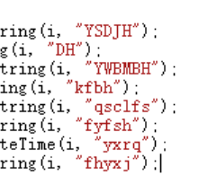

下达传入二维数组

后台循环调用PROC_FHDD_XD_READY

proc_kfzydd_lock

Update t_fhrwb Set ddczybh = v_worker

Where Trim(ysdjh) = Trim(v_ysdjh) And Trim(dh) = Trim(v_dh) And ddczybh Is Null And Trim(kfbh) = Trim(v_kfbh) And Trim(ywbmbh) = Trim(v_ywbmbh) And Trim(qsclfs) = Trim(s_qsclfs);

出循环调用 PROC_FHDD_XD_HF

DELETE FROM t_pf_temp WHERE trim(pfczybh) = v_worker;

proc_kfzydd_dsfp_xtw

Insert Into T_PF_TEMP

From T_FHRWB a, t_kcsm b

Where a.id = b.id And Trim(a.ddczybh) = Trim(v_czybh);

T_PF_TEMP。pfczybh= T_FHRWB。Ddczybh

根据ltkf 拆分T_PF_TEMP，置货位和货区，xz=1

ltkf不满足的

Insert Into t_pf_temp_QS_XTW

From t_pf_temp Where flowid_fhrw = c1.flowid_fhrw;

删除不满足的t_pf_temp

Delete From t_pf_temp Where pfczybh = v_czybh And hqbh Is Null

选择分配好的任务准备下达

FROM "T_PF_TEMP"

WHERE "T_PF_TEMP"."PFCZYBH" = :WORKER

GROUP BY "T_PF_TEMP"."DH", "T_PF_TEMP"."FHYXJ", "T_PF_TEMP"."HQLX"

循环没有选择的任务。组成二维数组

后台循环调用

proc_fhdd_xd_ready

proc_kfzydd_lock

传入dh 优先级，货区类型，ysdj传入空，代表没选。这个if很傻逼。放这有屁用

If v_ysdjh Is Null Then

Update t_pf_temp Set xz = 0

Where Trim(pfczybh) = Trim(v_worker) And Trim(dh) =Trim(v_dh) And Trim(fhyxj) = Trim(v_yxj) And Trim(hqlx) = Trim(v_hqlx);

End If;

PROC_FHDD_XD_HF

proc_kfzydd_xtw

PROC_KFZYDD_CANCEL_XTW，缺书后够数量的恢复到fhrwb，主键变了

t_pf_temp没选择的的恢复到fhrwb，减ltkf，kcsl占用

删除没有选择的 t_pf_temp对应的t_fhrwb

Delete From T_PF_TEMP Where XZ = 0 And PFCZYBH = P_CZYBH;

用剩下的缺书写不满足单据

Delete From t_pf_temp_qs_xtw Where pfczybh = p_czybh;