Juicer-master-----github

SelectAll------www.codeproject.com

WPF-Samples-master------github

ZhiHuDaily.UWP-master----github

ZXing.Net.0.14.0.0-------codeplex

MvcMusicStore----------- codeplex

**Toggling the States of all CheckBoxes Inside a DataGridView Column------**

<https://www.codeproject.com/articles/42437/toggling-the-states-of-all-checkboxes-inside-a-dat>

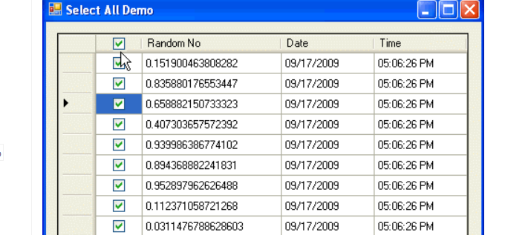

Wpf控件，multi-select-combobox ------ https://www.codeproject.com/articles/563862/multi-select-combobox-in-wpf

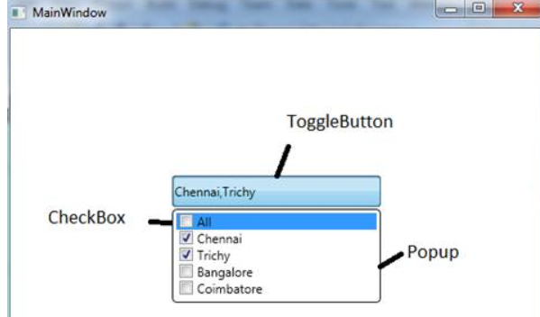

**Extending the DataGridView**

<https://www.codeproject.com/Articles/26263/Extending-the-DataGridView>