// Create a new ContextMenuStrip control.

fruitContextMenuStrip = new ContextMenuStrip();

可以绑定到多个控件

// Attach an event handler for the

// ContextMenuStrip control's Opening event.

fruitContextMenuStrip.Opening += new System.ComponentModel.CancelEventHandler(cms_Opening);

// Create a new ToolStrip control.

ToolStrip ts = new ToolStrip();

// Create a ToolStripDropDownButton control and add it

// to the ToolStrip control's Items collections.

ToolStripDropDownButton fruitToolStripDropDownButton = new ToolStripDropDownButton("Fruit", null, null, "Fruit");

ts.Items.Add(fruitToolStripDropDownButton);

// Assign the ContextMenuStrip control as the

// ToolStripDropDownButton control's DropDown menu.

fruitToolStripDropDownButton.DropDown = fruitContextMenuStrip;

// Create a new MenuStrip control and add a ToolStripMenuItem.

MenuStrip ms = new MenuStrip();

ToolStripMenuItem fruitToolStripMenuItem = new ToolStripMenuItem("Fruit", null, null, "Fruit");

ms.Items.Add(fruitToolStripMenuItem2);

// Assign the MenuStrip control as the

// ToolStripMenuItem's DropDown menu.

fruitToolStripMenuItem.DropDown = fruitContextMenuStrip;

// Assign the ContextMenuStrip to the form's

// ContextMenuStrip property.

this.ContextMenuStrip = fruitContextMenuStrip;

//Add a button to the form and assign its ContextMenuStrip.

Button b = new Button();

b.Location = new System.Drawing.Point(60, 60);

this.Controls.Add(b);

b.ContextMenuStrip = fruitContextMenuStrip;

// This event handler is invoked when the ContextMenuStrip

// control's Opening event is raised. It demonstrates

// dynamic item addition and dynamic SourceControl

// determination with reuse.

void cms_Opening(object sender, System.ComponentModel.CancelEventArgs e)

{

// Acquire references to the owning control and item.

Control c = fruitContextMenuStrip.SourceControl as Control;//绑定普通控件

ToolStripDropDownItem tsi = fruitContextMenuStrip.OwnerItem as ToolStripDropDownItem;//绑定到item时

// Clear the ContextMenuStrip control's Items collection.

fruitContextMenuStrip.Items.Clear();

// Check the source control first.

if (c != null)

{

// Add custom item (Form)

fruitContextMenuStrip.Items.Add("Source: " + c.GetType().ToString());

}

else if (tsi != null)

{

// Add custom item (ToolStripDropDownButton or ToolStripMenuItem)

fruitContextMenuStrip.Items.Add("Source: " + tsi.GetType().ToString());

}

// Populate the ContextMenuStrip control with its default items.

fruitContextMenuStrip.Items.Add("-");

fruitContextMenuStrip.Items.Add("Apples");

fruitContextMenuStrip.Items.Add("Oranges");

fruitContextMenuStrip.Items.Add("Pears");

// Set Cancel to false.

// It is optimized to true based on empty entry.

e.Cancel = false;

}

为contextMenuStrip1 设置点击处理函数

private void contextMenuStrip1_ItemClicked(object sender, ToolStripItemClickedEventArgs e)

{

if (e.ClickedItem.Text == "删除")

{

if (listView1.Items.Count == 0)

return;

if (listView1.SelectedIndices.Count == 0)

return;

foreach (ListViewItem lvi in listView1.SelectedItems)

lvi.Remove();

}

}

VS2008调试iis中的webservice时。应用程序池要选2.0. 是因为 webservice程序的.net framework 版本是3.5的原因？

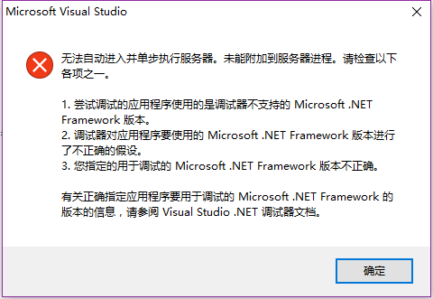

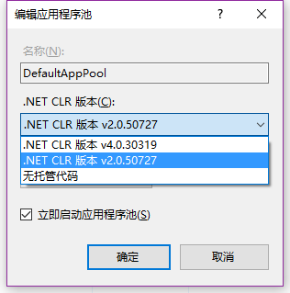

Webservice中的构造函数在每次调用其中的方式时都会首先被调用。静态构造函数没有被调用。

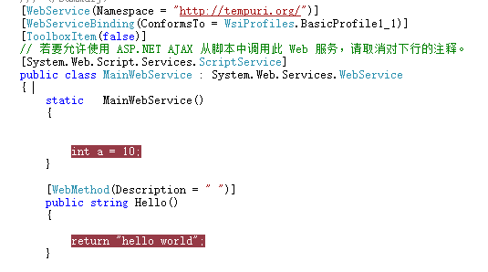

Binding b = new Binding("Enabled", checkBox1, "Checked");

b.DataSourceUpdateMode = DataSourceUpdateMode.Never; //txtpoint 的enable 状态不更新数据源

txtpoint.DataBindings.Add(b);

DataTable dt = new DataTable();

dt.Columns.Add("ytpch");

dt.Columns.Add("go");

dt.Rows.Add("1", "2");

dt.Rows.Add("2", "2");

string t =string.Join(",", dt.AsEnumerable().Select(s => s.Field<string>("ytpch")).ToArray());

int index = dataGridView1.Rows.Add();

dataGridView1.Rows[0].Cells[0].Value = 1;

dataGridView1.Rows[0].Cells[1].Value = "0";

DataGridViewCheckBoxColumn column0 = new DataGridViewCheckBoxColumn();

column0.HeaderText = "check";

dataGridView1.Columns.Add(column0);

DataGridViewTextBoxColumn column1 = new DataGridViewTextBoxColumn();

column1.HeaderText = "go";

dataGridView1.Columns.Add(column1);

dataGridView1.AutoGenerateColumns = false;

DataTable dt = new DataTable();

dt.Columns.Add("ytpch");//此方式添加的列默认是string类型

dt.Columns.Add("go");

dt.Rows.Add(0, "ytpch1");

dt.Rows.Add(1, "haha");

column0.FalseValue = "0"; //所以这里要用string

column0.TrueValue = "1";

dataGridView1.Columns[0].DataPropertyName = "ytpch";

dataGridView1.Columns[1].DataPropertyName = "go";

dataGridView1.DataSource = dt;

异步webservice

[WebMethod(Description = "haha")]

public DataSet QueryTable(string czybh, out string errMsg1)

{

errMsg1 = string.Empty;

Thread.Sleep(500);

string sql = "select name from t_user where usr_id=:p_czybh";

using (OracleConnection con = new OracleConnection(OracleHelper.LocalConnectionString))

{

con.Open();

。。。。。

}

}

service.QueryTableCompleted += new QueryTableCompletedEventHandler(service_QueryTableCompleted);

void service_QueryTableCompleted(object sender, QueryTableCompletedEventArgs e)

{

if (!string.IsNullOrEmpty(e.errMsg1))

{

MessageBox.Show(e.errMsg1);

return;

}

MessageBox.Show(e.Result.Tables[0].Rows[0][0].ToString());

}

private void button6_Click_1(object sender, EventArgs e)

{

service.QueryTableAsync("0001");

MessageBox.Show("zou");

}

QueryTableAsync 的第二个重载 public void QueryTableAsync(string czybh, object userState)

private void button6_Click_1(object sender, EventArgs e)

{

service.QueryTableAsync("0001","1");

}

private void button2_Click(object sender, EventArgs e)

{

service.QueryTableAsync("0001","2");

}

修改回调函数

void service_QueryTableCompleted(object sender, QueryTableCompletedEventArgs e)

{

if (!string.IsNullOrEmpty(e.errMsg1))

{

MessageBox.Show(e.errMsg1);

return;

}

if (e.UserState.ToString() == "1")

{

MessageBox.Show("左");

}

else if (e.UserState.ToString() == "2")

{

MessageBox.Show(" 右");

}

else

{

MessageBox.Show(e.Result.Tables[0].Rows[0][0].ToString());

}

}

Excel 批量导入

using ExcelDataReader;

private void button1_Click_1(object sender, EventArgs e)

{

OpenFileDialog dlg = new OpenFileDialog();

dlg.Filter = "(*.xls,*.xlsx )|*.xls;*.xlsx";

if (dlg.ShowDialog() != DialogResult.OK)

return;

using (var stream = File.Open(dlg.FileName, FileMode.Open, FileAccess.Read))

{

// Auto-detect format, supports:

// - Binary Excel files (2.0-2003 format; *.xls)

// - OpenXml Excel files (2007 format; *.xlsx)

using (var reader = ExcelReaderFactory.CreateReader(stream, new ExcelReaderConfiguration()))

{

ExcelDataSetConfiguration config = new ExcelDataSetConfiguration();

config.ConfigureDataTable = delegate(IExcelDataReader i)

{

// return new ExcelDataTableConfiguration();

return new ExcelDataTableConfiguration

{

UseHeaderRow = true,

};

};

// config.ConfigureDataTable = (i) => new ExcelDataTableConfiguration() { UseHeaderRow = true }; 和上面匿名委托等价

// 2. Use the AsDataSet extension method

DataTable dt = reader.AsDataSet(config).Tables[0];

// The result of each spreadsheet is in result.Tables

dt.TableName = "t_test2";

DataTable dt2 = dt.Clone();

DataColumn 的 DataType 必须和数据库表中的列类型一致。

数据库类型是char,excel生成的类型是decimal。结果 BulkInsertTable报错

foreach (DataColumn col in dt2.Columns)

col.DataType = typeof(string);

foreach (DataRow dr in dt.Rows)

dt2.ImportRow(dr);

StringBuilder sb = new StringBuilder();

foreach (ListViewItem lvi in listView1.Items)

sb.Append(lvi.SubItems[0].Text + ":" + lvi.SubItems[1].Text + ",");

sb.Remove(sb.Length - 1, 1);

errMsg = service.BulkInsertTable(sb.ToString(), dt2);

}

}

}

利用cache

public string GetPage(Dictionary<string, string> dic)

{

//replace(pic1,'\','/')

//param 格式 usr_id=:5000,bmbh=:3001

string totalCount = "";

CommonReturnValue crv = new CommonReturnValue();

StringBuilder ret = new StringBuilder();

if (dic["pageNumber"] == null)//检索，查询记录数为了生成分页

{

switch (dic["methodName"])

{

case "YibandinghuoJbsmQueryMX":

{

crv = GPsmgl.Instance.YibandinghuoJbsmQueryMX(dic, out totalCount);

}

break;

case "TicaidinghuoJbsmQueryMX":

{

crv = GPsmgl.Instance.TicaidinghuoJbsmQueryMX(dic, out totalCount);

}

break;

}

if (crv.ErrorCode != 0)

{

ret.Append("{\"count\":" + crv.ErrorCode + ",\"errortext\":\"" + crv.ErrorText + "\"}");

return ret.ToString();

}

ret.Append("{\"count\":" + totalCount + "}");

DataTable dt = crv.RealReturnValue as DataTable;

if (HttpRuntime.Cache[dic["cacheKey"]] != null)

{

HttpRuntime.Cache.Remove(dic["cacheKey"]);

}

HttpRuntime.Cache.Insert(dic["cacheKey"], dt, null, Cache.NoAbsoluteExpiration, new TimeSpan(0, 3, 0));

}

else

{

DataTable dt;

if (HttpRuntime.Cache[dic["cacheKey"]] == null)

{

switch (dic["methodName"])

{

case "YibandinghuoJbsmQueryMX":

{

crv = GPsmgl.Instance.YibandinghuoJbsmQueryMX(dic, out totalCount);

}

break;

case "TicaidinghuoJbsmQueryMX":

{

crv = GPsmgl.Instance.TicaidinghuoJbsmQueryMX(dic, out totalCount);

}

break;

}

if (crv.ErrorCode != 0)

{

ret.Append("{\"page\":[{\"error\":" + crv.ErrorCode + ",\"errortext\":\"" + crv.ErrorText + "\"}]}");

return ret.ToString();

}

dt = crv.RealReturnValue as DataTable;

HttpRuntime.Cache.Insert(dic["cacheKey"], dt, null, Cache.NoAbsoluteExpiration, new TimeSpan(0, 3, 0));

}

else

{

dt = (DataTable)HttpRuntime.Cache[dic["cacheKey"]];

}

int iPageSize = int.Parse(dic["pageSize"]);

int iPageNumber = int.Parse(dic["pageNumber"]);

int rowBegin = (iPageNumber - 1) * iPageSize;

int columnCount = dt.Columns.Count;

ret.Append("{ \"page\":[");

for (int i = rowBegin; i < rowBegin + iPageSize && i < dt.Rows.Count; i++)

{

ret.Append("{");

for (int c = 0; c < columnCount; c++)

{

ret.Append(" \"" + dt.Columns[c].Caption + "\":");

ret.Append(" \"" + dt.Rows[i][c].ToString() + "\",");

}

ret.Remove(ret.Length - 1, 1);

ret.Append("},");

}

if (ret[ret.Length - 1] == ',')

{

ret.Remove(ret.Length - 1, 1);

}

ret.Append("]}");

}

//拼接格式{ "page":[{ "USR_ID": "0001", "NAME": "超级管理员"},{ "USR_ID": "6019", "NAME": "强杏杏 "}]}

string strRet = ret.ToString();

return strRet;

}

: 已超过传入消息(65536)的最大消息大小配额。若要增加配额，请使用相应绑定元素上的 MaxReceivedMessageSize 属性

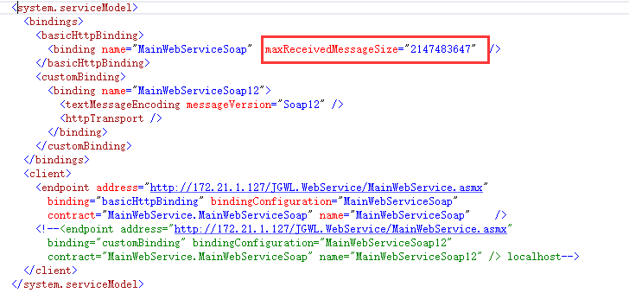

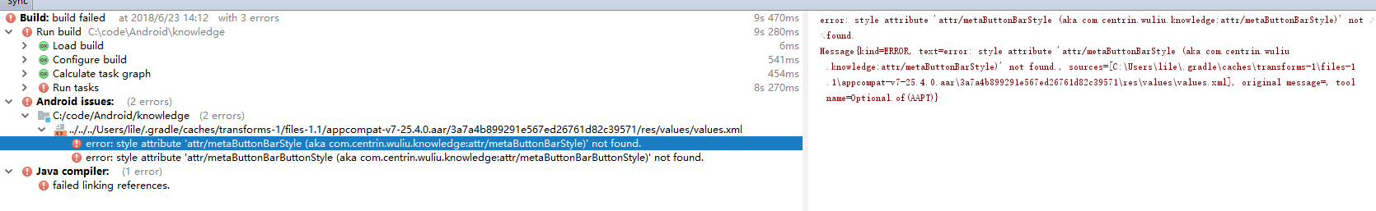

<https://stackoverflow.com/questions/11573947/error-error-no-resource-found-that-matches-the-given-name-attr-buttonbarbutt/14843198>

what I did in my Values folder added a attrs.XML file, with this codes in it:

*<!-- Declare custom theme attributes that allow changing which styles are  
 used for button bars depending on the API level.  
 ?android:attr/buttonBarStyle is new as of API 11 so this is  
 necessary to support previous API levels. -->*<**declare-styleable name="ButtonBarContainerTheme"**>  
 <**attr name="metaButtonBarStyle" format="reference"**/>  
 <**attr name="metaButtonBarButtonStyle" format="reference"**/>  
</**declare-styleable**>

启用noactionbar主题

**final** ActionBar ab = getSupportActionBar();  
**if** (ab **instanceof** WindowDecorActionBar) {  
 **throw new** IllegalStateException(**"This Activity already has an action bar supplied "** +  
 **"by the window decor. Do not request Window.FEATURE_SUPPORT_ACTION_BAR and set "** +  
 **"windowActionBar to false in your theme to use a Toolbar instead."**);  
}

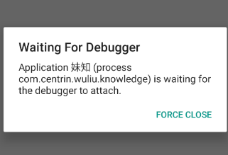

rf_sjhg 中报错rollback后，如果update t_pmsjrwb 没加 commit ; 会报错提取违反顺序

ORA-01002: 提取违反顺序

Update t_pmsjrwb Set sjczybh = '0001' Where tm = s_tm;

commit ;

For c1 In (Select * From t_pmsjrwb Where tm = s_tm) Loop

if trim(c1.hwh) is null then

select hw into c1.hwh from t_hwdy where hqbh =c1.hqbh and rownum=5;

end if ;

begin

rf_sjhg(c1.flowid_sj, c1.hwh, 0, ERRNO, errtext);

exception

When Others Then

errno := Sqlcode;

errtext := Sqlerrm;

end ;

End Loop;

**android:theme="@style/AppTheme.NoActionBar"**

Error inflating class android.support.design.widget.NavigationView

Didn't find class "android.support.design.widget.NavigationView"

加入引用 implementation **'com.android.support:design:27.1.1'** *//design support library*

动态加载菜单后，再执行setContentView，菜单会丢失

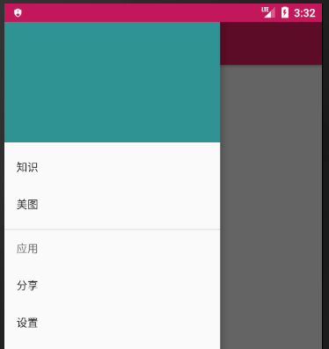 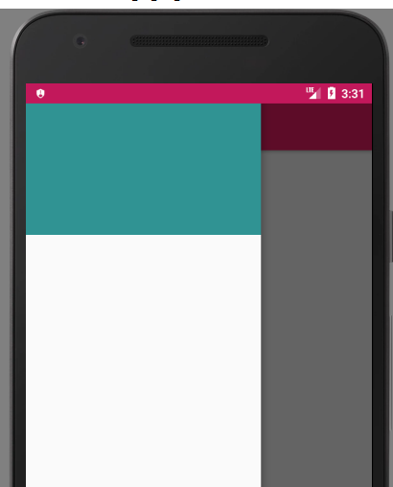

@Override  
**protected void** initViews() {  
 **super**.initViews();  
 setupDrawer();**navView**.inflateMenu(R.menu.***main_drawer***);  
 setContentView(R.layout.***activity_main***);  
 }

