<https://documentation.devexpress.com/XtraReports/2587/Detailed-Guide-to-DevExpress-Reporting/Introduction-to-Banded-Reports>

DevExpress reports follow a conventional banded report design advocated by Microsoft® Access® and adopted by many [other report engines](https://documentation.devexpress.com/XtraReports/1468/Getting-Started-with-DevExpress-Reporting/Adding-a-Report-to-Your-NET-Application/Converting-Third-Party-Reports-to-DevExpress-Reports).

The following image illustrates a sample report layout along with the [Report Explorer](https://documentation.devexpress.com/XtraReports/4258/Visual-Studio-Report-Designer/Dock-Panels-and-Designer-Options/Report-Explorer) reflecting its structure: 两张图片是同一个连续的报表

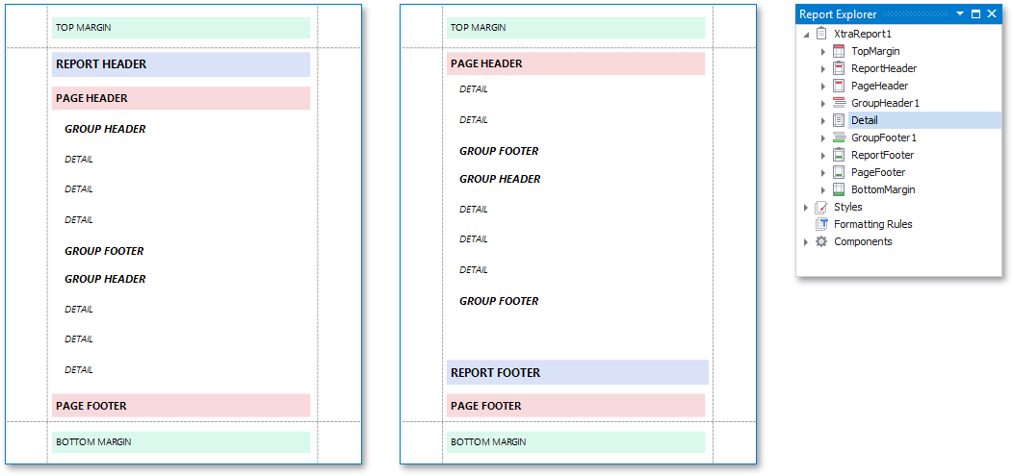

Another special band kind is the detail report band

You can display hierarchical information in a report in two different ways:

* by creating groups
* by using subreports

In essence, a detail report band is a separate report (subreport) with its own data source, detail and other bands.

The following image illustrates a master-detail report along with the Report Explorer reflecting its structure.

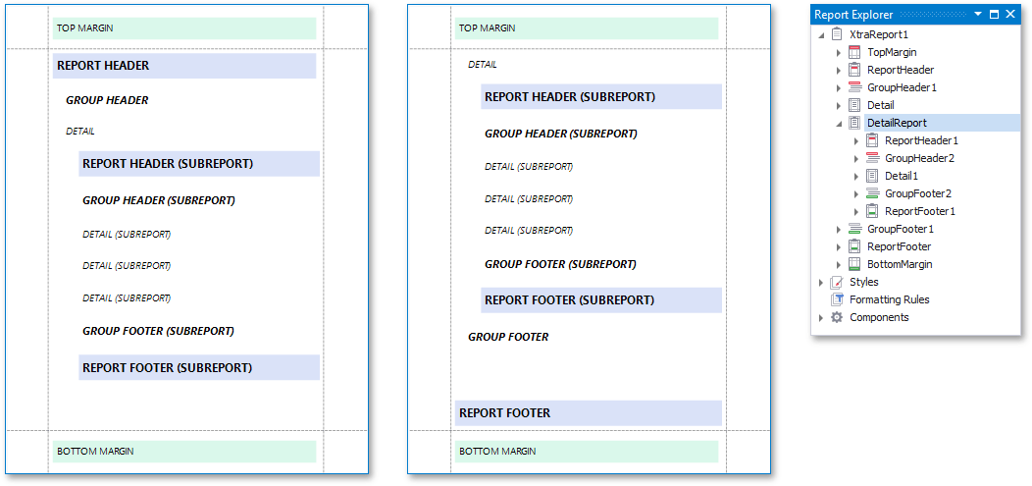

You can avoid printing a band's content in a document by setting its **Height** to a zero value or its **Visible** property to **false**.

After connecting a report to a data source, the available data fields become listed in the [Field List](https://documentation.devexpress.com/XtraReports/4259/Visual-Studio-Report-Designer/Dock-Panels-and-Designer-Options/Field-List), from where they can be dropped onto the report to create [data-aware controls](https://documentation.devexpress.com/XtraReports/1180/Detailed-Guide-to-DevExpress-Reporting/Providing-Data-to-Reports/Data-Binding-Overview/Binding-Report-Controls-to-Data).

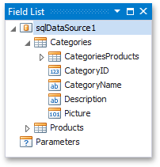

To reuse a data source in other reports, right-click it in the **Field List** or [Report Explorer](https://documentation.devexpress.com/XtraReports/4258/Visual-Studio-Report-Designer/Dock-Panels-and-Designer-Options/Report-Explorer) and add it to the [Report Gallery](https://documentation.devexpress.com/XtraReports/118624/Visual-Studio-Report-Designer/Dock-Panels-and-Designer-Options/Report-Gallery).

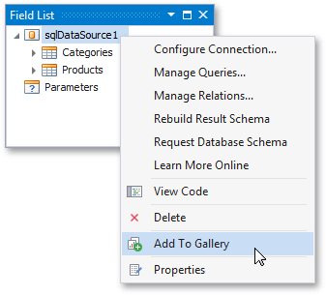

**Binding a Report without Loading Data at Design Time**

You can avoid loading actual data at design time while still being able to adjust the report's layout and bind report controls to data fields. The real data is loaded at runtime when the report is generated.

Use one of the following approaches to accomplish this task, depending on which data source is assigned to your report:

* [Bind a Report to a Data Source Schema](https://documentation.devexpress.com/XtraReports/4797/Detailed-Guide-to-DevExpress-Reporting/Providing-Data-to-Reports/Tutorials-and-Code-Examples/Bind-a-Report-to-a-Data-Source-Schema)
* [Bind a Report to a List Object at Design Time and Provide Data at Runtime](https://documentation.devexpress.com/XtraReports/7547/Detailed-Guide-to-DevExpress-Reporting/Providing-Data-to-Reports/Tutorials-and-Code-Examples/Bind-a-Report-to-a-List-Object-at-Design-Time-and-Provide-Data-at-Runtime)

**Create a Data Source Schema**

You can create an XSD file containing a schema of a data source, using the **WriteXmlSchema** method. For example:

|  |  |
| --- | --- |
| |  | | --- | | C# | |
| nwindDataSet ds = new nwindDataSet();  ds.WriteXmlSchema(@"C:/Temp/1.xsd"); |

**Assign the Data Source Schema to a Report**

expand the drop-down menu for the **DataSource** property and click **Add Report Data Source...**

• On the first page of the invoked [Data Source Wizard](https://documentation.devexpress.com/XtraReports/120164/Visual-Studio-Report-Designer/Data-Source-Wizard), select **Database** and click **Next**.

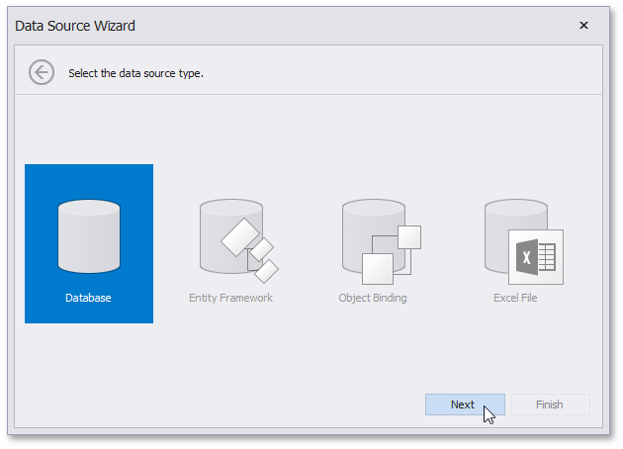

• The next page allows you to specify whether you want to use an existing data connection or create a new data connection. Select "**No, I'd like to specify the connection parameters myself**" and click **Next**.

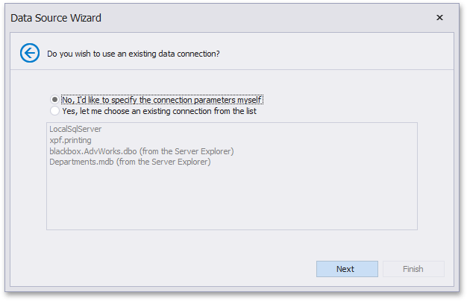

• On the next page, specify the data provider (**XML file**) and the path to the database schema file.

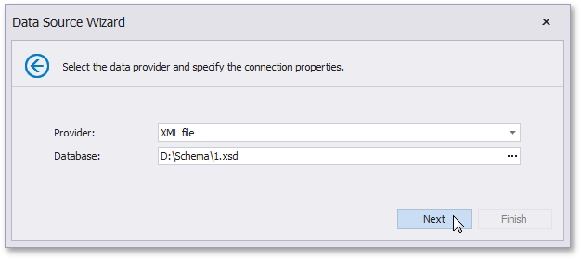

To proceed to the next wizard page, click **Next**.

• Click **Next** on the following page to save the created connection string to the configuration file.

• On the next page, you can select a table, view or stored procedure or construct a custom query using the [Query Builder](https://documentation.devexpress.com/XtraReports/17308/Visual-Studio-Report-Designer/Query-Builder).

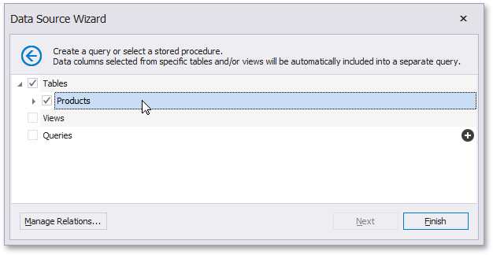

Note

Some of the data shaping capabilities available to SQL data sources (such as sorting, grouping and filtering data, as well as using aggregate functions) are not supported for XML files.

Click **Finish** in the **Data Source Wizard** to exit the wizard.

The newly created SQL data source will be displayed in the **Components** node of the [Report Explorer](https://documentation.devexpress.com/XtraReports/4258/Visual-Studio-Report-Designer/Dock-Panels-and-Designer-Options/Report-Explorer).

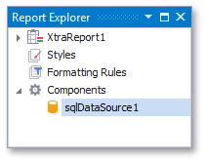

You can see the data source structure in the [Field List](https://documentation.devexpress.com/XtraReports/4259/Visual-Studio-Report-Designer/Dock-Panels-and-Designer-Options/Field-List) window.

<https://documentation.devexpress.com/XtraReports/7547/Detailed-Guide-to-DevExpress-Reporting/Providing-Data-to-Reports/Tutorials-and-Code-Examples/Bind-a-Report-to-a-List-Object-at-Design-Time-and-Provide-Data-at-Runtime>

This tutorial demonstrates how to bind a report to data that is available only at runtime using the **System.Windows.Forms.BindingSource** component.

Add a new class to the application (named **Data.cs**) with the following code.

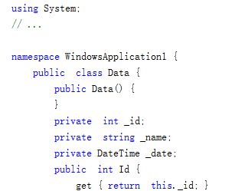

From the **Data** Toolbox tab, drop the **System.Windows.Forms.BindingSource** component onto the report.

After this, the report's [XtraReportBase.DataSource](https://documentation.devexpress.com/XtraReports/DevExpress.XtraReports.UI.XtraReportBase.DataSource.property) property is automatically set to **bindingSource1**.

The next step is to select the **bindingSource1** component and set its **DataSource** property to the **Data** type in the **Components** node of the [Report Explorer](https://documentation.devexpress.com/XtraReports/4258/Visual-Studio-Report-Designer/Dock-Panels-and-Designer-Options/Report-Explorer).

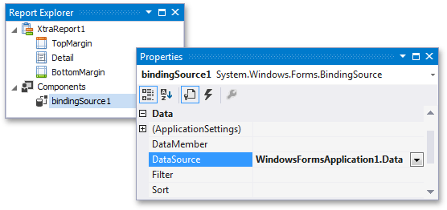

To bind the band to a data source, click its [smart tag](https://documentation.devexpress.com/XtraReports/4260/Detailed-Guide-to-DevExpress-Reporting/Using-Report-Controls/Manipulating-Report-Controls), and in the invoked actions list, expand the **Data Source** drop-down list and click **Add Report Data Source...**

每个detailband可以指定不同的数据源？

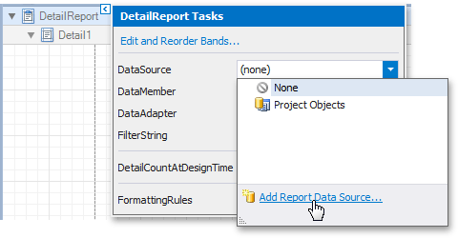

可以插入多个detailband

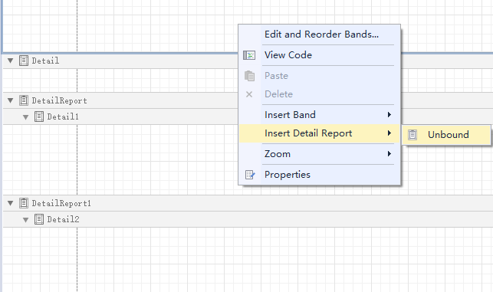

• To force a page break between Detail Reports, set the [Band.PageBreak](https://documentation.devexpress.com/XtraReports/DevExpress.XtraReports.UI.Band.PageBreak.property) property of the first DetailReportBand to **AfterBand**.

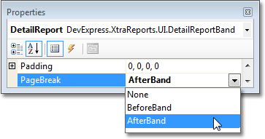

[Add a dataset to the project](https://documentation.devexpress.com/XtraReports/2554/Detailed-Guide-to-DevExpress-Reporting/Providing-Data-to-Reports/Tutorials-and-Code-Examples/Bind-a-Report-to-a-Database), which uses two non-linked tables, e.g., the "Employees" and "Products" tables of the sample **Northwind** database.

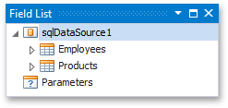

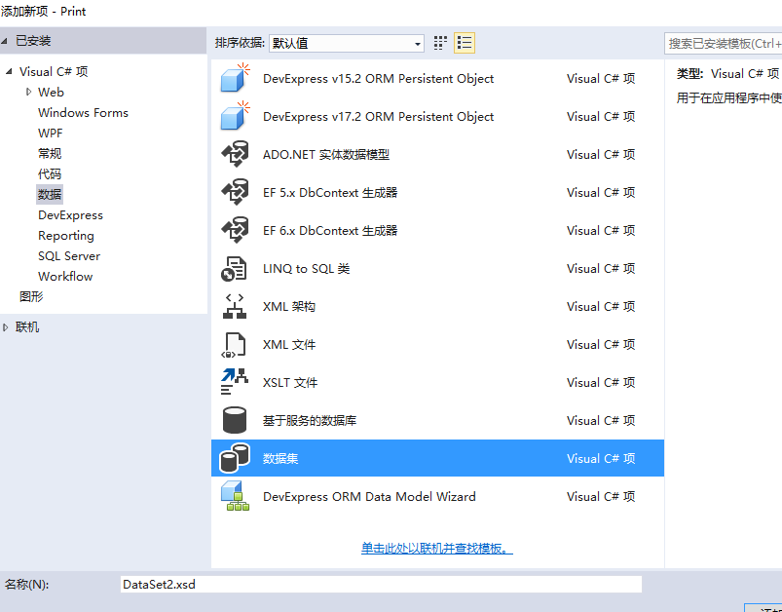

添加table

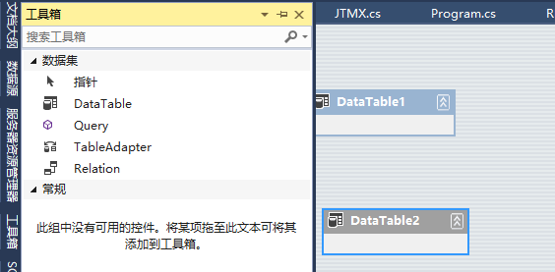

# Data Binding Modes

This document describes the available binding modes used to provide dynamic contents to your reports.

* [Selecting a Data Binding Mode](https://documentation.devexpress.com/XtraReports/119236/Detailed-Guide-to-DevExpress-Reporting/Providing-Data-to-Reports/Data-Binding-Overview/Data-Binding-Modes#DataBindingModes)
* [Converting Bindings to Expressions](https://documentation.devexpress.com/XtraReports/119236/Detailed-Guide-to-DevExpress-Reporting/Providing-Data-to-Reports/Data-Binding-Overview/Data-Binding-Modes#ConvertingBindings)
* The **Expression Editor** supports all standard summary functions and allows you to access report bands and controls, as well as reference the current data source values.
* 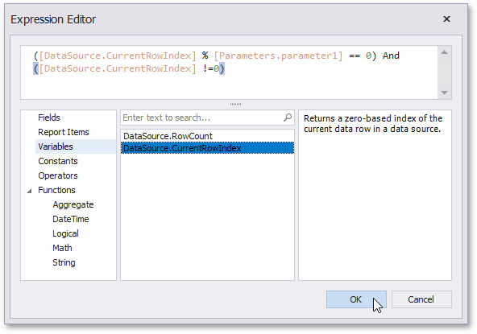
* You can handle some of the most popular events of a report or its elements and specify a custom expression that defines this element's behavior in the published report.
* 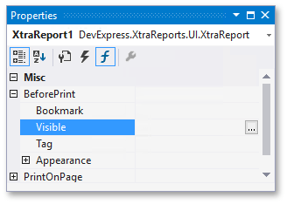

**Legacy Data Bindings**

This is the legacy approach earlier report versions use.

Its main downside is that providing any custom logic to reports requires handling [report script events](https://documentation.devexpress.com/XtraReports/2593/Detailed-Guide-to-DevExpress-Reporting/Reporting-API/Using-Report-Scripts), which have certain [security](https://documentation.devexpress.com/XtraReports/2616/Detailed-Guide-to-DevExpress-Reporting/Reporting-API/Using-Report-Scripts/Scripting-Security) implications if you need to allow your end-users to edit reports.

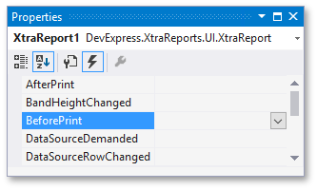

Dropping a data field onto a report's surface creates a new report control bound to the corresponding field.

Dropping a data field onto an existing control binds this control to the corresponding field.

Note that all these ways assign the field to the control's property with the **DefaultBindableProperty** attribute (usually, [XRControl.Text](https://documentation.devexpress.com/XtraReports/DevExpress.XtraReports.UI.XRControl.Text.property)). You can also bind a control to the [calculated fields](https://documentation.devexpress.com/XtraReports/4813/Detailed-Guide-to-DevExpress-Reporting/Shaping-Report-Data/Using-Calculated-Fields/Calculated-Fields-Overview) and [report parameters](https://documentation.devexpress.com/XtraReports/4812/Detailed-Guide-to-DevExpress-Reporting/Shaping-Report-Data/Using-Report-Parameters)

When the [UserDesignerOptions.DataBindingMode](https://documentation.devexpress.com/XtraReports/DevExpress.XtraReports.Configuration.UserDesignerOptions.DataBindingMode.property) is set to [DataBindingMode.Expressions](https://documentation.devexpress.com/XtraReports/DevExpress.XtraReports.UI.DataBindingMode.enum) or [DataBindingMode.ExpressionsAdvanced](https://documentation.devexpress.com/XtraReports/DevExpress.XtraReports.UI.DataBindingMode.enum), a report uses expressions to provide data to controls.

In these modes, the **Properties** grid contains the **Expressions** tab providing properties for which you can specify custom expressions with the available data fields.

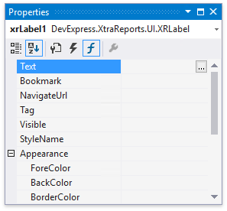

When the [UserDesignerOptions.DataBindingMode](https://documentation.devexpress.com/XtraReports/DevExpress.XtraReports.Configuration.UserDesignerOptions.DataBindingMode.property) is set to [DataBindingMode.Bindings](https://documentation.devexpress.com/XtraReports/DevExpress.XtraReports.UI.DataBindingMode.enum), you can set a control's bindable properties to the report's data source fields.

The set of bindable properties differs depending on the control type. The **Properties** grid's **Data Bindings** group provides access to these properties. Choose the property you want to bind and select the required data field in the drop-down list.

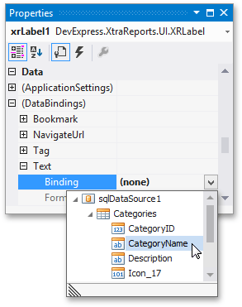

To unbind a control's property, invoke the binding drop-down list and select **None**.

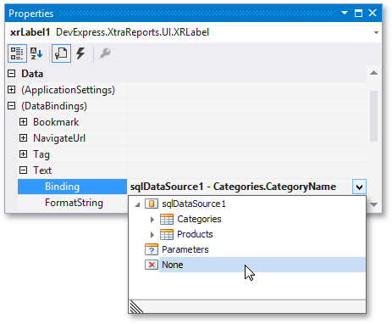

## Control Behavior on Different Bands

Data-bound report controls' rendering in Print Preview depends on the controls' band type. Only the detail and [group bands](https://documentation.devexpress.com/XtraReports/1298/Detailed-Guide-to-DevExpress-Reporting/Shaping-Report-Data/Grouping-and-Sorting/Grouping-and-Sorting-a-Report-s-Data) can display dynamic data source content. Controls in the **Detail** band are printed for each record in the assigned data source. The [group bands](https://documentation.devexpress.com/XtraReports/1298/Detailed-Guide-to-DevExpress-Reporting/Shaping-Report-Data/Grouping-and-Sorting/Grouping-and-Sorting-a-Report-s-Data) contain controls whose values are used as grouping criteria. Controls bound to data and placed in remaining bands display the current record's content.

The following image illustrates the report layout and its rendering result in Print Preview:

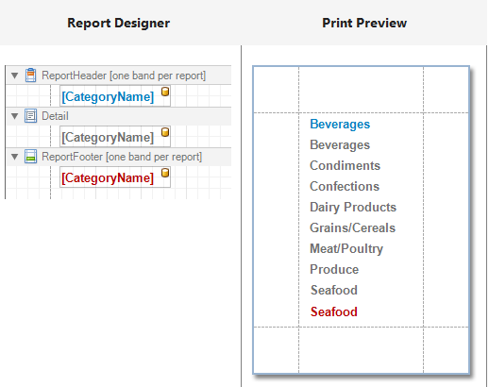

# Using Embedded Fields (Mail Merge)

This feature allows you to create templates in which data source values populate specific fields while other text remains constant.

* You can use mail merge to merge multiple data fields and static content in a control's text instead of running the **Expression Editor** and specifying a complex expression with formatting functions.
* For the [XRRichText](https://documentation.devexpress.com/XtraReports/DevExpress.XtraReports.UI.XRRichText.class) control, mail merge allows you to change specific text parts' appearance using the formatting toolbar.

## Embed Fields in a Control Text

Initially, you can apply mail merge to the [XRControl.Text](https://documentation.devexpress.com/XtraReports/DevExpress.XtraReports.UI.XRControl.Text.property) property only. Double-click the required control on the design surface to invoke the in-place editor. Insert data field names with square brackets to create embedded fields and use any prefixes or postfixes.

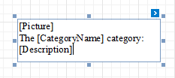

For the [XRRichText](https://documentation.devexpress.com/XtraReports/DevExpress.XtraReports.UI.XRRichText.class) control, you can select any text part and adjust its color and font options using the formatting toolbar.

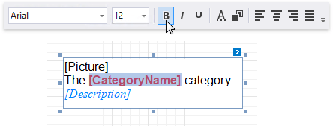

## Format Embedded Fields

The mail merge feature enables you to apply formats to embedded field values. Select a required data field and click the control's smart tag. Click the [XRControl.TextFormatString](https://documentation.devexpress.com/XtraReports/DevExpress.XtraReports.UI.XRControl.TextFormatString.property) property's ellipsis button, and in the invoked **Format String Editor**, choose a built-in format pattern.

只能format Field？

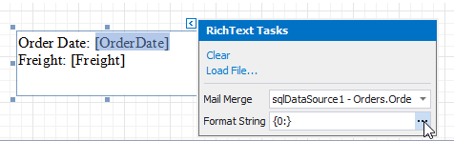

<https://documentation.devexpress.com/XtraReports/2555/Detailed-Guide-to-DevExpress-Reporting/Providing-Data-to-Reports/Tutorials-and-Code-Examples/Bind-a-Report-to-an-MDB-Database-Runtime-Sample>

private SqlDataSource BindToData() {

// Create a data source with the required connection parameters.

Access97ConnectionParameters connectionParameters =

new Access97ConnectionParameters("../../nwind.mdb", "", "");

SqlDataSource ds = new SqlDataSource(connectionParameters);

// Create an SQL query to access the Products table.

CustomSqlQuery query = new CustomSqlQuery();

query.Name = "customQuery";

query.Sql = "SELECT * FROM Products";

// Add the query to the collection and return the data source.

ds.Queries.Add(query);

// Make the data source structure displayed

// in the Field List of an End-User Report Designer.

ds.RebuildResultSchema();

return ds;

}

# Binding a Report Using Standard .NET Data Providers

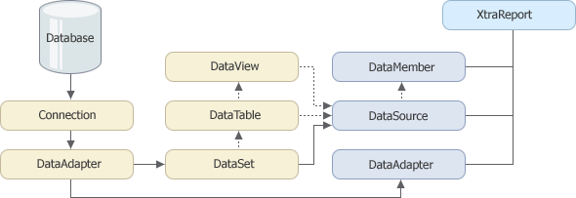

You can bind a report to a System.Data.DataSet in the following ways:

* By assigning the required table from the dataset to the [XtraReportBase.DataSource](https://documentation.devexpress.com/XtraReports/DevExpress.XtraReports.UI.XtraReportBase.DataSource.property) property.
* By assigning the dataset to the [XtraReportBase.DataSource](https://documentation.devexpress.com/XtraReports/DevExpress.XtraReports.UI.XtraReportBase.DataSource.property) property and supplying the required table's name when binding a report control to a data column in this table.
* By setting the [XtraReportBase.DataSource](https://documentation.devexpress.com/XtraReports/DevExpress.XtraReports.UI.XtraReportBase.DataSource.property) property to a System.Data.DataView object bound to a table from the dataset.

You need to fill the dataset with data manually by calling the data adapter's System.Data.Common.DataAdapter.Fill method. For instance, you could do this before previewing or printing the report. However, you can avoid manually filling the dataset by setting the [XtraReportBase.DataAdapter](https://documentation.devexpress.com/XtraReports/DevExpress.XtraReports.UI.XtraReportBase.DataAdapter.property) property to the data adapter that was used to create the dataset. In this case, the report automatically populates the dataset with data.

**Display Summaries**

You can make the label display a [summary function's result](https://documentation.devexpress.com/XtraReports/119436/Detailed-Guide-to-DevExpress-Reporting/Shaping-Report-Data/Shaping-Data-using-Expression-Bindings/Calculating-a-Summary) by setting the [XRSummary.Running](https://documentation.devexpress.com/XtraReports/DevExpress.XtraReports.UI.XRSummary.Running.property) property to the required range and selecting the summary function in the **Summary Expression Editor**.

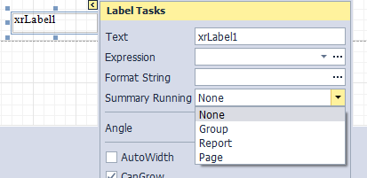

At design time, you can change a label's size to fit its static text ([XRControl.Text](https://documentation.devexpress.com/XtraReports/DevExpress.XtraReports.UI.XRControl.Text.property)) by right-clicking the label and selecting the **Fit Bounds To Text** command in the context menu:

• If the [XRControl.WordWrap](https://documentation.devexpress.com/XtraReports/DevExpress.XtraReports.UI.XRControl.WordWrap.property) option is enabled, the command keeps control content displayed in multiple lines. It decreases the control's height and adjusts the width to fit this content.

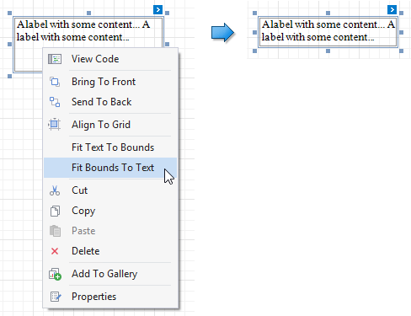

Use the **Fit Text To Bounds** command to adjust the control's font size to fit its area.

Use the label's [XRLabel.InteractiveSorting](https://documentation.devexpress.com/XtraReports/DevExpress.XtraReports.UI.XRLabel.InteractiveSorting.property) option to enable sorting report data by clicking this label in Print Preview. Set the [SortingOptions.TargetBand](https://documentation.devexpress.com/XtraReports/DevExpress.XtraReports.UI.SortingOptions.TargetBand.property) property to the required Group Header or Detail band, and the [SortingOptions.FieldName](https://documentation.devexpress.com/XtraReports/DevExpress.XtraReports.UI.SortingOptions.FieldName.property) property to the corresponding data field.

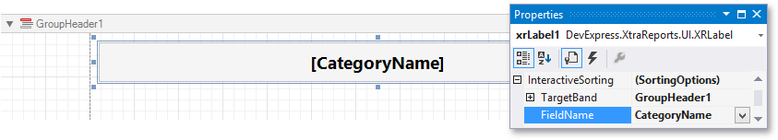

You can also create two tables simultaneously, for instance, one that shows column titles in the Page Header and one that shows regular information in the Detail band. Select the **XRTable** item in the Toolbox and draw a rectangle across these bands.

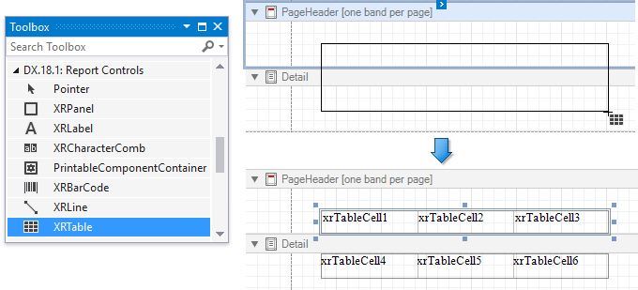

The XRTable control contains one or more rows ([XRTableRow](https://documentation.devexpress.com/XtraReports/DevExpress.XtraReports.UI.XRTableRow.class) objects) stored in the [XRTable.Rows](https://documentation.devexpress.com/XtraReports/DevExpress.XtraReports.UI.XRTable.Rows.property) collection. Each row contains one or more cells ([XRTableCell](https://documentation.devexpress.com/XtraReports/DevExpress.XtraReports.UI.XRTableCell.class) objects) that you can access using the [XRTableRow.Cells](https://documentation.devexpress.com/XtraReports/DevExpress.XtraReports.UI.XRTableRow.Cells.property) property. See the [Report Explorer](https://documentation.devexpress.com/XtraReports/4258/Visual-Studio-Report-Designer/Dock-Panels-and-Designer-Options/Report-Explorer) for a table structure example.

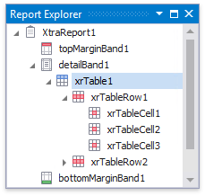

You can assign different [visual styles](https://documentation.devexpress.com/XtraReports/1303/Detailed-Guide-to-DevExpress-Reporting/Customizing-Appearance/Report-Visual-Styles) for even and odd table rows to improve readability.

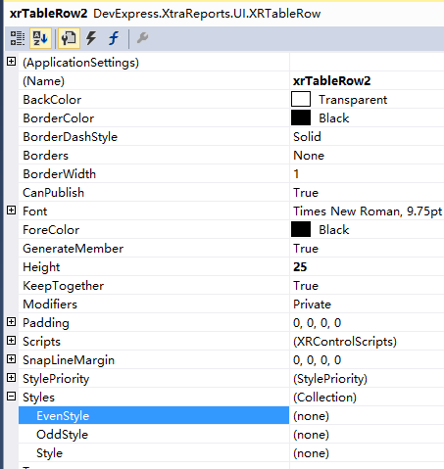

Drag and drop the same fields with the right mouse button to create column headers with the corresponding field names.

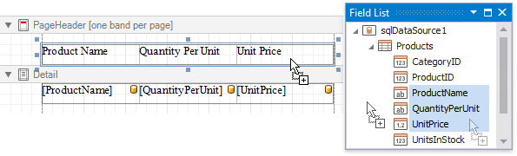

Resizing a column while holding the SHIFT key shifts the other columns in the corresponding direction without changing their size.

# Data Filtering Overview

* [Filter a SQL Data Source](https://documentation.devexpress.com/XtraReports/1184/Detailed-Guide-to-DevExpress-Reporting/Shaping-Report-Data/Data-Filtering/Data-Filtering-Overview#FilterDataSource)  
  Filter records at data source level using your data connection query if you are binding to a large data source and want to speed up the retrieval process.
* [Filter Data Using Report's Settings](https://documentation.devexpress.com/XtraReports/1184/Detailed-Guide-to-DevExpress-Reporting/Shaping-Report-Data/Data-Filtering/Data-Filtering-Overview#FilterReport)  
  Use the report's settings demonstrated in this section if you want to load the entire dataset and filter it on the client.
* [Limit the Number of Records to Display](https://documentation.devexpress.com/XtraReports/1184/Detailed-Guide-to-DevExpress-Reporting/Shaping-Report-Data/Data-Filtering/Data-Filtering-Overview#PrintOptions)  
  Options described in this section allow you to emulate the Top N feature in a sorted report or increase the Print Preview performance by rendering only a subset of a report’s data.
* [Conditionally Change Element Visibility](https://documentation.devexpress.com/XtraReports/1184/Detailed-Guide-to-DevExpress-Reporting/Shaping-Report-Data/Data-Filtering/Data-Filtering-Overview#ConditionalVisibility)  
  Use this technique to hide certain report elements from the Detail band when the corresponding data records meet the specified criteria.

You can also apply filtering in an existing data source by right-clicking it in the [Report Explorer](https://documentation.devexpress.com/XtraReports/4258/Visual-Studio-Report-Designer/Dock-Panels-and-Designer-Options/Report-Explorer) or [Field List](https://documentation.devexpress.com/XtraReports/4259/Visual-Studio-Report-Designer/Dock-Panels-and-Designer-Options/Field-List) and selecting **Manage Queries**. In the **Manage Queries** window, click the required query's ellipsis button.

* 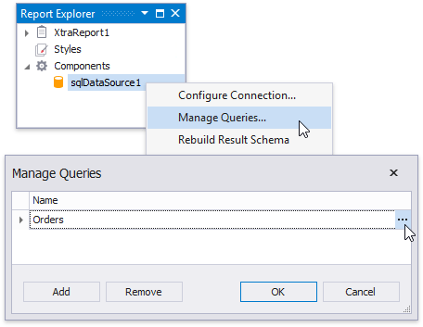
* To apply filtering to the report, click its smart tag, and click the ellipsis button for the [XtraReportBase.FilterString](https://documentation.devexpress.com/XtraReports/DevExpress.XtraReports.UI.XtraReportBase.FilterString.property) property in the invoked actions list.
* In the **FilterString Editor** that is invoked, construct an expression in which the **UnitPrice** data field is compared with the required value.
* 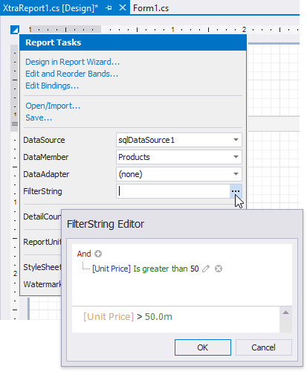

# Grouping and Sorting a Report's Data

Switch to the [Group and Sort](https://documentation.devexpress.com/XtraReports/5752/Visual-Studio-Report-Designer/Dock-Panels-and-Designer-Options/Group-and-Sort-Panel) panel, click **Add a Group** and select the required data field in the invoked drop-down menu.

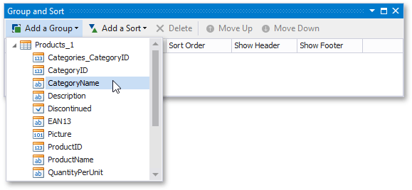

This creates an empty [group header](https://documentation.devexpress.com/XtraReports/2587/Detailed-Guide-to-DevExpress-Reporting/Introduction-to-Banded-Reports) with a corresponding group field added to its [GroupHeaderBand.GroupFields](https://documentation.devexpress.com/XtraReports/DevExpress.XtraReports.UI.GroupHeaderBand.GroupFields.property) collection.

You can use the **Group Field Collection Editor** to group data by multiple criteria. Click **Add** to create a new group field in this editor and specify its [GroupField.FieldName](https://documentation.devexpress.com/XtraReports/DevExpress.XtraReports.UI.GroupField.FieldName.property) property.

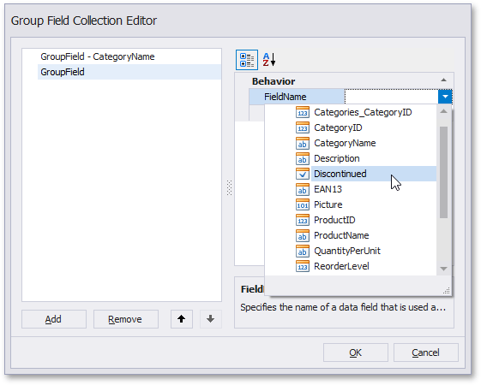

When a report has multiple groups, you can change their order by clicking **Move Up** or **Move Down**.为分组添加header和footer

指定分组之间的排序？

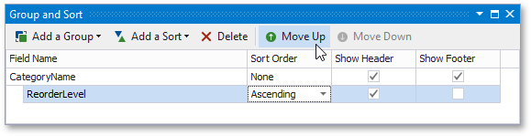

The following images illustrate how a report looks when it is grouped by multiple criteria:

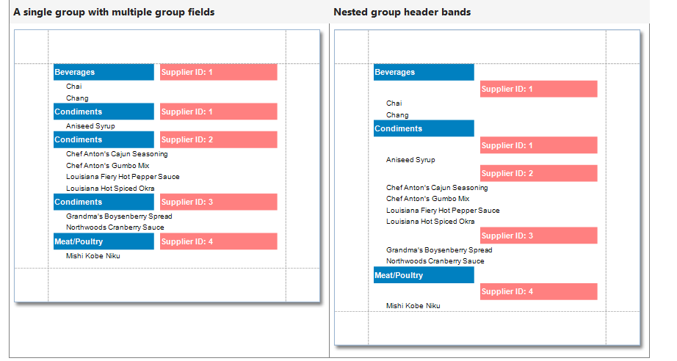

如果两个分组show header 那就是nested group？

Drag the corresponding field from the [Field List](https://documentation.devexpress.com/XtraReports/4259/Visual-Studio-Report-Designer/Dock-Panels-and-Designer-Options/Field-List) and drop it onto the group footer to display the group field's value in the report.

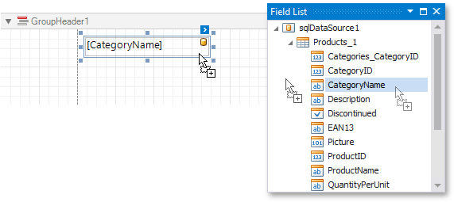

Use the [GroupHeaderBand.GroupUnion](https://documentation.devexpress.com/XtraReports/DevExpress.XtraReports.UI.GroupHeaderBand.GroupUnion.property) property to keep a group's content on the same page when possible.

Use the [Band.KeepTogether](https://documentation.devexpress.com/XtraReports/DevExpress.XtraReports.UI.Band.KeepTogether.property) property to print the group header/footer on the same page as the group's contents.

Use the [Band.PageBreak](https://documentation.devexpress.com/XtraReports/DevExpress.XtraReports.UI.Band.PageBreak.property) property to start a new page before or after each group.

# Grouping Data by a Custom Field

In the report created in this example, products are grouped by a calculated field that returns the first letter of the product name.

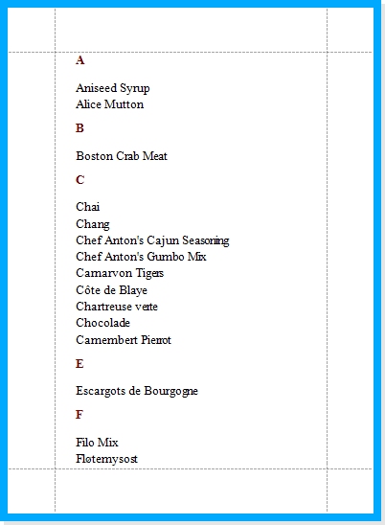

To create a [calculated field](https://documentation.devexpress.com/XtraReports/4813/Detailed-Guide-to-DevExpress-Reporting/Shaping-Report-Data/Using-Calculated-Fields/Calculated-Fields-Overview), switch to the [Field List](https://documentation.devexpress.com/XtraReports/4259/Visual-Studio-Report-Designer/Dock-Panels-and-Designer-Options/Field-List), right-click any item inside the **nwindDataSet1** and select **Add Calculated Field** in the menu that is invoked.

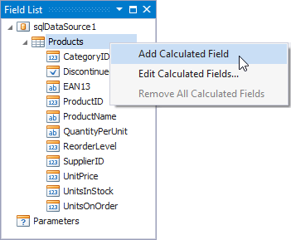

Next, select the created field, set its [CalculatedField.Name](https://documentation.devexpress.com/XtraReports/DevExpress.XtraReports.UI.CalculatedField.Name.property) property to **Initial。**and set the [CalculatedField.FieldType](https://documentation.devexpress.com/XtraReports/DevExpress.XtraReports.UI.CalculatedField.FieldType.property) property to **String**.

Then click the ellipsis button for the calculated field's [CalculatedField.Expression](https://documentation.devexpress.com/XtraReports/DevExpress.XtraReports.UI.CalculatedField.Expression.property) property, to invoke the **Expression Editor**.

Define the following expression in the editor that is invoked: **Substring([ProductName], 0 ,1 )**.

# Sorting Data by a Custom Field

To accomplish this task, create a [calculated field](https://documentation.devexpress.com/XtraReports/4813/Detailed-Guide-to-DevExpress-Reporting/Shaping-Report-Data/Using-Calculated-Fields/Calculated-Fields-Overview), handle its [CalculatedField.GetValue](https://documentation.devexpress.com/XtraReports/DevExpress.XtraReports.UI.CalculatedField.GetValue.event) event to evaluate the required value, and then sort the report's data against this field.

# Sorting Groups by a Summary Function's Result

In the report created in this tutorial, groups are sorted by the number of records they contain.

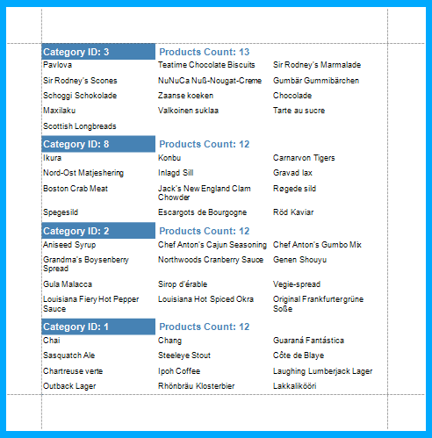

Click the Group Header band's [smart tag](https://documentation.devexpress.com/XtraReports/4260/Detailed-Guide-to-DevExpress-Reporting/Using-Report-Controls/Manipulating-Report-Controls), and click the ellipsis button for the [GroupHeaderBand.SortingSummary](https://documentation.devexpress.com/XtraReports/DevExpress.XtraReports.UI.GroupHeaderBand.SortingSummary.property) property in the invoked actions list.

In the invoked **Group Sorting Summary Editor**, turn on the **Enabled** option, set the **Field** option to **ProductName**, and set the **Summary function** to **Count**.

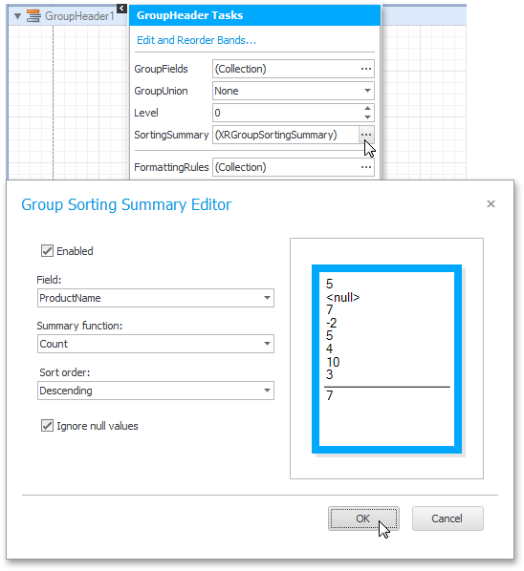

# Formatting Data

• Invoke the control's smart tag and click the **Format String** property's ellipsis button:

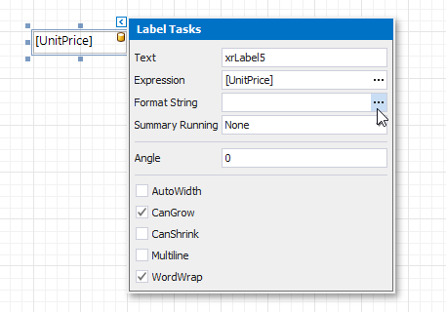

Alternatively, you can use the **FormatString** function within the expression you specified for the report control.

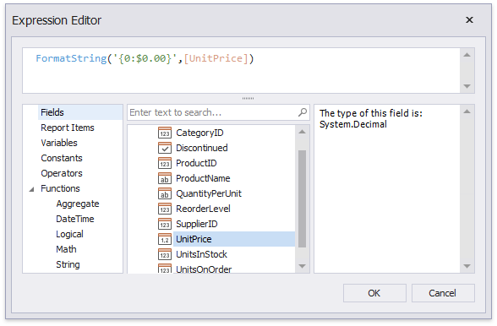

# Conditionally Changing a Control's Appearance

• Switch to the [Report Explorer](https://documentation.devexpress.com/XtraReports/4258/Visual-Studio-Report-Designer/Dock-Panels-and-Designer-Options/Report-Explorer) and right-click the **Styles** category to create a new visual style.

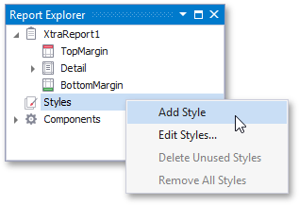

Right-click the created styles and select **Edit Styles**.

Back in the Report Explorer, select a report element to which you wish to assign the created styles.

• Switch to the **Expressions** section in the Properties window and click the ellipsis button for the control's **StyleName** property (you can find it under the **BeforePrint** event's category if you are using the **ExpressionsAdvanced** binding mode).

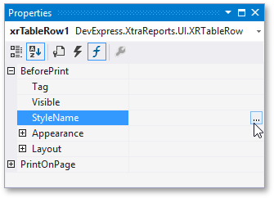

• This invokes the **Expression Editor** where you can specify the required condition for switching between the created styles.

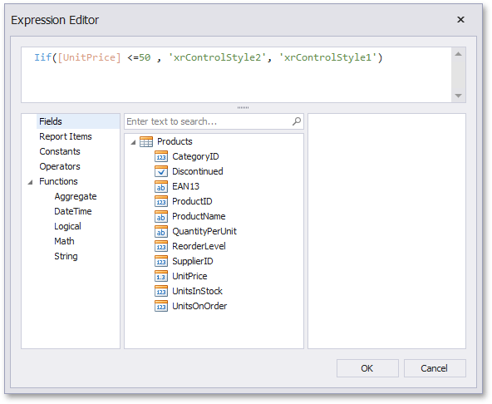

# Conditionally Changing a Label's Text

This document describes how to display different values in a report control based on a specified logical condition.

选择控件

invokes the **Expression Editor** where you can specify the required [expression](https://documentation.devexpress.com/XtraReports/120091/Detailed-Guide-to-DevExpress-Reporting/Using-Expressions):

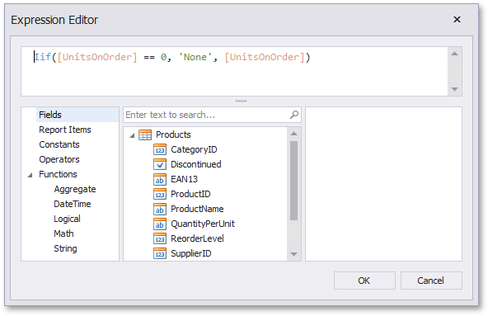

# Limiting the Number of Records per Page

Switch to the [Field List](https://documentation.devexpress.com/XtraReports/4259/Visual-Studio-Report-Designer/Dock-Panels-and-Designer-Options/Field-List), right-click the **Parameters** section and add a new report parameter.

Specify the parameter's description displayed in Print Preview and set its type to **Number (Integer)**.

• Drop an [XRPageBreak](https://documentation.devexpress.com/XtraReports/DevExpress.XtraReports.UI.XRPageBreak.class) control onto the report's detail band and switch to the Visual Studio property grid. Switch to its **Expressions** section and click the **Visible** property's ellipsis button (you can find it under the **BeforePrint** event's category if you are using the **ExpressionsAdvanced** binding mode).

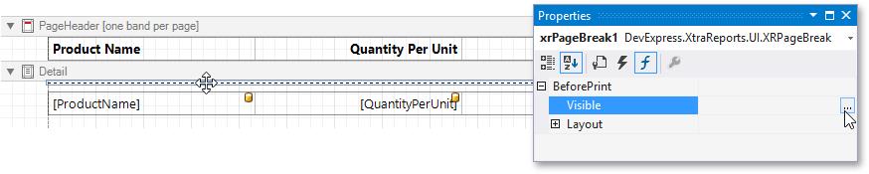

specify the required [expression](https://documentation.devexpress.com/XtraReports/120091/Detailed-Guide-to-DevExpress-Reporting/Using-Expressions).

For example:  
([DataSource.CurrentRowIndex] % [Parameters.parameter1] == 0) And ([DataSource.CurrentRowIndex] !=0)

# Counting the Number of Groups in a Report

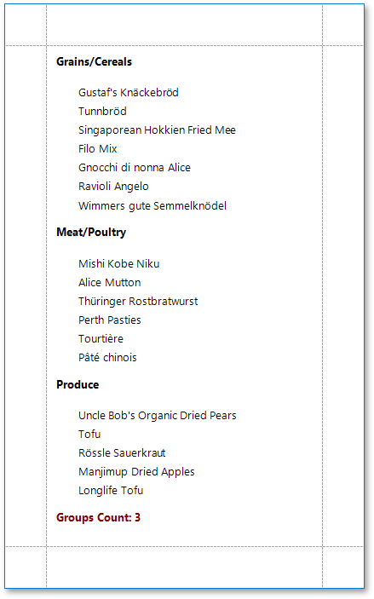

Switch to the [Field List](https://documentation.devexpress.com/XtraReports/4259/Visual-Studio-Report-Designer/Dock-Panels-and-Designer-Options/Field-List) and drop the group field onto the created group header.

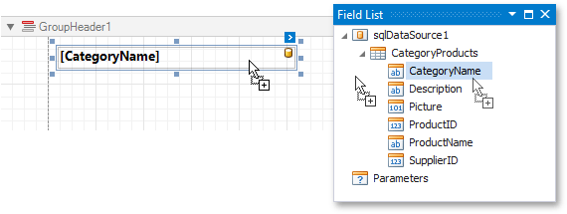

• Drop a label onto the report footer and invoke its smart tag. Set its **Summary Running** property to **Report**.

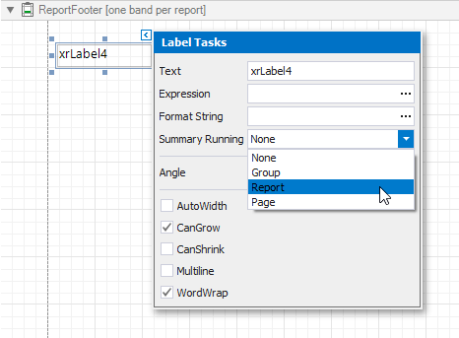

• This invokes the **Summary Expression Editor** where you can specify the required summary function.

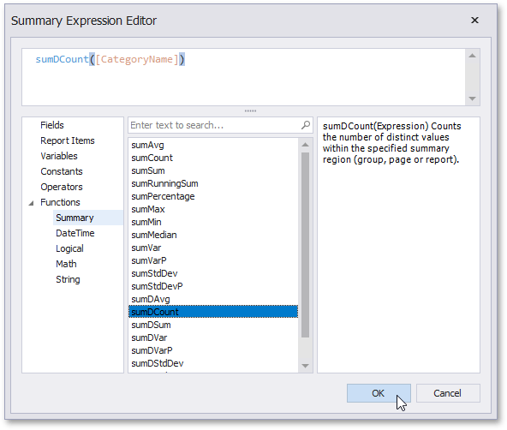

• When using [mail-merge](https://documentation.devexpress.com/XtraReports/4791/Creating-Popular-Reports/Creating-a-Letter) to make a label display both static and dynamic data, you can add a format to the label's dynamic contents by separating it from the data field name with the **!** symbol.

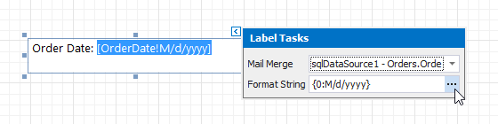

## Expression Syntax

Date-time constants must be wrapped in hashtags (**#**) (e.g., **[OrderDate] >= #1/1/2009#**). To represent a null reference (one that does not refer to any object), use a question mark (e.g., **[Region] != ?**). To denote strings, use apostrophes (**'**), otherwise an error will occur.

## Maintain Page Breaks

Use the [XRPageBreak](https://documentation.devexpress.com/XtraReports/DevExpress.XtraReports.UI.XRPageBreak.class) control to insert a page break at the required location in a report.

You can use the [Band.PageBreak](https://documentation.devexpress.com/XtraReports/DevExpress.XtraReports.UI.Band.PageBreak.property) property to add a page break before or after printing a specific band.

## Maintain the Band Location on a Page

Use the [GroupFooterBand.PrintAtBottom](https://documentation.devexpress.com/XtraReports/DevExpress.XtraReports.UI.GroupFooterBand.PrintAtBottom.property) and [ReportFooterBand.PrintAtBottom](https://documentation.devexpress.com/XtraReports/DevExpress.XtraReports.UI.ReportFooterBand.PrintAtBottom.property) properties to choose whether group and report footers should appear at the bottom of a page or immediately after the previous band.

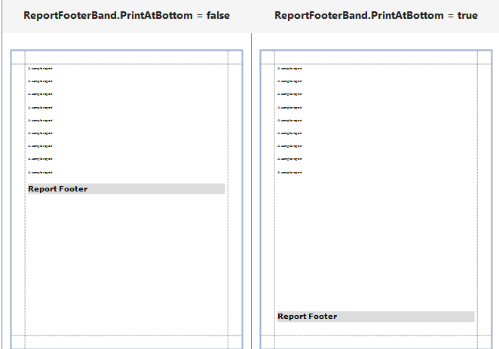

Use the [PageBand.PrintOn](https://documentation.devexpress.com/XtraReports/DevExpress.XtraReports.UI.PageBand.PrintOn.property) property to avoid printing page headers and footers on the same page with a report header and/or footer.

**PageHeaderBand.PrintOn = NotWithReportHeader**

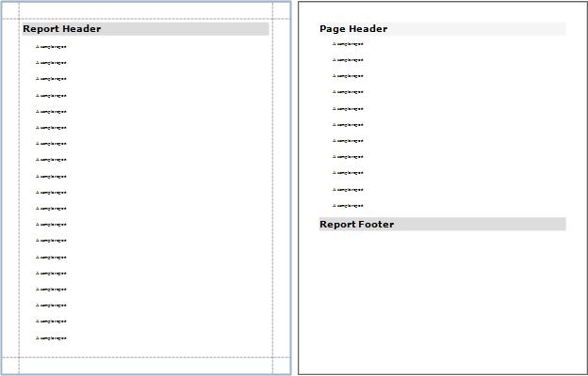

Use the [GroupBand.RepeatEveryPage](https://documentation.devexpress.com/XtraReports/DevExpress.XtraReports.UI.GroupBand.RepeatEveryPage.property) property to repeat group footers and headers on every page.

## Keeping Content Together

You can choose whether a control's content can be split across several pages using its [XRControl.KeepTogether](https://documentation.devexpress.com/XtraReports/DevExpress.XtraReports.UI.XRControl.KeepTogether.property) property.

Use the [XRLabel.AutoWidth](https://documentation.devexpress.com/XtraReports/DevExpress.XtraReports.UI.XRLabel.AutoWidth.property) property to make a data-bound [XRLabel](https://documentation.devexpress.com/XtraReports/DevExpress.XtraReports.UI.XRLabel.class) or [XRCharacterComb](https://documentation.devexpress.com/XtraReports/DevExpress.XtraReports.UI.XRCharacterComb.class) automatically adjust its width to its content. This option behavior depends on the control's current horizontal alignment (the [XRControl.TextAlignment](https://documentation.devexpress.com/XtraReports/DevExpress.XtraReports.UI.XRControl.TextAlignment.property) property value).

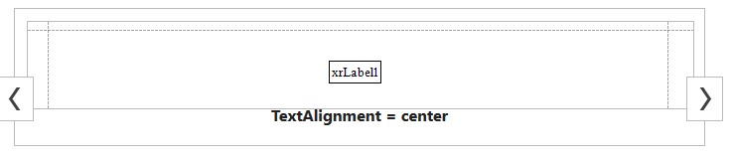

## Anchoring Controls

You can anchor a control to the top, bottom, or both edges of its parent container using the [XRControl.AnchorHorizontal](https://documentation.devexpress.com/XtraReports/DevExpress.XtraReports.UI.XRControl.AnchorHorizontal.property) and [XRControl.AnchorVertical](https://documentation.devexpress.com/XtraReports/DevExpress.XtraReports.UI.XRControl.AnchorVertical.property) properties.

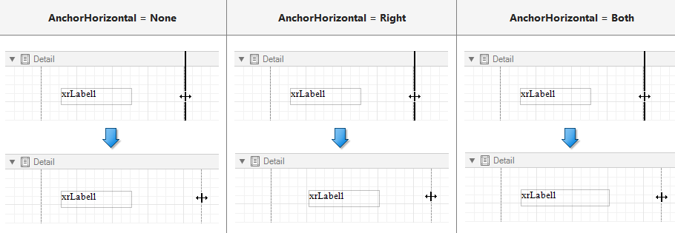

**Avoid Duplicated and Empty Values**

When identical or null values appear in a report's data source, you can suppress these values in a report using the following properties:

* [XRControl.ProcessDuplicatesMode](https://documentation.devexpress.com/XtraReports/DevExpress.XtraReports.UI.XRControl.ProcessDuplicatesMode.property)  
  Specifies how to process report controls with identical values (leave them as is, merge, suppress, or suppress and shrink).
* [XRControl.ProcessNullValues](https://documentation.devexpress.com/XtraReports/DevExpress.XtraReports.UI.XRControl.ProcessNullValues.property)  
  Specifies how to process report controls receiving null values from a data source (leave them as is, suppress, or suppress and shrink).
* [XRControl.ProcessDuplicatesTarget](https://documentation.devexpress.com/XtraReports/DevExpress.XtraReports.UI.XRControl.ProcessDuplicatesTarget.property)  
  Specifies whether to process duplicate the [XRControl.Text](https://documentation.devexpress.com/XtraReports/DevExpress.XtraReports.UI.XRControl.Text.property) or [XRControl.Tag](https://documentation.devexpress.com/XtraReports/DevExpress.XtraReports.UI.XRControl.Tag.property) property values.

In addition to the ability to specify [appearance property](https://documentation.devexpress.com/XtraReports/5165/Detailed-Guide-to-DevExpress-Reporting/Customizing-Appearance/Appearance-Properties) values for every control and band, it is possible to create a global style in a report

To assign a particular style to a control, set its **Styles.Style** property at design time (or [XRControl.StyleName](https://documentation.devexpress.com/XtraReports/DevExpress.XtraReports.UI.XRControl.StyleName.property) property at runtime) to one of the styles stored in a report's style sheet collection.

To access the style collection, you can also use the [Report Explorer](https://documentation.devexpress.com/XtraReports/4258/Visual-Studio-Report-Designer/Dock-Panels-and-Designer-Options/Report-Explorer). Commands of the context menu allow you to add, edit or delete a style.

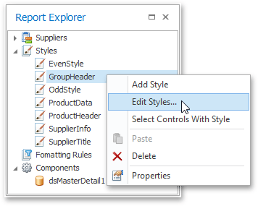

To apply a style to a report element, drag it from the Report Explorer onto the required report element.

if a certain property is set both in the styles and in the control's own appearance property, the priority is required for deciding which of the properties to use. The [XRControl.StylePriority](https://documentation.devexpress.com/XtraReports/DevExpress.XtraReports.UI.XRControl.StylePriority.property) property is intended for this.

By default, all the **Style Priority** options。This means that if any style is assigned to a control using its **Styles** property, all its properties will have a higher priority than the properties stored in the control or in its parent. If you want some of the properties to be determined by a control, not by its style, set the corresponding **Use\*** property to **false**.

The following image demonstrates how the [XRControl.StylePriority](https://documentation.devexpress.com/XtraReports/DevExpress.XtraReports.UI.XRControl.StylePriority.property) property works.

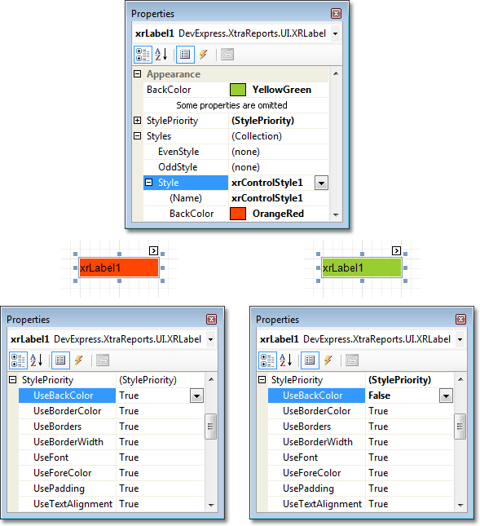

# Creating a Master-Detail Report using Detail Report Bands

This approach is effective if your data source contains an ADO.NET master-detail relationship.

添加数据源，

DataSource = dtHz;

DetailReport.DataSource = dtMx;

或者

DataSource =Dataset

DetailReport .DataSource =Dataset

Datamember=dtHz

DetailReport .Datamember= dtMx

we will use the **Categories** and **Products** data tables of the Northwind database

The **Field List** will be updated to reflect the new hierarchy of the report's data.

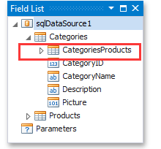

• To create a detail report, right-click the report's Detail band. In the invoked context menu, point to **Insert Detail Report** and click **"CategoriesProducts"**.

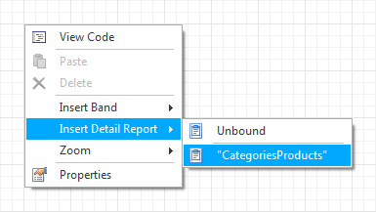

• If the **DetailReport** is properly bound to the data, the following properties of the created **DetailReport** band should be set automatically.

- the [XtraReportBase.DataMember](https://documentation.devexpress.com/XtraReports/DevExpress.XtraReports.UI.XtraReportBase.DataMember.property) property should be set to **Categories.CategoriesProducts**;

- the [XtraReportBase.DataSource](https://documentation.devexpress.com/XtraReports/DevExpress.XtraReports.UI.XtraReportBase.DataSource.property) property should be set to **sqlDataSource1**.

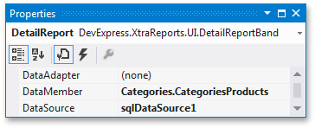

# Creating a Master-Detail Report using Subreports

This approach is useful if your data source does not contain ADO.NET relationship or you prefer to store master and detail reports in different files

添加数据源

DataSource = dtHz;

xrSubreport1.ReportSource.DataSource = dtMx;

## Create and Customize the Detail Report

• To add a parameter to the report, right-click the **Parameters** section and choose **Add Parameter** in the [Field List](https://documentation.devexpress.com/XtraReports/4259/Visual-Studio-Report-Designer/Dock-Panels-and-Designer-Options/Field-List).

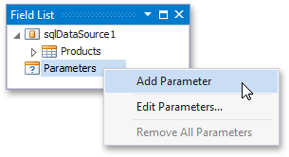

click the report's smart tag,

In the invoked [FilterString Editor](https://documentation.devexpress.com/WindowsForms/114635/Controls-and-Libraries/Data-Grid/Filter-and-Search), construct an expression where the **CategoryID** data field is compared to the **CatID** parameter. To access the parameter, click the icon on the right until it turns into a question mark.

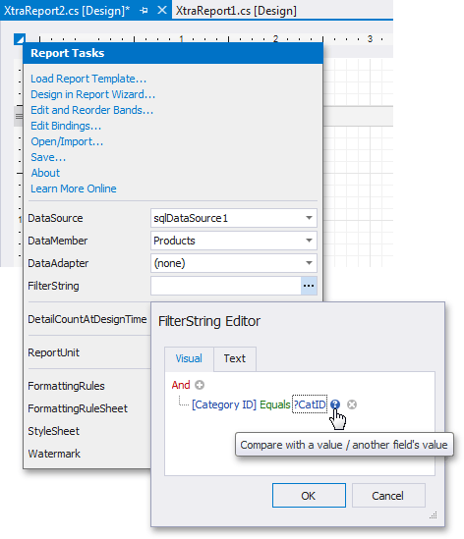

## Embed the Subreport

Switch back to the **XtraReport1.cs**, and drop the [XRSubreport](https://documentation.devexpress.com/XtraReports/DevExpress.XtraReports.UI.XRSubreport.class) control from the **DX.18.1: Report Controls** [Toolbox](https://documentation.devexpress.com/XtraReports/4257/Creating-End-User-Reporting-Applications/WinForms-Reporting/Report-Designer/API-and-Customization) tab onto the **Detail** band.

Next, bind the subreport's **CatID** parameter used as a filtering criterion to the master report's **CategoryID** data field, which will serve as a source of the parameter value. To do this, click the subreport's smart tag and select **Edit Parameter Bindings** in the invoked actions list.

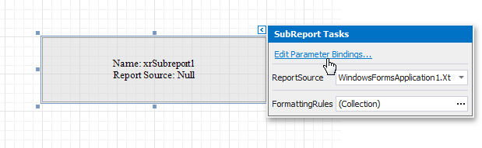

• To avoid printing blank space when the subreport's height exceeds the height of its content, set the [XRSubreport.CanShrink](https://documentation.devexpress.com/XtraReports/DevExpress.XtraReports.UI.XRSubreport.CanShrink.property) property to **true**.

