• [PHP](https://secure.php.net/) version 7.3 or greater.

• [MySQL](https://www.mysql.com/) version 5.6 or greate

[HTTPS](https://wordpress.org/news/2016/12/moving-toward-ssl/) support

make sure you have [Compose installed](https://docs.docker.com/compose/install/).

Docker在安装到Mac和Windows操作系统时，已经包含了Docker Compose

Linux操作系统在安装Docker后需要单独安装 Compose

• To run Compose as a non-root user, see [Manage Docker as a non-root user](https://docs.docker.com/install/linux/linux-postinstall/).

Run this command to download the current stable release of Docker Compose:

curl -L "https://github.com/docker/compose/releases/download/1.24.0/docker-compose-$(uname -s)-$(uname -m)" -o /usr/local/bin/docker-compose

Apply executable permissions to the binary:

sudo chmod +x /usr/local/bin/docker-compose

• Test the installation.

$ docker-compose --version

docker-compose version 1.24.0, build 1110ad01

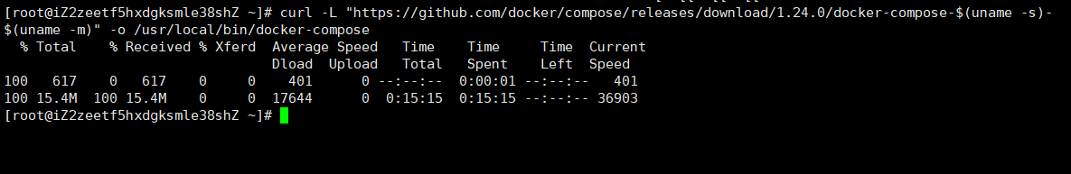

linux 文件扩展名

Create an empty project directory The directory should only contain resources to build that image.