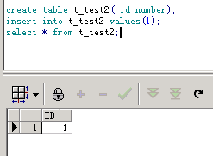

CREATE OR REPLACE Procedure PROC_parent

(

ERRNO Out Number,

ERRTEXT Out Varchar2) As

Begin

update t_test2 set id=2;

PROC_child(ERRNO,ERRTEXT);

commit;

End;

CREATE OR REPLACE Procedure PROC_child

(

ERRNO Out Number,

ERRTEXT Out Varchar2) As

*-- PRAGMA AUTONOMOUS_TRANSACTION;*

Begin

rollback;

End;

测试 PROC_parent

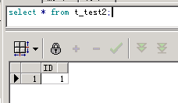

打开自治事务

CREATE OR REPLACE Procedure PROC_child

(

ERRNO Out Number,

ERRTEXT Out Varchar2) As

PRAGMA AUTONOMOUS_TRANSACTION;

Begin

rollback;

End;

测试 PROC_parent

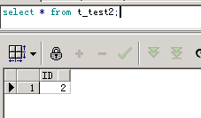

CREATE OR REPLACE Procedure PROC_parent

(

ERRNO Out Number,

ERRTEXT Out Varchar2) As

Begin

PROC_child(ERRNO,ERRTEXT);

rollback;

End;

CREATE OR REPLACE Procedure PROC_child

(

ERRNO Out Number,

ERRTEXT Out Varchar2) As

*-- PRAGMA AUTONOMOUS_TRANSACTION;*

Begin

insert into t_test2 values (2);

End;

测试 PROC_parent

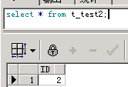

打开自治事务

CREATE OR REPLACE Procedure PROC_child

(

ERRNO Out Number,

ERRTEXT Out Varchar2) As

PRAGMA AUTONOMOUS_TRANSACTION;

Begin

insert into t_test2 values (2);

End;

测试 PROC_parent

报错

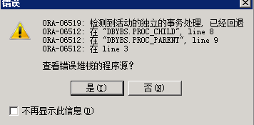

ORA-06519: 检测到活动的独立的事务处理, 已经回退

ORA-06512: 在 "DBYBS.PROC_CHILD", line 8

ORA-06512: 在 "DBYBS.PROC_PARENT", line 9

ORA-06512: 在 line 3

查看错误堆栈的程序源？

自治事务必须显示rollback或commit？

CREATE OR REPLACE Procedure PROC_parent

(

ERRNO Out Number,

ERRTEXT Out Varchar2) As

Begin

PROC_child(ERRNO,ERRTEXT);

update t_test2 set id=1;

End;

CREATE OR REPLACE Procedure PROC_child

(

ERRNO Out Number,

ERRTEXT Out Varchar2) As

PRAGMA AUTONOMOUS_TRANSACTION;

Begin

insert into t_test2 values (2);

commit;

End;

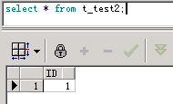

测试 PROC_parent

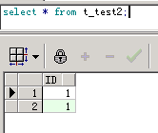

CREATE OR REPLACE Procedure PROC_parent

(

ERRNO Out Number,

ERRTEXT Out Varchar2) As

Begin

insert into t_test2 values (5);

PROC_child(ERRNO,ERRTEXT);

rollback;

End;

CREATE OR REPLACE Procedure PROC_child

(

ERRNO Out Number,

ERRTEXT Out Varchar2) As

PRAGMA AUTONOMOUS_TRANSACTION;

Begin

update t_test2 set id=2;

commit;

End;

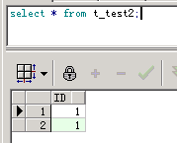

测试 PROC_parent

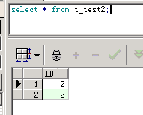

关闭自治事务

CREATE OR REPLACE Procedure PROC_child

(

ERRNO Out Number,

ERRTEXT Out Varchar2) As

*--PRAGMA AUTONOMOUS_TRANSACTION;*

Begin

update t_test2 set id=2;

commit;

End;

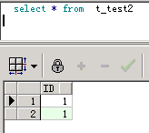

测试PROC_parent

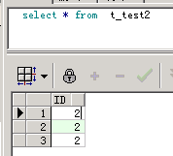

测试自治事务对临时表影响

create global temporary table TMP_TRANSjhmx

(

id number

)

on commit delete rows;

CREATE OR REPLACE Procedure PROC_parent

(

ERRNO Out Number,

ERRTEXT Out Varchar2) As

Begin

PROC_child(ERRNO,ERRTEXT);

insert into t_test2 select * from tmp_transjhmx;

commit;

End;

CREATE OR REPLACE Procedure PROC_child

(

ERRNO Out Number,

ERRTEXT Out Varchar2) As

*--PRAGMA AUTONOMOUS_TRANSACTION;*

Begin

insert into tmp_transjhmx values(1);

commit;

End;

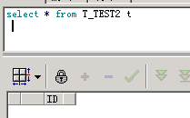

测试PROC_parent

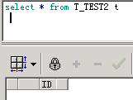

CREATE OR REPLACE Procedure PROC_child

(

ERRNO Out Number,

ERRTEXT Out Varchar2) As

*--PRAGMA AUTONOMOUS_TRANSACTION;*

Begin

insert into tmp_transjhmx values(1);

End;

