Mobility analysis for exceptional events

Overview

"As is" mobility

Demand forecast

Overall demand forecast
In our overall traffic forecast, we do not focus on travel on match days and non-match days because we want to explore the impact of the event on the overall region.

The Louis Vuitton 38th America’s Cup will take place in spring and summer 2027 on the bay of Naples, Italy. A large number of tourists are expected to participate, including both domestic and international tourists.

Traffic forecasting methods
We use a gravity model commonly used in traffic engineering to predict traffic flow, where beta is an impedance parameter that reflects people's sensitivity to "distance".

$$q_{ij}=O_{i}∗\frac{D_{j}∗e^{−βC_{ij}}}{\sum_{k}{D_{k}∗e^{−βC_{ik}}}}$$

$q_{ij}$: Predicted traffic from i to j
$O_{i}$: Known originating traffic volume
$D_{j}$: Target zones attraction weight
$β$: The impedance function that needs to be calibrated, reflects the population's sensitivity to travel costs.
$C_{ij}$: Cost & Travel Time of the trips

In traffic engineering, we need to calibrate the beta using existing data. The specific calibration process will not be detailed here, but the basic principle is to continuously fit the existing data using a Poisson mathematical model to reduce the error between the predicted and actual values. Ultimately, we obtain a parameter of $β$ = 0.04 in the “trips from Campania” scenario. In “Trips not from Campania” scenario, we will talk about it later.

Trips from Campania
We will first predict and analyze the number of travelers originating within Campania. We filtered out all trips from the original OD data that occurred only within the Campania region, removing trips originating from or leaving the Campania region not from Campania. This ensures that all trips are confined to the Campania region, reflecting, to some extent, the daily travel patterns of residents within the region. This is very helpful for predicting intra-regional travel, as total travel includes both intra-regional and international travel. Therefore, in the first part, we used the previously predicted number of 800,000 travelers from Campania to distribute them into traffic zones based on the distribution of the original OD data.
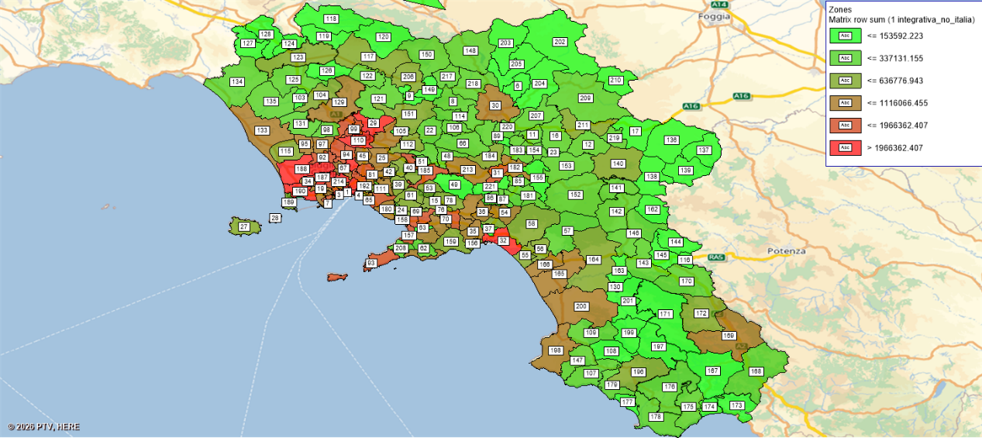
Origin Zones (Original OD data)

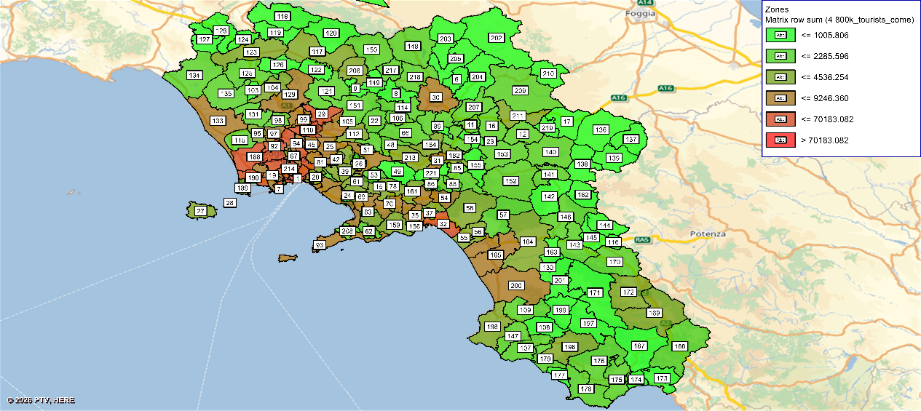
Origins from 800,000 Trips in Campania

For these 800,000 intra-district trips, we believe the destination should be from the previously mentioned POIs and traffic zones with concentrated accommodation areas: 1, 3, 10, 71, 73, 195, 216.
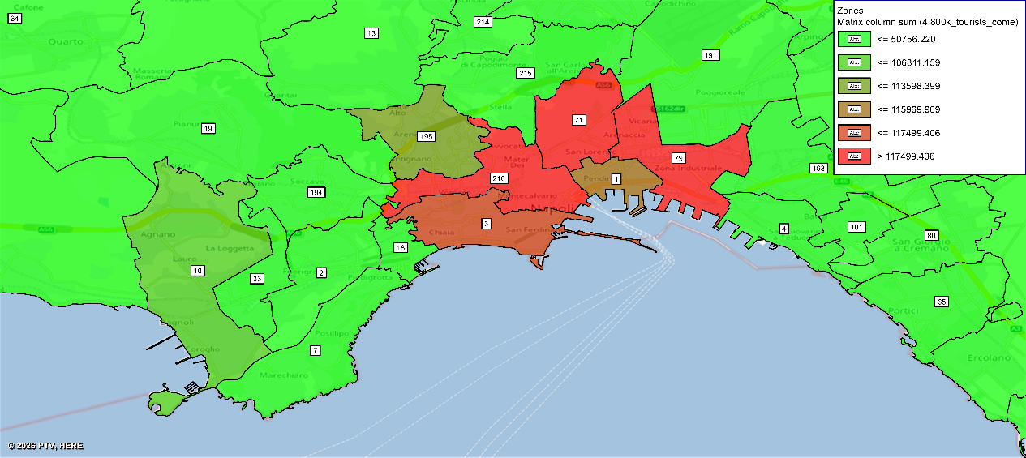
Destination from 800,000 Trips in Campania

For the return trips of these 800,000 intra-regional trips, we used a similar method, with the return origin points being traffic zones 1, 3, 10, 71, 73, 195, and 216. The return destinations were distributed based on the existing Campania regional OD data distribution.

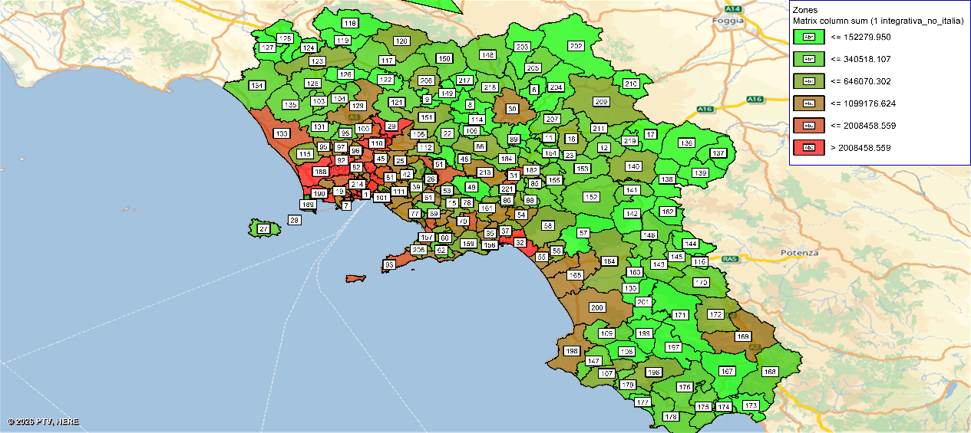
Destination Zones (Original OD data)

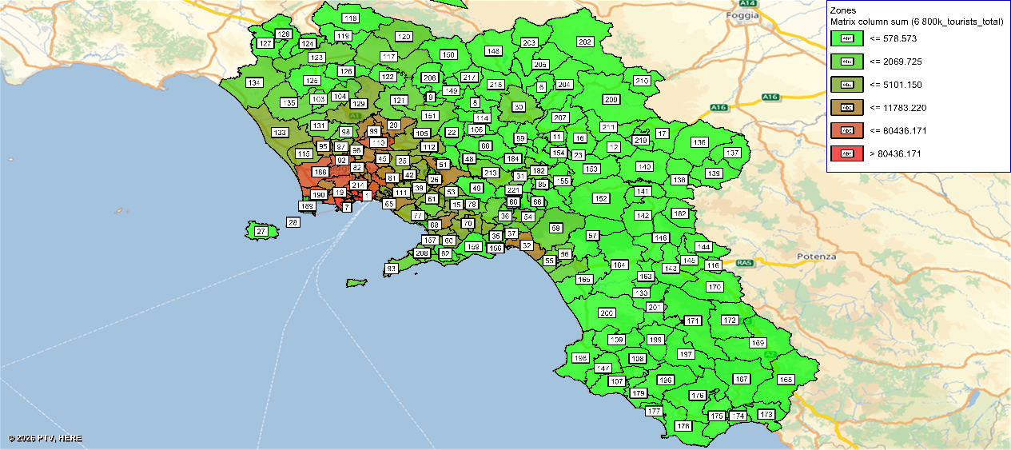
Origins from 800,000 Trips in Campania

By combining these two matrices, we obtain the OD distribution of 800,000 travelers within Cambodia. Here are the result:
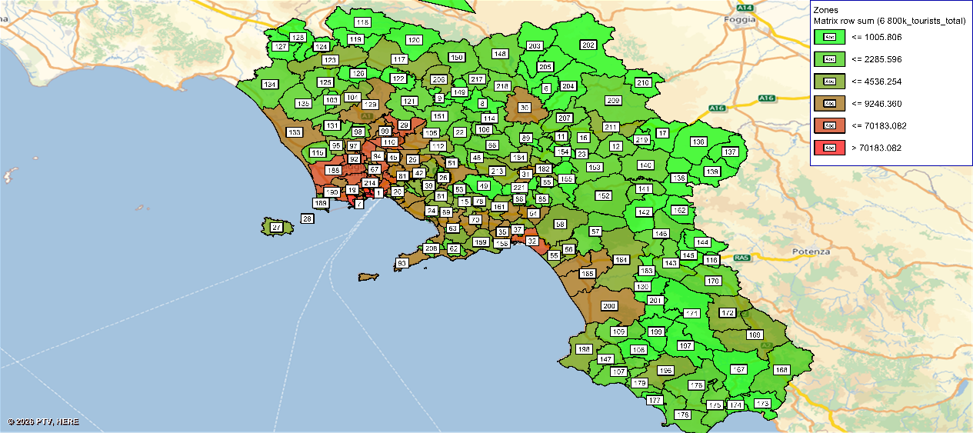
Origin distribution of residents' trips within the Campania area

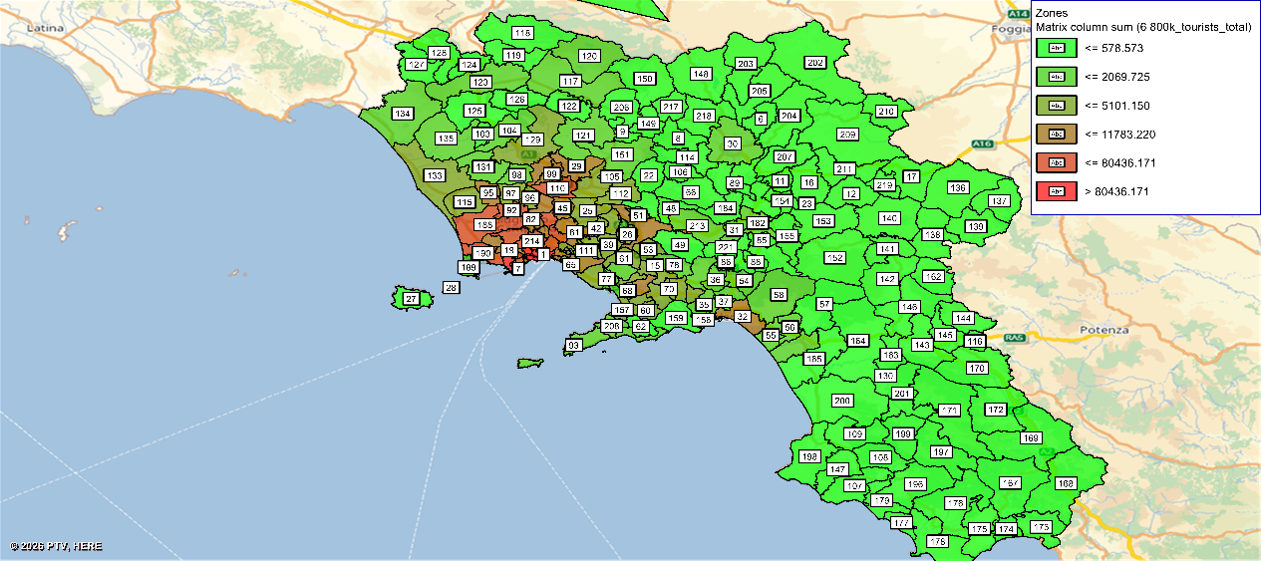
Destination distribution of residents' trips within the Campania area

Compared to the Origin distribution of residents' trips, the destinations are more concentrate in the zones that closed to the Naples region, the Origin distribution of residents' trips are more spread within the Campania region. This is reasonable because in this context, we are estimating the trips generated by the Campania residents.

Trips not from Campania
In our previous predictions, 300,000 tourists were expected to come from outside the Campania region, which can be roughly considered as tourists from outside Italy or from other Italian cities. These tourists will primarily be concentrated in accommodation areas, match areas, and potential tourist destinations throughout the America’s Cup.

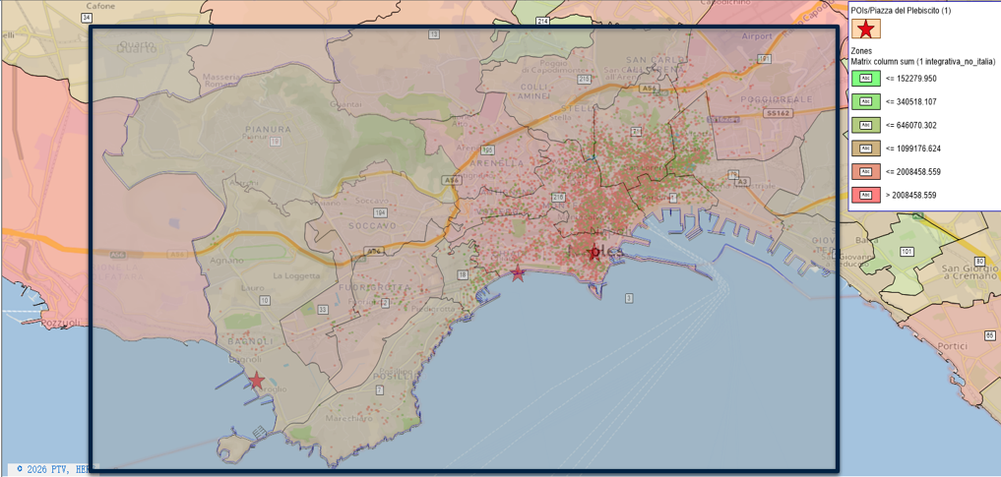
The distribution of accommodation locations in Naples

The image below shows the distribution of accommodation locations within the Naples area. In addition to accommodation, we also focused on points of interest (POIs) such as shops and tourist attractions to roughly determine the number of POIs in each traffic zone. This information is helpful for subsequent traffic volume prediction.

In this scenario, unlike the "Trips from Campania" scenario where we can extract travel cost/time between two traffic zones, there are no reference travel times for international travel. Therefore, in this section, we do not determine traffic volume allocation based on traffic impedance. Instead, we directly measure the attractiveness of a region to traffic by the number of POIs within a traffic zone.

$$q_{ij}=O_{i}∗\frac{D_{j}}{\sum_{k}{D_{k}}}$$

$O_{i}$: Known originating traffic volume
$D_{j}$: Target zones attraction weight

Highlights

Services improvement

