*In the Line of Duty*: Justification Document

The initial concept for my game was for it to be based on line-drawing. I enjoy drawing as a hobby, so I wanted to create a game that drew on that as a foundation. I quickly realized that making a game with actual drawing would be extremely difficult both to implement and to play (imagine drawing a person with a mouse!), so I decided the most people should have to draw are lines and very basic, sloppy shapes. Thus, the first iteration of my game was much like many flash games online and in the app store, and is what I turned in for my Gold Spike. It was a simple puzzle game with a static box, a ball, and a target. The object of the game was to get the ball to the target by drawing lines on the screen and using gravity to guide the ball. I knew that there were many games like this, so I tried to spice it up by adding tiles that the ball could bounce off of, wormholes that would allow the ball to warp from one place to another, etc. I also tried to make the levels difficult enough to be interesting. The game looked overall like this:

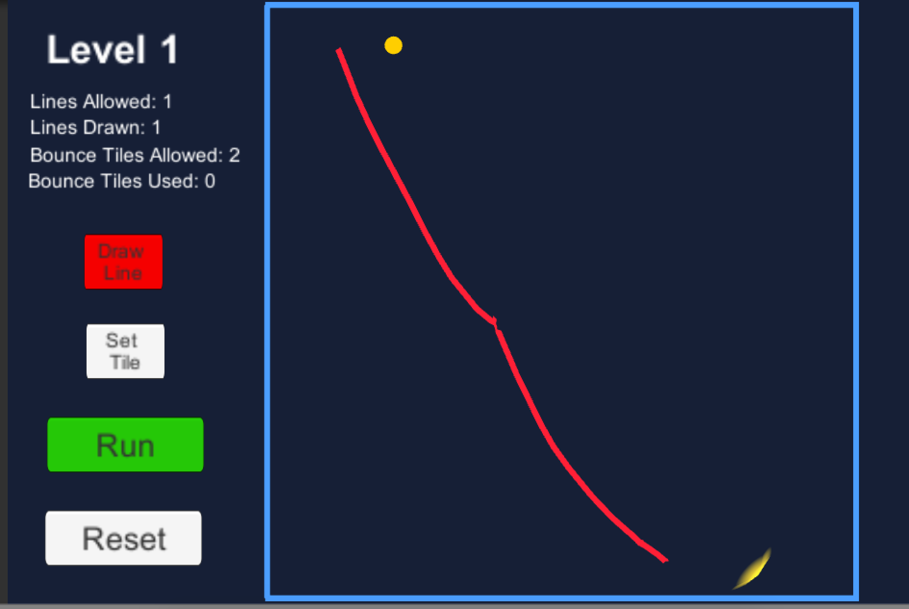 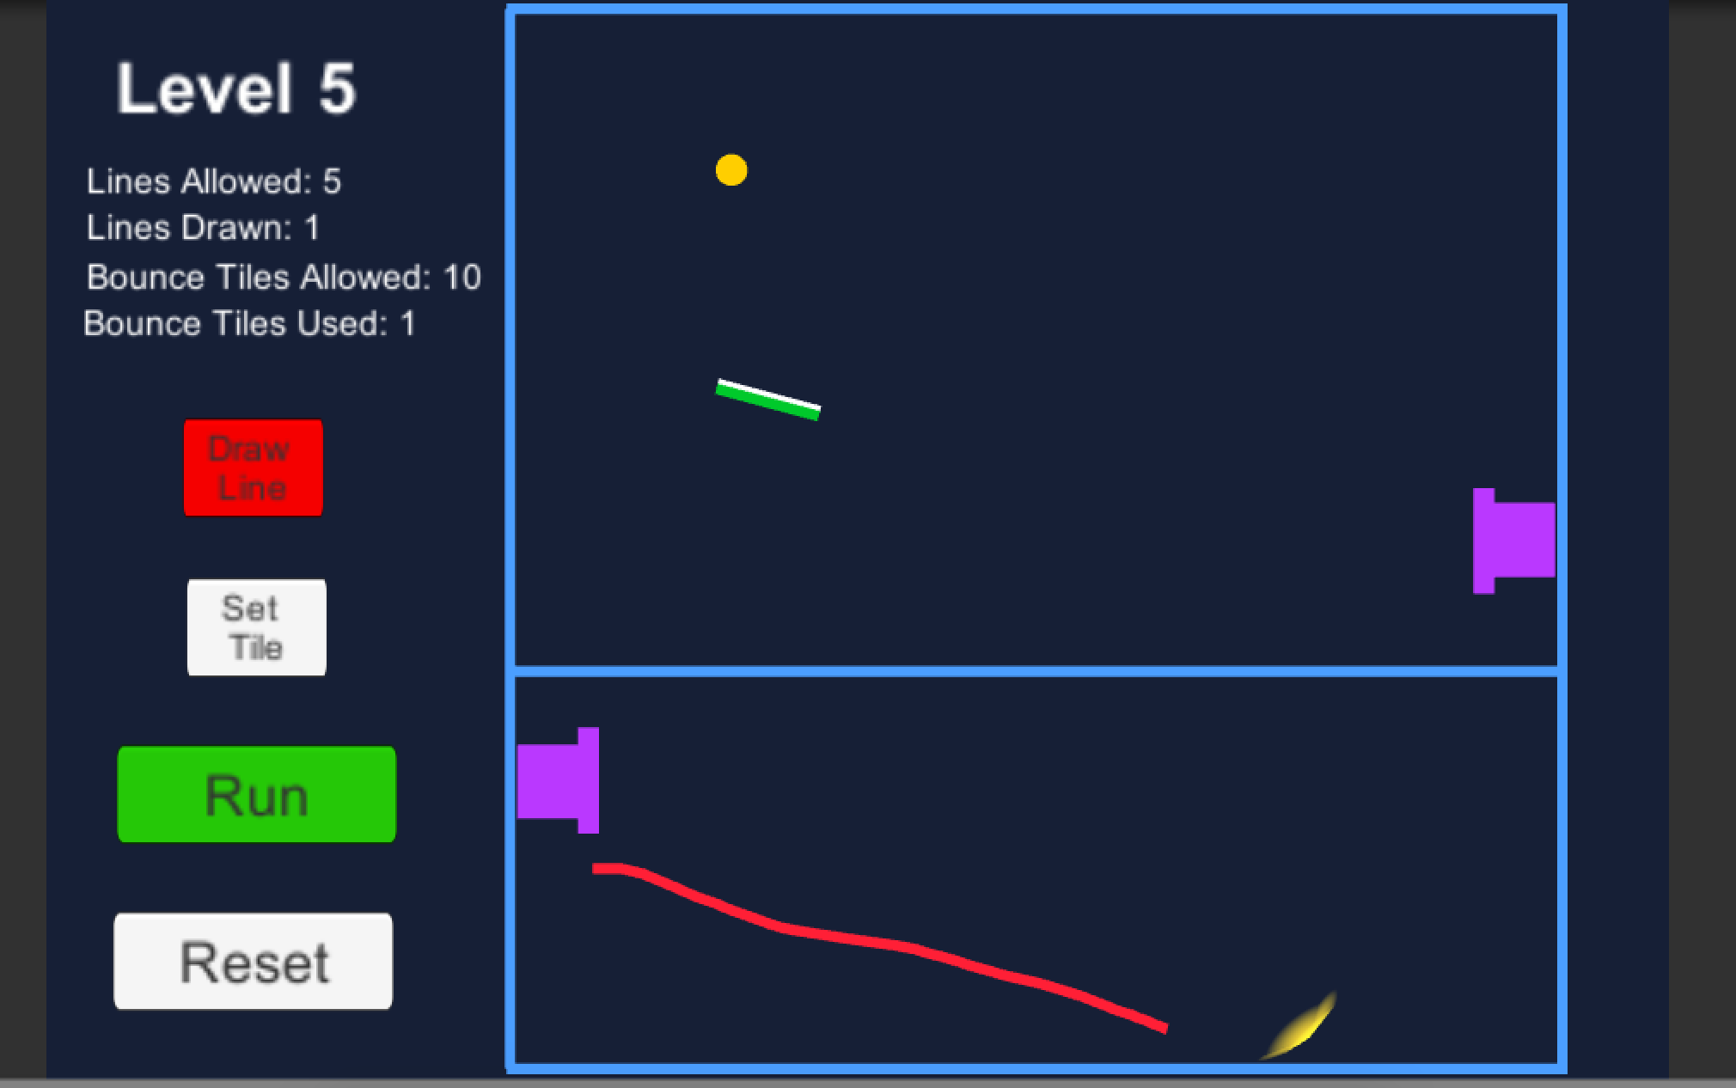

In the first screenshot, you can see the basic premise of the game, whereas in the second, you can see the purple “wormholes” (there could be multiple sets, paired off by color) and the green bounce tiles. In the end though, the game simply was not engaging, and besides it had been done a hundred times before. I could spice it up with a lot of cool pickups that changed gravity or other mechanics, but that felt gimmicky and forced. So I wanted to do it over completely during the second week, but still use my initial idea of line-drawing somehow.

After some thought, I decided maybe I could change the premise of my game. Instead of getting a ball to a target, I could use lines to protect a target from balls. I thought I could make this more into an action-type game instead of a puzzle, but there should still be some strategy involved. I thought maybe if I limited the number of line segments someone could draw, and decreased that number over time, that could make the game more difficult, and the player would have to think about how to allocate his or her limited segments. I also thought maybe it would be cool if instead of one target, the player would have to protect and “shepherd” multiple targets and keep them onscreen, as well as away from enemies. Thus the idea of my new game arose.

As for playtesting, the feedback I was able to give myself was more about player mechanics and juice. Because I knew what happened at what times, it was easy to tell when something important happened (like a target died, for example) but it slipped by unnoticed. So, I was better able to provide juice (mostly in the form of sound effects) to that end. I could also see when objects didn’t act the way I wanted them to, like if enemies’ AI were wonky or if the collisions of the targets caused problems, and I was able to tinker with that to get them to work better.

In terms of player intuition, though, I was useless, since I created the game and knew what was going on. So in terms of that aspect of game design, the feedback I got from my friends, classmates, and instructors were really helpful. For example, some people felt the title screen went by too slow and grew impatient to start playing, so I was able to speed that up. I also sped up the learning curve and difficulty—playtesters would get bored in the beginning and lacked the challenge they were looking for. Another thing was player direction—I was told to slow that down at the start of the game so that people can get used to player mechanics a little before the more difficult part begins, because otherwise there wasn’t enough time to read all the text as well as focus on keeping the targets on the screen. I really think that the feedback I got on this front helped make my game more intuitive and playable, as I could get a glimpse into how my game looked in others’ eyes.

Overall, my game was not what I expected. I really believed I would make a quiet puzzle game, much more like my initial idea, not a slightly stressful action-oriented game. However, I liked where I went with my prototype, as I think the second iteration was more original and in the end much more fun—what every game strives to be.