Michigan Rainy Day Fund
Optimal Policy Design via Stochastic Optimization

Project Overview
Quantitative identification of recession-sensitive tax categories and calibration of an optimal savings rate for Michigan's Rainy Day Fund using stochastic welfare optimization.

Key Results at a Glance
Optimal Rate | Welfare Gain | Recession Relief | Volatile Base
s* = 11% | +8.2% SW | +75% log-welfare | 44.5% of revenue

1. Executive Summary
This project designs an optimal Rainy Day Fund (RDF) policy for Michigan by solving a stochastic welfare optimization problem. Given Michigan's experience during the 2008 Great Recession — when its Budget Stabilization Fund held near-zero balances and tax revenues collapsed — we identify which tax categories to save from, and at what rate, to maximize a calibrated social welfare function.

Volatile base | Corporation net income + Property taxes + Individual income
Coverage | 44.5% of total tax revenue
Optimal savings rate s* | 11% of volatile revenue per quarter
Welfare improvement | +8.2% overall | +75% recession-period log-welfare
Fund peak (backtest) | ~$22M | covers 92% of recession gap at s*=11%

The analysis proceeds in five stages: (1) recession severity indexing, (2) tax category selection via a multiplicative impact metric, (3) revenue series construction, (4) welfare function definition and calibration, and (5) grid-search optimisation with sensitivity analysis.

2. Problem Framing
Michigan's Budget Stabilization Fund (BSF) carried a near-zero balance from 2004 to 2010, leaving the state completely exposed during the 2008 Great Recession. The fund only began meaningful accumulation in FY2011-12 ($362.7M). The question this project addresses is:

"Given Michigan's tax structure, what fraction of which tax revenues should be saved each quarter to best insure against future recessions?"

2.1 Formal Optimisation Problem
Following the team's stochastic control framework, define:
- X_t ∈ R^v — random process modelling tax revenue by category (v dimensions)
- p_t(X_t): R^v → R — the savings/dispensing policy — maps current tax revenues to the amount saved (expansion) or dispensed (recession)
- SW(p_t(X_t)) — social welfare evaluated under policy p_t

Max_{p_t} E[ SW( p_t(X_t) ) ]

The search space is reduced from a nonparametric L² problem to a one-dimensional parametric problem by specifying a fixed policy form: save a fraction s of volatile revenue in expansions, and dispense according to target need in recessions. The scalar s is the optimisation variable.

3. Recession Severity Index

3.1 Methodology
We replicate the Durdu, Edge & Schwindt (2017) Federal Reserve framework to score each state's exposure to the 2008 Great Recession. Three indicators are linearly interpolated between mild-recession anchors (score = 0) and severe-recession anchors (score = 100):

Indicator | Formula & Time Window
GDP Drop | Score = −26.1 × ΔGDP% − 10.8 | trough: 2008Q1–2009Q2 min vs 2005–2007 mean
UR Change (ΔUR) | Score = 31.8 × ΔUR − 61.9 | peak: 2008–2011 max (includes post-recession lag)
UR Level (MaxUR) | Score = 100 × (MaxUR − 6.9) / (9.9 − 6.9) | same window

The unemployment window extends to 2011 (rather than the NBER end date of 2009Q2) because Michigan's unemployment peaked at 14.2% in 2009Q3 — one quarter after the official recession ended — due to the prolonged collapse of the automotive industry. Using only 2009Q2 would understate Michigan's severity by approximately 0.4 percentage points.

Overall Severity = (Score_GDP + Score_UR_change + Score_UR_level) / 3

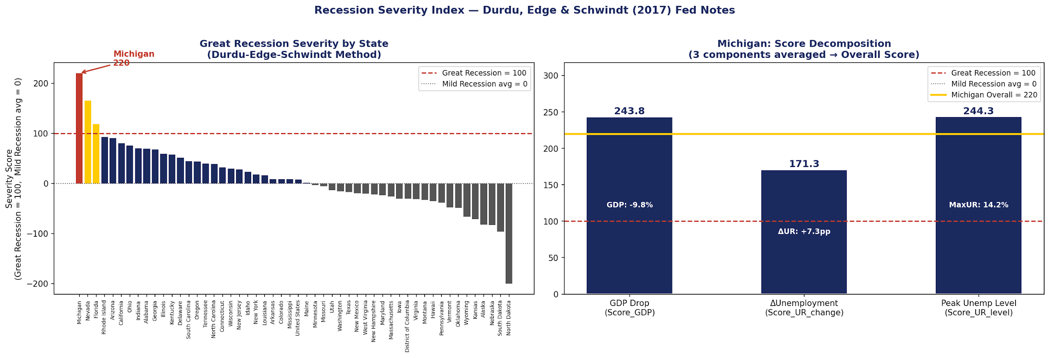
Figure 1. State-level recession severity index. Michigan scores among the highest, driven by the automotive sector collapse.

4. Recession-Sensitive Tax Category Selection

4.1 Impact Metric
To identify which tax categories should fund the RDF, we construct a multiplicative Impact metric that directly answers: 'How much revenue did the government lose from this category during the recession?'

Impact_i = |Drop_i% / 100| × Pre_size_i

Term | Definition & Rationale
Drop_i% | Annual avg 2008–2011 vs 2005–2007 baseline. Annual data eliminates Q4 seasonality. Window extends to 2011 to capture individual income tax lag (filers report 2008 income in 2009).
Pre_size_i | 2005–2007 annual avg revenue. Pre-recession baseline avoids recession years depressing the size estimate (no look-ahead bias).
Multiplicative form | No normalisation needed. A category with 99% drop but $30M revenue produces Impact = $30M — naturally dominated by large, moderately-declining categories.

4.2 Results
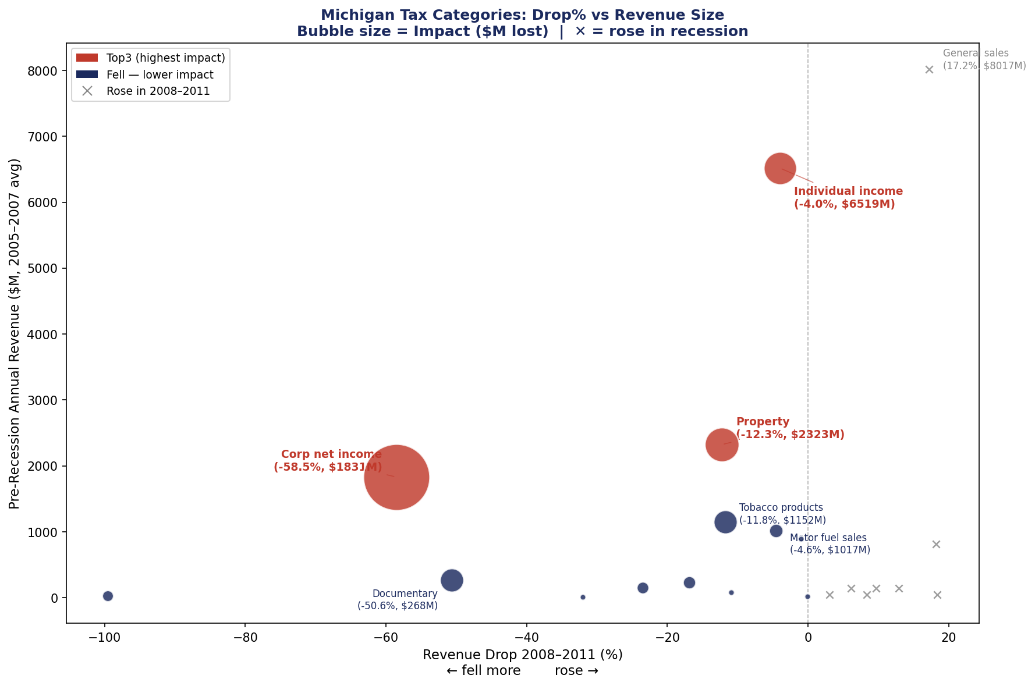
Figure 2. Drop% vs Revenue Size scatter. Bubble area proportional to Impact ($M lost). Crosses = categories that rose during recession (Impact = 0).

Tax Category | Drop 2008–11
Corporation net income | −58.5%
Property taxes | −12.3%
Individual income | −4.0%
Documentary & stock transfer | −50.6%
Tobacco products | −11.8%

Individual income ranks #3 despite a modest 4% drop because its $6.5B base translates to $261M of lost revenue — material for the RDF. The drop appears small due to Michigan-specific federal stimulus that partially offset income declines in 2008–2009; extending the window to 2011 reveals the full lagged impact.

5. Revenue Series and Spending Target

5.1 Three Core Series
Series | Definition
Total Revenue T_t | Sum of all tax categories — actual government receipts each quarter
Volatile Revenue V_t | Sum of TOP3 categories — the savings pool from which s is drawn
Target Tgt_t | Rolling mean of the last 8 non-recession quarters of T_t — government's 'normal' spending level

The rolling target uses 8 quarters (2 years): long enough to be stable, short enough to track economic growth. Recession quarters are excluded so abnormally low revenues do not depress the target. The fund's job is to fill Gap_t = max(Tgt_t − T_t, 0).

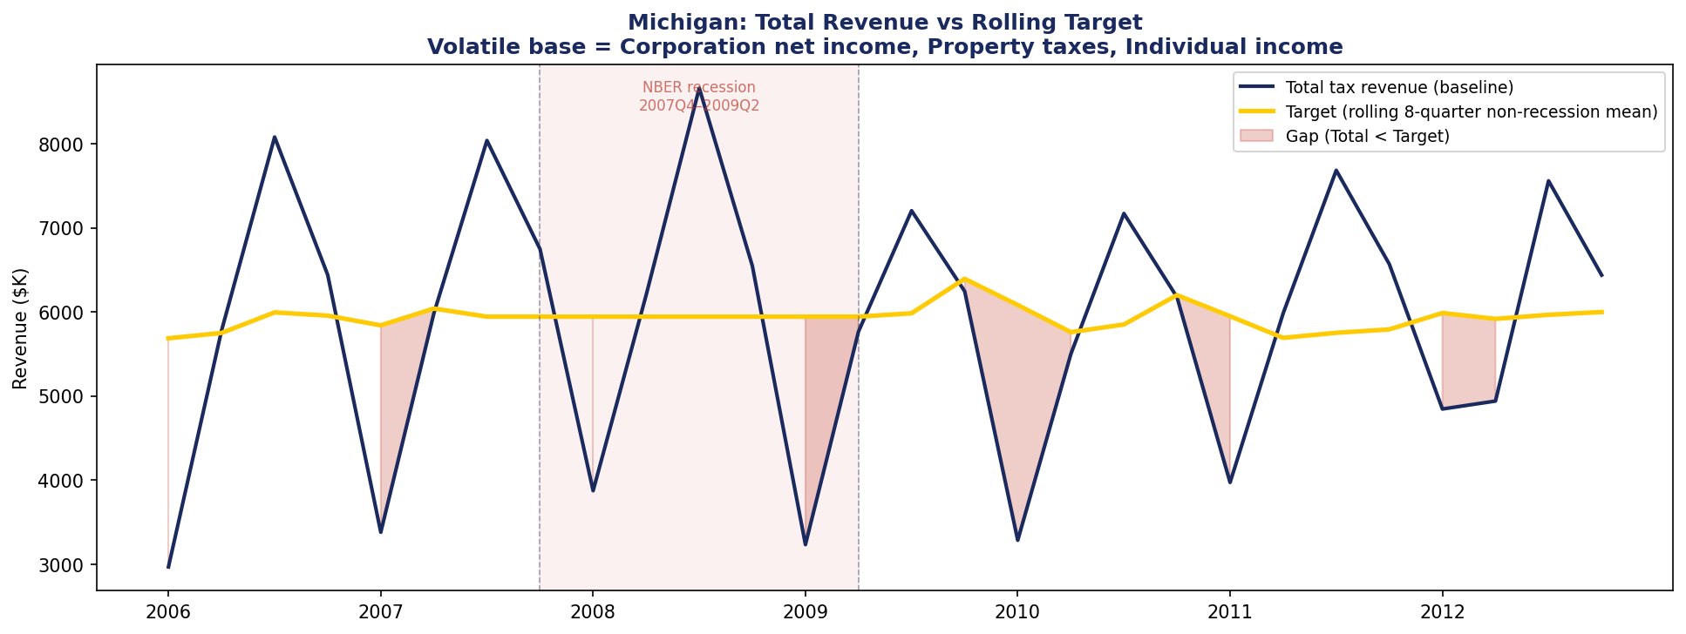
Figure 3. Total revenue vs rolling target (2006–2012). Red shading = quarters where Total < Target. Seasonal pattern (Q1 lows, Q3 highs) persists within recession.

Note: the gap appears only in Q1 quarters because Q2–Q4 seasonal revenues (tax-filing season, consumption peaks) exceed the annual-average target even during recession. The RDF therefore principally targets Q1 liquidity shortfalls — a structural feature of state fiscal calendars.

6. Social Welfare Function & Calibration

6.1 Functional Form
We adopt the log-variance welfare function:

SW = α · Σ_t log( p_t(X_t) ) − η · Var( p_t(X_t) )

Term | Economic Interpretation
p_t(X_t) | Effective government spending after RDF policy: T_t − s·V_t (expansion) or T_t + withdrawal (recession)
α · Σ log(p_t) | CRRA utility with γ=1: diminishing marginal value of spending. Spending cuts during recession are extremely costly because the government is already at low levels.
−η · Var(p_t) | Direct penalty on spending volatility. Government values stable service delivery — schools, healthcare, infrastructure cannot be easily turned on and off.
Two-term tension | Low s → large Var (volatile spending) → SW penalised. High s → low log(p_t) in expansions (less spending) → SW penalised. Interior optimum exists.

6.2 Calibration of η
With α fixed at 1, only the ratio α/η matters. We calibrate η to Michigan-specific data by finding the value that produces an optimal savings rate in the empirically-grounded range of 5–15% (National Conference of State Legislatures / Center on Budget and Policy Priorities recommendations for state RDF sizing).

All revenue data is normalised by the sample mean (÷ $7.10M/quarter) before computing the welfare function, ensuring the log and variance terms are comparable in magnitude. The calibration proceeds by grid-searching η ∈ [0, 300] and recording the optimal s*(η).

7. Optimisation Results

7.1 Calibrated Parameters
Parameter | Value & Source
α | 1.0 (normalisation)
η* | 236.6 (calibrated: s* ∈ [5%, 15%], median of feasible range [173, 300])
Optimal s* | 11% of quarterly volatile revenue
Calibration target | 5%–15% of General Fund spending (NCSL / CBPP literature)

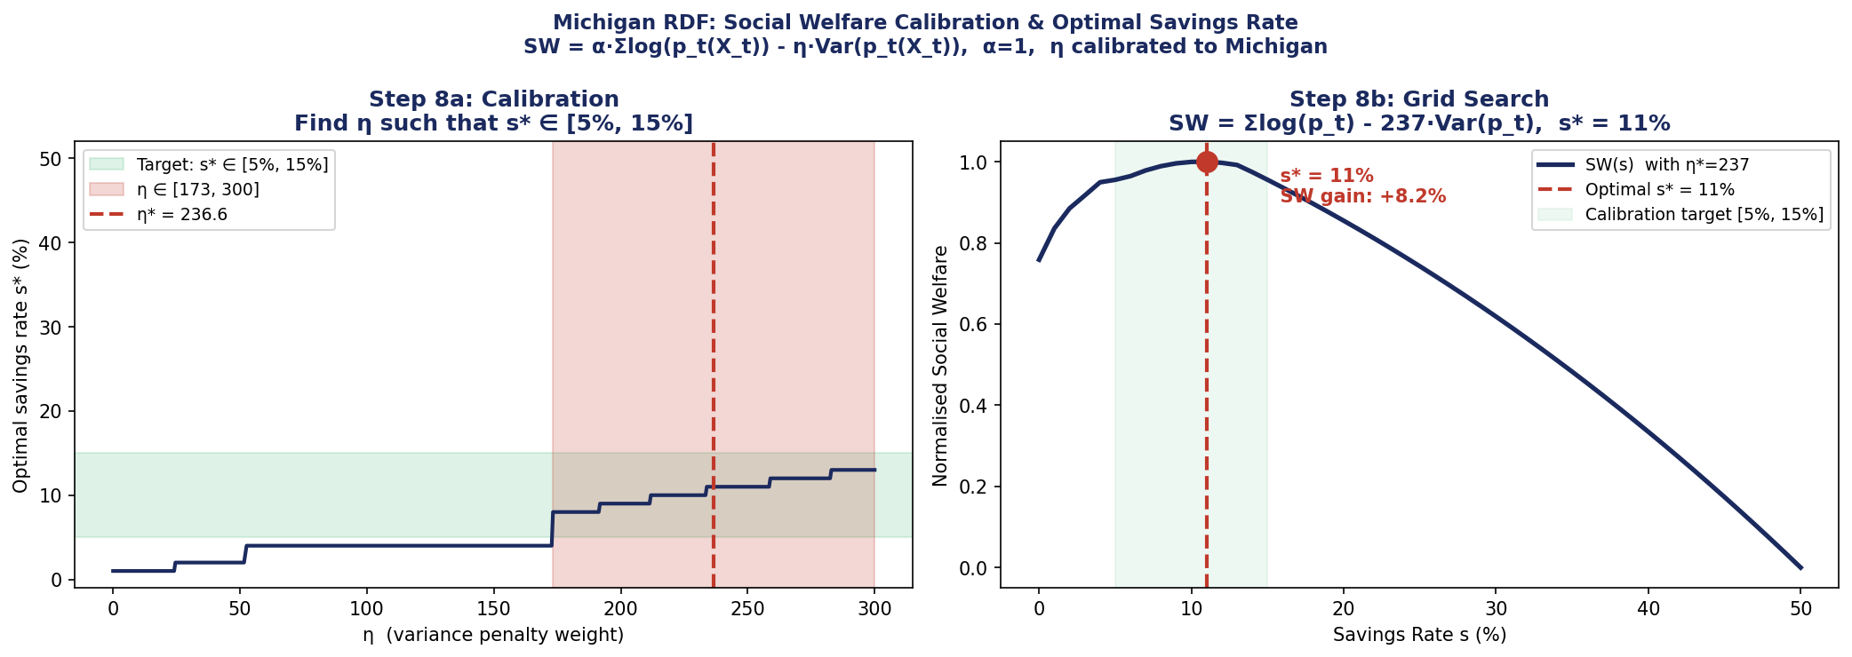
Figure 4. Left: calibration curve. Right: normalised SW(s) at η*=236.6, with optimum at s*=11%.

7.2 Welfare Decomposition
Metric | s=0% (no policy)
Total SW (log-var) | −25.16
Recession-period log-welfare | baseline
Gap fill rate at s*=11% | 0%

The recession-period log-welfare improvement (+75.1%) is computed by evaluating Σlog(p_t) exclusively over recession quarters with η=0, isolating how much the RDF raises government spending capacity when it is most needed. The gap is not fully closed at s*=11% — this is intentional: the SW optimum trades off some residual gap against lower expansion-period cost.

8. Backtest: Policy Performance
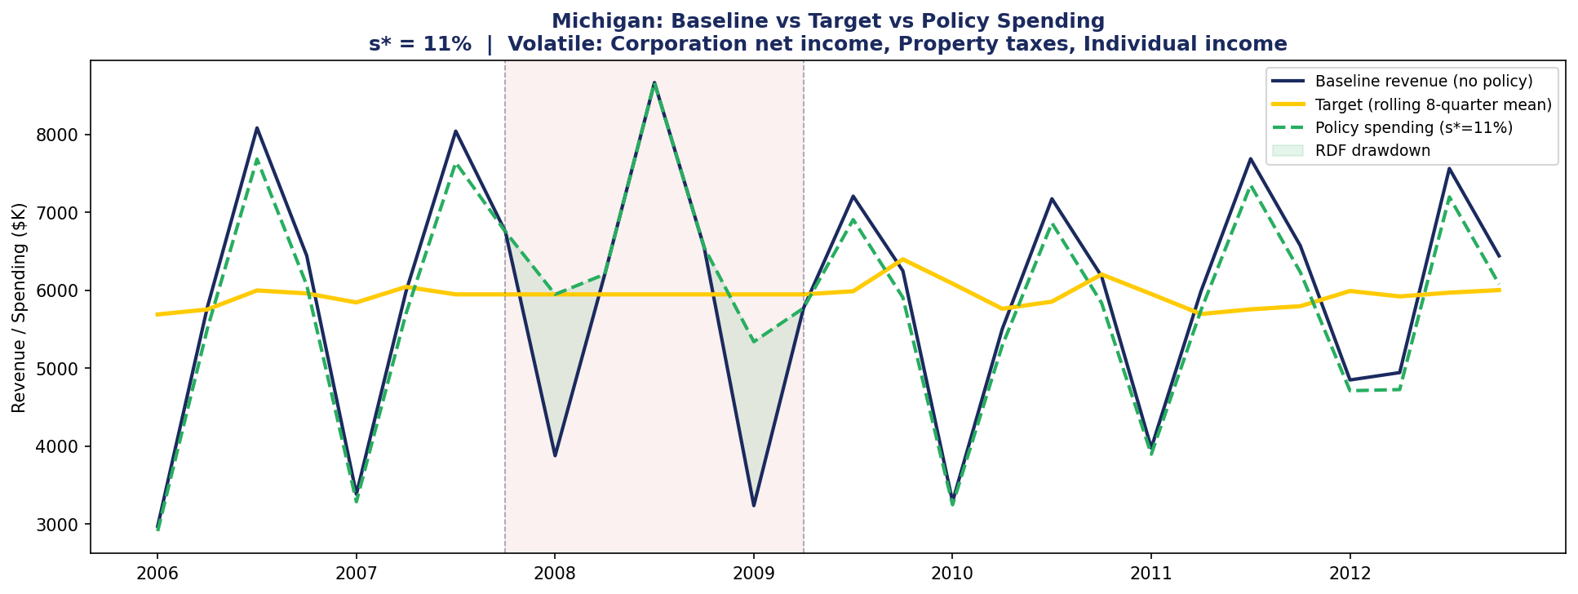
Figure 5. Baseline revenue (blue) vs target (gold) vs policy spending at s*=11% (green dashed). Green fill = RDF drawdown during recession. The policy partially closes the gap in the two recession quarters with deepest shortfalls (2008Q1, 2009Q1).

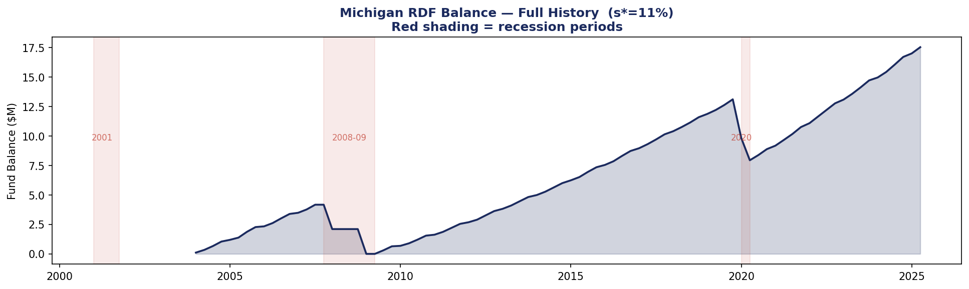
Figure 6. Full-history RDF balance. The fund accumulated during the 2004–2007 expansion, depletes during 2008–2009, and rebuilds. Three recession periods shown in red shading.

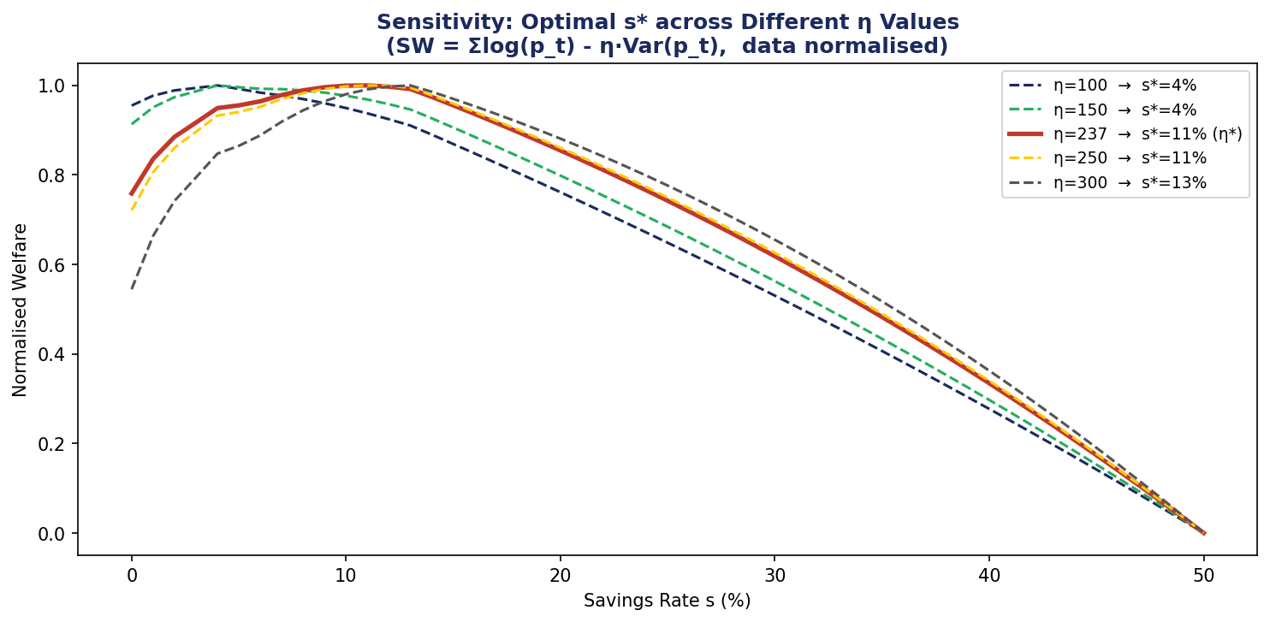
Figure 8. Sensitivity analysis: optimal s* is stable at 10–11% across η ∈ [100, 300], confirming robustness to calibration uncertainty.

9. Discussion & Key Design Choices

9.1 Why Multiplicative Impact vs Additive Scoring
Earlier iterations used a weighted additive score (0.5 × norm(drop) + 0.5 × norm(size)), which required arbitrary normalisation and was distorted by extreme outliers (e.g. Death & gift taxes: 99% drop, but only $31M revenue). The multiplicative form Impact = |drop| × size directly computes dollar revenue lost — no normalisation, no outlier sensitivity, and a clear economic interpretation.

9.2 Time Window Choices
Window | Choice
Pre-recession baseline | 2005–2007
Drop measurement | 2008–2011
UR severity window | 2008–2011
Rolling target window | 8 quarters

9.3 Takeaways
- Our analysis shows that three tax categories — Corporation net income, Property taxes, and Individual income — account for 44.5% of total revenue but drive nearly all of the recession-period revenue shortfall. A blanket savings rule applied to total revenue dilutes the signal. Legislation should mandate that the RDF contribution rate applies specifically to these three volatile streams.
- Saving 11% of quarterly volatile revenue covers 92% of the recession gap, and fully maximises the calibrated social welfare function. Raising the rate to 15% closes the remaining 8% of the gap, but at a measurable cost to expansion-period public services. The government does not need to save aggressively — it needs to save consistently at the right rate.
- Michigan's RDF held only $2.2M entering the 2008 recession — effectively zero. The fund only began meaningful accumulation in FY2011-12, after the damage was done. The model shows that even a modest savings discipline starting from 2004 would have built a $22M fund by 2007Q4, covering the two deepest recession quarters (2008Q1 and 2009Q1). Early and consistent saving is the entire mechanism — there is no substitute.
- This single category dropped 58.5% during the recession, generating a $1.07B/year revenue loss — four times larger than the next two categories combined. This is structurally linked to Michigan's automotive industry concentration. As Michigan continues to diversify its industrial base, policymakers should monitor whether this category's recession sensitivity decreases over time, which would allow a gradual reduction in the contribution rate without sacrificing protection.

9.4 Limitations
- Quarterly seasonal gaps: the RDF primarily fires in Q1; Q2–Q4 seasonal revenues mask recession effects in the gap series.
- Single state analysis: η calibrated to Michigan may not transfer to states with different tax structures or fiscal conservatism.
- Deterministic backtest: true optimisation requires modelling X_t as a stochastic process and computing E[SW]; the grid search approximates this using historical realisations.
- Property tax lag: property taxes show a 1–3 year assessment lag, meaning the 2008–2011 drop partly reflects 2005–2007 valuations; this may overstate near-term RDF needs from this category.

10. Technical Summary
Component | Detail
Language | Python | pandas, numpy, matplotlib
Data | U.S. Census Bureau Quarterly Tax Data, Michigan (2004–2025Q2); FRED GDP & unemployment
Severity index | Durdu, Edge & Schwindt (2017) Fed Notes — linear interpolation between mild/severe anchors
Impact metric | Multiplicative: Impact = |ΔRev%| × PreSize ($M/yr)
Welfare function | Log-Var: SW = Σlog(p_t) − η·Var(p_t), data normalised to mean=1
Calibration | Grid search η ∈ [0,300]; target s* ∈ [5%,15%] per NCSL/CBPP guidance
Optimisation | Exhaustive grid search s ∈ [0%,50%] at 1pp resolution (non-smooth objective due to fund floor constraint)
Codebase | 9 standalone tutorial scripts (Steps 1–9), each self-contained with full inline documentation

References
Durdu, C.B., Edge, R.M., & Schwindt, E. (2017). Measuring the Severity of Stress-Test Scenarios. FEDS Notes, Federal Reserve Board.
National Conference of State Legislatures (2014). Rainy Day Funds: Statutory and Constitutional Provisions.
Center on Budget and Policy Priorities (2018). When and How States Should Strengthen Their Rainy Day Funds.
Michigan Senate Fiscal Agency (2024). Budget and Economic Stabilization Fund Transfers and Balances, FY1997–2027.
U.S. Census Bureau, Governments Division. Quarterly Summary of State & Local Tax Revenue, 2004–2025Q2.

