Houston Community College

**Game Design Document**

3rd Grade Math Challenge

By Alejandra Lilian Cruz Purata

GAME 2341 GAME SCRIPTING

Dr. Reni Abraham

5/15/20

Contents

Game Development Team 3

Game Overview 3

High Concept 3

Unique Selling Points 3

Platform Minimum Requirements 3

Competence Titles 4

Synopsis 4

Game Objectives 4

Game Rules 4

Game Structure 5

Game Play 5

Game Camera 5

HUD 5

Art 6

Level Design 6

Audio 6

LayOut 6

# Game Development Team

Producer: Alejandra Lilian Cruz Purata

Game Designer: Alejandra Lilian Cruz Purata

Programmer: Alejandra Lilian Cruz Purata

# Game Overview

Title: 3rd Grade Math Challenge

Platform: PC Standalone

Genre: Education

Target: Children 7-9 years old

Release Date: 5/15/20

Publisher: Python

3rd Grade Math Challenge is a single person quiz game where the player can practice his Math Skills by responding a set of 25 random questions covering Addition, Subtraction and Estimation.

# High Concept

3rd Grade Match Challenge in Addition Subtraction and Estimation, encourage students to solve computer generated questions.

3rd Grade Match Challenge is a multiple choice question game.

# Unique Selling Points

Sound Effects

Learning Experience

# Platform Minimum Requirements

Processors: Intel Atom® processor or Intel® Core™ i3 processor

Disk space: 1 GB

Operating systems: Windows* 7 or later, macOS, and Linux

# Competence Titles

Name of the title: 3rd Grade Math Challenge

Publisher: Alejandra Cruz

Game screen shot:

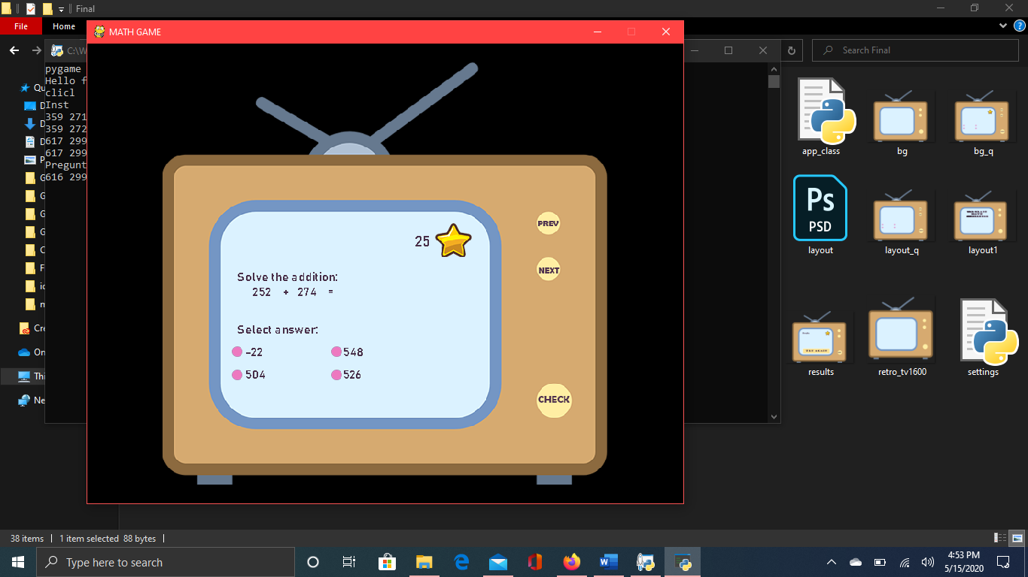

# Synopsis

To solve a set of 25 math questions.

# Game Objectives

The objective of the game is to test the ability of the students to solve math problems.

# Game Rules

The player will star with 25 stars. The student will have to solve one question at a time. If the player answers the question correctly, it will keep the stars. If the player answers is incorrect, it looses one star. At the end the player will see an Assessment Report of how many stars they got, their numeric score out of 25.

# Game Structure

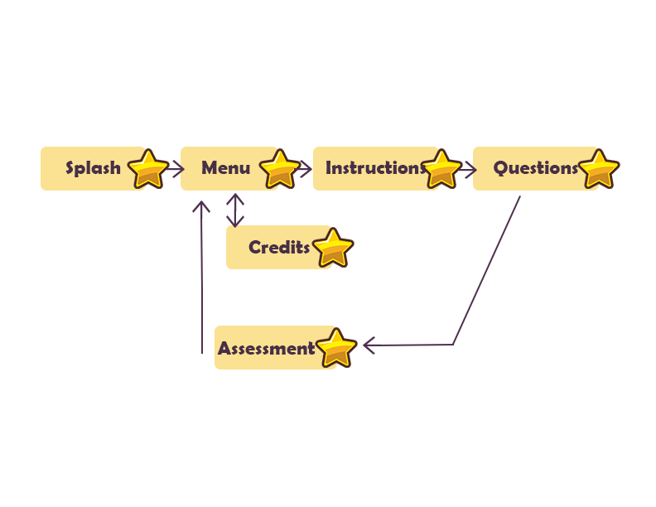

# Game Play

**Game controls(PC)**

Mouse Click: it is a multiple choice game.

# Game Camera

Camera Start:

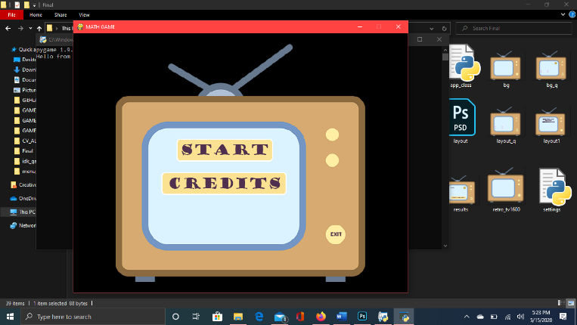

During the Game:

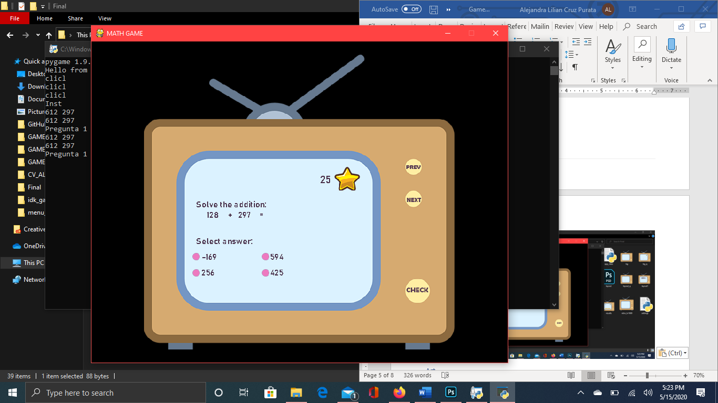

# HUD

Player Damage: The students looses stars with wrong answers.

Health Bar: Keeps the stars with good answers.

# Art

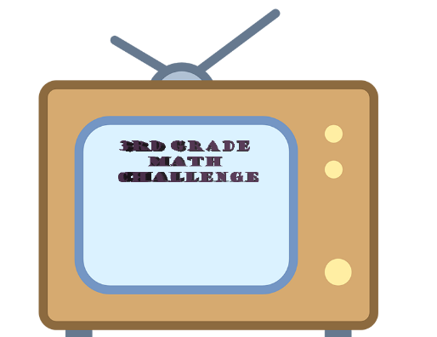

# Level Design

The game consist on a computer like screen. It will display one question per screen. It will have controls to get to the next question. At the top it will have the stars that will work as a health system.

# Audio

Winning Sound Effect: plays when the student gets the right answer.

Sad Sound Effect: plays when the student gets the wrong answer.

Final Sound Effect: plays when the test is finish.

# LayOut

