**Game Design Document**

By Alejandra Lilian Cruz Purata

**Game Overview**

Title: 3rd Grade Math Challenge

Platform: PC Standalone

Genre: Education

Target: Children 7-9 years old

Release Date: Coming Soon

Publisher: Python

3rd Grade Math Challenge is a single person quiz game where the player has the opportunity to practice his Math Skills by responding a set of 25 random questions covering Addition, Subtraction and Estimation.

**High Concept**

3rd Grade Match Challenge in Addition Subtraction and Estimation, encourage the player to resolve every single question with they keyboard.

**Unique Selling Points**

Sound Effects

Visual Effects

**Platform Minimum Requirements**

Processors: Intel Atom® processor or Intel® Core™ i3 processor

Disk space: 1 GB

Operating systems: Windows* 7 or later, macOS, and Linux

**Competence Titles**

Math Tutor

**Synopsis**

To solve questions.

**Game Objectives**

The objective of the game is to learn addition, subtraction and estimation and solve a set of 25 questions.

**Game Rules**

The player will star with 25 stars as a the health system. Player will have to solve one question at a time. If the player answers the question correctly, it will keep the stars. If the player answers is incorrect, it looses one star. At the end the player will see an Assessment Report of how many stars they got, their numeric score out of 25 and how much time they took to complete.

**Game Structure**

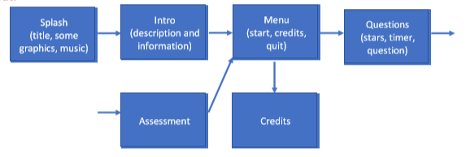

**Game Play**

**Game controls(PC)**

Keyboard + Mouse

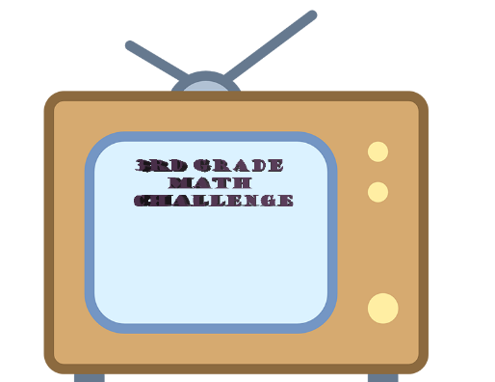

**Art**

**Level Design**

The game consist on a computer like screen. It will display one question per screen. It will have controls to get to the next question. At the top it will have the stars that will work as a health system.

**Audio**

WinindSound(yet to find)

LoosingSound(yet to find)

**LayOut**

