ANALYSIS REPORT

Summary

|  |  |  |
| --- | --- | --- |
| Date | CLIENT | ANALYSIS BY |
| 16/Mei/2023 | Project DH | Lina P |

ABSTRACT

**Background**: Quality of Life in COPD patients are assessed using SGRQ method. However, SGRQ questionnaire is complex and requires a longer time to complete than COPD Assessment Test (CAT).

**Objective** To evaluate factors associated to Quality of Life (SGRQ) value in COPD patients.

**Methods** 101 observations were collected from COPD patients and 85 data were included in the analysis. Multivariate linear regression was used to assess risk factors for wheeze.

**Results** The mean of SGRQ in the COPD patients is 39.7±17.4. In multivariable analysis, CAT and HAD been two factors that were significantly associated with SGRQ value.

**Conclusion** CAT and HAD been important predictors of quality of life in patients with COPD. Further analysis is required to obtain other predictors.

INtroDUCtion

The St. George's Respiratory Questionnaire (SGRQ) is a specialized tool designed to measure health-related quality of life in patients with chronic respiratory diseases, particularly chronic obstructive pulmonary disease (COPD). However, SGRQ questionnaire is complex and requires a longer time to complete than COPD Assessment Test (CAT). This analysis aims to develop a regression model to predict SGRQ score based on COPD patient’ characteristics.

RESULT AND INTERPRETATION

The database consists of 24 variables and 101 observations:

* Characters: Age, Gender, Pack History, Smoking
* Disease: COPDSeverity, CAT
* Walking ability: MWT1, MWT2, MWT1Best
* Lung function: FEV1, FEV1PRED, FVC, FVCPRED
* Anxiety Depression: HAD
* QoL: SGRQ
* Comorbidities: Diabetes, Muscular, Hypertension, AtrialFib, IHD

SQGR value stratified by gender, smoking history, COPD severity and comorbid

1. Data exploration

Variables with potential outliers:

* AGE (55-85)
* PackHistory >95)
* MWT1Best (value > 650 and < 150)
* CAT (value > 40)
* HAD (value > 50)
* Outliers and NAs were removed using imputation. The number of observations included in the model were 85.

Correlation matrix

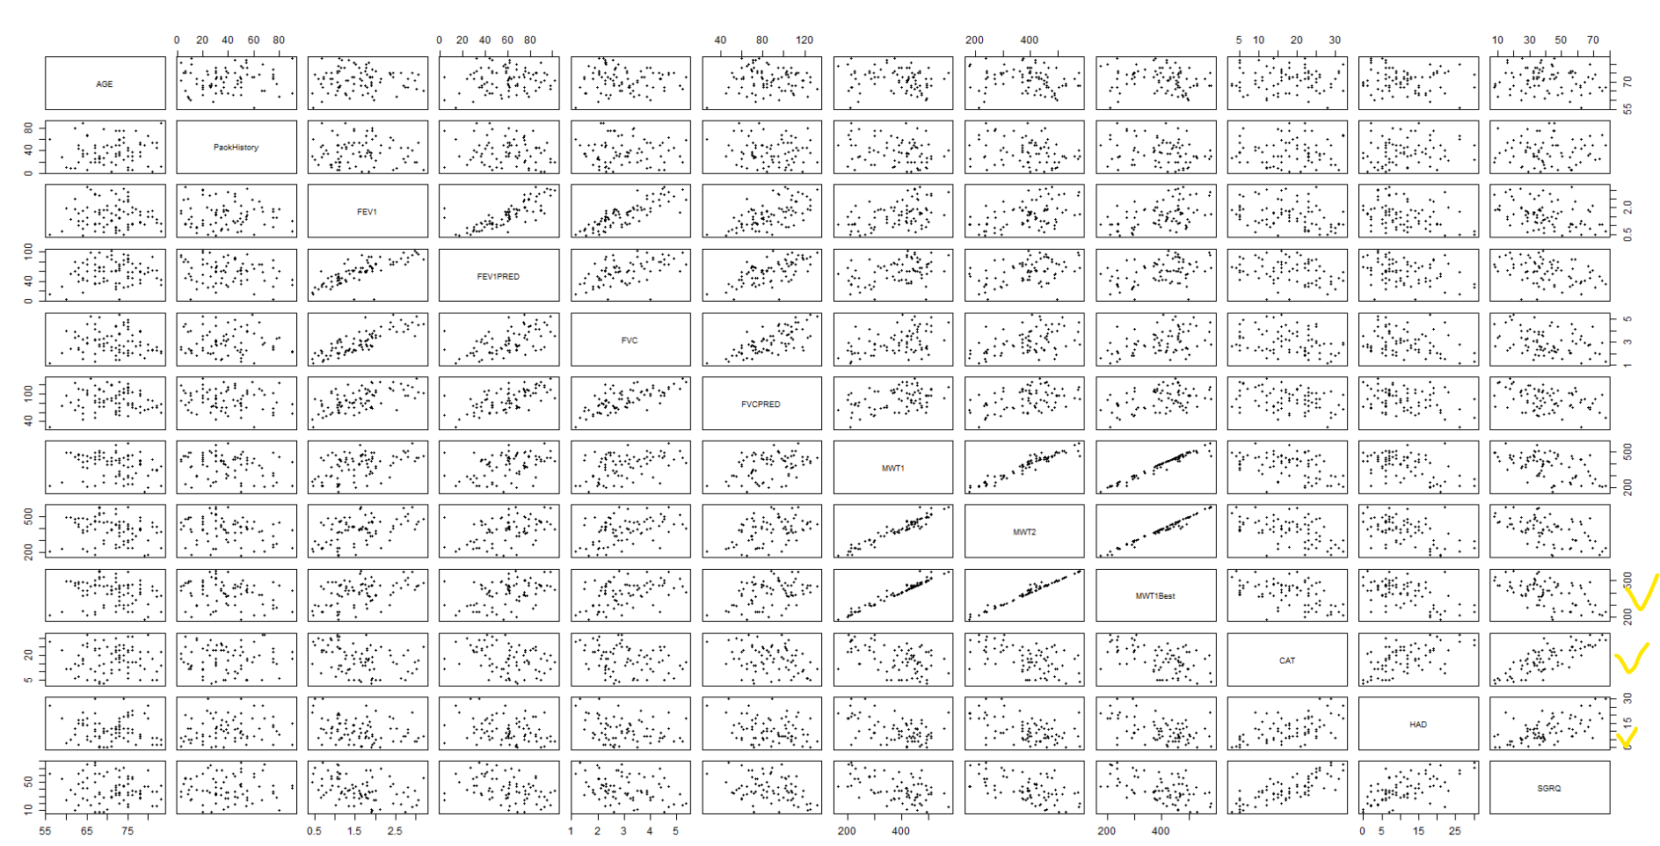

1. Descriptive analysis

Table 1. Subject characteristics for multivariate model candidate

|  |  |
| --- | --- |
|  | Mean±SD or n(%)  n total = 85 |
| Age (years) | 71.2±5.97 |
| Male | 54(63.5) |
| Pack history | 36 (3-90) |
| Smoking | 71(83.5) |
| FEV | 1.59±0.68 |
| FVC | 2.97±1.00 |
| Walking distance | 420(176-582) |
| COPD Assessment Test (CAT) | 18(3-32) |
| COPD Severity |  |
| Mild | 18(21.2) |
| Moderate | 38(44.7) |
| Severe | 22(25.9) |
| Very severe | 7(8.2) |
| Hospital Anxiety and Depression Scale (HAD) | 9(0-30) |
| SGRQ | 39.7±17.4 |
| Comorbid | 47(55.3) |
| Diabetes | 17(20) |
| Muscular | 16(18.8) |
| Hypertension | 9(10.6) |
| Atrial fibrillation | 19(22.4) |
| IHD | 7(8.2) |

1. Univariate analysis

|  |  |  |
| --- | --- | --- |
| **Variables** | **95% CI** | **p-value** |
| Age | -0.26(-0.90 to 0.37) | 0.409 |
| Female | -2.48 (-10.32 to 5.36) | 0.53 |
| Pack history | -0.00154(-0.18 to 0.18) | 0.99 |
| Smoking | -10.76(-20.69 to -0.83) | <0.05 |
| FEV | -9.77(-14.93 to -4.61) | <0.001 |
| FVC | -4.76(-8.41 to -1.10) | <0.05 |
| Walking distance | -0.09 (-0.12 to – 0.06) | <0.001 |
| COPD Assessment Test (CAT) | 1.72 (1.43 to 2.00) | <0.001 |
| COPD Severity |  |  |
| Moderate | 5.46(-3.62 to 14.53) | 0.234 |
| Severe | 19.05(8.96 to 29.13) | <0.001 |
| Very severe | 19.63(5.50 to 33.76) | <0.05 |
| Hospital Anxiety and Depression Scale (HAD) | 1.52(1.10 to 1.94) | <0.001 |
| Comorbid | 4.71(-2.83 to 12.25) | 0.218 |
| Diabetes | 7.51(-1.80 to 16.82) | 0.113 |
| Muscular | 2.24(-7.42 to 11.91) | 0.645 |
| Hypertension | 4.75(-7.50 to 17.00) | 0.443 |
| Atrial fibrillation | 7.22(-1.72 to 16.16) | 0.112 |
| IHD | -1.14(-14.90 to 12.62) | 0.869 |

1. Multivariate Analysis

|  |  |  |  |  |  |  |  |
| --- | --- | --- | --- | --- | --- | --- | --- |
|  | Variables | Coeff | 95% CI | p-value | R2 | F-stats | p-value |
| Model 0 | Intercept | 37.87 | -12.34 to 88.09 | 0.137 | 0.739 | (17,67) 11.2 | <0.001 |
|  | AGE | -0.20 | -0.68 to 0.27 | 0.393 |  |  |  |
|  | Gender1 | 2.00 | -4.38 to 8.38 | 0.533 |  |  |  |
|  | FEV1 | -6.44 | -14.96 to 2.08 | 0.136 |  |  |  |
|  | FVC | 2.03 | -2.48 to 6.55 | 0.371 |  |  |  |
|  | CAT | 1.37 | 0.96 to 1.78 | <0.001 |  |  |  |
|  | MWT1Best | -0.02 | -0.05 to 0.021 | 0.362 |  |  |  |
|  | COPDSEVERITYMODERATE | 0.82 | -6.40 to 8.05 | 0.821 |  |  |  |
|  | COPDSEVERITYSEVERE | -0.90 | -12.40 to 10.62 | 0.878 |  |  |  |
|  | COPDSEVERITYVERYSEVERE | -10.66 | -27.43 to 6.11 | 0.209 |  |  |  |
|  | HAD | 0.47 | 0.06 to 0.88 | 0.026 |  |  |  |
|  | Comorbid1 | 0.35 | -8.80 to 9.51 | 0.939 |  |  |  |
|  | Smoking | -3.18 | -9.63 to 3.28 | 0.329 |  |  |  |
|  | Diabetes | 0.91 | -6.97 to 8.80 | 0.818 |  |  |  |
|  | Hypertension | 5.54 | -4.14 to 15.22 | 0.257 |  |  |  |
|  | Muscular | -2.00 | -10.07 to 6.08 | 0.623 |  |  |  |
|  | Atrial fibrilation | 1.29 | -7.39 to 9.97 | 0.767 |  |  |  |
|  | IHD | 0.91 | -8.94 to 10.77 | 0.854 |  |  |  |
| Model 9 | Intercept | 8.17 | 2.95 to13.40 | <0.001 | 0.681 | (2,82) 87.6 | <0.001 |
|  | CAT | 1.41 | 1.09 to1.73 | <0.001 |  |  |  |
|  | HAD | 0.63 | 0.27 to1.00 | <0.001 |  |  |  |
| Model 10 | Intercept | 17.70 | 3.10 to 32.30 | 0.02 | 0.689 | (3,81) 59.7 | <0.001 |
|  | CAT | 1.33 | 0.99 to 1.67 | <0.001 |  |  |  |
|  | HAD | 0.56 | 0.18 to 0.94 | 0.004 |  |  |  |
|  | MWT1Best | -0.02 | -0.04 to 0.01 | 0.168 |  |  |  |
| Mlr2 | Intercept | 16.55 | -10.70 to 43.80 | 0.230 | 0.685 | (5,79) 34.4 | <0.001 |
|  | CAT | 1.42 | 1.09 to1.74 | <0.001 |  |  |  |
|  | HAD | 0.60 | 0.22 to 0.98 | 0.002 |  |  |  |
|  | AGE | -0.13 | -0.51 to 0.24 | 0.490 |  |  |  |
|  | Gender1 | 0.45 | -4.23 to 5.14 | 0.848 |  |  |  |
|  | Comorbid1 | 1.70 | -2.73 to 6.14 | 0.447 |  |  |  |

CONCLUSION