Project Report
Project Title:
Spam Email/SMS Classifier Using Machine Learning

1. Objective:
The objective of this project is to develop a machine learning model that classifies incoming SMS or email messages as Spam or Not Spam (Ham). This system helps users automatically filter unwanted messages.

2. Dataset Source:
The dataset used for this project is the SMS Spam Collection Dataset obtained from the UCI Machine Learning Repository/Kaggle. It contains SMS messages labelled as Spam and Ham (Not Spam).
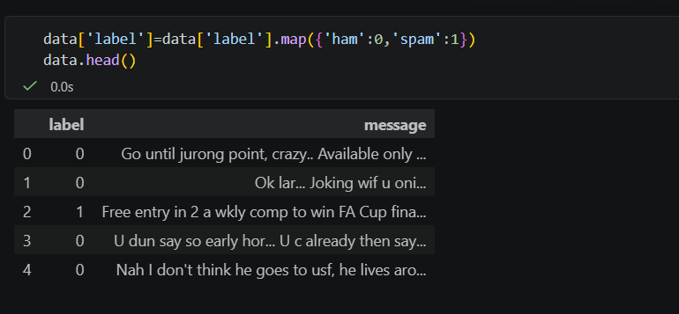
Fig 1: Dataset Preview

3. Tools & Technologies:
- Programming Language: Python
- IDE: Visual Studio Code (Jupyter Notebook)
- Machine Learning Algorithm: Naive Bayes
- Libraries:
- Pandas
- NumPy
- Scikit-learn
- NLTK
- Matplotlib

4. Project Workflow:
- Load the dataset.
- Preprocess the dataset.
- Clean the text messages.
- Convert text into TF-IDF features.
- Split the dataset into training and testing data.
- Train the Naive Bayes classifier.
- Evaluate the model using Accuracy, Confusion Matrix, and Classification Report.
- Test the classifier with a new message.
- Save the trained model (spam_model.pkl).

5. Minimum Features:
- Text Preprocessing
- TF-IDF Feature Extraction
- Spam Detection
- Confusion Matrix
- Accuracy Evaluation
- Sample Predictions

6. Results:
The model was trained using the Naïve Bayes algorithm and achieved approximately 97% accuracy.
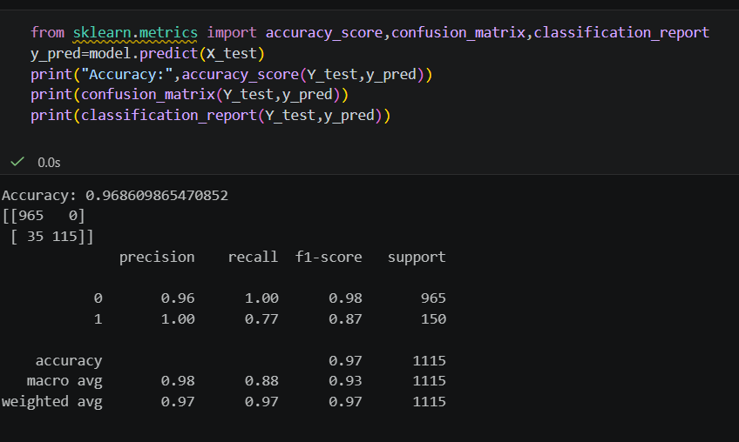
Fig 2: Model Evaluation Results

The trained model was tested using a new SMS message and correctly identified it as spam.
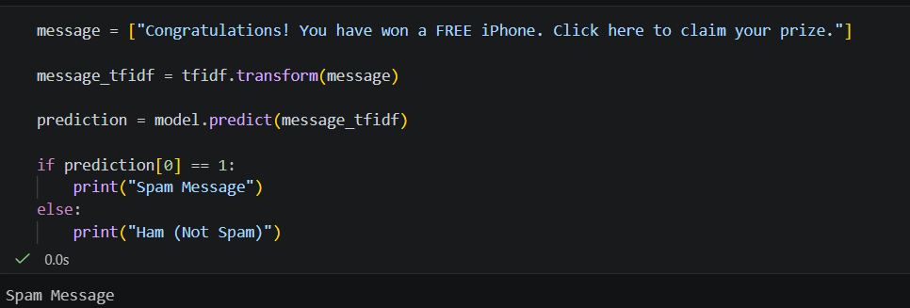
Fig 3: Sample Prediction

7. Conclusion:
The Spam Email/SMS Classifier successfully detects spam messages using machine learning techniques. By using TF-IDF feature extraction and the Naive Bayes algorithm, the system classifies messages with high accuracy. This project demonstrates the practical use of machine learning in email and SMS filtering.

