

NZQA Approved

Internal Assessment Resource

Chemistry Studies Level 3

|  |
| --- |
| This resource supports assessment against:  Achievement Standard 91388  Demonstrate understanding of spectroscopic data in chemistry |
| Resource title: Solving organic structural problems |
| 3 credits |
| This resource:   * Clarifies the requirements of the Standard * Supports good assessment practice * Should be subjected to the school’s usual assessment quality assurance process * Should be modified to make the context relevant to students in their school environment and ensure that submitted evidence is authentic |

|  |  |
| --- | --- |
| Date version published by Ministry of Education | February 2017 Version 2  To support internal assessment from 2017 |
| Quality assurance status | These materials have been quality assured by NZQA. NZQA Approved number: A-A-02-2017-91388-02-6371 |
| Authenticity of evidence | Teachers must manage authenticity for any assessment from a public source, because students may have access to the assessment schedule or student exemplar material.  Using this assessment resource without modification may mean that students’ work is not authentic. The teacher may need to change figures, measurements or data sources or set a different context or topic to be investigated or a different text to read or perform. |

Internal Assessment Resource

Achievement Standard Chemistry 91388: Demonstrate understanding of spectroscopic data in chemistry

Resource reference: Chemistry 3.2A v2

Resource title: Solving organic structural problems

Credits: 3

Teacher guidelines

The following guidelines are supplied to enable teachers to carry out valid and consistent assessment using this internal assessment resource.

Teachers need to be very familiar with the outcome being assessed by Achievement Standard Chemistry 91388. The achievement criteria and the explanatory notes contain information, definitions, and requirements that are crucial when interpreting the Standard and assessing students against it.

Context/setting

This activity requires students to interpret spectral data to determine the identity of discrete aspects of the structure of an organic compound. The data will be provided for the students. They will interpret each piece of data and combine the information to determine the structure of the organic molecule. Information about the empirical formula of the molecule will be provided.

Conditions

It is suggested that this assessment task will take place over 1-2 class periods. Students will be able to use annotated data tables for IR absorption frequencies and 13C NMR chemical shifts.

Resource requirements

Tables for IR absorption frequencies and 13C NMR chemical shifts.

Additional information

Before students can realistically attempt to use spectral data they need to be familiar with the structures of organic molecules including functional groups and isomers as required by Achievement Standard 3.5. However, it would be possible to work with Level 2 compounds but this restricts the range of possible compounds that can be used in the assessment tasks

Internal Assessment Resource

Achievement Standard Chemistry 91388: Demonstrate understanding of spectroscopic data in chemistry

Resource reference: Chemistry 3.2A v2

Resource title: Solving organic structural problems

Credits: 3

| Achievement | Achievement with Merit | Achievement with Excellence |
| --- | --- | --- |
| Demonstrate understanding of spectroscopic data in chemistry. | Demonstrate in-depth understanding of spectroscopic data in chemistry. | Demonstrate comprehensive understanding of spectroscopic data in chemistry. |

Student instructions

Introduction

This assessment activity requires you to analyse the spectral data provided to determine the structure of organic molecules and to justify how the spectroscopic data were used to determine the structure.

Data provided is: mass spectra, IR spectra, and 13C NMR spectra.

Combining the information from all three sets of spectra will enable you to work out the actual structure of the molecule. You will also be given the empirical formula of each molecule to be analysed.

This is an individual task and will take place over 1-2 class periods.

You will be assessed on the comprehensiveness of your understanding of spectroscopic data in chemistry.

Task

Part 1

Compound A contains carbon, hydrogen, and a halogen (X). Elemental analysis shows the empirical formula to be C4H9X.

1. The mass spectrum for compound A is given below.

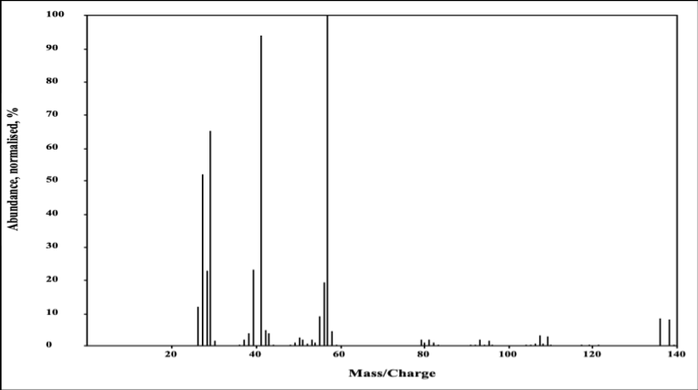

1. Use the mass spectrum to work out the molar mass of compound A and hence the identity of the halogen X. Give a reason for your answer.
2. Explain the most likely reason for the peak at 57.
3. Compound A is produced from the action of the halogen, X2, on an isomer of butane. Possible products are:
4. Determine the number of different chemical environments for the

carbon atoms in each of these isomers.

1. The 13C NMR spectrum for compound A is given below. Identify which of structures above matches that of compound A. (Note that the peak at 75 ppm is a solvent peak.)



1. The IR spectrum for compound A is given below.

What structural feature of an organic compound is responsible for the group of peaks marked X?

X



1. When compound A is treated with alcoholic KOH, there are two possible reactions – substitution to produce an alcohol or elimination to produce an alkene.

Compound B was isolated from the reaction of compound A with KOH (alc). The IR spectrum for compound B was obtained and is given below. Use the spectrum to identify which reaction product has been obtained. Justify your answer.



Part 2

Compound C is known to be one of the following:



Spectral data for compound C are given in a separate data sheet.

Your task is to determine which of the three structures is compound C.

Answer each of the following questions and use your answers to help determine the identity of the unknown compound C.

1. Determine the molar mass of compound C using the mass spectrum. Give a reason for your answer and explain how this information can help identify compound C.
2. Identify the functional group/s present in compound C using the IR spectrum. Explain your answer in terms of the observed peaks and the peaks that would have indicated the functional groups in the alternative structures given.
3. Use the 13C NMR spectrum to determine the number of carbon chemical environments in compound C. Match this to the appropriate structure(s) given for compound C. Explain your answer.
4. Identify compound C: _______________________

Briefly summarise how the spectral data supports your answer.

Part 3

Compound D contains carbon, hydrogen, and oxygen only. Elemental analysis shows the empirical formula to be C2H4O.

Identify the structure of compound D using the data provided in the data sheet. You may annotate the spectra as part of your working.

1. Use the mass spectra to determine the molar mass and hence the molecular formula of compound D. Explain you answer.
2. Use the IR spectrum to identify the functional group/groups in compound D. Justify your answer.
3. Draw the possible isomers of compound D and determine the number of different electronic carbon environments they have. Match the appropriate isomers with the 13C NMR data.
4. Give the structure of compound D.

Resource A: Data sheets for compound C and compound D

NOTE: An alternative mass spec for compound D, which enables the M+ peak to be identified.

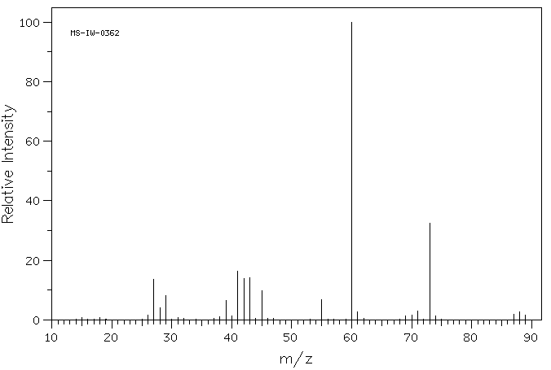

Assessment schedule: Chemistry 91388 Solving organic structural problems

|  |  |  |
| --- | --- | --- |
| Evidence/Judgements for Achievement | Evidence/Judgements for Achievement with Merit | Evidence/Judgements for Achievement with Excellence |
| The student identifies discrete aspects of the structure of organic compounds using spectroscopic data. For a given structure, the student identifies discrete aspects for all three spectra:   * the molecular ion in mass spec data * key peaks in IR spectra and links to functional groups * the number of different carbon environments in a molecule and relates these to 13C NMR.   Evidence could be found from annotated spectra. | The student interprets spectra and determines the structure of an organic molecule.  The student links the key aspects of all three spectra to the structure.  For example:  The student recognises most of the key features of the spectra but does not integrate all the spectral data (for instance, does not discuss expected peaks for alternative compounds) to show how the structures could be determined/distinguished.  The examples above relate to only part of what is required, and are just indicative. | The student has interpreted spectra to solve the structure of a molecule.  The student justifies the structure of an organic molecule by integrating spectroscopic data.  For example:  **Compound A is 2-bromomethylpropane**  *Mass spec* – molecular ion, M+, is at 136 which is *Mr*(C4H9Br)so X is Br (for 79Br).  Other evidence for Br is M+ and M++2 peaks of the same size (79Br and 81Br) and peak at 57 which is C4H9+fragment *Mr*(X)=136 – 57 = 79 i.e. the lowest mass isotope of Br.  *13C NMR* – 2 lines which suggests 2-bromomethylpropane which gives 2 different C environments – CH3C(Br)(CH3)CH3.  For the other isomers:  1-bromobutane is CH3CH2CH2CH2Br – 4 different C atom environments  2-bromobutane – CH3CH2(Br)CH2CH3 – 4 different C environments  1-bromomethylpropane – CH3CH(CH3)CH2Br – 3 different C environments  *IR* spec – peak X is C-H bonding.  **Compound C is pentan-3-one**  *Mass spec* – molecular ion, M+, is at 86 so *Mr*(Compound C)= 86 – so can’t be ethyl ethanoate as this compound has *M*r = 88. Large peak at 57 could be CH3CH2C=O = confirms pentan-3-one.  *IR* peak 3000 cm-1 is C-H stretching peak at 1725 cm-1 C=O . There is no peak around 3400 cm-1 so no -OH present and no peak at 3100 cm-1 so no double bond present,  *13C NMR* – 3 peaks, one downfield (> 200 ppm).  CH3CH2C(=O)CH2CH3 has 3 C environments (molecule is symmetrical) and C=O will be downfield from the other 2.  CH3CH=CHCH2CH2OH has 5 C environments.  So pentan-3-one matches all the data.  **Compound D is butanoic acid**  *Mass spec* – molecular ion at 88, *Mr*(C2H4O)= 44 so formula for Compound D is C4H8O2.  Possible functional groups; acid, ester (or 2 alcohols with double bond).  *IR –* broad peak around 3000 cm-1 indicates  -OH and at 1750cm-1 is C=O so suggests carboxylic acid.  Possible isomers are butanoic acid and methylpropanoic acid.  *13C NMR* – 4 peaks with 1 downfield – suggests butanoic acid, CH3CH2CH2COOH, i.e. 4 different C environments with 1 C=O giving peak downfield.  Methylpropanoic acid, (CH3)2CH2COOH, would have 3 different C environments so 3 peaks with one downfield for C=O.  Straight chain matches data.  *The examples above relate to only part of what is required, and are just indicative.* |

Final grades will be decided using professional judgement based on a holistic examination of the evidence provided against the criteria in the Achievement Standard.