1. Run ng g d input-format (input-format is the name of your directive)
2. 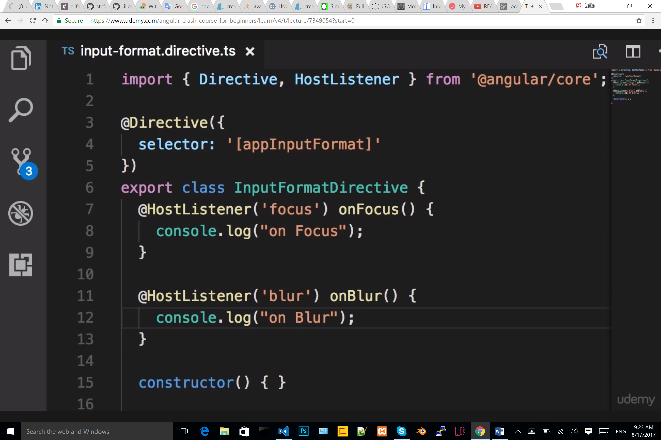
3. 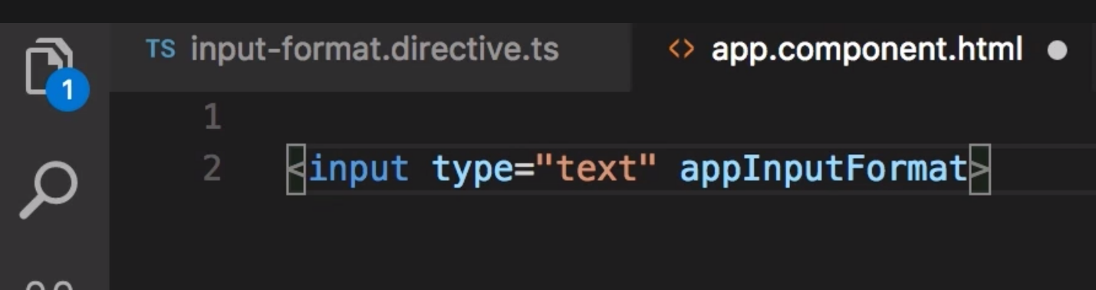
4. 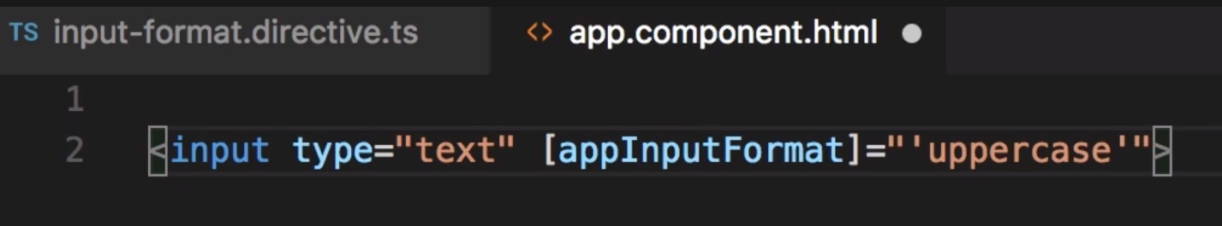
5. 