Meeting Minutes

**Project:**

Entrepreneurship Support

Platform

**Meeting Type:**

Meeting with the Entrepreneurial Code Crafters

**Date:**

11 October 2024

**Time:**

13h40

**Location:**

Computer Room 3 (IIE Varsity College Durban North Campus)

**Meeting Facilitator:**

Hayley Chetty

**Minutes Taker:**

Sibusisiwe Kunene

Call to order

•

Time: 10h00

•

Facilitator/

Chairman: Hayley Chetty is our technical writer.

Attendees and Apologies

Malibongwe Ndlovu (Project Manager was present)

Lilitha Njeje (Database Administrator was present)

Sibusisiwe Kunene (Software Architect was present)

Avarn Sewlal: (UI/UX Designer)

Hayley Chetty: (Technical Writer)

Allison Gopal: (Lead Developer)

.

Agenda

The agenda of this meeting is to breakdown the structure of the documentation. Hayley our technical writer organized the meeting and she opened the meeting at exactly 13:40.

Detailed meeting notes

In this meeting we discussed how the structure of the documentation should be, each member brought their part of work they had to do, regarding the documentation, and we showed the technical writer so she can combine everything into one documentation.

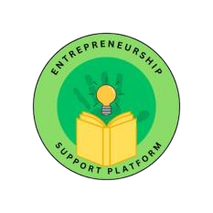

:

Adjournment

The meeting was closed at exactly 16:30.

Approval

**Minutes approved by:**

Sibusisiwe Kunene

11 October 2024