

Z-Bot 1.0b (03.01.2011.) Manual Book

1. Introduction
__________________________________________________________________________________________

Z-Bot is an application that helps you manage your eRepublik accounts. Basically, it does everything what you would normally do. Here is a full list of stuff Z-Bot can do:

- Work
- Eat food before work
- Eat food after work
- Get a job if unemployed
- Train
- Eat food after train
- Fight
- Vote
- Subscribe
- Buy products from market
- Solve treasure maps
- MULTIES THAT OWN A COMPANY ARE NOT SUPPORTED! ZBOT COULD CRASH IF YOU PUT THEM IN THE ACCOUNTS.TXT FILE !

The technical features:

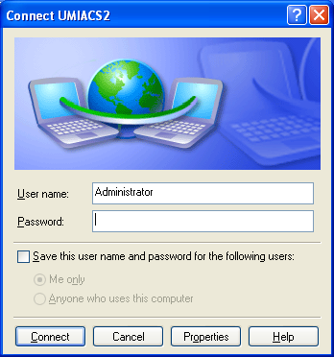
- Incase you have a dynamic IP, Z-Bot can automatically renew your IP address using your modem page (if your modem isn’t supported, please contact us : zbot.erep@gmail.com) !
- Incase you have a dynamic IP and you connect to internet via a network connection, like the one pictured to the right (this picture is from XP, but Z-Bot is compatible with all Windows that have .NET 3.5), Z-Bot can also automatically renew your IP address between logging into accounts!
- Z-Bot is also compatible with the Hotspot Shield proxy!
- Z-Bot automatically clears cookies each time before logging into an account !
- Z-Bot auto-updates itself, so you don’t have to worry about new versions!

What you SHOULD NOT DO:
- Sharing Z-Bot is not allowed, and doing so will result in you being banned from using Z-Bot ! ONLY 1 Z-BOT PER COMPUTER IS ALLOWED!

The author is constantly upgrading Z-Bot, so if you have any features you would want to see in the next version, feel free to send suggestions to zbot.erep@gmail.com
2. How to use
__________________________________________________________________________________________

0.) First and foremost, make sure you have extracted Z-Bot.rar properly and that all these files are located in the same folder. Then, if on Vista/Win7, disable UAC (click here for guide).
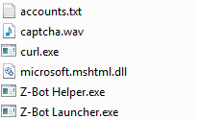

After that, open accounts.txt and add your accounts in the shown format.

1.) Run Z-Bot Launcher.exe as administrator (right click – Run as Administrator), type in your nickname and press Enter.
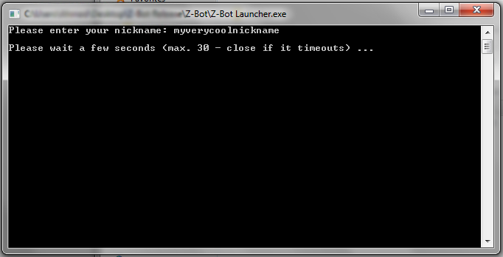

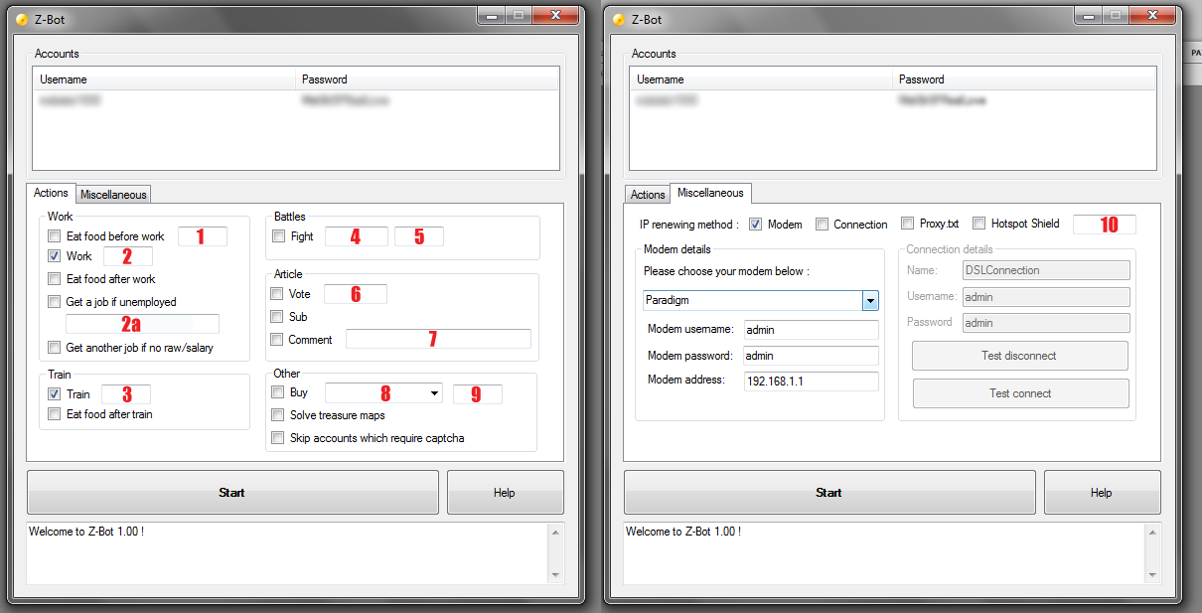
2.) Main Z-Bot window should appear. What follows is an explanation of the empty boxes, almost everything else is self-explanatory.
1. How many food to eat before work
2. The booster to use with work (1 = first booster, 2 = second booster, 3 = third booster etc.)
2a. Job offer link (the link to your job offer, not all job offers!), i.e. http://economy.erepublik.com/en/market/job/offer/1489262
3. The booster to use with train (same as above)
4. The battle ID at the end of the battlefield link, i.e. 3193
5. How many times to fight (and eat! you should have enough food to eat after every fight!)
6. Article ID at the end of the article link, i.e. 1623765
7. The comment text to submit
8. Product to buy (in brackets are the properties)
9. How many products to buy
10. Hotspot Shield connect link (the link you get when you go to Hotspot Shield -> Connect), i.e. http://127.0.0.1:895/config/?action=connect&lang=eng&afd=1294153106
&afc=774484F00E471CA2DF54EAC4A8BDB6FB
3.) a) The Modem proxy setting is for those who have a dynamic IP and can reset it via their modem page (like 192.168.1.1). If this option is checked, you have to correctly fill in the Modem username, Modem password and Modem address! You also have to choose your modem in the list. If your modem is not supported, please contact us at zbot.erep@gmail.com so we can add your modem to the list. NOTE: The modem username, password are not the username and password your ISP gives you! These are the details you use in order to open the modem page. If there is no username or password, leave empty.

b) The Connection proxy setting is also for those who have a dynamic IP, however it is for those who connect via a Windows Network Connection, and not via modem page (see picture – this picture is from XP, but this setting works for all Windows). Incase you check this setting, then you have to input your connection Name (for example, if you had a connection like from the picture on the right, in Connection name you would type UMIACS2). You also have to input connection Username and Password – the ones that ISP gives you or the ones that you type in a window similiar to the right.

c) The Hotspot Shield proxy settings is for those who want to use this with Hotspot Shield proxy. In the box below you have to input the Hotspot link, mentioned under 2.

4.) Press Start and good luck! When a CAPTCHA appears, you will be notified with a sound signal. You will also see an IE/Firefox window where you will submit (not only type!) the captcha, and then press OK in the Z-Bot window.

Enjoy.

