Part 1- Overall Information
Proposal Form for Advantech AIoT InnoWorks
University Name | Phenikaa Universiy | Department/Institute | EEE
Professor Name  (Applicant/Host) | Dr. Nguyen Dac Cu
Email | cu.nguyendac@phenikaa-uni.edu.vn
Overall Information and Resource Requirement for AIoT InnoWorks Program
Duration of AIoT InnoWorks  Please specify the timeline of skills developments, application development and final demo. The suggested overall duration is 4-6 months. | l Skills developments: 2026/05/07 to 2026/07/23  l Application development: 2026/07/31 to 2026/11/20  l Final Demo Day: 2026/11/27
How many number of students participate?  Please include:  1. Number of teams  2. Number of team members in each teams | Number of teams: 01 team  Number of teams members: 3 members
How many slots on WISE-IoT’s training websites are needed for participants? | 03 WiSE- IoT account for team
The duration of WISE-IoT space open for application developments and final demo?  For example: 2026 Jun 1~2026 Dec 30 | 2026 Jun 1 - 2026 Dec 30

Part 2- Project Information (at least 05 projects)
Please fill in project information for each team. The form can be copied for use.
Advantech AIoT InnoWorks - Project Information: Team
Team Name | TaskForce141 | No. of Team Members | 3
Project Topic | Edge AI-Based Electronic Nose for Hydrogen Sulfide Leak Detection in Natural Gas Processing Plants | Adviser | Dr. Nguyen Dac Cu
Member background (department) | - Do Duc Khoi – Lead  - Le Pham Thanh Dat – Member  - Vu Anh Kiet - Member
Project introduction  For example:  The target audience of the project, the issue want to be resolved and the expected benefits of the project | This project proposes an advanced AIoT-based Electronic Nose (E-Nose) system engineered for real-time monitoring, multi-gas pattern recognition, and predictive risk assessment in industrial facilities. Traditional safety systems rely on isolated threshold-based detectors, which frequently yield high false-alarm rates or fail to differentiate between different toxic gas species and harmless environmental fluctuations. To overcome these limitations, our solution mimics biological olfaction by integrating a specialized multi-sensor array capable of accurately distinguishing between Hydrogen Sulfide ($H_{2}S$), Ammonia ($NH_{3}$), and Normal Ambient Air under dynamic operational conditions.  The physical architecture comprises distributed ESP32-based E-Nose field nodes deployed across target monitoring zones. Each node features a hybrid sensor matrix: an electrochemical ZE03-$H_{2}S$ sensor for selective concentration measurement, and a custom-designed dual MOS sensor module featuring MQ136 and MQ2. Rather than using generic breakout boards, both the MQ136 and MQ2 schematic circuits have been custom-engineered from the ground up. This custom hardware topology optimizes signal conditioning, suppresses board-level noise, minimizes thermal drift, and enhances baseline voltage stability, allowing the system to capture distinct cross-sensitivity signatures for $H_{2}S$, $NH_{3}$, and clean air baselines.  Field node data are packaged into Modbus RTU frames and transmitted over an industrial RS-485 bus to a central Raspberry Pi 4 Edge Gateway. Serving as the system’s edge intelligence core, the Raspberry Pi 4 executes real-time data ingestion, local database logging, and Edge AI inference. High-level risk metrics, gas classification results, and predictive alerts are seamlessly synchronized via MQTT to the WISE-IoT platform for centralized visualization, historical trend analysis, and automated alarm distribution.
Please provide the functional/system diagram of the project and briefly describe how Edge AI / Edge Computing will be utilized in the project? | 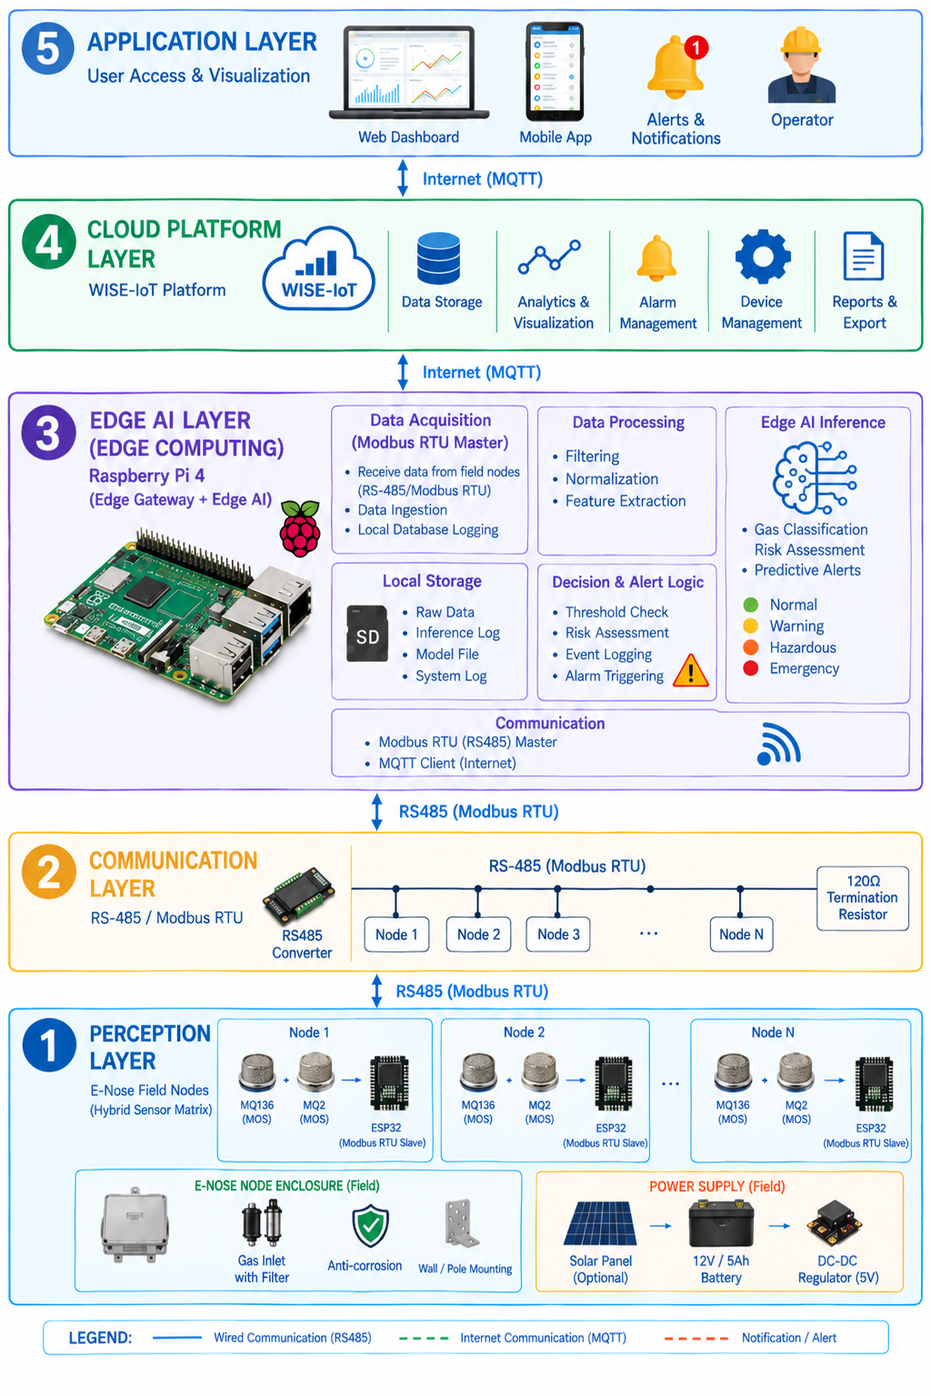  System Architecture Description  The proposed Electronic Nose (E-Nose) system is structured into a 5-layer industrial architecture designed for real-time multi-gas monitoring ($H_{2}S$, $NH_{3}$, and Clean Ambient Air) and predictive risk early warning:  1. Perception Layer (E-Nose Field Nodes): Built around distributed ESP32 microcontrollers deployed across critical monitoring zones. Each node features a hybrid sensing matrix: an electrochemical ZE03-$H_{2}S$ sensor for target selectivity, alongside a custom-engineered dual MOS sensor module (custom MQ136 & custom MQ2). The custom schematic circuits optimize signal conditioning, suppress board-level noise, and minimize thermal drift. The ESP32 handles signal filtering, timestamp generation, data packaging into Modbus RTU frames, and functions as a Modbus RTU Slave.  2. Communication Layer: Utilizes an industrial RS-485 bus running the Modbus RTU protocol. This infrastructure guarantees high immunity to electromagnetic interference (EMI), long-distance data integrity, and robust multi-drop networking across harsh plant environments.  3. Edge Computing Layer (Edge Gateway & Edge AI): Implemented on a Raspberry Pi 4 Edge Gateway acting as the Modbus RTU Master. It continuously ingests sensor streams, manages local SQLite database storage, performs feature extraction, and executes a lightweight TensorFlow Lite (TFLite) Edge AI model. The model analyzes multi-gas pattern dynamics and temporal rate-of-change ($ΔC/Δt$) to classify current atmospheric states ($H_{2}S$, $NH_{3}$, or Clean Air) and predict future risk trajectories across 4 operational levels (Normal, Warning, Hazardous, and Emergency).  4. Cloud Platform Layer: Powered by the WISE-IoT platform via MQTT over Ethernet/Wi-Fi. It provides long-term historical data storage, remote device management, trend analytics, automated report generation, and multi-channel alarm dispatching.  5. Application Layer: Delivers intuitive user interfaces including Web Dashboards, Mobile App views, and real-time alerts. Plant operators can monitor real-time gas concentrations, review predictive AI risk forecasts, and initiate proactive safety measures before critical exposure limits are reached.  Edge AI and Edge Computing Utilization  The proposed system leverages Edge Computing and Edge AI by executing machine learning models directly on the Raspberry Pi 4 Edge Gateway rather than relying on cloud-based processing.  Sensor data collected from distributed Electronic Nose nodes are processed locally at the edge. The Raspberry Pi 4 performs real-time data acquisition, noise filtering, feature extraction, and executes inference using an optimized TensorFlow Lite (TFLite) framework.  1. Multi-Gas Pattern Recognition & Feature Extraction: Instead of relying on simplistic scalar threshold checks, the Edge AI model analyzes a dynamic feature space constructed from the combined signals of the electrochemical ZE03-$H_{2}S$ sensor, the custom-designed MQ136 circuit, and the custom-designed MQ2 circuit. By cross-referencing response dynamic ratios across these specialized sensors, the model effectively decouples cross-sensitivity patterns and accurately classifies current atmospheric conditions into three distinct states:  - Hydrogen Sulfide ($H_{2}S$) Leakage  - Ammonia ($NH_{3}$) Leakage  - Clean Ambient Air Baseline  2. Predictive Early Warning & Future Risk Forecasting: Beyond real-time classification, the Edge AI evaluates time-series temporal derivatives ($ΔC/Δt$) to track gas dispersion speed and concentration rate-of-rise. This enables the model to predict impending gas accumulation trends and forecast potential hazard trajectories before critical exposure thresholds are reached. The prediction output is categorized into four operational risk levels:  - Normal: Stable clean air baseline.  - Warning: Early micro-leakage signature or initial trend elevation detected ($ΔC/Δt>θ$).  - Hazardous: Sustained gas elevation with confirmed multi-sensor pattern alignment.  - Emergency: Critical safety threshold breach requiring immediate automated shutdown and personnel evacuation.  3. Operational Advantages & Technical Efficiency:  - Low-Latency & Cloud Independence: Executing inference directly on the Raspberry Pi 4 achieves sub-100ms response times and ensures continuous, uninterrupted 24/7 operation even during complete WAN or cloud connectivity outages (utilizing local Store-and-Forward mechanisms).  - Cost Efficiency & Practical Deployment: Deploying full multi-gas classification and predictive analytics on a cost-effective Raspberry Pi 4 demonstrates the high efficiency and commercial viability of the system for industrial-scale adoption.  - Scalable Hardware Architecture: The software pipeline is hardware-agnostic, allowing seamless drop-in upgrades to Raspberry Pi 5 or NVIDIA Jetson edge hardware as plant expansion demands higher node density in future phases.

Appendix

1. Experimental Setup and Data Visualization

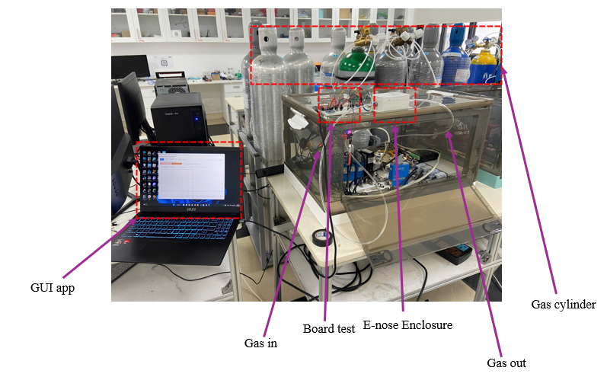
Figure 1: Experimental Setup
The hardware design, dataset collection, and Edge AI performance were validated using a dedicated laboratory gas-testing setup. The core testing environment consists of a sealed acrylic E-nose Enclosure that maintains a controlled atmosphere for gas sampling while preventing ambient air interference and hazardous gas leakage. Gas delivery is regulated via precision valves connecting standard cylinders ($H_{2}S$, $NH_{3}$, and Clean Air) to the chamber’s intake tube, with target exposure concentrations of 1–10 ppm for $H_{2}S$ and 10–100 ppm for $NH_{3}$. An exhaust line clears residual gas between 60-second test cycles.
The current prototype node utilizes a custom-designed MQ136 sensor module integrated with an ESP32 microcontroller. Rather than using generic off-the-shelf boards, the MQ136 schematic circuit was custom-engineered to optimize signal conditioning, minimize thermal drift, and improve baseline stability for cross-sensitive gas detection. For data acquisition and real-time monitoring, a host application connects directly to the node via a Serial (UART/USB) interface. This GUI application displays live voltage waveforms, logs raw 250-point sensor pulses (~4.17 Hz), and records labeled time-series datasets to train and evaluate the Edge AI model under controlled test conditions.

2. Signal Cleaning & Dual-Mode Feature Engineering
Raw 60-second time-series pulses undergo an automated 3-stage preprocessing pipeline:
- Outlier Rejection: Drops corrupted cycles caused by baseline instability ($\text{MAE}>μ+2.5σ$ or $V_{min}<0.35\text{V}$).
- Cubic Spline Despiking: Reconstructs transient hardware voltage steps occurring at sample index 125 (caused by heater cycling) using Hermite Cubic Spline Interpolation.
- Savitzky-Golay Smoothing: Applies a 9-point moving frame ($p=2$) to eliminate ADC noise while rigorously preserving adsorption/desorption kinetics ($\text{Rise_Slope},\text{Decay_Slope}$)
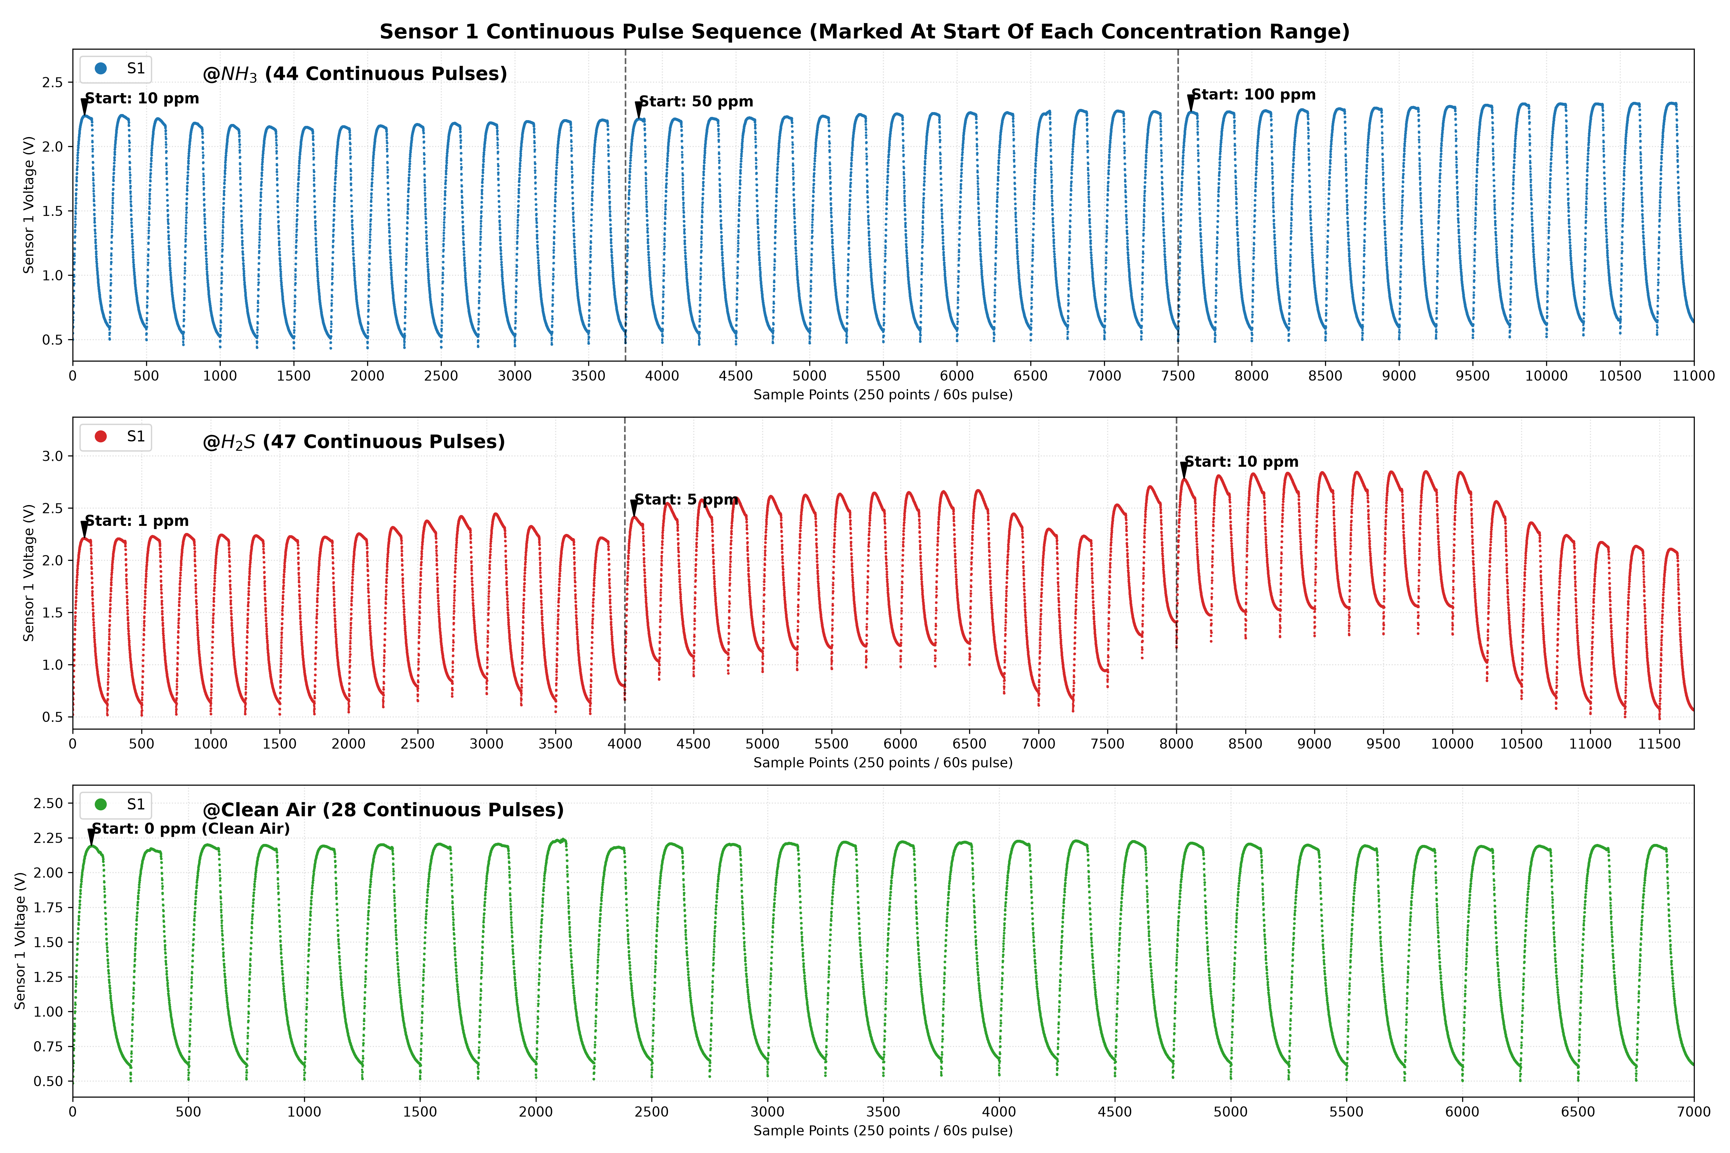
Figure 2: Real data of three gas after
The system deploys a Dual-Mode Random Forest Architecture (100 decorrelated decision trees):
- Pulse-Level Model (Diagnostic / 60s Cycle): Evaluates a 19-dimensional feature vector (statistical moments, Area Under Curve $\text{AUC}$, adsorption/desorption velocity, and 10 temporal anchor points).
- Window-Level Model (Streaming / Real-Time): Operates on a 20-sample sliding window (~4.8s) extracting 32 rolling statistical features for sub-second early leak detection.
- Cross-Validation: Enforces Zero-Overlap Stratified 5-Fold Cross-Validation grouped strictly by pulse index to prevent data leakage.

3. Experimental Results & Industrial Safety Classification

Table 1: System Performance Benchmark Summary
Model Level | Task | Evaluation Metric | Verified Result
Pulse-Level (60s) | Gas Classification ($H_{2}S$ / $NH_{3}$ / Clean Air) | Accuracy / Macro F1 | 95.76% / 95.25%
Pulse-Level (60s) | Concentration Estimation | MAE / $R^{2}$ | 5.58 ppm / 0.7947
Window-Level (Streaming) | Real-Time Classification | Accuracy | 94.97%
Window-Level (Streaming) | Real-Time Regression | MAE / $R^{2}$ | 2.47 ppm / 0.9333

Table 2: Per-Class Classification Performance
Target Gas Profile | Precision | Recall | F1-Score | Support (Pulses)
Clean Ambient Air (0 ppm) | 89.7% | 92.9% | 91.2% | 28
$H_{2}S$ (1, 5, 10 ppm) | 97.8% | 93.6% | 95.7% | 47
$NH_{3}$ (10, 50, 100 ppm) | 97.8% | 100.0% | 98.9% | 44
Weighted Average | 95.87% | 95.80% | 95.80% | 119

- Zero Cross-Misclassification: The confusion matrix verifies 0 false cross-classifications between $H_{2}S$ and $NH_{3}$.
- 4-Tier OSHA Risk Matrix: Local predictions map to 4 operational risk levels: Level 1 (Normal) ($S_{3}≤0.65\text{V}$ baseline guard check forces 0.0 ppm), Level 2 (Warning) ($H_{2}S≥1.0\text{ ppm}$ or $NH_{3}≥25.0\text{ ppm}$), Level 3 (Hazardous) ($H_{2}S≥10.0\text{ ppm}$ or $NH_{3}≥50.0\text{ ppm}$), and Level 4 (Emergency) ($H_{2}S≥50.0\text{ ppm}$ or $NH_{3}≥100.0\text{ ppm}$).

Next Steps & WISE-IoT Integration Roadmap
To transition from the current validated local prototype to a full industrial IoT deployment, the team has outlined a 2-step integration roadmap:
- Modbus RTU over RS-485 Migration: Upgrade the Serial communication line to an industrial RS-485 bus using Modbus RTU protocol, enabling multi-node daisy-chaining to the Raspberry Pi 4 Edge Gateway.
- WISE-IoT Telemetry Integration: Implement a lightweight background daemon on the Raspberry Pi 4 to publish local inference results, risk levels, and system health metrics via MQTT to the Advantech WISE-IoT Cloud for remote dashboard visualization.

- Web dashboard
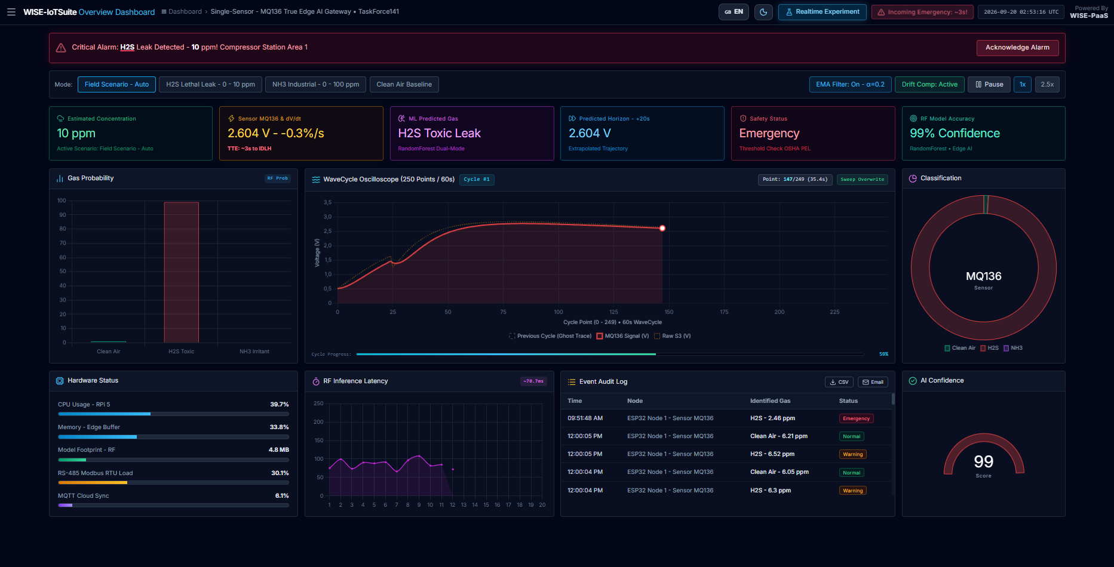
Figure 3: SCADA Operations & Edge AI Gateway Dashboard
- What it has:
  - Critical leak alarm banner with one-click alarm acknowledgment.
  - Scenario simulation bar (Clean Air, H_2S leak, NH_3 emission) with EMA filtering and drift compensation.
  - 6 KPI summary cards: Gas concentration (ppm), voltage rate ($dV/dt$), +20s predictive horizon, and safety status.
  - Central analytics: Gas probability bars, single-sensor oscilloscope, and classification donut chart.
  - System diagnostics: Edge gateway health (CPU, RAM, RS-485 Modbus load) and event audit log table.
- What it does:
  - Serves as an industrial SCADA dashboard for factory safety surveillance.
  - Predicts gas concentration trends 20 seconds ahead to warn operators before hazard thresholds are reached.
  - Monitors edge gateway resource usage to ensure stable 24/7 continuous operation.
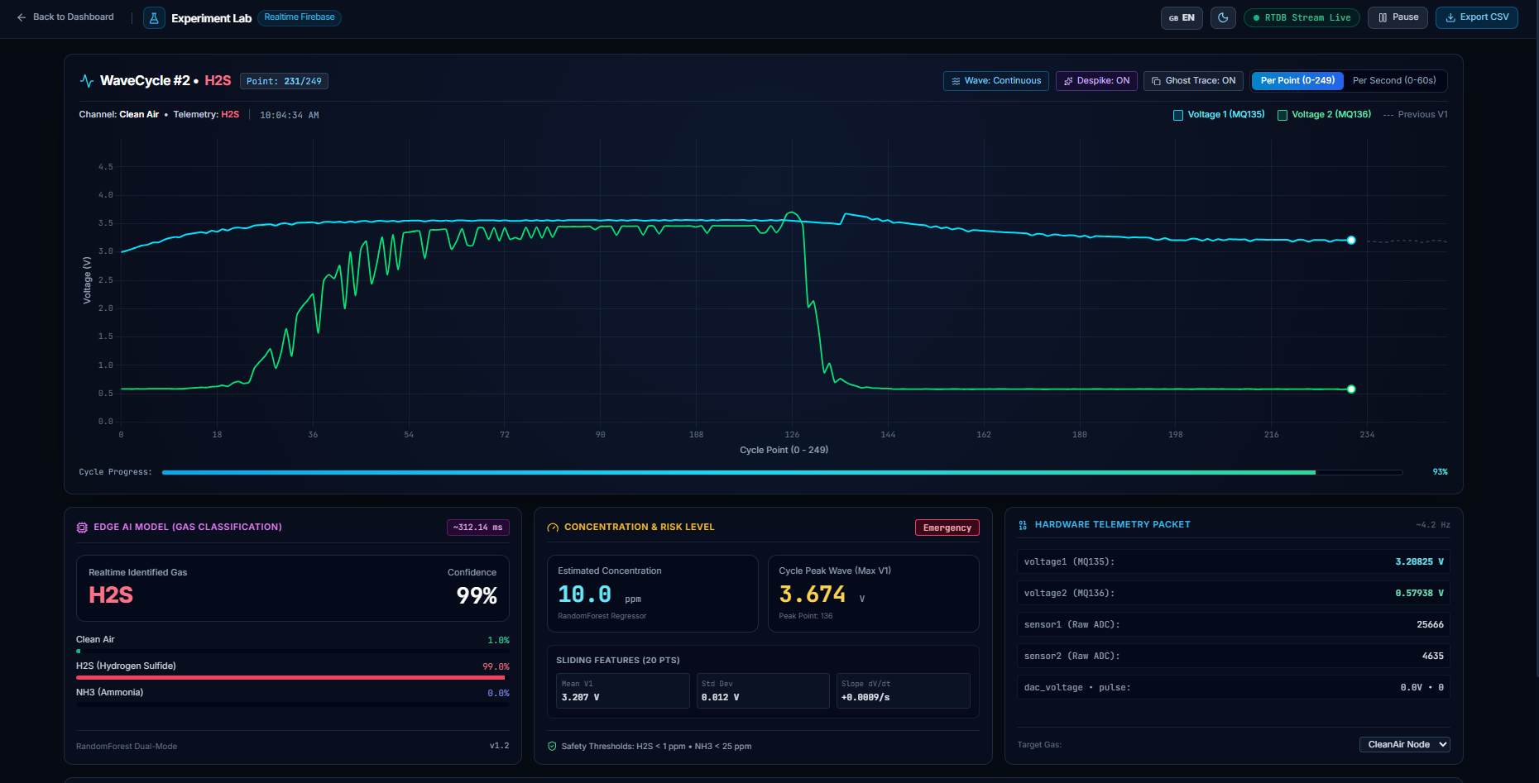
Figure 4: Hardware Experimentation & Real-Time WaveCycle Oscilloscope
- What it has:
  - Real-time dual-channel oscilloscope plotting sensor response curves (MQ135 & MQ136) over a 60-second heating cycle.
  - Waveform control tools: Point/Second mode, Continuous/Sweep display, Despike filter, and Ghost Trace comparison.
  - Real-time AI classification card (99% confidence, probability breakdown, ppm concentration, risk level).
  - Live hardware telemetry (raw ADC, calibrated voltages, DAC pulse) and cycle history log table with CSV export.
- What it does:
  - Displays live hardware sensor signals from Firebase RTDB without clipping peak voltages.
  - Instantly detects toxic gases and calculates gas concentration using edge-trained Random Forest models.
  - Logs and exports experimental cycle data for research and model re-training.

