This python 2.7 script can help you to jump from your text editor to the OF documentation.

Usage example ( Code Blocks )

Place the insertion point on an OF keyword (a global function or a class name),
and call the script, with the menu or a keyboard shortcut ( Alt-O in this case ):

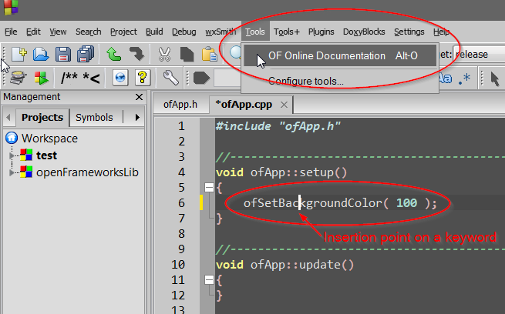

This lead you to the right documentation entry in your web browser:

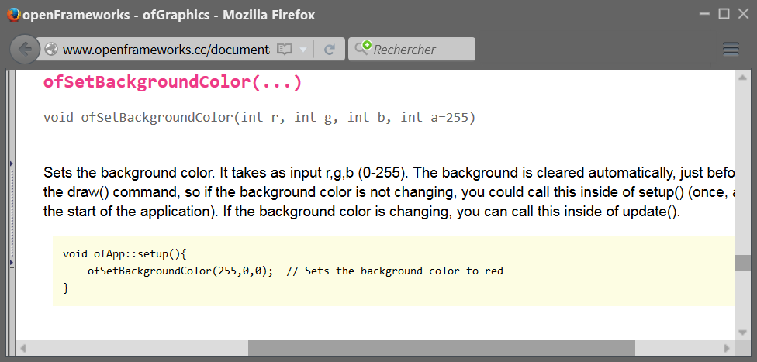

Requirement
You need to have Python 2.7 installed.

Installation
Put the script somewhere, for example C:\Users\username\Documents\python\OF doc
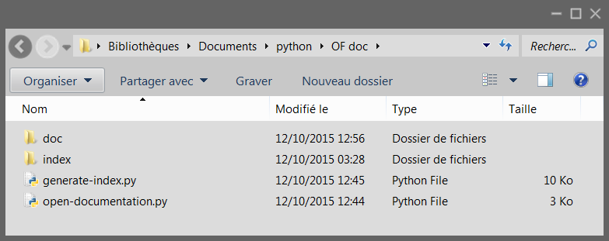

Edit open-documentation.py to set the correct path, and eventually the OF documentation URL:
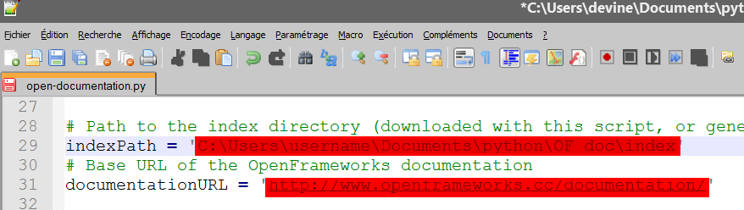

You should now be able to use the tool with a command line to find an OF keyword in the documentation:
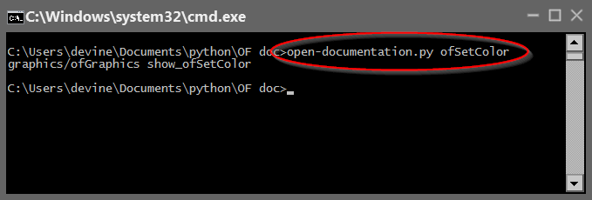
This should open your web browser pointed to the right place, the ofSetColor documentation.
If this doesn't work, read the documentation at the beginning of open-documentation.py
If the command output is Item not found in the documentation, perhaps you need to generate the index for your current OF version. In this case read the beginning of generate-index.py, and use it to generate the index.

Editor configuration ( Code Blocks )
You can now configure your code editor to use the script and be able to show you the documentation for a selected keyword.
Here's an example for Code Blocks 12.11.
First, add the script in the Tools menu:
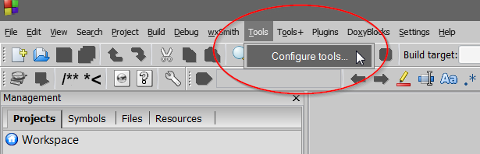

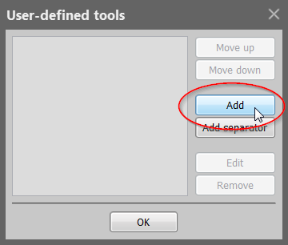

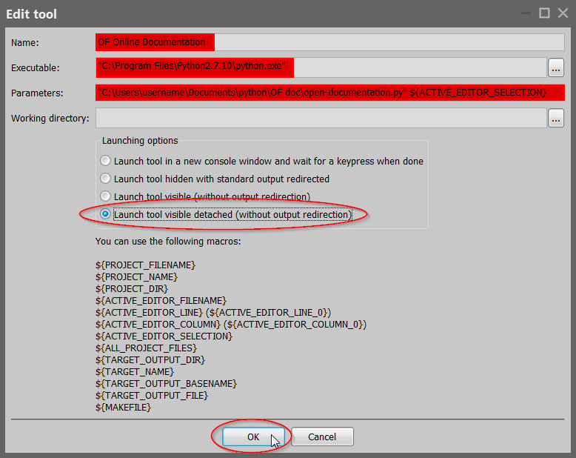

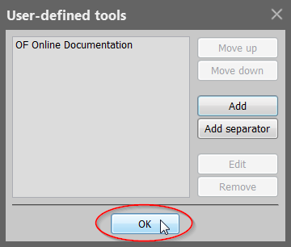

You can if you want assign a keyboard shortcut to this new tool:
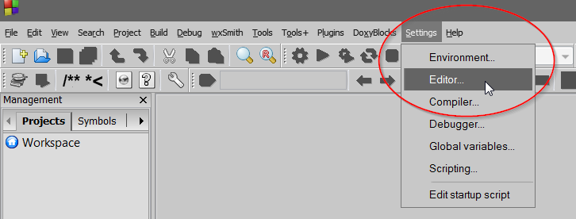
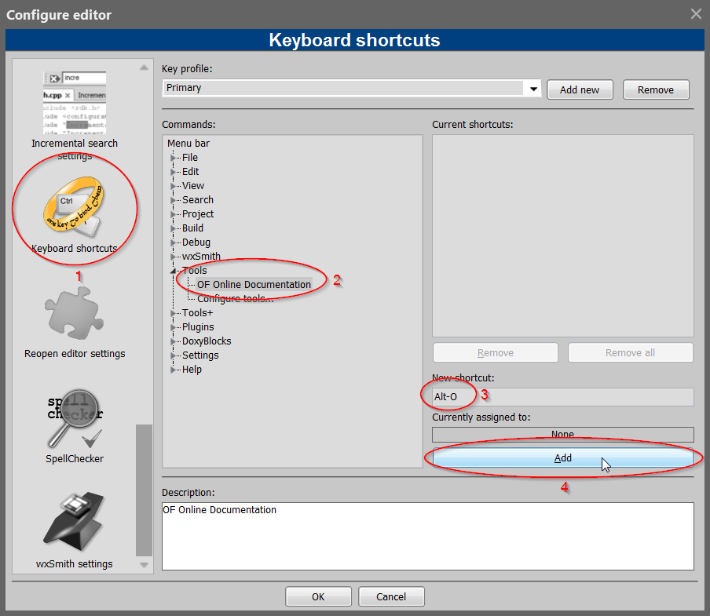

You can now place the insertion point on an OF keyword (a global function or a class name), and see its documentation with this tool. Invoque the tool either by the menu or its keyboard shortcut:

This lead you to the right documentation entry in your web browser:

