Infosys 320 – Lab Test 1

Name: Lisa Bell

ID: 8070708

UPI: lbel173

Question 5:

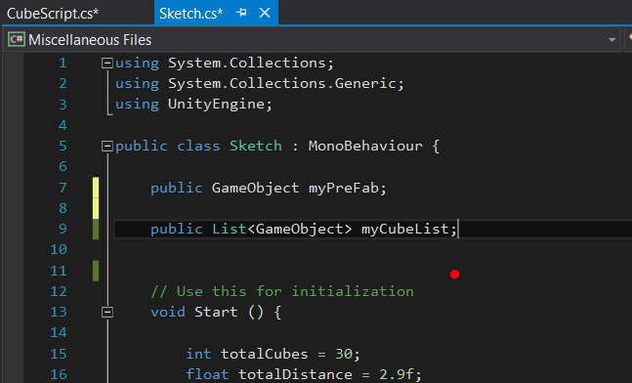

First we will declare a list called myCubeList, we will make this public so all functions within the Sketch class can call it.

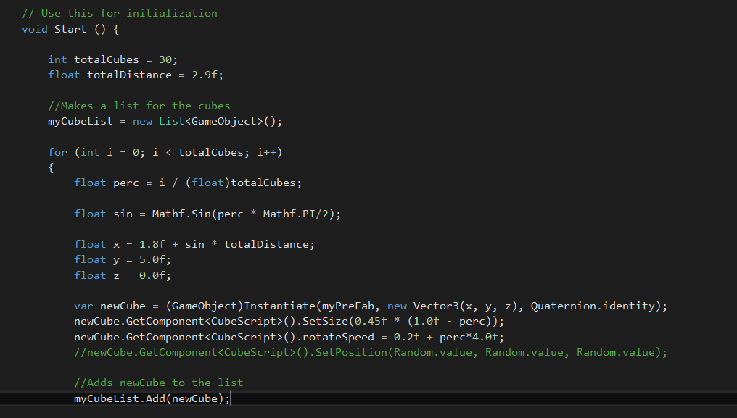

We then Make the list in the start function, myCubeList = new List <GameObject>();

Then we add the newCube into the list using myCubeList.Add(newCube);

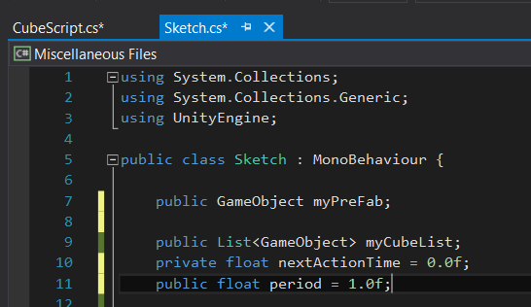

We then need to declare some new variables to create a timer like fuction as the colours of the cube will need to change per second. NextActionTime is set to 0 and period is set to 1 second.

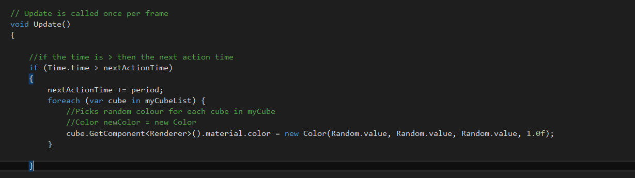

We then use the ‘if’ condition, if the running time is greater than the nextActionTime, we add the one second (period) to the nextActionTime. Then for each cube in the myCubeList, we get change the material colour to a random colour.

This changes the colour of the cube every second.