Healthcare Breach Impact Analyzer
An End-to-End Analysis of 7,795 U.S. Healthcare Data Breaches (2009–2026)
Data source: HHS Office for Civil Rights Breach Portal · Joel William Kommu · July 2026
Live dashboard: healthcare-breach-analyzer.streamlit.app
Code: github.com/lilkommu/healthcare-breach-analyzer

Contents
1. Executive Summary
2. Data Source and Preparation
3. Exploratory Analysis: What 17 Years of Breaches Show
4. Breach Segments: K-Means Clustering
5. How Breaches Happen: Mining 6,400 Federal Case Narratives
6. Predicting Large Breaches: XGBoost + SHAP
7. Real Dollars: Official HHS Penalties Joined to Breaches
8. Estimated Financial Exposure (Clearly Labeled)
9. The Product: Dashboard and Self-Updating Pipeline
10. Conclusions
Sources

1. Executive Summary
Since 2009, U.S. law has required every healthcare organization that loses control of 500 or more patients’ protected health information to report the incident to the Department of Health and Human Services (HHS), which publishes the list. This project analyzes the complete record — 7,795 breaches from October 2009 to July 2026, affecting over 1.04 billion individual records — and turns it into a public, self-updating analytical product.
Principal findings:
- The mechanism of breach has completely inverted. In 2010, half of reported breaches were physical theft and only 4% were hacking. By 2024, hacking accounts for 83% of reports and theft has nearly vanished (1–2%).
- Hacking is also the most severe breach type — median 8,000 individuals per incident versus roughly 1,700–2,200 for every other type.
- Vendors concentrate the damage. Business Associates (claims processors, IT vendors, mailing houses) file only 15% of reports but account for about half of all records ever exposed (~520M), including the largest breach in history (Change Healthcare, 2024, 192.7M records).
- Ransomware is new and uniquely damaging. Text mining of 6,400 federal case narratives shows ransomware was essentially absent before 2016, then became the single most damaging attack vector (median 12,060 records per breach).
- Official penalties are rare and barely track harm. Joining HHS enforcement data reveals fewer than 1% of breaches draw a published fine, penalty size correlates only weakly with breach size (Spearman 0.14), and the record $16M Anthem settlement equals $0.20 per breached record.
- Breach severity is partially predictable at report time. An XGBoost model reaches AUC 0.73 predicting 10,000+ record breaches from structured fields alone, with SHAP analysis quantifying each risk driver.
All results are explorable in a live 8-tab dashboard, and a GitHub Actions pipeline refreshes the data from HHS monthly and redeploys automatically.

2. Data Source and Preparation
The dataset is two exports from the HHS OCR Breach Portal (informally, the “Wall of Shame”): breaches under active investigation (733 rows) and archived, resolved cases (7,064 rows). Fields include entity name, state, entity type, individuals affected, submission date, breach type, location of the breached information, business-associate involvement, and — for closed cases — a written investigation narrative.

2.1 Defects repaired
- Broken column headers. The first and second-to-last columns carry corrupted “javax.faces.component.UIPanel@…” headers from the portal’s export mechanism; they were restored to “Name of Covered Entity” and “Business Associate Present” per the official HHS field order.
- Embedded control characters. 151 narrative fields contained bare carriage returns that silently corrupt CSV round-trips; all whitespace was normalized. Literal “\N” database null markers were treated as missing.
- Duplicates and types. Two exact duplicate rows removed; dates parsed; affected counts converted to numeric (one legitimately missing value — a case consolidated into another report).
The cleaned dataset: 7,795 breaches, October 21, 2009 – July 1, 2026. Every count and chart in this report derives from it; the analysis pipeline is fully reproducible from the five notebooks in the repository.

2.2 Known limits (stated up front)
- No financial field exists anywhere in the data — all cost figures in Section 7 are estimates from an external benchmark and labeled as such; Section 6 contains the only real dollars (official penalties).
- No rural/critical-access hospital flag exists; entity types are broad categories, so no rural-hospital claims are made.
- “Individuals affected” is record-level: one person breached twice counts twice.
- State reflects where the covered entity is registered, not where affected patients live.

3. Exploratory Analysis: What 17 Years of Breaches Show

3.1 Volume and severity over time
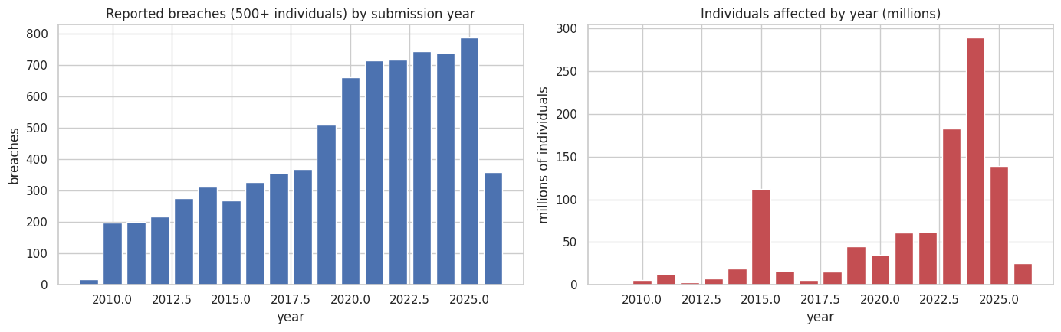
Figure 1. Breach counts rose from ~200–300/yr in the early 2010s to ~700–790/yr in the 2020s. Records affected is spikier: 2015 (Anthem, 78.8M) and 2024 (Change Healthcare, 192.7M) dominate. 2026 is a partial year.
The severity distribution is extremely heavy-tailed: the median breach affects 3,916 people, the mean 133,252 — pulled up by a handful of mega-events. The top five breaches account for roughly a third of every record ever exposed.
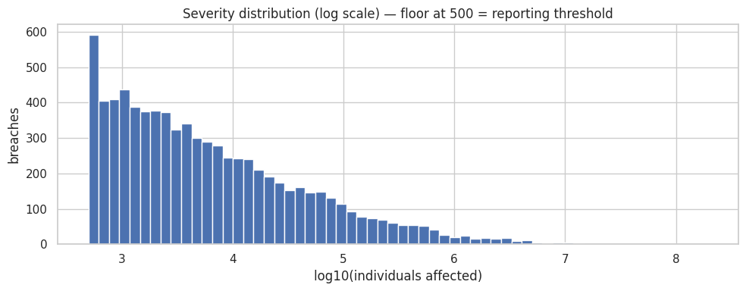
Figure 2. Severity on a log scale. The floor at 500 is the legal reporting threshold; the tail extends past 100 million.
Entity | State | Year | Individuals affected | Type
Change Healthcare, Inc. | MN | 2024 | 192,700,000 | Hacking/IT
Anthem Inc. | IN | 2015 | 78,800,000 | Hacking/IT
Conduent Business Services LLC | NJ | 2025 | 62,224,658 | Hacking/IT
Welltok, Inc. | CO | 2023 | 14,782,887 | Hacking/IT
Aflac Incorporated | GA | 2025 | 13,924,906 | Hacking/IT
Table 1. The five largest breaches on record — all hacking incidents.

3.2 The regime change: theft out, hacking in
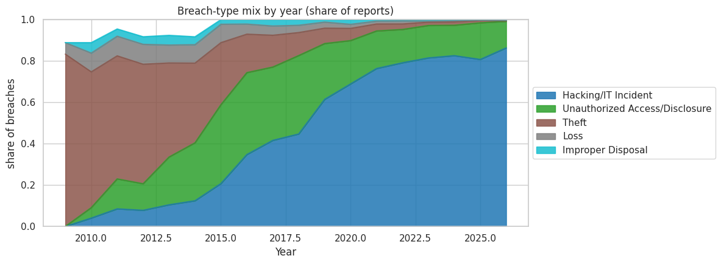
Figure 3. Breach-type mix by year. Physical theft (green) collapses from ~50% to ~1–2%; hacking (blue) grows from 4% to ~83%.
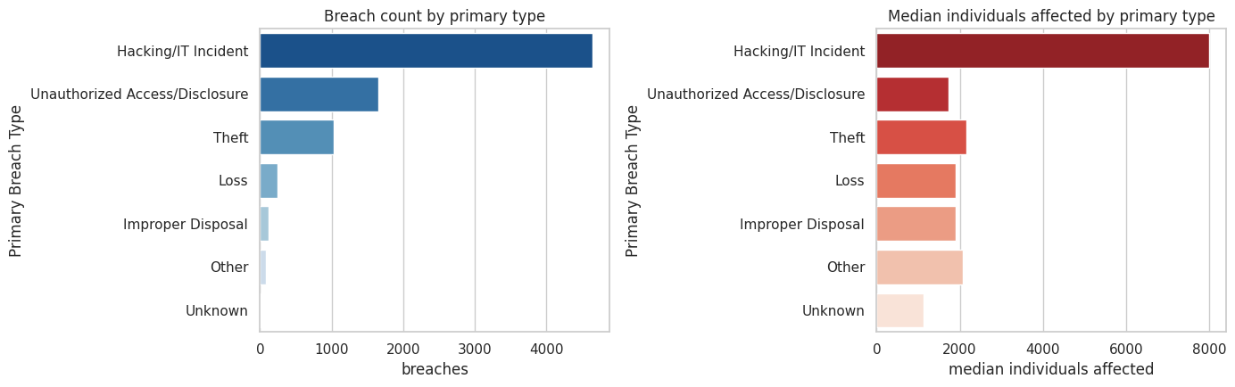
Figure 4. Hacking is both the most common and the most severe type: median 8,000 affected vs 1,700–2,200 for all others.

3.3 Who gets breached — and who loses the records
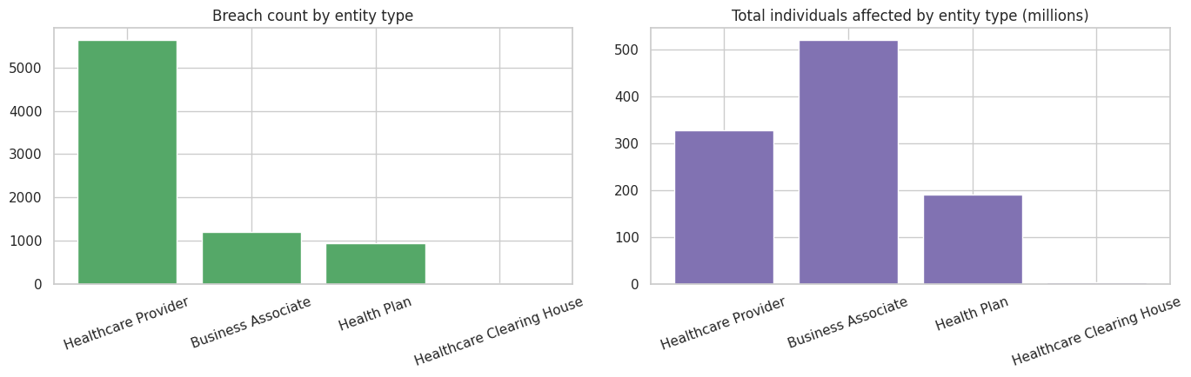
Figure 5. Healthcare providers file most reports, but Business Associates — 15% of reports — account for ~50% of all records affected (~520M of ~1,039M).
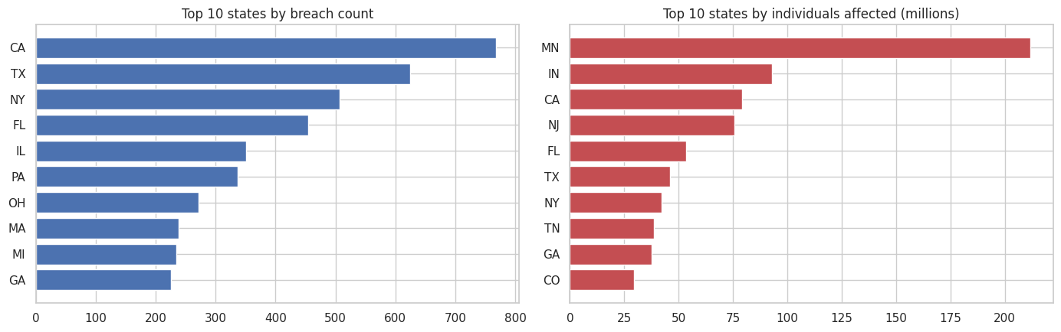
Figure 6. Breach counts track population (CA, TX, NY, FL); records affected do not — MN “leads” only because Change Healthcare is registered there.

4. Breach Segments: K-Means Clustering
To move beyond one-dimensional charts, breaches were clustered on log-severity, submission year, business-associate involvement, breach type, and entity type (scikit-learn, k = 5 chosen by elbow and silhouette analysis). State was tested as a feature and excluded after the test showed it added no geographic structure — every cluster’s top states were simply the biggest states.
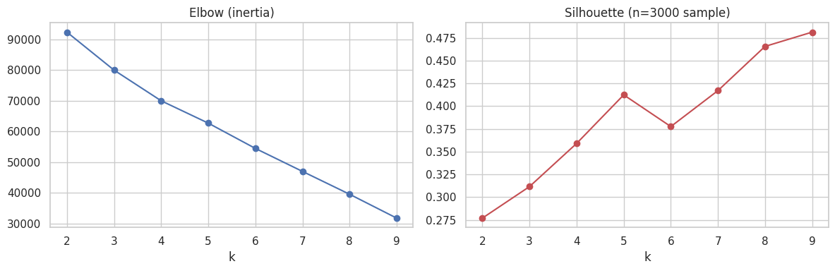
Figure 7. Model selection: k = 5 sits at a local silhouette peak and yields interpretable segments.
# | Segment | Share | Median affected | Total affected | Character
0 | Modern provider hacking | 44% | 8,175 | 293M | Providers, 100% hacking, centered ~2022
1 | Provider human error / insider | 18% | 1,654 | 24M | Disclosure, loss, improper disposal
2 | Health-plan breaches | 12% | 3,000 | 189M | Mixed hacking + disclosure; incl. Anthem
3 | Business associate / vendor | 15% | 5,696 | 520M | Half of all records; incl. Change Healthcare
4 | Physical theft era (legacy) | 11% | 2,000 | 13M | ~100% theft, mean year 2014; extinct
Table 2. The five segments and what they actually contain.
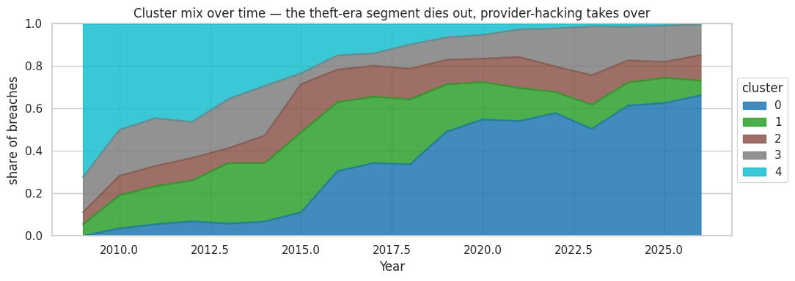
Figure 8. Segment mix over time: the theft-era cluster dies out as provider hacking takes over — the clustering independently rediscovers the regime change.

5. How Breaches Happen: Mining 6,400 Federal Case Narratives
When OCR closes an investigation it writes a narrative describing what happened and what the entity did in response — information available nowhere else in structured form. A rule-based classifier (documented regex rules, manually validated against sampled narratives) extracted the attack vector and post-breach actions from 6,379 narratives.
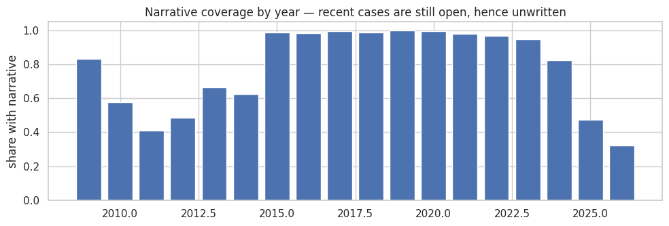
Figure 9. Coverage caveat: narratives exist only for closed cases, so 2024–26 are under-covered. All shares below are of narrated breaches.
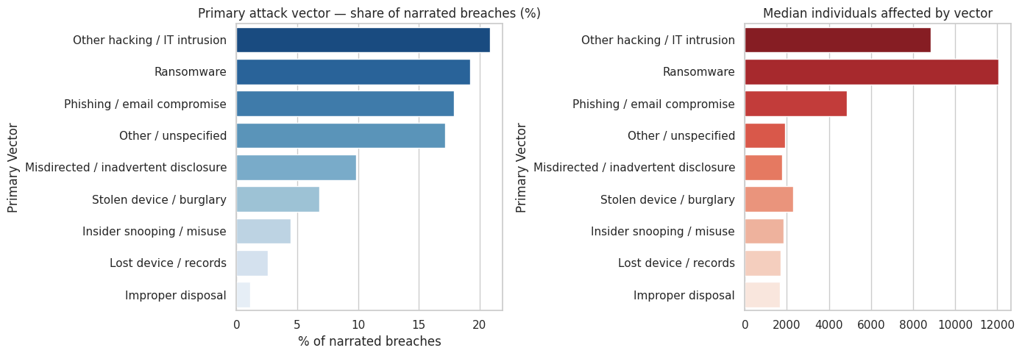
Figure 10. Attack vectors: intrusion (~21%), ransomware (~19%), and phishing (~18%) dominate; ransomware’s median of 12,060 records per breach is 5–7× any physical or human-error vector.
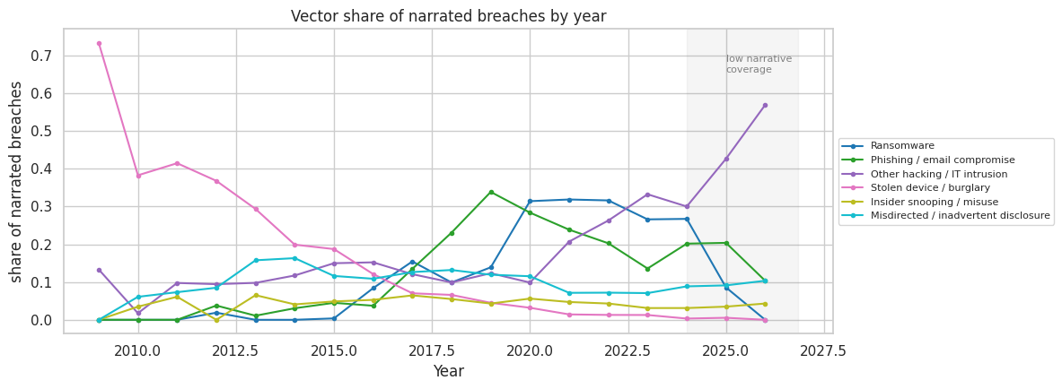
Figure 11. Ransomware is a post-2016 phenomenon — 3 cases total before 2016, then 200+ per year through 2020–2023. The post-2023 dip is partly a coverage artifact (shaded).
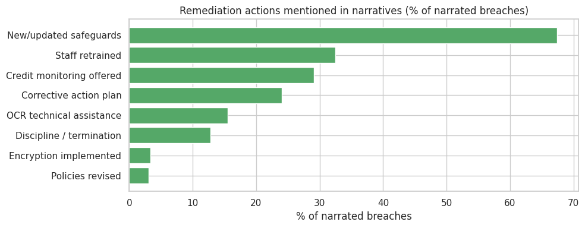
Figure 12. What entities do afterward: generic “additional safeguards” (67%) and retraining (32%) lead; encryption is specifically mentioned in only ~3% of narratives.
Method note: this is transparent keyword extraction, not a trained classifier; ~17% of narratives state no clear mechanism and are labeled “Other / unspecified” rather than force-fitted.

5.1 From vectors to prevention
Each vector maps to well-established controls — and the strongest evidence that controls work is in this dataset itself: the stolen-device era, half of all breaches in 2010, collapsed to near zero once full-disk encryption became standard practice. The same playbook applies to the current regime:
Attack vector | Share | Median affected | Primary preventive controls
Phishing / email compromise | ~18% | 4,845 | Multi-factor authentication; phishing training; limit PHI stored in mailboxes
Ransomware | ~19% | 12,060 | Offline, tested backups; prompt patching; MFA on remote access; network segmentation
Other hacking / IT intrusion | ~21% | 9,967 | Regular risk analysis (OCR’s most-fined failure); patch management; disable unused remote access
Insider snooping / misuse | ~4% | 1,670 | Least-privilege access; audit logs with alerts; immediate access revocation at termination
Stolen device / burglary | ~7% | 2,340 | Full-disk encryption; physical security; no local PHI storage
Misdirected / inadvertent disclosure | ~10% | 1,669 | Address verification and mailing QA; DLP rules on email; four-eyes checks on bulk mailings
Lost device / records | ~3% | 1,673 | Encryption; device inventory; minimize portable media
Improper disposal | ~1% | 1,821 | Shredding and certified media destruction; disposal vendor contracts
Table: attack vectors observed in the narratives mapped to preventive controls.
One control cuts across every vector: vendor risk management. Business Associates account for roughly half of all records ever exposed, so vendor security requirements, business associate agreements, and minimizing the data vendors hold matter as much as any internal safeguard.

6. Predicting Large Breaches: XGBoost + SHAP
Can the eventual size of a breach be predicted the day it is reported? An XGBoost classifier was trained to predict whether a breach reaches 10,000+ individuals (the worst ~third) using only fields available at report time: entity type, breach type, information location, business-associate flag, state, and date. Narrative-derived features were deliberately excluded — they only exist after a case closes, and using them would leak the future.
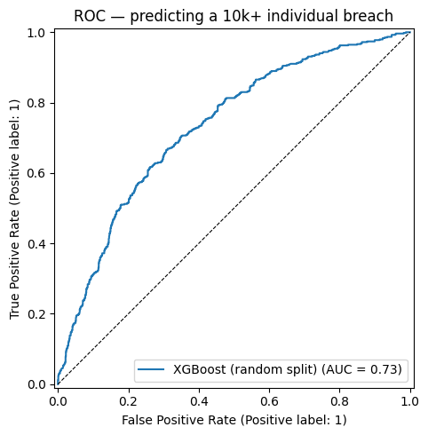
Figure 13. ROC curve. AUC = 0.73 on a random split; 0.67 on a temporal split (train <2023, test 2023+).
The honest reading: real but partial signal. The temporal drop is itself a finding — models trained on the pre-2023 breach mix underestimate the modern hacking-dominated regime.
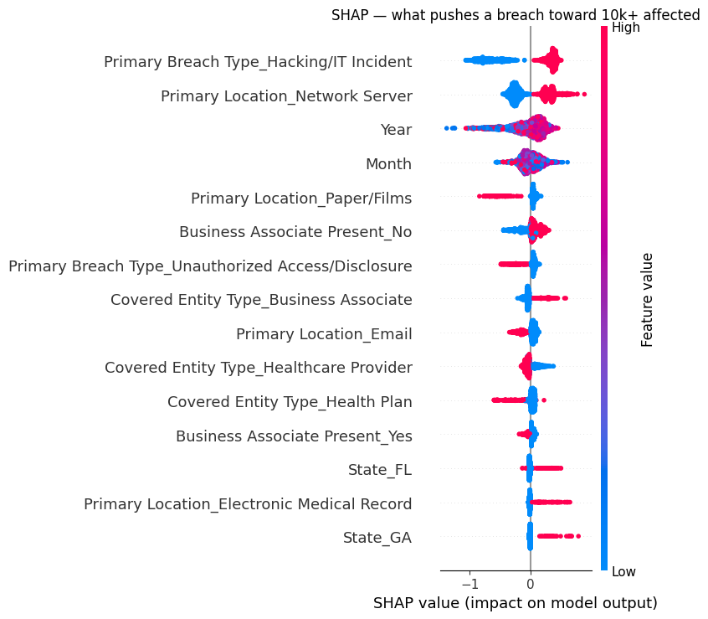
Figure 14. SHAP analysis: hacking incidents, network-server locations, and recent submission years push predicted severity up hardest; paper records and disclosure incidents push it down.
The dashboard exposes this model as a live “what-if” scorer: choose an entity type, breach type, location, and state, and get the predicted probability of a 10,000+ record outcome.

7. Real Dollars: Official HHS Penalties Joined to Breaches
The breach data contains no financial field — but HHS separately publishes every HIPAA settlement and civil money penalty. 65 enforcement actions with amounts stated on the official HHS Resolution Agreements page (~$126M, 2009–2026; amounts never guessed) were matched to breach reports by normalized organization name with a manually audited exclusion list — 42 verified matches.
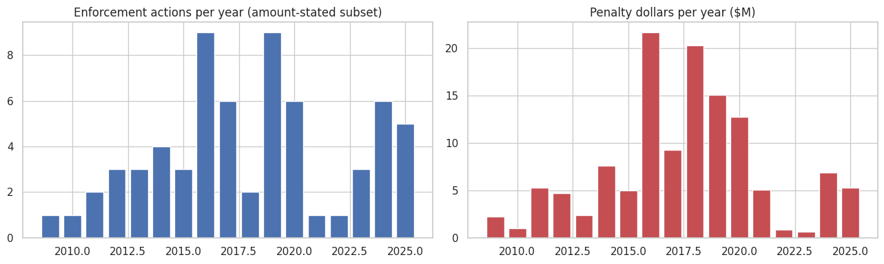
Figure 15. Matched enforcement actions and dollars by year.
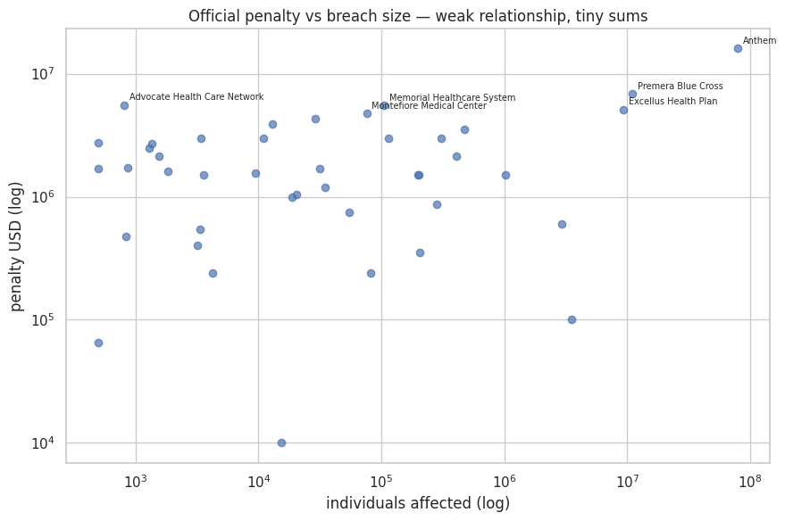
Figure 16. Penalty vs breach size (log-log): Spearman correlation just 0.14. Enforcement targets compliance failures found during investigation — missing risk analyses, no encryption — not harm volume.
Year | Entity | Penalty | Breach size
2018 | Anthem | $16,000,000 | 78,800,000
2020 | Premera Blue Cross | $6,850,000 | 11,000,000
2016 | Advocate Health Care Network | $5,550,000 | (org-level match)
2017 | Memorial Healthcare System | $5,500,000 | 105,646
2021 | Excellus Health Plan | $5,100,000 | 9,358,891
2024 | Montefiore Medical Center | $4,750,000 | 76,068
Table 3. Largest matched penalties. Anthem’s record settlement works out to about $0.20 per breached record.
Fewer than 1% of reported breaches result in a published financial penalty. This section contains the only non-estimated dollar figures in the project.

8. Estimated Financial Exposure (Clearly Labeled)
Applying IBM’s Cost of a Data Breach healthcare benchmark of ~$408 per breached record to the 1.04B records affected yields an estimated total exposure on the order of $420+ billion. This figure is directional only: per-record scaling overstates costs for mega-breaches (costs do not scale linearly) and ignores fixed costs for small ones. The dashboard makes the assumption adjustable ($50–$600 per record) and labels the entire tab as an estimate, never as data.

9. The Product: Dashboard and Self-Updating Pipeline
All results are served in a public Streamlit dashboard — healthcare-breach-analyzer.streamlit.app — with sidebar filters (breach type, entity type, state, year, cluster) driving eight tabs:
- Trends — volumes, records affected, and type mix by year
- Breakdown — by type, entity, and state
- Clusters — the five K-Means segments
- How breaches happen — attack vectors and remediation from the narratives
- Risk model — SHAP drivers plus the live what-if scorer
- Penalties — the 42 official enforcement matches
- Cost estimate — the adjustable, clearly-labeled exposure estimator
- Data — filterable table with CSV download
A GitHub Actions workflow runs monthly: it attempts to pull fresh portal exports and new enforcement actions from HHS, rebuilds every derived dataset with the persisted models, and commits changes — which triggers Streamlit Cloud to redeploy. Fetch failures degrade gracefully (existing data is kept), so the pipeline never breaks the live app.

9.1 Repository structure
Path | Contents
data/ | Raw OCR exports + five generated/curated datasets
notebooks/ | eda → clustering → text_mining → severity_model → enforcement (all executed, with outputs)
models/ | K-Means pipeline, XGBoost model, SHAP importances, feature manifests
app/ | streamlit_app.py — the 8-tab dashboard
scripts/ | refresh_data.py — the monthly rebuild pipeline
.github/workflows/ | refresh-data.yml — scheduled automation

10. Conclusions
Seventeen years of mandatory disclosure tell a coherent story: healthcare data loss has transformed from an accident problem (stolen laptops, misdirected mail) into an adversary problem (ransomware, phishing, network intrusion) — and the financial and regulatory apparatus has not kept pace. Penalties reach fewer than 1% of breaches and barely correlate with harm; the single most damaging vector, ransomware, did not exist in this data a decade ago; and half of all exposed records flow through vendors rather than the hospitals patients actually visit.
Methodologically, the project demonstrates an end-to-end data science workflow: cleaning defective government exports, honest exploratory analysis, unsupervised segmentation, NLP feature extraction with documented rules, leakage-disciplined supervised modeling with explainability, record linkage to a second official source, and deployment as a self-updating public product.

Sources
- HHS OCR Breach Portal — primary dataset (public; entity-level reports, no patient data)
- HHS Resolution Agreements & Civil Money Penalties — official enforcement actions
- IBM Cost of a Data Breach Report — cost-per-record benchmark (used for labeled estimates only)

