Wrangling and messy data

We set out to answer three main questions:
- How many job ads fit the Data Analyst skillset?
- Which are the top employers by number of job ads?
- What is the number of job ads which has salary information?

Process:

Data cleaning/wrangling
- created columns which validates if our list of keywords are present in the description
- created filter for top employers
- created new columns which validates if the description has salary information or not
Data visualisations
- created visuals to answer the questions we had

Main findings:
- The top five locations for data analyst positions are:
1.Seatlle, 2 New York, 3. Cambridge, 4. Boston, 5. SanFrancisco
- The top employers by number of vacancies:
1. Amazon, 2. Ball Aerospace, 3. Microsoft, 4. Google, 5. NYU Langone Health
- Half of the job ads have salary information
- More than twice of the job ads are actually looking for a Data Analyst than what they state in the Position Title
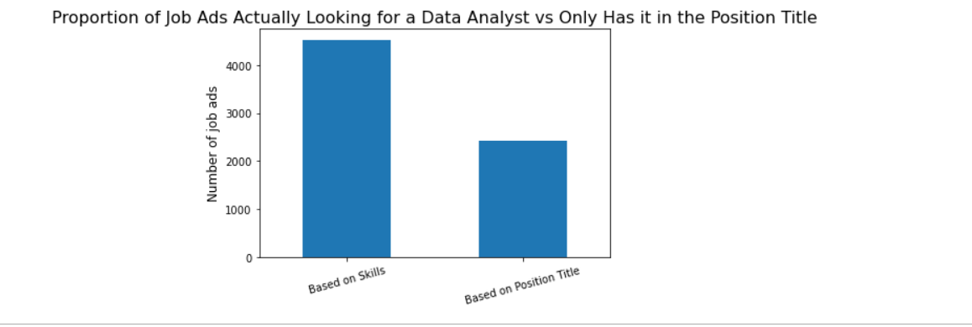
Reflection:
The team worked amicably, we thought we planned well but ran out of time to achieve all our aims. To meet the timeline, we rescoped the requirements.
Scraping; it was difficult to retrieve the key words in the description column.
We may have missed some data because the same tasks, skills, positions are expressed differently.

